How to Execute The test cases:  
Step 1: Configure Test Runner

1. Open Test Runner class and Click on Edit Configuration  
   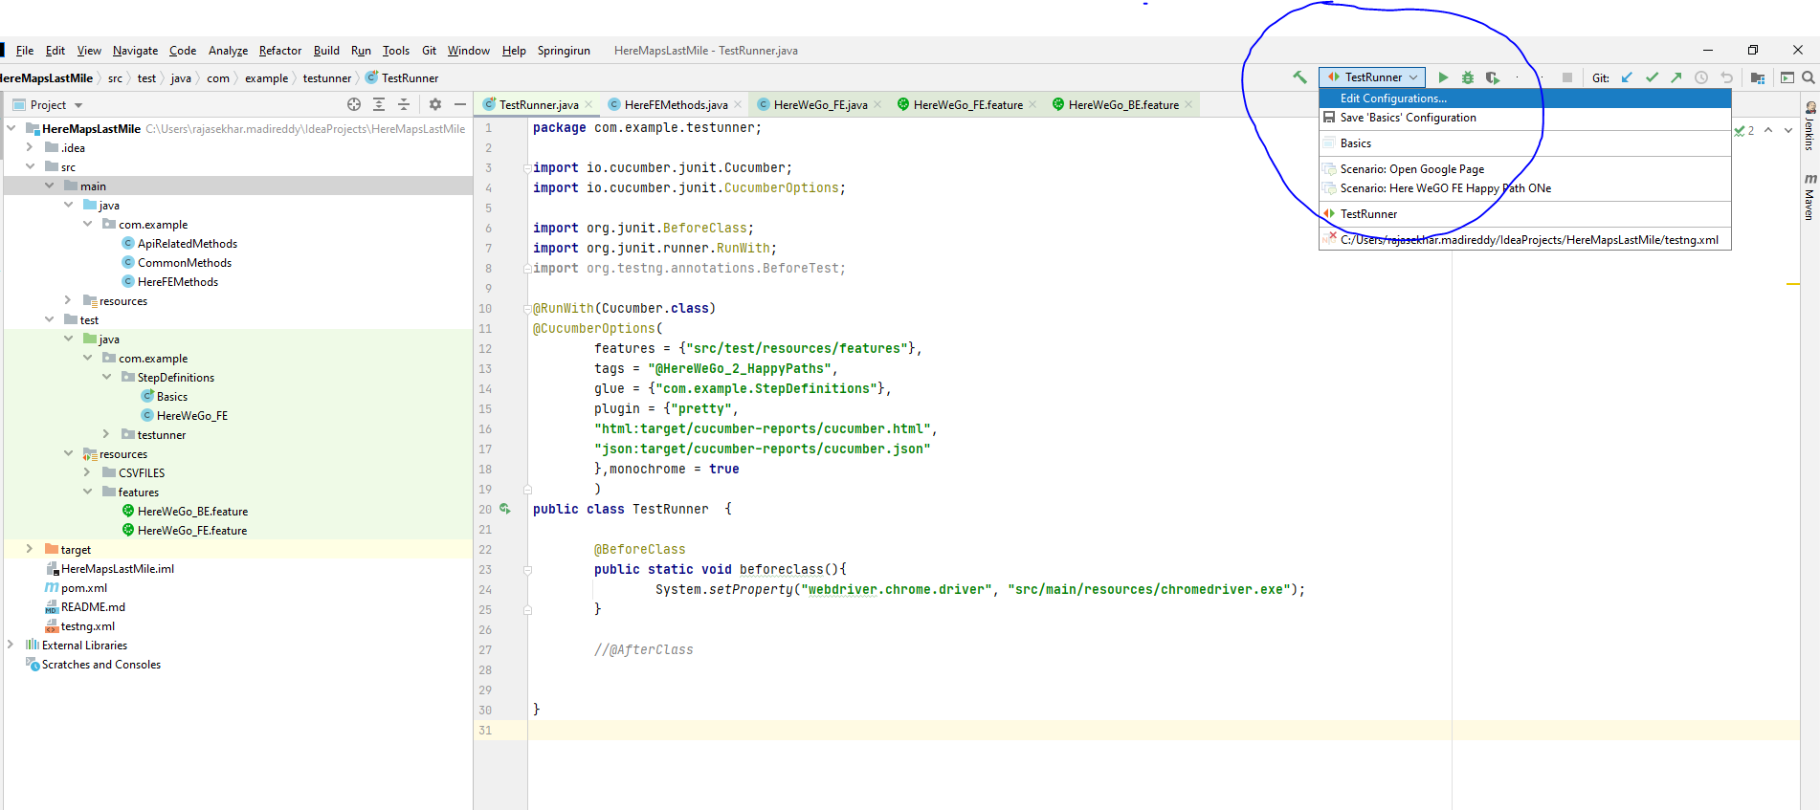
2. Configuration Details:

Click on + icon and select Junit and give appropriate name complete the following necessary details  
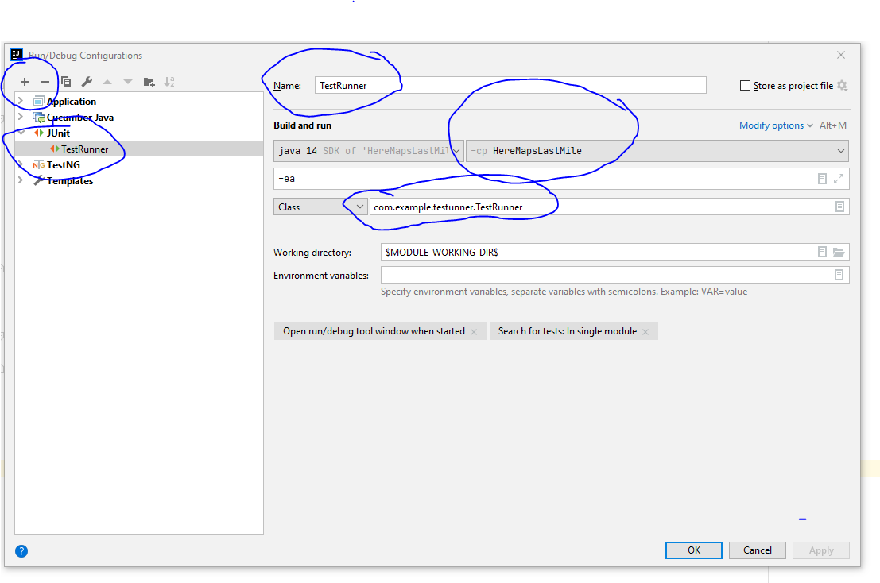

How to Run FE Test Scenarios

1. Go to Test Runner class and give proper tag(@HereWeGO_2_HappyPaths is to run both the test scenarios, we can also run one by one  
   Example: line 13: where tags=”HereWeGo_2_HappyPaths”)

**How to run BE Test cases:** Go to Test Runner class and update the tag as @HereWego_BE