REGISTER NEW USER

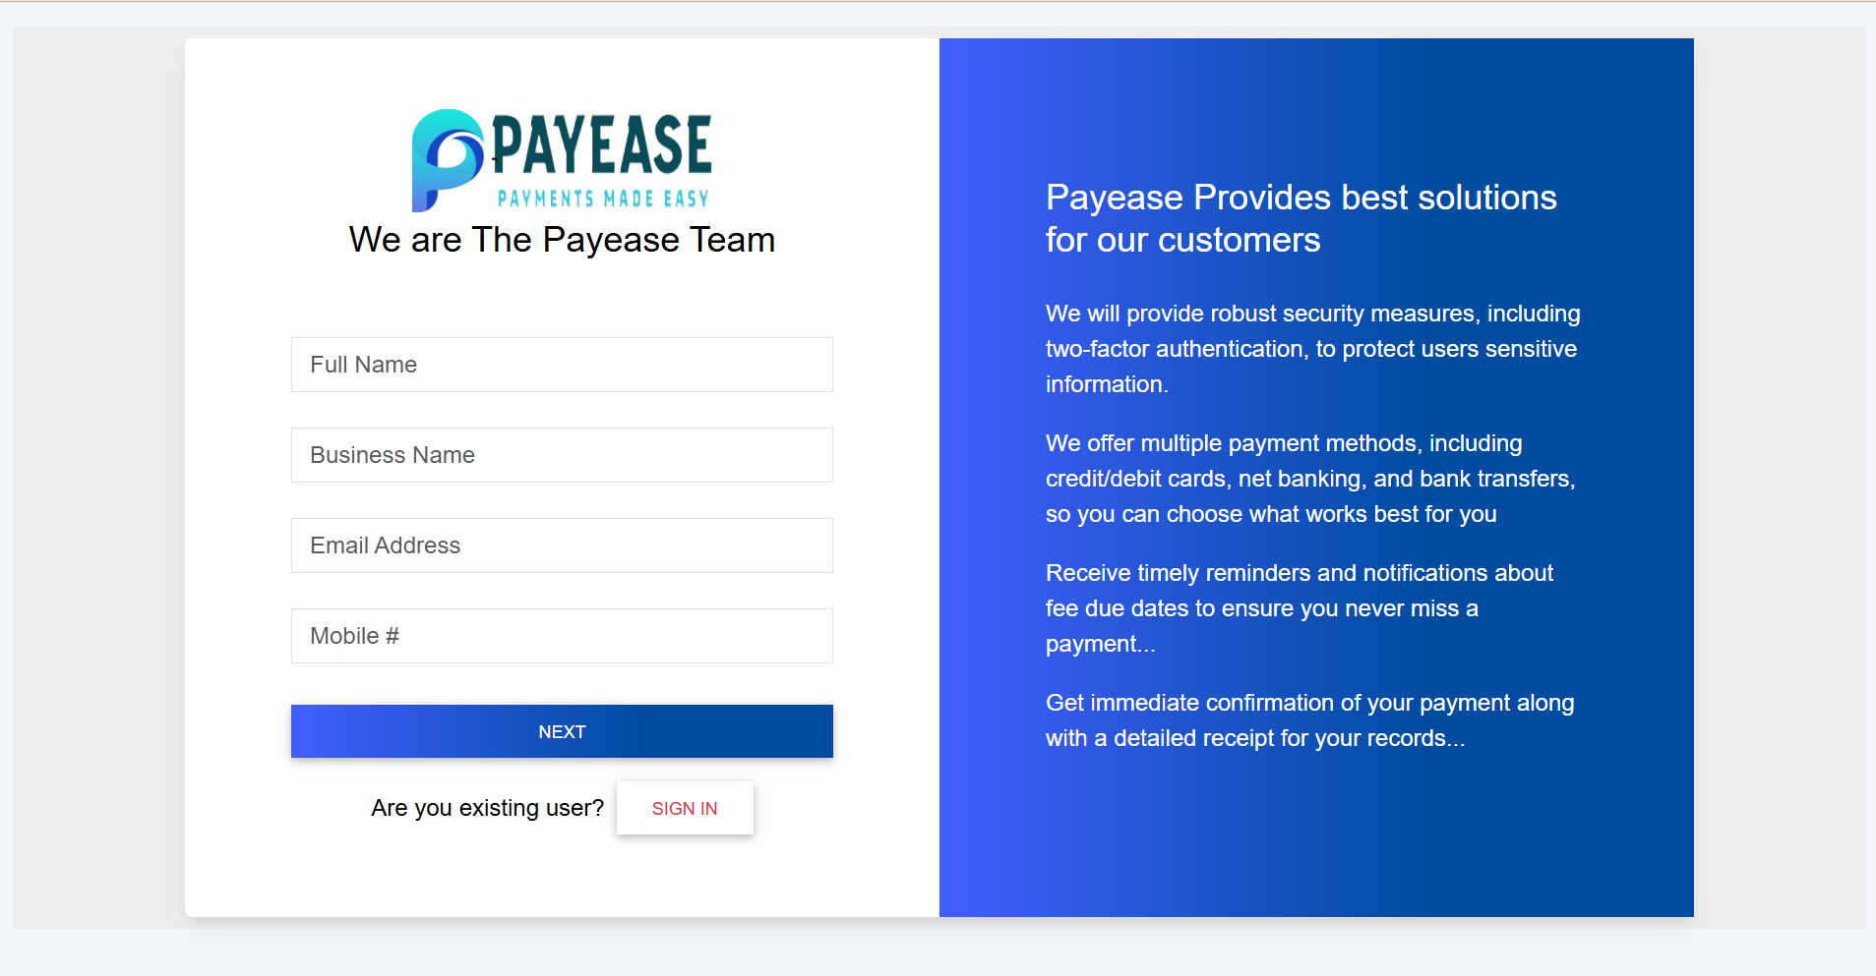

Landing page

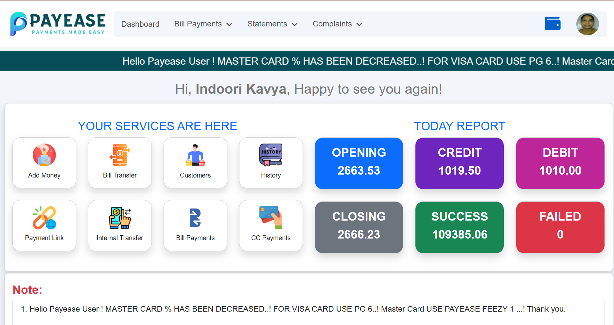

Profile

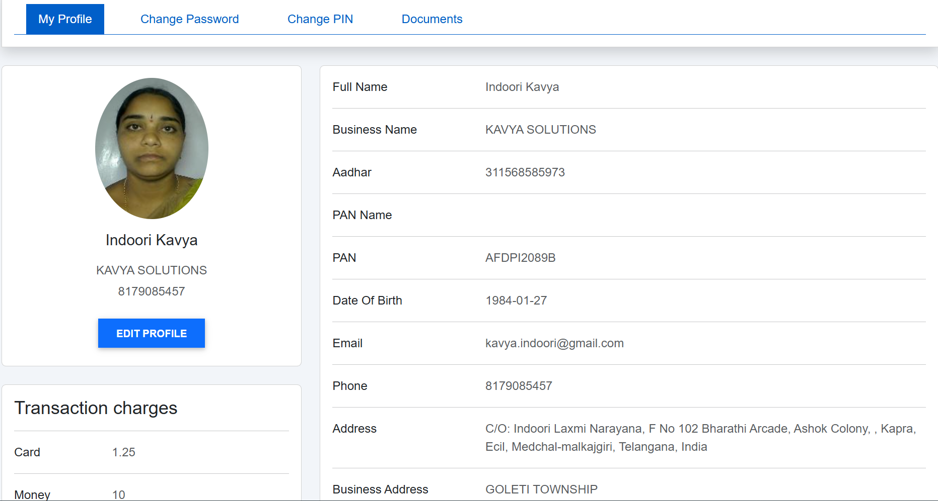

Edit Profile

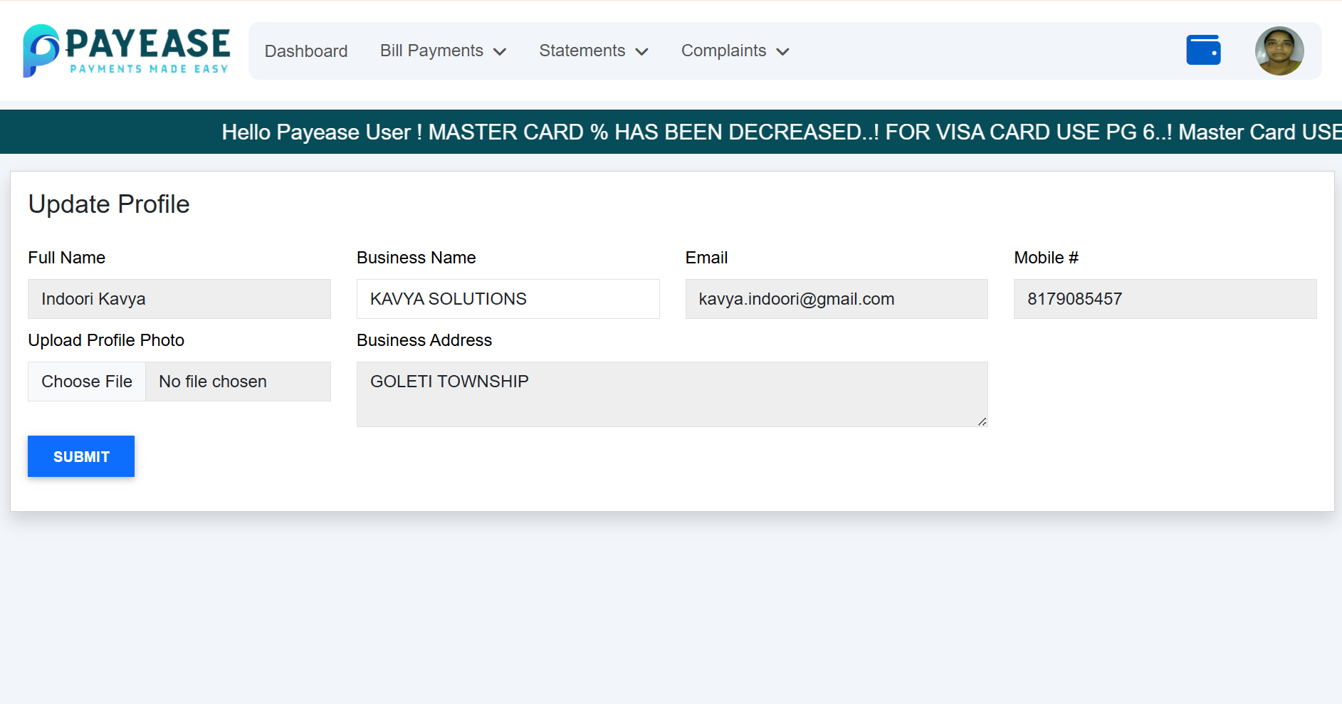

DASHBOARD🡪ADD MONEY

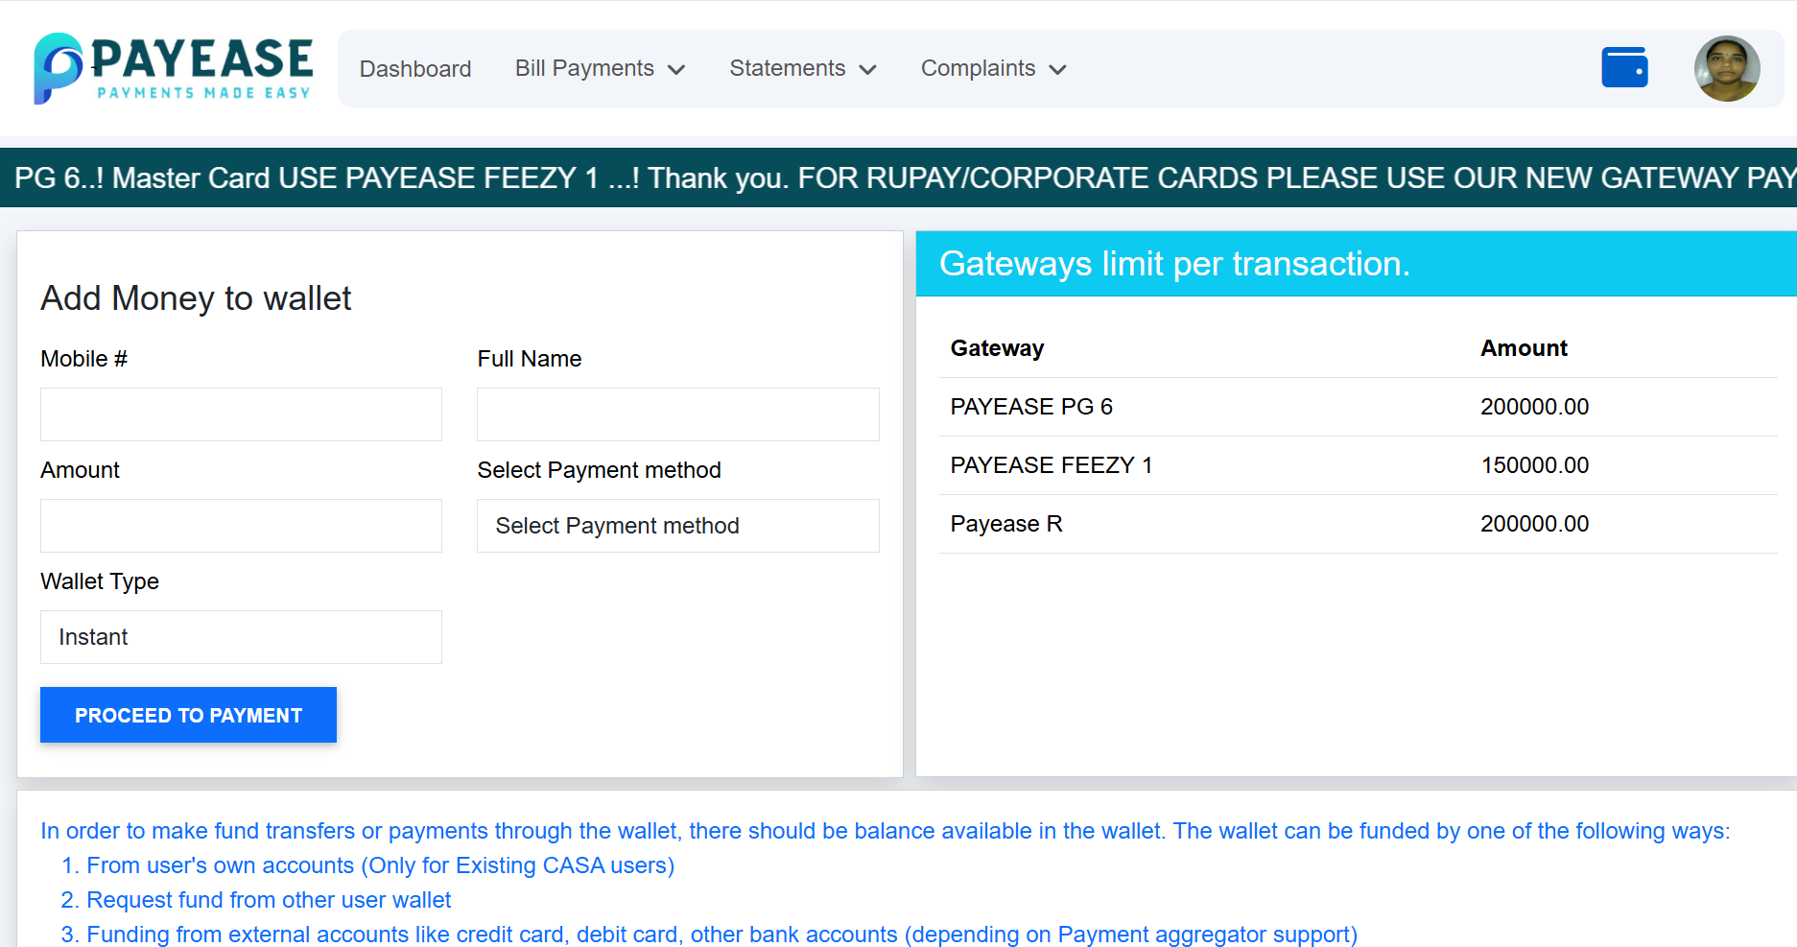

DASHBOARD🡪 BILL TRANSFER

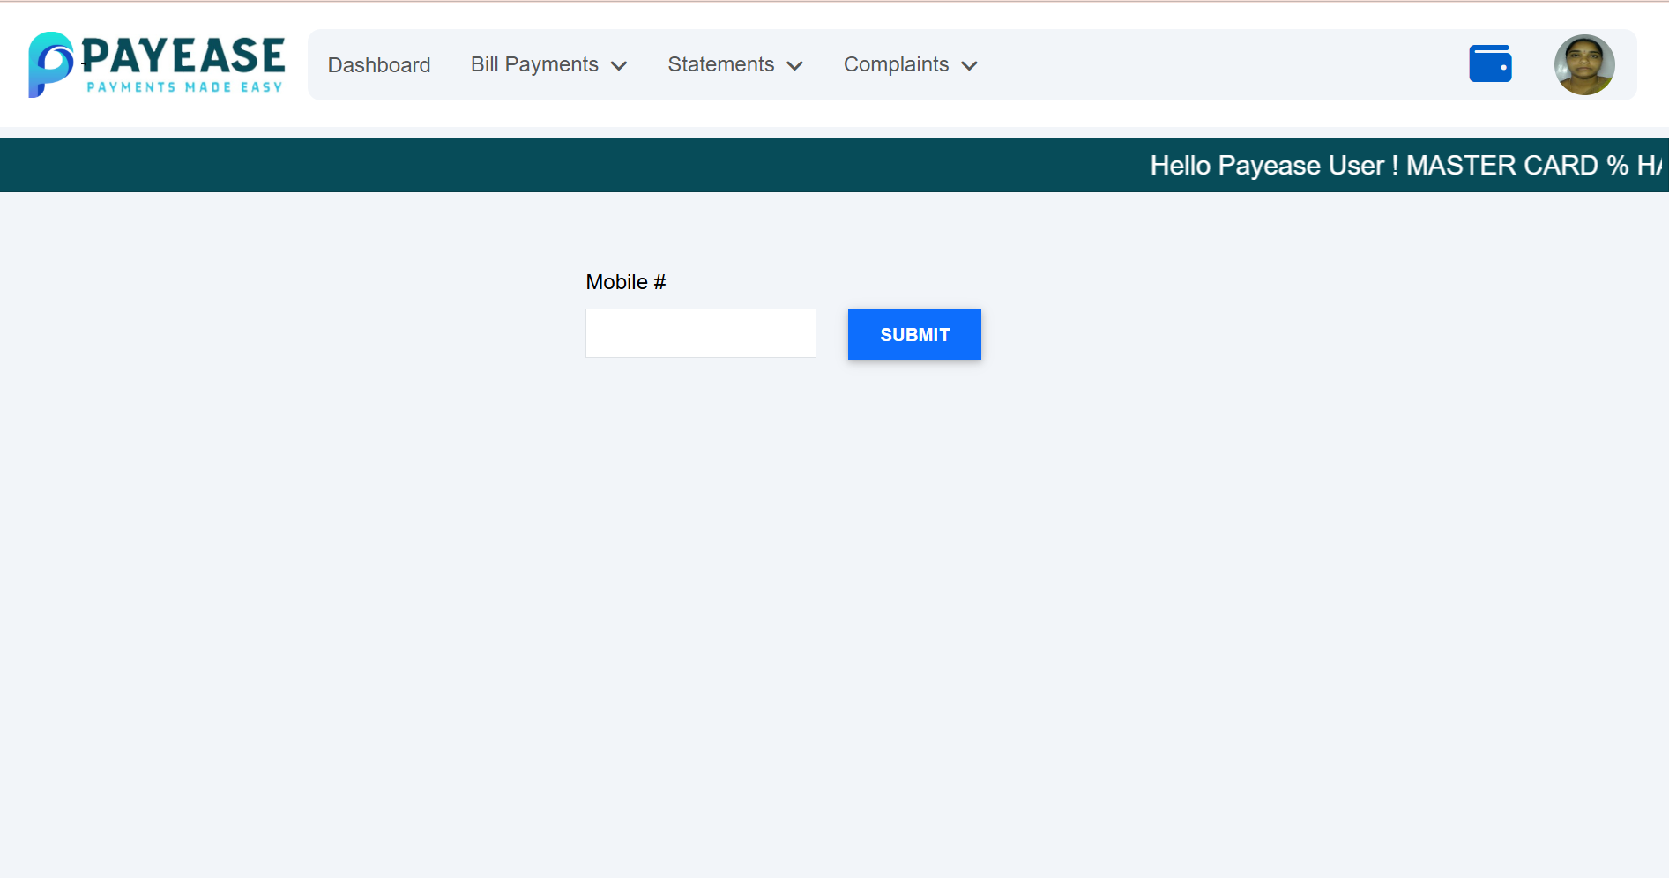

DASHBOARD🡪CUSTOMERS

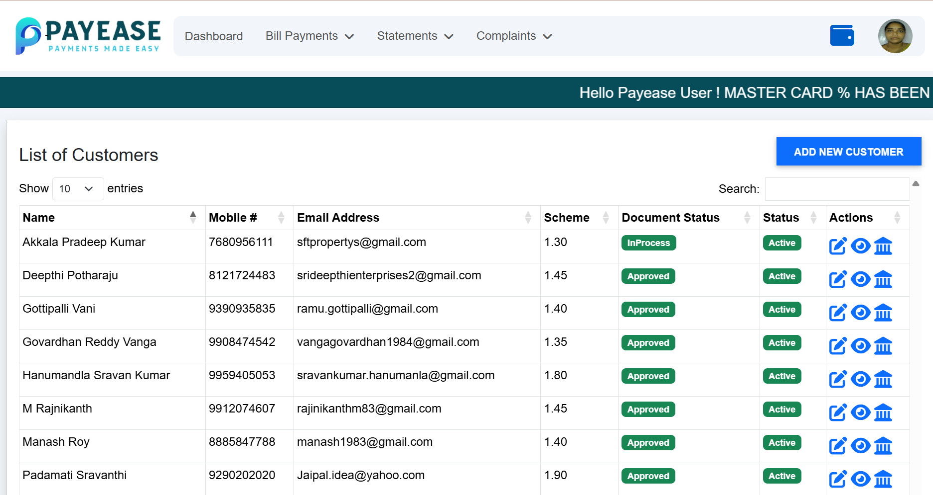

DASHBOARD🡪CUSTOMER VIEW🡪UPDATE CUSTOMER

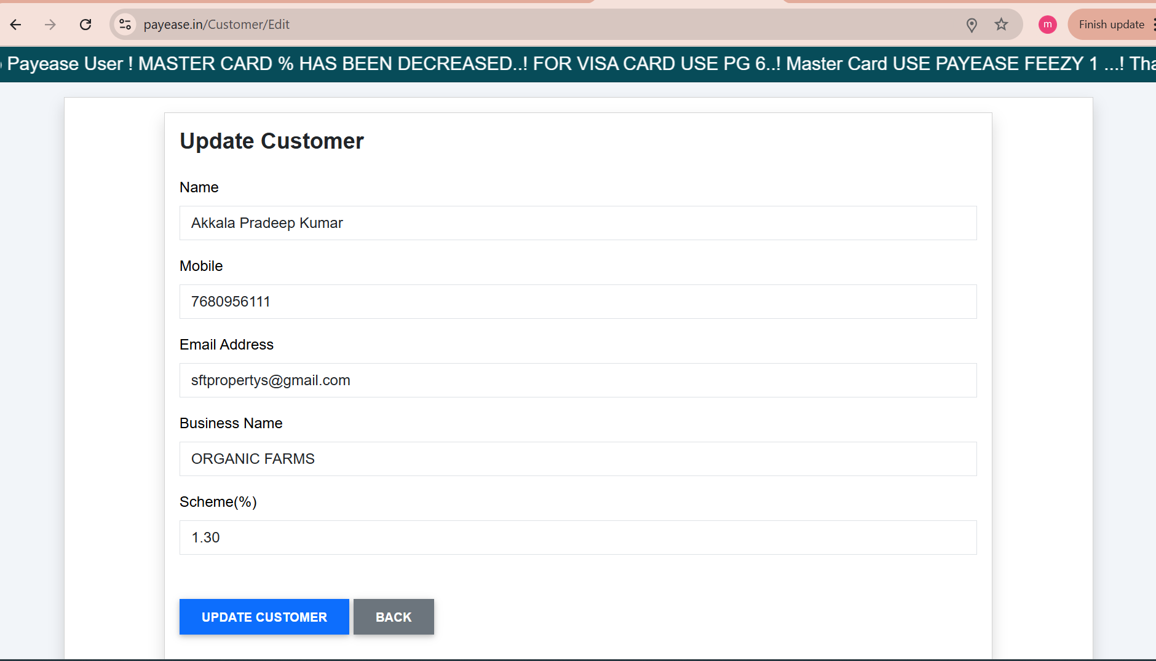

DASHBOARD🡪CUSTOMER VIEW🡪VIEW CUSTOMER

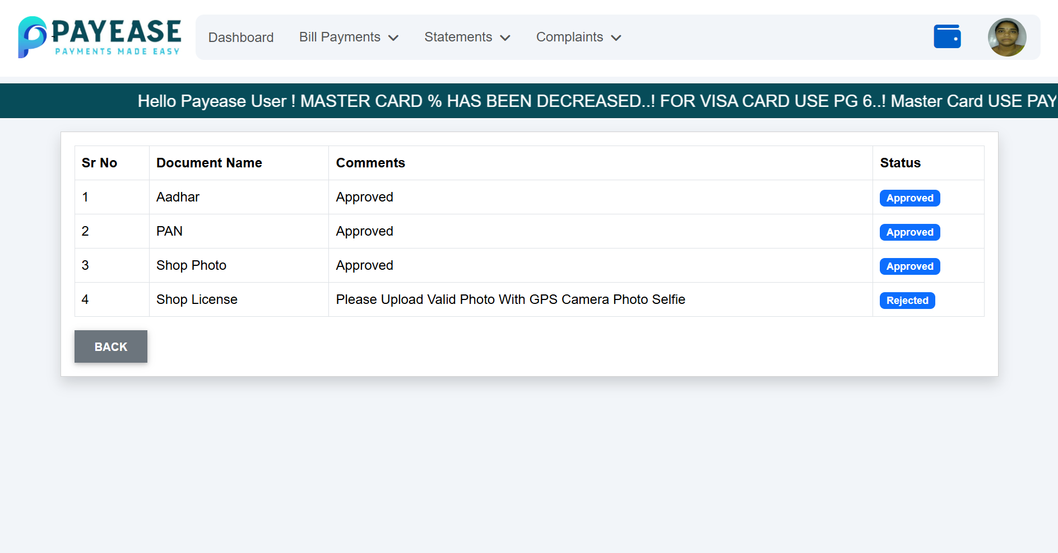

DASHBOARD🡪CUSTOMER VIEW🡪ADD NEW CUSTOMER

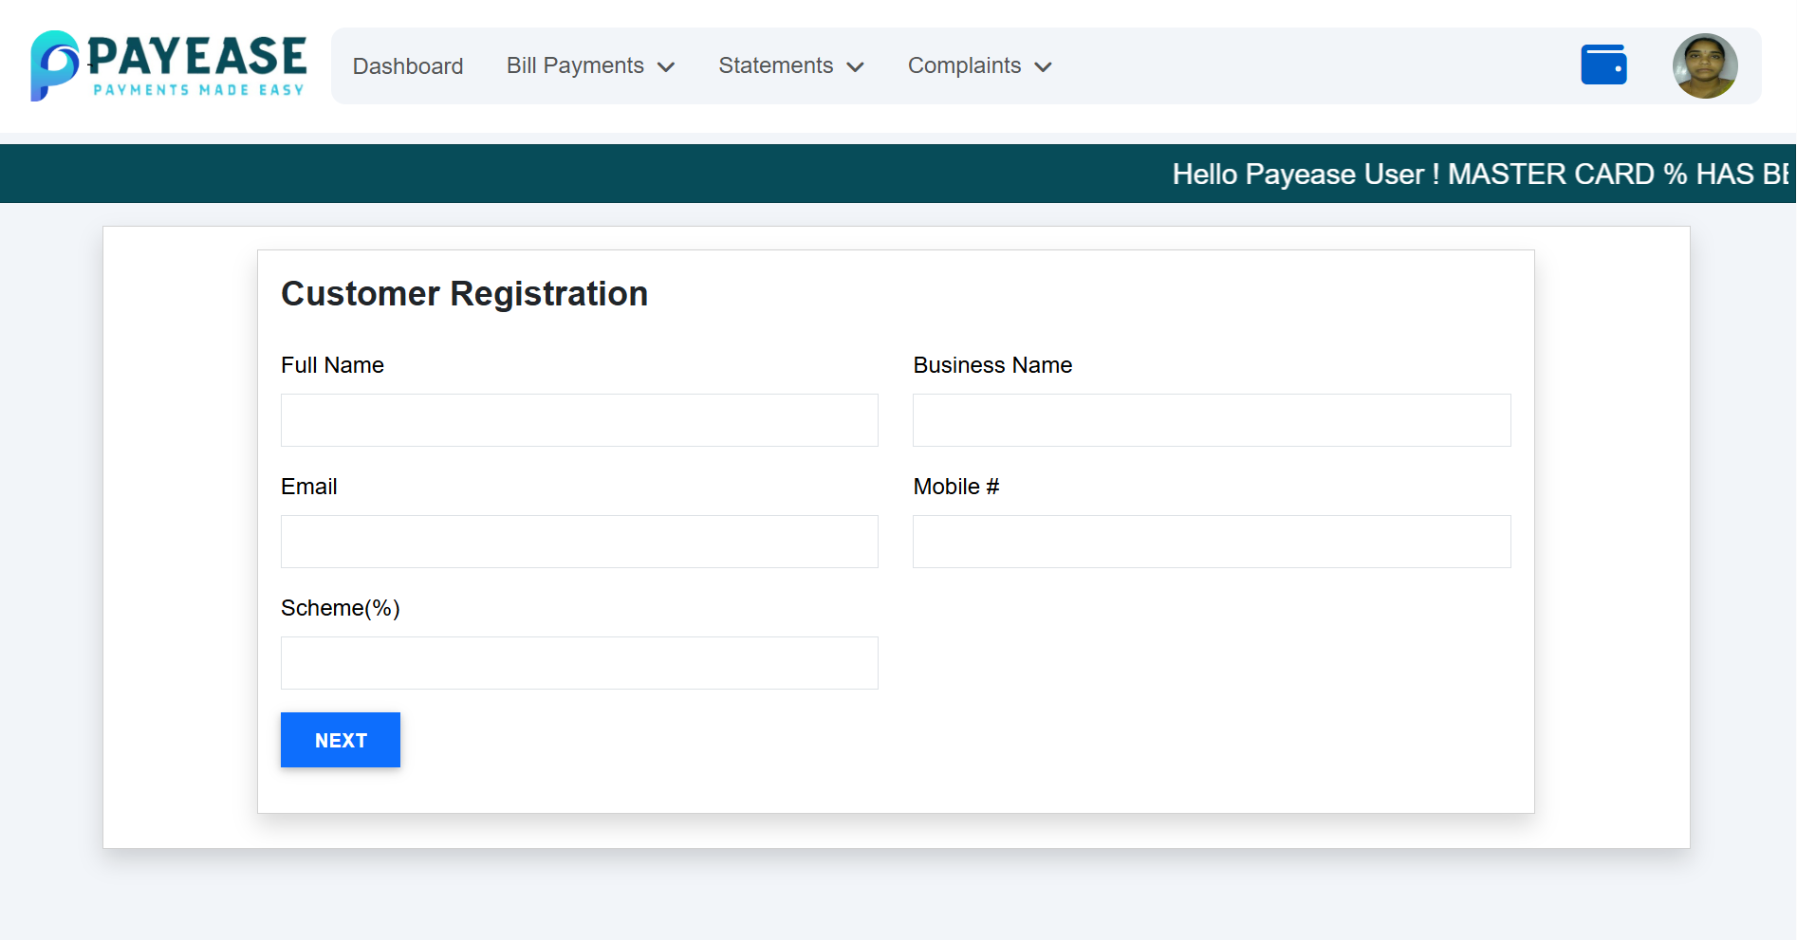

DASHBOARD🡪CUSTOMER VIEW🡪ADD CUSTOMER-2

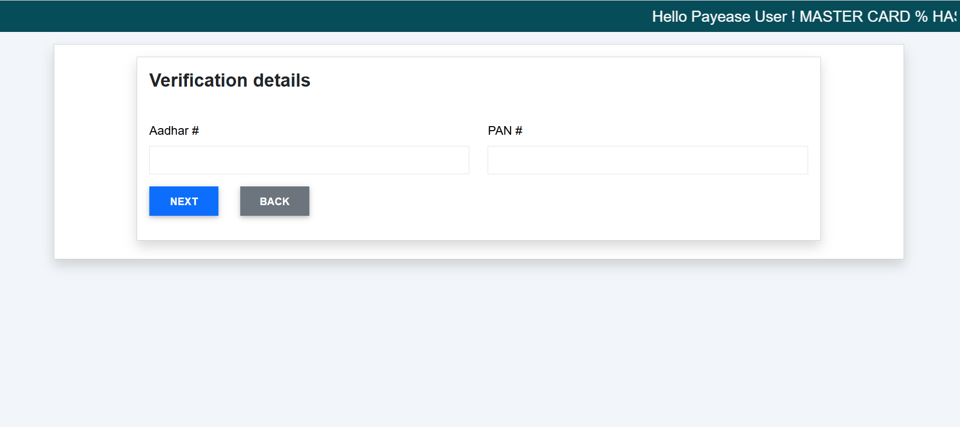

DASHBOARD—HISTORY—CARD TRANSACTIONS

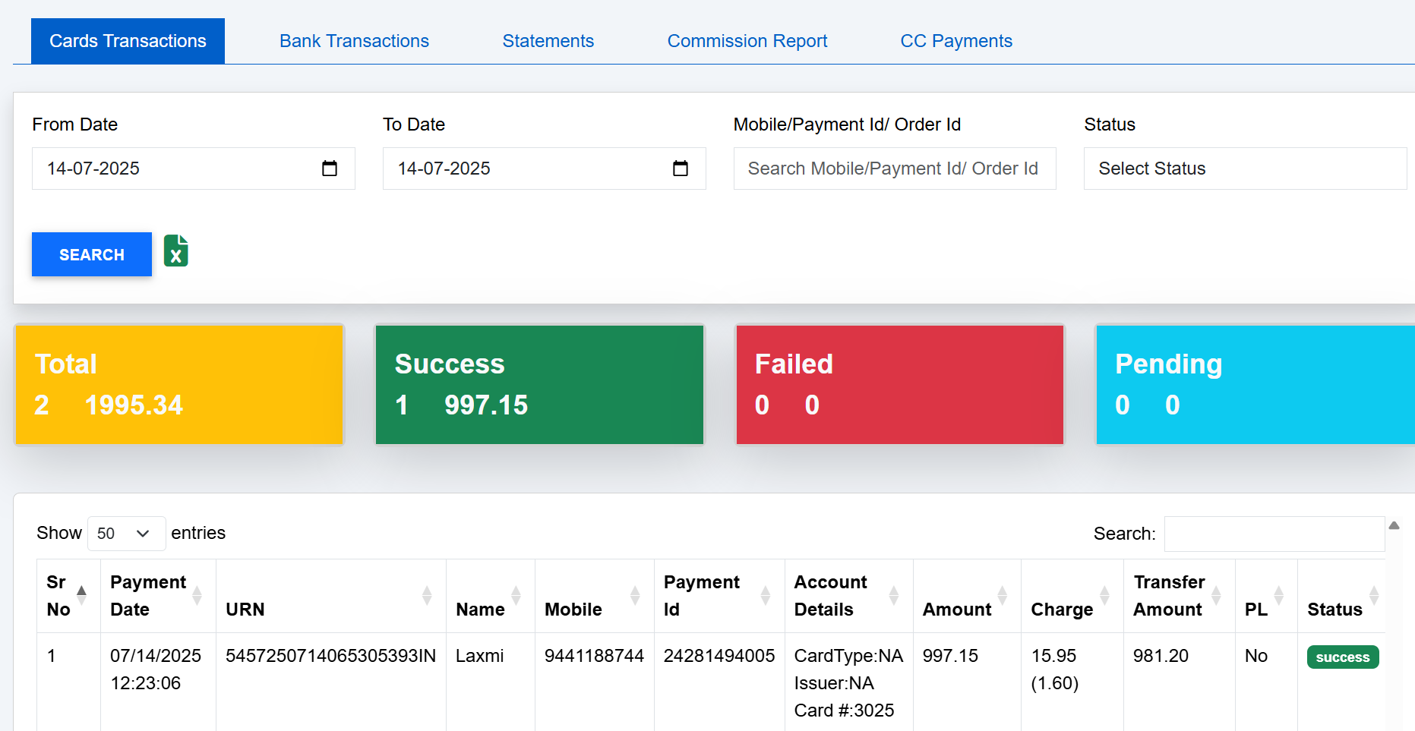

DASHBOARD🡪HISTORY🡪STATEMENTS

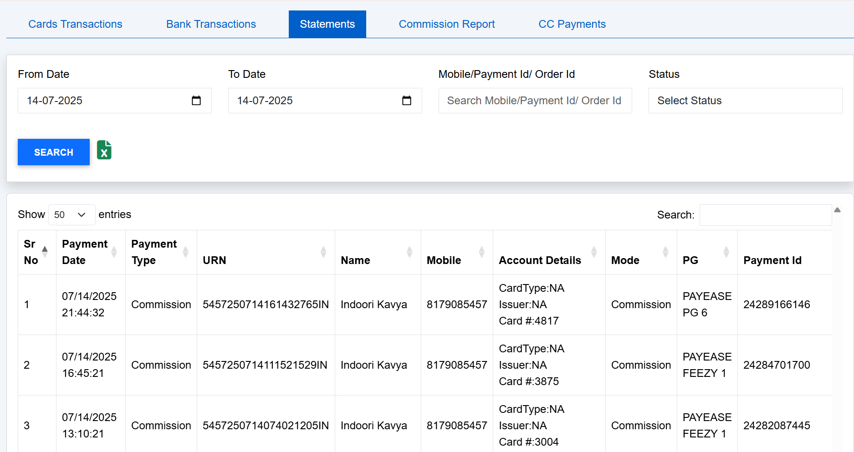

DASHBOARD🡪HISTORY🡪COMMISSION REPORT

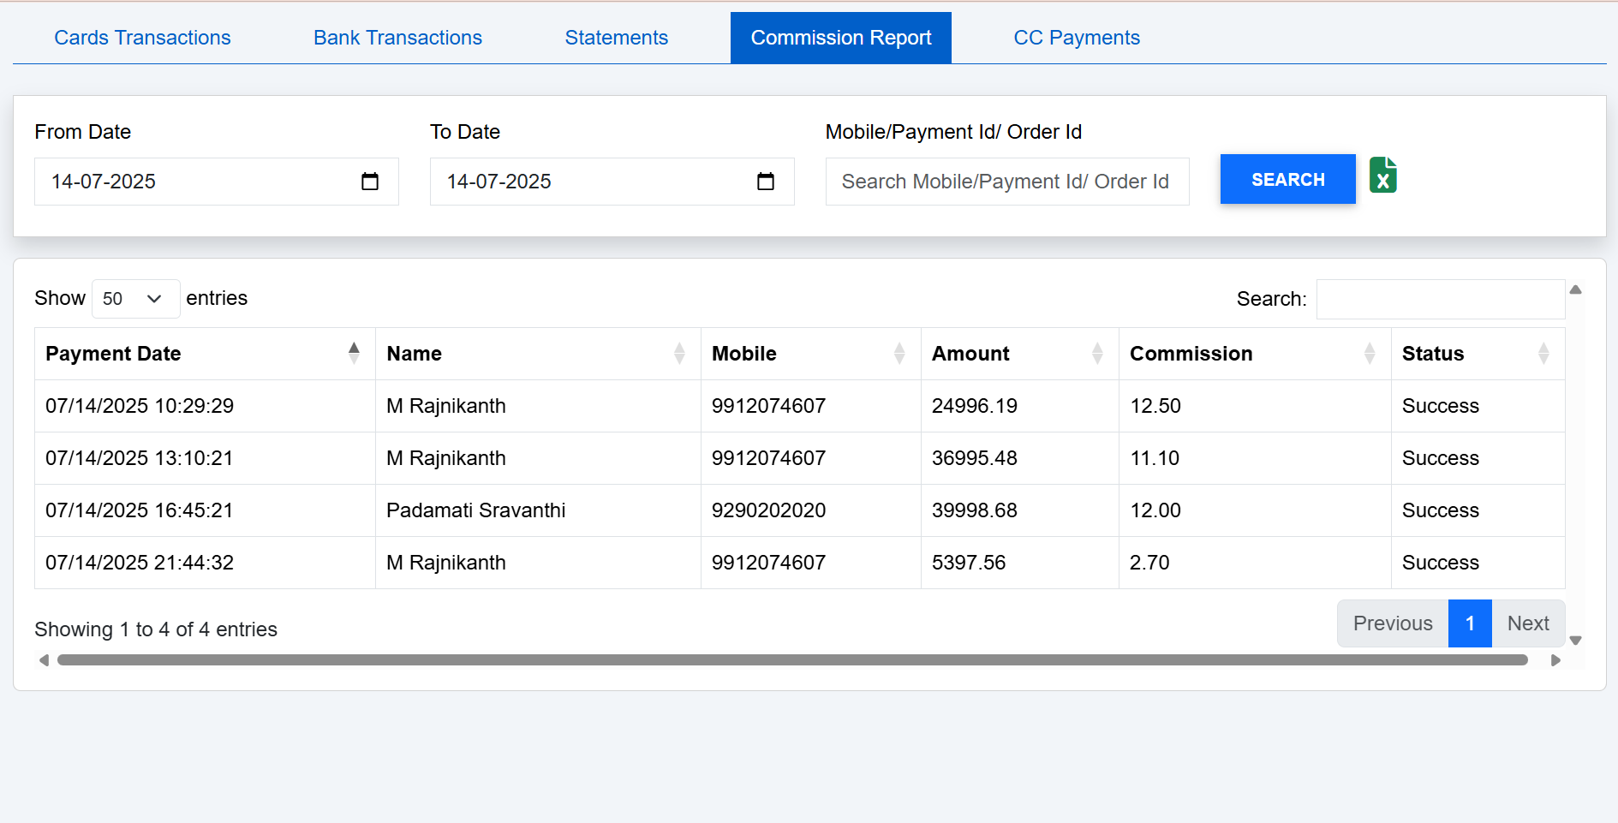

DASHBOARD🡪QUERY🡪TRANSACTION STATUS

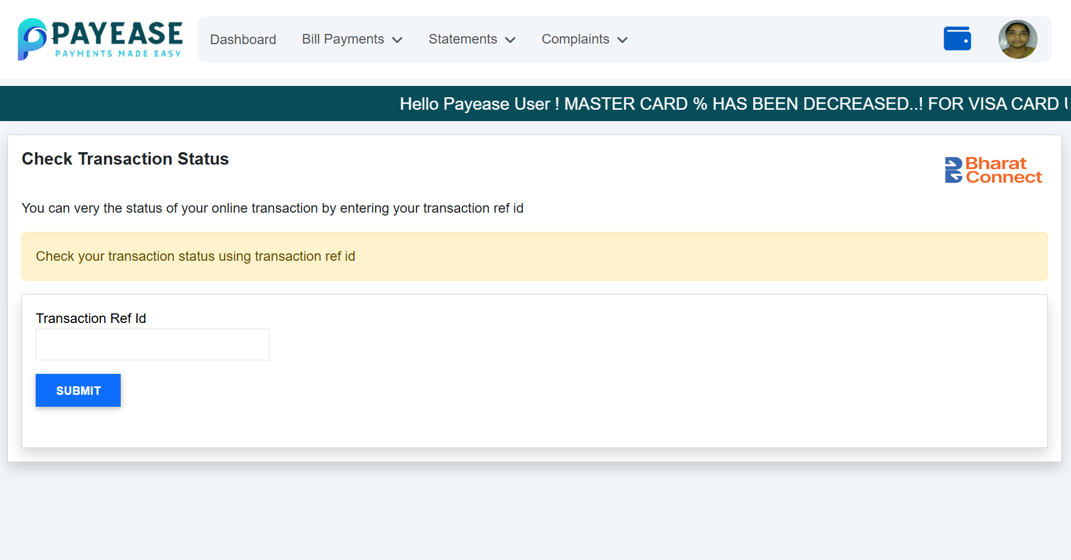

DASHBOARD🡪COMPLAINT🡪TRANSACTION HISTORY

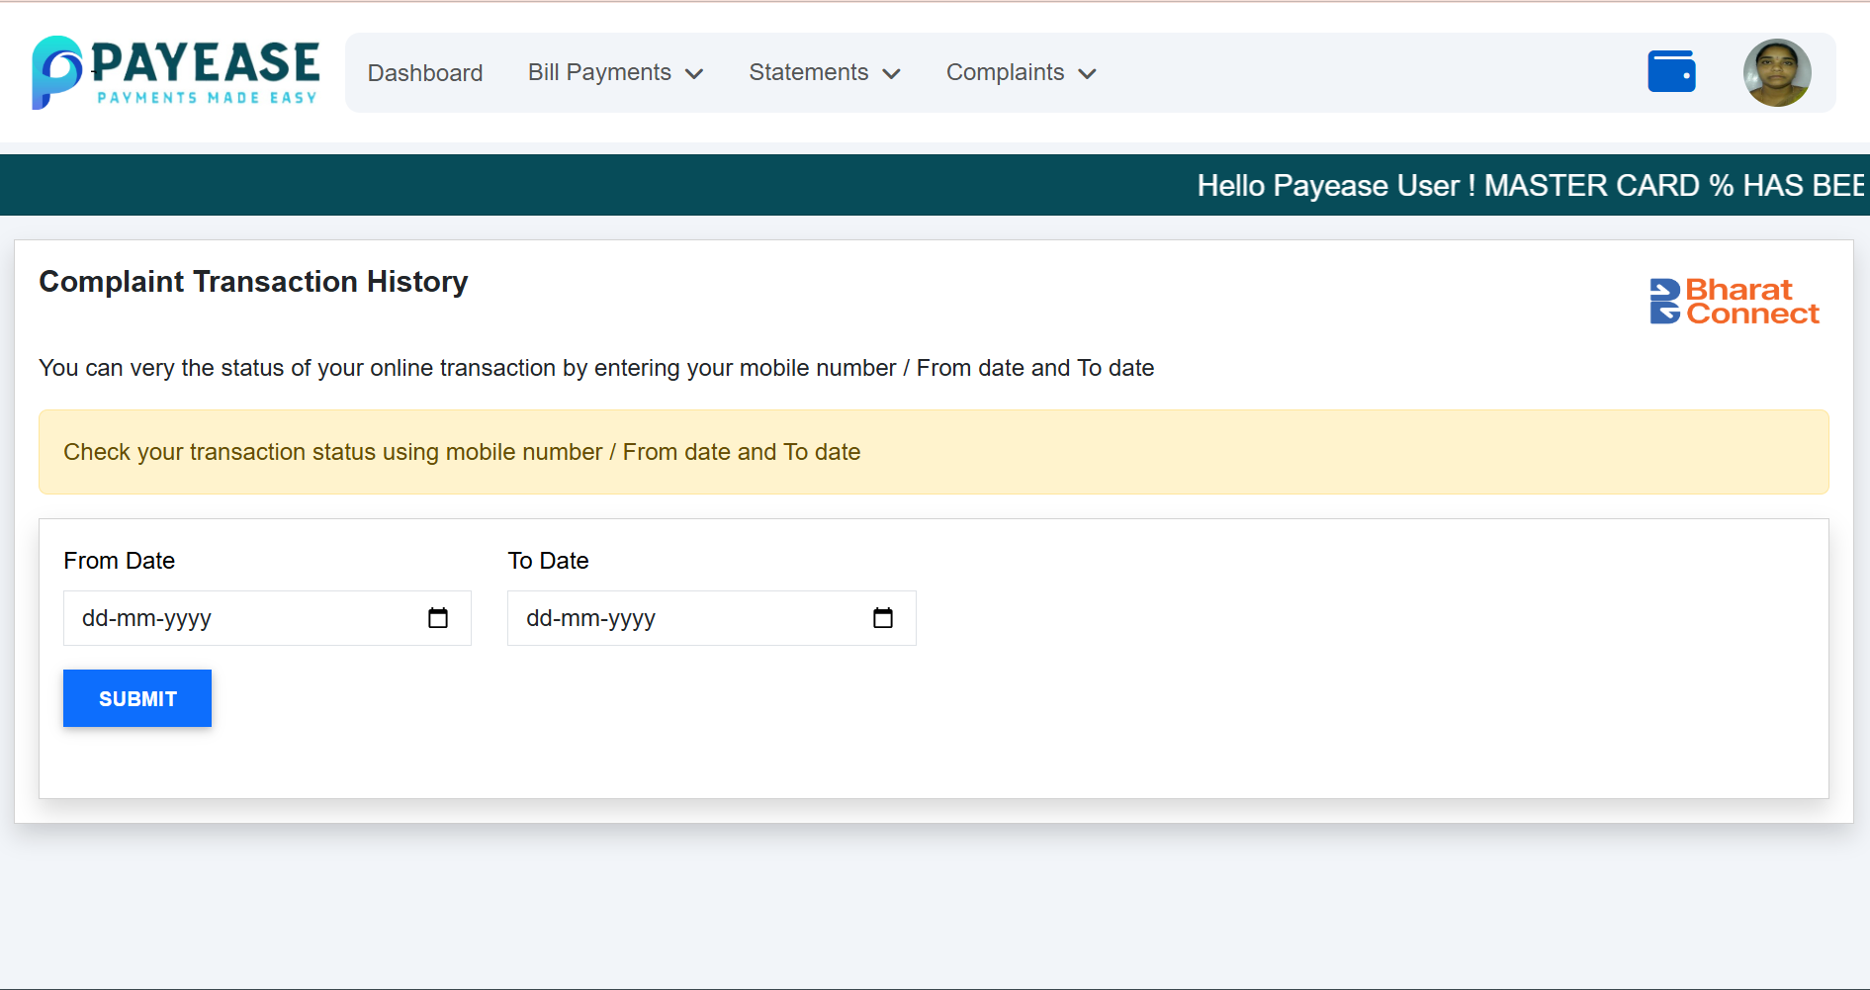

DASHBOARD🡪COMPLAINTS🡪 RAISE A COMPLAINT

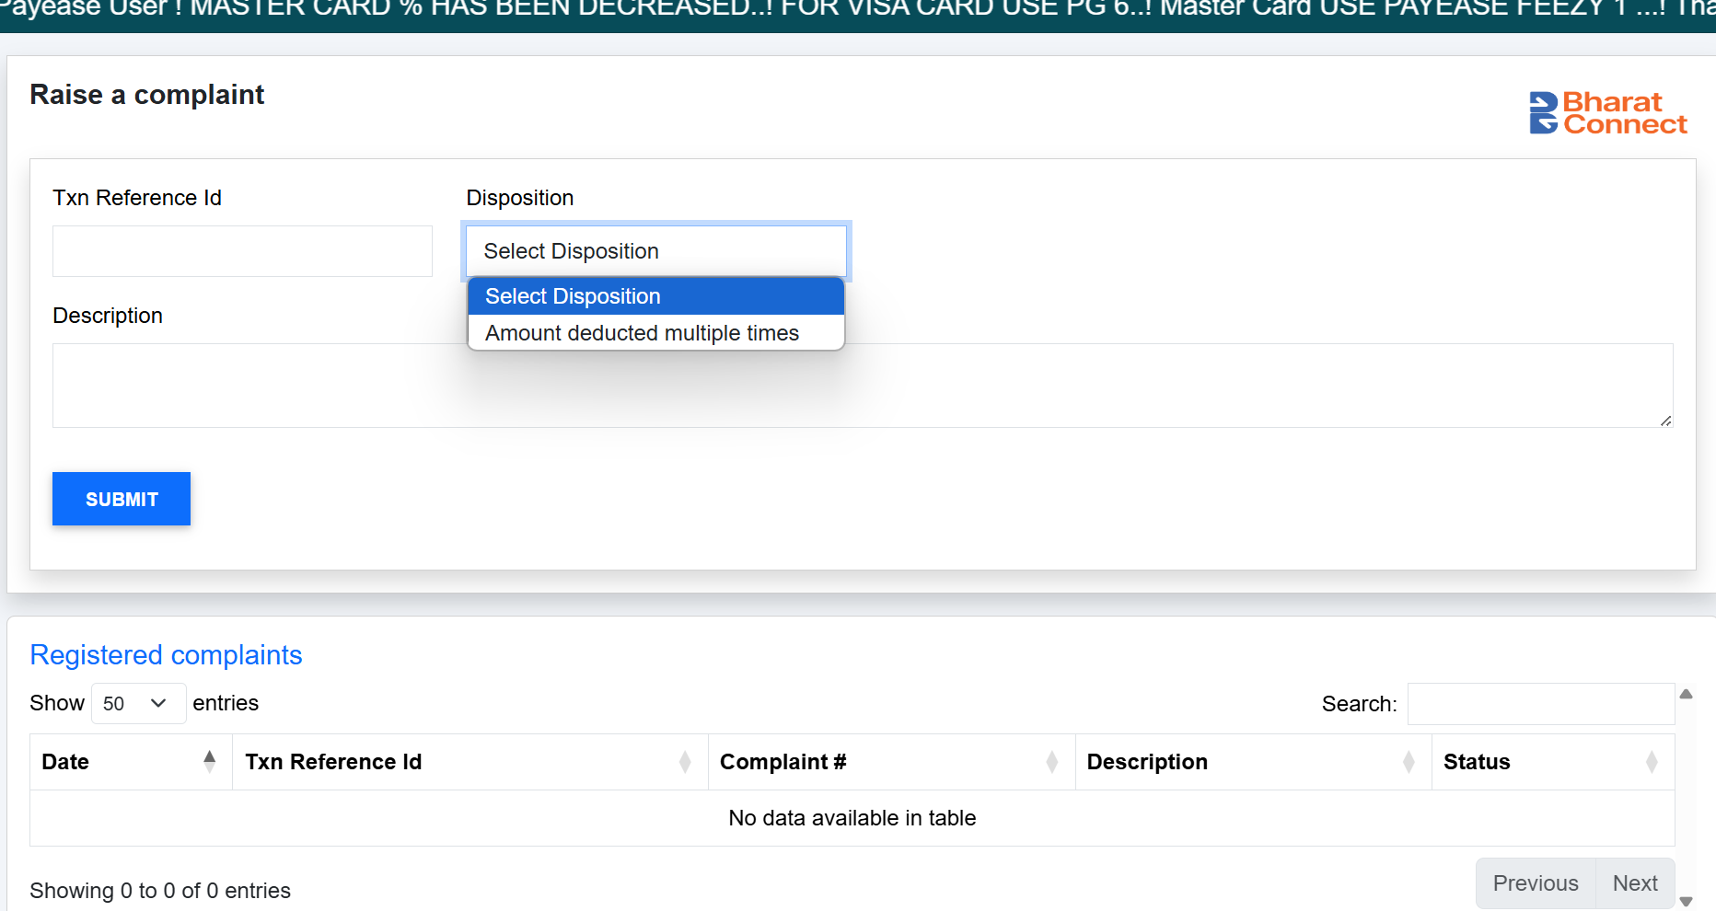

DASHBOARD🡪COMPLAINTS🡪COMPLAINT STATUS

