# GlusterFS-Progress

# Gluster Server status

* Take ubuntu 18.04 and install glusterfs server. GlusterFS installed and the gluster service should be running
* Then we need to start glusterd service, and we check the gluster status
* If the service is up and running, you’ll receive output like this.

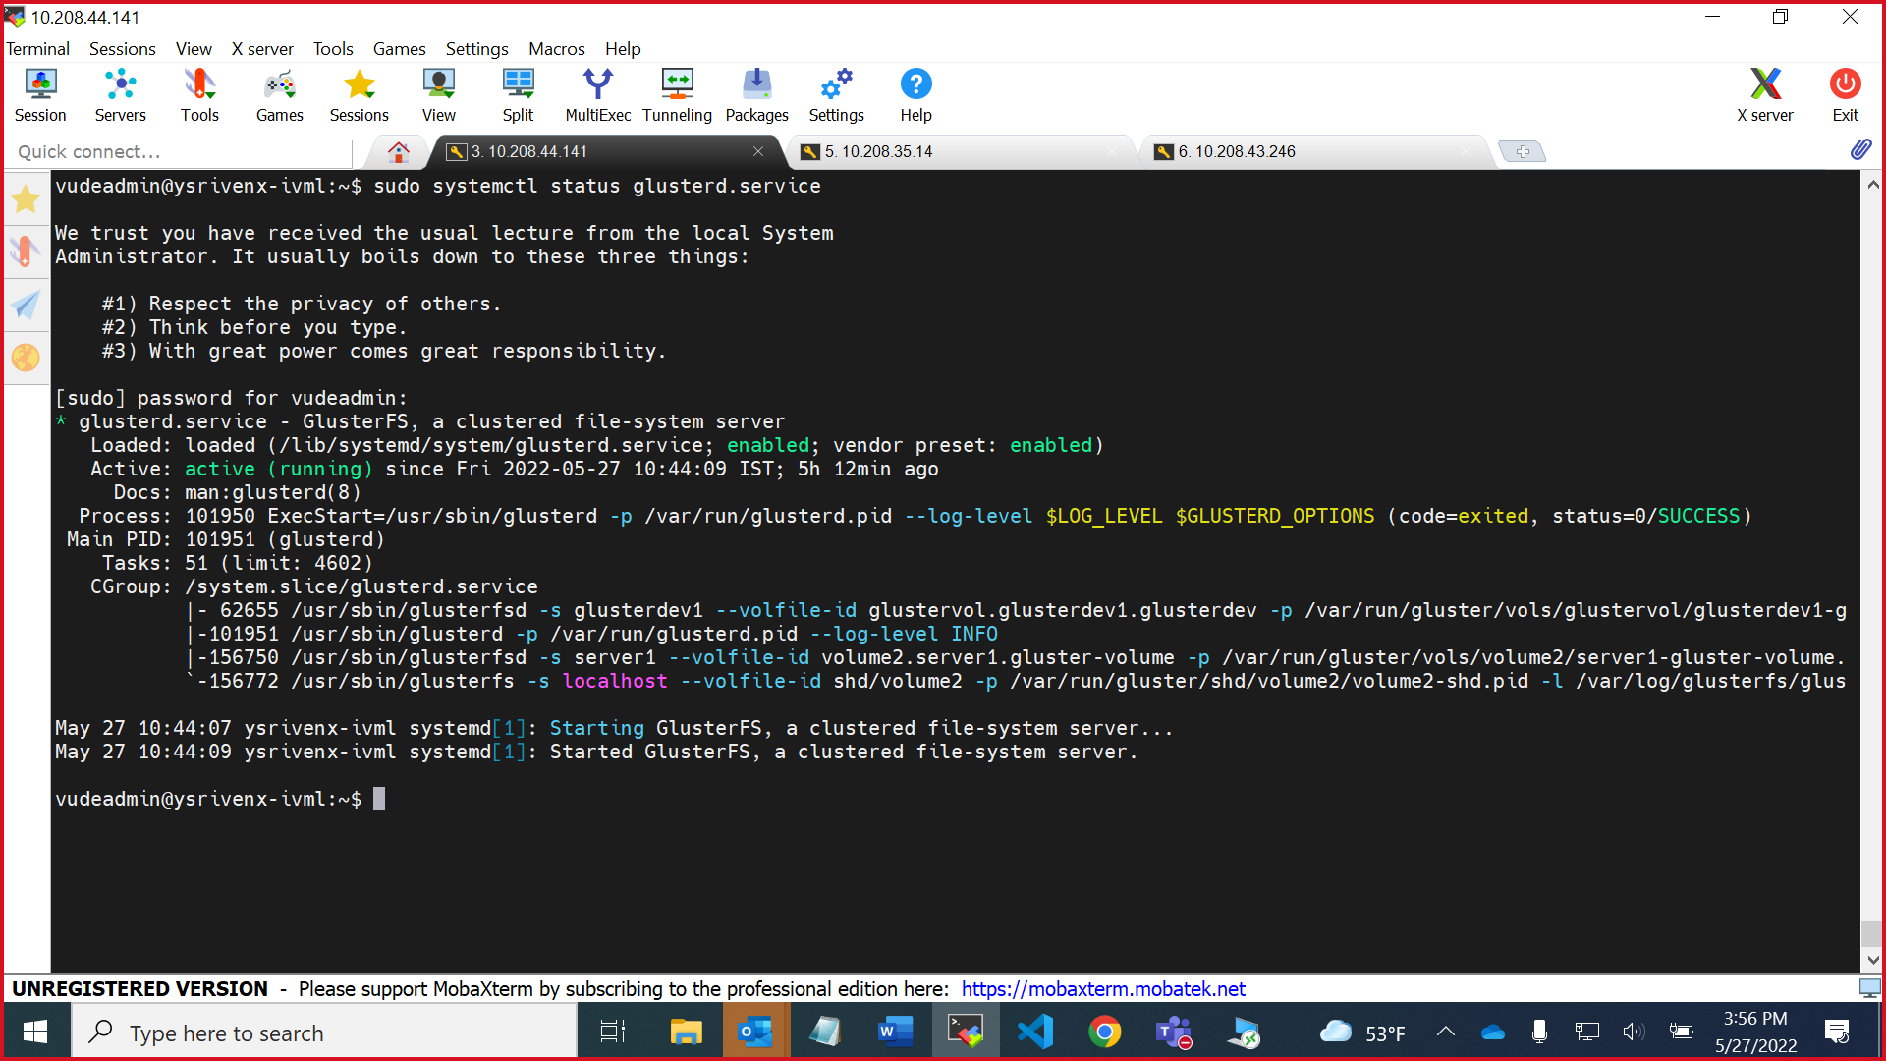

# Gluster peer status

* Next, you’ll need to establish communication between **gluster server1** and **gluster server2**.
* you’ll need to run the gluster peer probe command on one of your nodes. It doesn’t matter which node you use.
* You can check the nodes are communicating any time running cluster peer status.
* Below command tells **gluster server1** to trust **gluster server2** and register it as part of its storage pool.

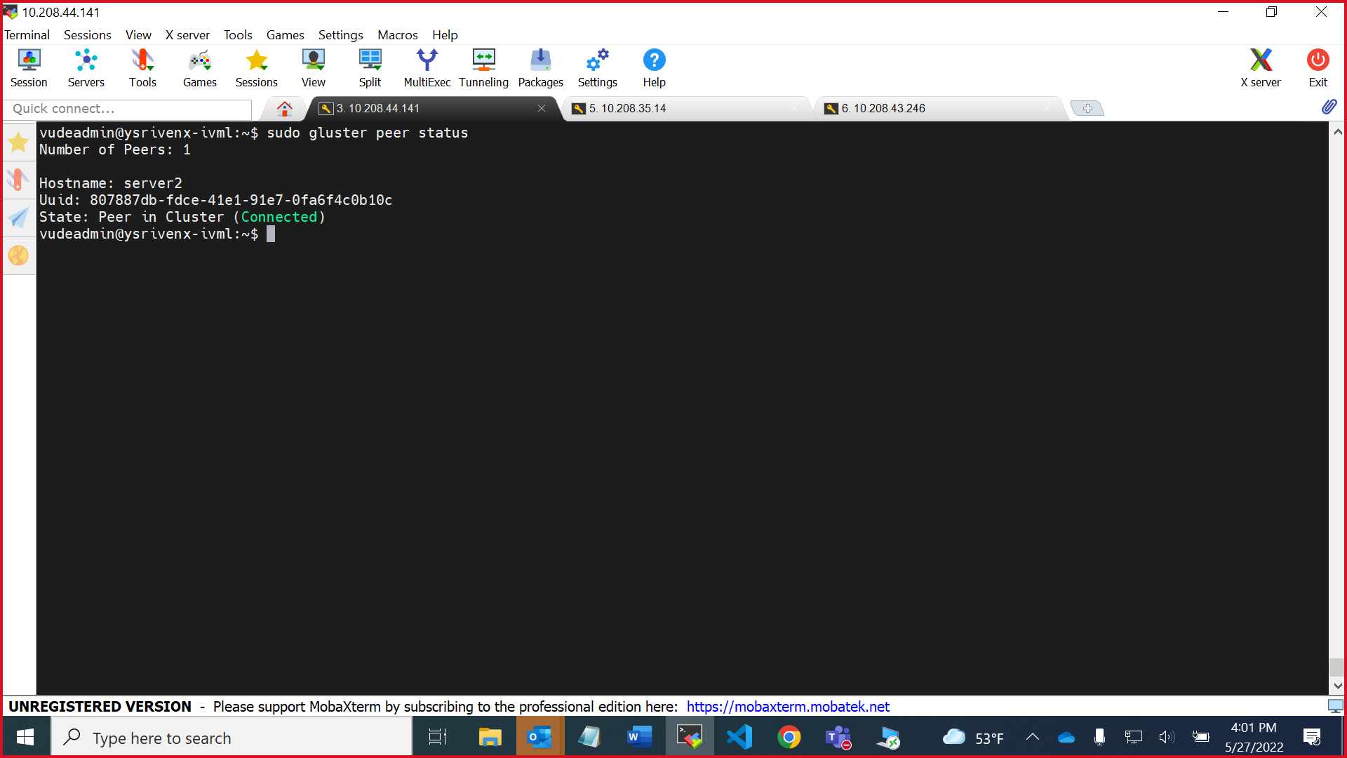

# Gluster client status

* You need to install the glusterfs-client package from PPA to set up. From this package dependence include some glusterfs common libraries and translator modules and FUSE tools required for it to work

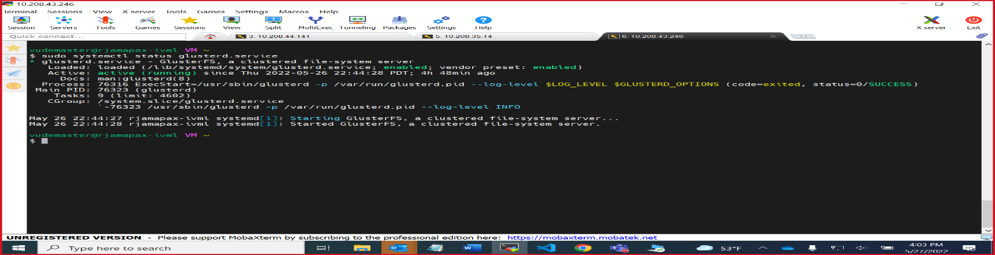

# Gluster volume status

* To create the volume, you will use the gluster volume create command
* Following the volume name, you can define what type of volume you want to create.
* Recall that the goal of this tutorial is to create a redundant storage pool, so we’ll use the replica volume type.
* The machines and directory location of the bricks glusterfs term for its basic unit of storage
* Force option will override any warnings or options that would otherwise come up and halt the volume’s creation.

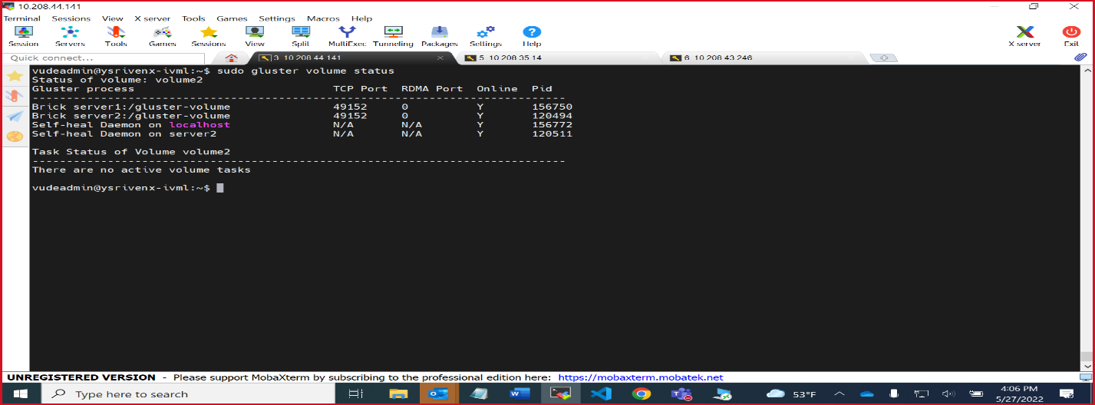

# Gluster volume info

* your volume has been created, but it’s not yet active. You can start the volume and make it available for use by running gluster volume start
* There are number of different commands that are available on your nodes to retrieve this data and interact with your storage pool
* A screenshot of a computer

  Description automatically generatedIf you want information about each of your volumes, run the command as gluster volume info