GlusterFS-Progress

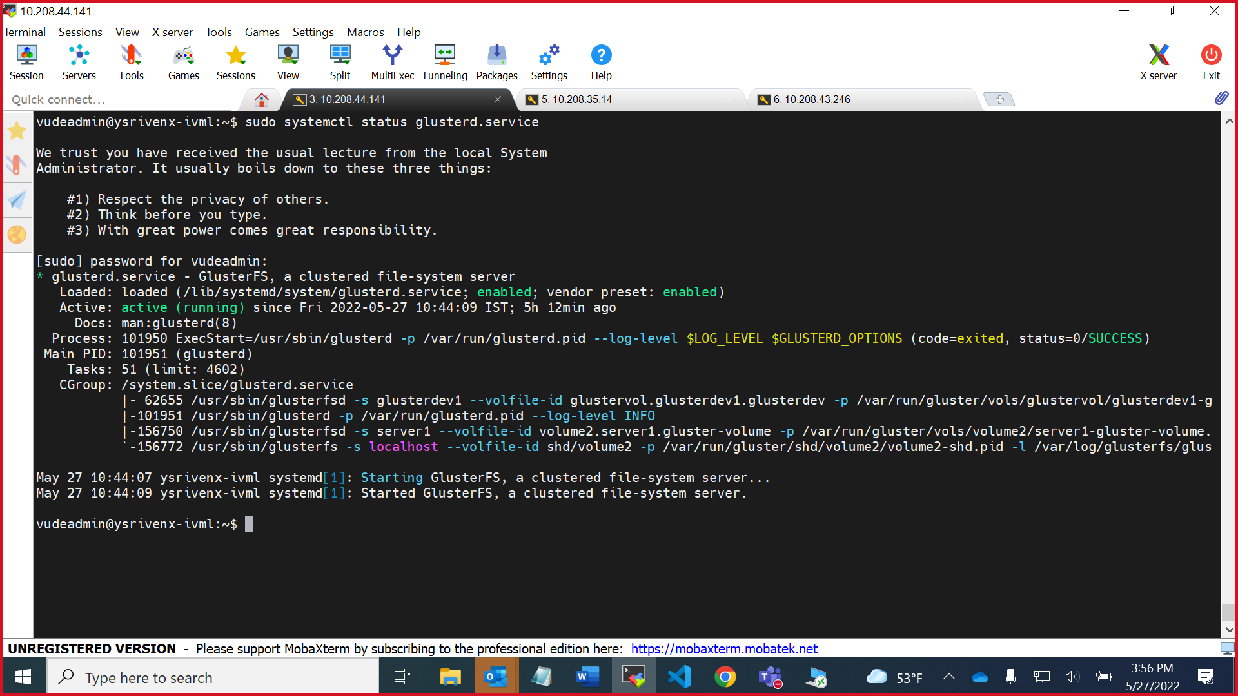

Gluster Server status

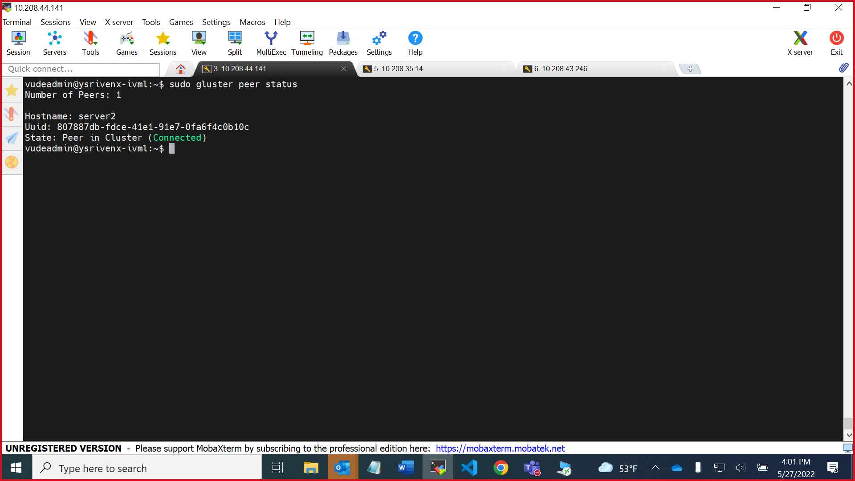

Gluster peer status

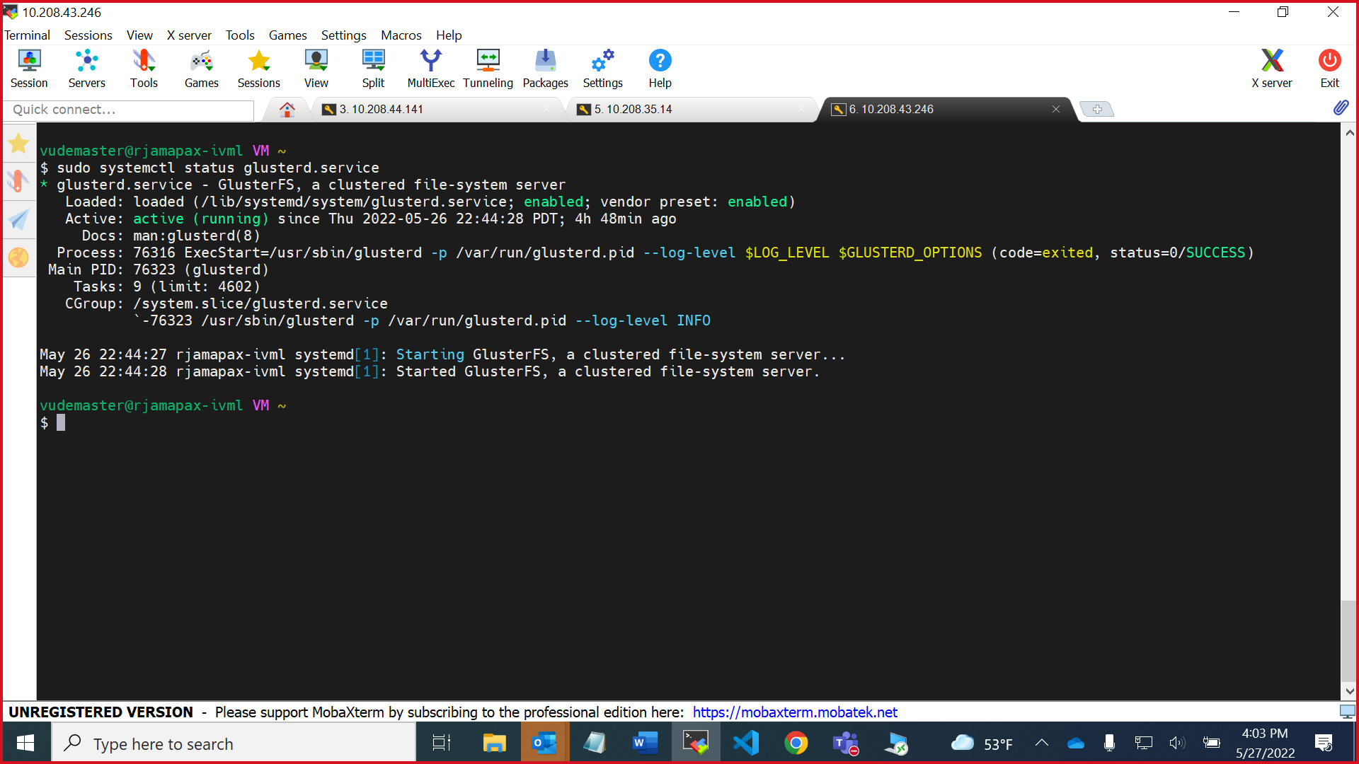

Gluster client status

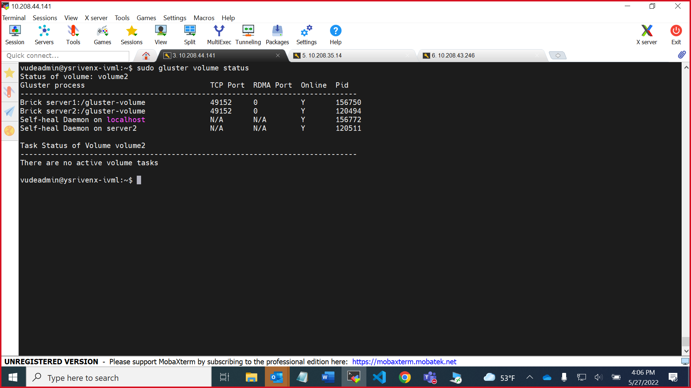

Gluster volume status

Gluster volume info