Automated Single-Image to 3D Asset and Point Cloud Generation System
MCA Capstone Project Report
Submitted by:
Rajashekhar B Durgad (01FE24MCA027)
Under the Guidance of:
Prof. Akash Hulkund
Department of MCA
KLE Technological University, Hubballi
2025-2026

CHAPTER - 1: INTRODUCTION
1.1 Background
With the rapid advancement of computer vision, deep learning, and 3D graphics technologies, there is a growing need for intelligent systems capable of automating the understanding and digital reconstruction of physical objects from images. Traditional approaches to 3D digitisation typically rely on manual 3D modelling, specialised photogrammetry equipment, or controlled multi-view capture setups that require significant time, expertise, and infrastructure. These limitations create bottlenecks for e-commerce, augmented reality (AR), robotics, and industrial inspection.
The Automated Single-Image to 3D Asset and Point Cloud Generation System is a fully integrated, end-to-end system designed to take a single input image and automatically produce a textured 3D mesh and a segmented, colour-labelled 3D point cloud of the primary object within it. The pipeline eliminates the need for manual prompt engineering, controlled lighting, or multi-view capture by combining state-of-the-art foundation models into a unified automated workflow.
By combining modern vision-language models, object localization networks, segmentation frameworks, and diffusion-based 3D generators, this project establishes a streamlined pathway for creating assets. The system is designed to take raw, unedited photographs under variable lighting, perform self-contained enhancement, identify the subject, construct its 3D mesh representation, synthesise appropriate textures, and construct downstream spatial point clouds.

1.2 Problem Statement
Existing 3D reconstruction systems are heavily fragmented and brittle. Photogrammetry pipelines require multiple clean, well-lit photographs from multiple angles and fail completely under poor lighting, low-contrast, or grayscale environments. Generative 3D frameworks require users to manually write precise prompts to guide the creation process, and they assume background-free inputs. Furthermore, modern shape generators demand significant VRAM, frequently causing Out-Of-Memory (OOM) failures on standard 16 GB GPUs when loaded concurrently with detection and segmentation models. Finally, standard pipelines output raw, unsegmented meshes, lacking downstream geometric categorization.
This fragmentation results in a high barrier to entry for developers and designers who need rapid asset creation. An end-user must manually enhance their images in Photoshop, use separate captioning services to write prompts, load regional segmentation tools to mask backgrounds, configure local python pipelines to extract meshes, and then use specialized desktop software (like Blender or CloudCompare) to sample and segment point clouds. The lack of automation, combined with heavy GPU hardware constraints, makes local bulk generation tasks highly inefficient and error-prone.

1.3 Objectives
The primary objectives of this project are:
- To develop a voice-guided and automated prompt-free single-image to 3D asset generation pipeline.
- To implement adaptive preprocessing (CLAHE) that automatically enhances low-illumination and low-contrast input images.
- To design a zero-shot, open-vocabulary object detection and part segmentation workflow combining Florence-2 and SAM2.1.
- To integrate a flow-matching diffusion transformer (Hunyuan3D-2) to reconstruct watertight meshes with synthesized PBR textures.
- To implement a sequential GPU memory scheduler that loads, executes, and clears VRAM cache for each model to prevent OOM errors on standard hardware.
- To perform downstream point cloud generation and spatial segmentation using Poisson Disk sampling and DBSCAN clustering.

1.4 Scope of the Project
The scope of this project covers the development of the Python backend and web-based frontend. It includes the automation of image enhancement, caption generation, bounding box object detection, background extraction, 3D shape generation, UV texturing, dense point cloud sampling, surface normal estimation, and DBSCAN clustering. The system is designed to run on a single NVIDIA GPU with at least 16 GB VRAM and export standard 3D formats (.glb, .ply) suitable for AR, VR, and digital twins.
Specifically, the scope includes:
- Adaptive color-space conversions and local contrast adjustments (CLAHE).
- Sequence-to-sequence captioning and parsing structures using Florence-2-base.
- Multi-pass grounding box thresholding with GroundingDINO-tiny.
- Hierarchical masking and best-IoU selection using SAM2.1-large.
- Background removal using rembg with ONNX GPU runtime dependencies.
- Two-stage 3D reconstruction using Tencent Hunyuan3D-2 framework.
- GPU memory management routines, executing garbage collections (gc.collect) and CUDA cache evictions.
- Poisson Disk Sampling and normal estimation math utilizing Open3D.
- Euclidean distance spatial partitioning utilizing DBSCAN.

1.5 Organization of the Report
This report is organized into the following chapters:
- Chapter 1 contains the background, problem statement, objectives, and scope of the project.
- Chapter 2 details the literature survey, study of existing tools, comparative analysis, and research gaps.
- Chapter 3 presents the system analysis, feasibility studies, and software/hardware requirements.
- Chapter 4 defines the software requirement specification (SRS) including functional and non-functional requirements.
- Chapter 5 describes the system design, including system architecture, DFDs, UML diagrams, and database details.
- Chapter 6 focuses on the implementation details, modules, algorithms, and code logic.
- Chapter 7 describes the test plan, testing strategies, and test cases.
- Chapter 8 covers the experimental results, discussions, execution performance, and visualizations.
- Chapter 9 concludes the project and suggests future enhancements.

CHAPTER - 2: LITERATURE REVIEW
2.1 Introduction
This literature survey reviews recent advancements in object detection, instance segmentation, generative 3D shape reconstruction, and point cloud clustering. It highlights how these models can be consolidated to address the limits of traditional photogrammetry.

2.2 Study of Existing Systems
GroundingDINO (Liu et al., 2023) introduced a zero-shot detector by marrying visual encoders with BERT text encoders, enabling open-vocabulary box detection. While powerful, its detection accuracy declines in dark or low-contrast images. Florence-2 (Xiao et al., 2024) formulated vision-language tasks as sequence-to-sequence operations, showing excellent captioning and part-detection capabilities. SAM 2 (Ravi et al., 2024) achieved state-of-the-art interactive instance segmentation but is limited to 2D space. Hunyuan3D-2 (Tencent, 2025) leveraged flow-matching diffusion transformers to generate high-resolution textured 3D assets, but requires background-free inputs and has a high memory footprint.
Let's review these models in detail:
- 1. GroundingDINO: Combines DINO visual backbone with BERT text encoders. It utilizes cross-modal feature fusion layers, allowing the network to search for objects based on natural language expressions. The model is zero-shot, meaning it requires no fine-tuning to find custom classes. However, poor lighting affects its visual feature maps, causing failures that this project resolves via CLAHE pre-processing.
- 2. Florence-2: A unified, multi-task representation model from Microsoft. It processes tasks like image captioning, phrase grounding, and detailed segmentation using a sequence-to-sequence architecture. This project utilizes it to eliminate user prompt inputs by automatically captioning images and extracting primary subject nouns.
- 3. Segment Anything Model (SAM) 2: A foundation model for image and video segmentation. It uses a transformer-based mask decoder that takes box coordinates or point prompts to output high-fidelity binary masks. The project uses SAM 2.1 to isolate object pixels from background clutter.
- 4. Tencent Hunyuan3D-2: A high-fidelity 3D generator that uses a two-stage process. Stage 1 utilizes a Flow-Matching Diffusion Transformer (DiT) to generate watertight 3D meshes. Stage 2 utilizes an appearance-flow network to synthesize high-resolution textures. It requires transparent RGBA inputs and high GPU VRAM, which we manage using a sequential scheduler.
- 5. Open3D and DBSCAN: Open3D is a modern library for 3D data processing, used in this project for Poisson Disk sampling and normal estimation. DBSCAN (Ester et al., 1996) partitions the sampled points into geometric clusters based on spatial density, enabling part analysis.

2.3 Comparative Analysis
A comparative analysis of modern 3D generation frameworks and pipelines highlights the trade-offs in processing latency, output quality, and memory requirements:
Model/Framework | Input Type | Texture Quality | Generation Speed | Peak VRAM | Downstream Segmentation
TripoSR (2024) | RGBA Crop | Low (Vertex colors) | Fast (~1 sec) | 4 GB | No
Hunyuan3D-2 (2025) | RGBA Crop | High (PBR 1024x1024) | Moderate (3-4 mins) | 14-16 GB | No
CRM (2024) | RGBA Crop | Medium | Fast (~10 sec) | 8 GB | No
LGM (2024) | RGBA Crop | Medium (Splatting) | Fast (~5 sec) | 10 GB | No
Proposed System | Raw RGB Image | High (PBR 1024x1024) | Moderate (3-4 mins) | 16 GB (sequential) | Yes (DBSCAN + Normals)

2.4 Summary of Literature Review
In summary, while state-of-the-art vision and generative models excel individually, they are disconnected. This Capstone project integrates these models into a unified, memory-efficient pipeline that automates 3D digitization from raw photographs to segmented 3D point clouds.

CHAPTER - 3: SYSTEM ANALYSIS
3.1 Existing System
Traditional 3D reconstruction systems rely on multi-view photogrammetry or manual modelling. Photogrammetry pipelines require dozens of high-quality photographs taken from overlapping angles and fail to resolve structures under poor lighting or uniform texture surfaces. The process is manual and highly fragmented.
Drawbacks of the Existing System:
- Manual and slow: Requires manual prompt tuning and Photoshop cropping.
- High hardware demands: Loading all models concurrently leads to VRAM OOM crashes on consumer systems.
- No downstream analysis: Reconstructed models are raw meshes, lacking semantic part partitioning.

3.2 Proposed System
The proposed system provides a fully automated pipeline from a single raw image to a segmented point cloud. It features CLAHE adaptive preprocessing, sequential VRAM allocation, and DBSCAN point cloud clustering.
Advantages of the Proposed System:
- Prompt-free operation: Auto-captioning extracts search prompts automatically.
- Hardware efficiency: Enforces sequential unloading and torch.cuda.empty_cache().
- Downstream segmentation: Outputs color-labeled geometric clusters.

3.3 Feasibility Study
A feasibility study was conducted across three areas:
3.3.1 Technical Feasibility
The project uses open-source libraries (PyTorch, Open3D, Trimesh) and pre-trained model weights. The sequential memory scheduling allows these models to fit within a single 16 GB VRAM GPU, making it technically feasible.
3.3.2 Economic Feasibility
The software runs on standard workstations without cloud subscription costs, and uses free database services (Supabase), making it economically feasible.
3.3.3 Operational Feasibility
The user interface requires zero technical knowledge (drag-and-drop file upload), making it highly feasible for general usage.

3.4 Requirements Analysis
Hardware Requirements:
- Processor: Intel Core i7 or AMD Ryzen 7 (or higher)
- System RAM: 16 GB minimum (32 GB recommended)
- GPU: NVIDIA GPU with CUDA compatibility and minimum 16 GB VRAM (e.g., T4, RTX 3080, A10G)
- Storage: 50 GB free disk space
Software Requirements:
- Operating System: Windows 11 or Ubuntu 22.04 LTS
- Programming Language: Python 3.11+
- Frameworks & Libraries: PyTorch 2.2 (CUDA 12.1), Open3D, OpenCV, rembg, FastAPI, Next.js, Three.js
- Database: Supabase (PostgreSQL)

CHAPTER - 4: SOFTWARE REQUIREMENT SPECIFICATION
4.1 Overview of SRS
This Software Requirements Specification (SRS) document describes the complete functional, non-functional, and hardware/software specifications for the Automated Single-Image to 3D Asset and Point Cloud Generation System.

4.2 Functional Requirements
- FR-1 (Adaptive Preprocessing): The system shall compute image brightness and contrast, and automatically apply LAB-space CLAHE if brightness < 0.30 or contrast < 0.15.
- FR-2 (Auto-Captioning): The system shall use Florence-2 to auto-caption the input image and extract the primary object nouns.
- FR-3 (Zero-Shot Detection): The system shall perform multi-pass GroundingDINO detection using confidence thresholds of 0.20 down to 0.10 to locate the bounding box.
- FR-4 (Precise Segmentation): The system shall use SAM2.1 to generate a binary pixel-level mask using the bounding box coordinate cues.
- FR-5 (Background Removal): The system shall crop the primary object and remove the background using the mask and rembg, producing an RGBA image.
- FR-6 (3D Shape Reconstruction): The system shall generate a watertight 3D mesh from the RGBA crop using Hunyuan3D-2 Stage 1.
- FR-7 (PBR UV Texturing): The system shall synthesize and bake appearance-flow textures onto the generated mesh using Hunyuan3D-2 Stage 2.
- FR-8 (Point Cloud Generation): The system shall convert the output GLB mesh into a dense point cloud (100,000 points) using Poisson Disk Sampling.
- FR-9 (Point Cloud Clustering): The system shall compute surface normals and partition the point cloud using DBSCAN clustering, saving the result as a color-coded PLY file.
- FR-10 (Sequential Memory Swapping): The system shall release VRAM allocation and invoke CUDA garbage collection between sequential stages.

4.3 Use Case Scenarios
Use Case Scenario: 3D Asset Generation (Pressman Template)
Model/Framework | Input Type
Use Case Name | Generate 3D Asset and Point Cloud
Primary Actor | End-User / Developer
Preconditions | User has access to the web dashboard and has a valid RGB image file.
Trigger | User clicks the 'Upload and Process' button after selecting an image.
Basic Path | 1. User uploads an RGB image.  2. System validates format and file size.  3. Pipeline executes adaptive enhancement, auto-captioning, object detection, background extraction, 3D mesh generation, and point cloud clustering.  4. System saves outputs (.glb, .ply) and updates Supabase.  5. Web dashboard displays the interactive 3D model viewer.
Alternative Path | If object detection confidence is below 0.10, the system falls back to processing the full image without bounding box cropping and records a warning log.
Postconditions | Interactive 3D mesh and segmented point cloud are displayed and available for download.

4.4 Non-Functional Requirements
4.4.1 Performance Requirements
- The pipeline must complete execution in under 4 minutes on a single NVIDIA GPU with 16 GB VRAM.
- WebGL rendering frames must maintain a minimum of 60 FPS under standard user interactions.
4.4.2 Safety and Security Requirements
- The system must implement thermal threshold limits: if GPU temperatures exceed 85°C, the pipeline must pause active jobs.
- Restrict image uploads to a maximum file size of 25 MB to prevent Denial of Service (DoS) attacks.
- Enforce Row-Level Security (RLS) on the Supabase database to protect user data privacy.

4.5 Acceptance Test Plan
The acceptance test plan verifies that the system meets user criteria: successful file ingestion, completion of the background-removed crop, export of a watertight GLB mesh, point cloud sampling of exactly 100,000 points, and partition of DBSCAN clusters.

CHAPTER - 5: SYSTEM DESIGN
5.1 Introduction
The system design outlines the structure of the system, data flow pathways, and database schemas. Decoupling design layers ensures scalability and modularity.
5.2 System Architecture
The system uses a decoupled client-server architecture. The Client (Next.js web portal) communicates with the backend REST API (FastAPI) to trigger pipeline operations.
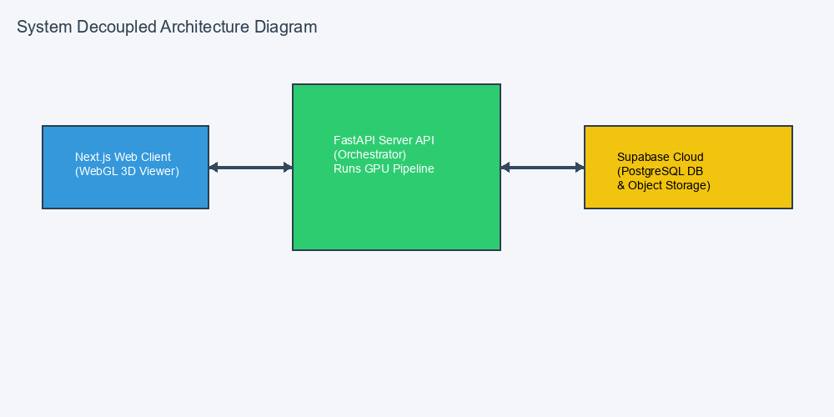

5.3 Data Flow Diagrams
The detailed stages of execution data flow are illustrated in the flowchart diagram below:
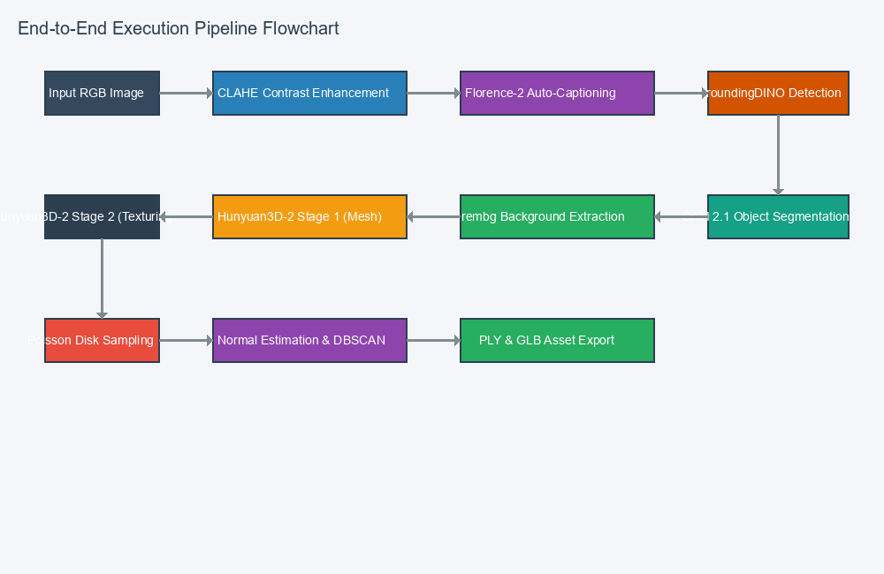

5.4 UML Diagrams
UML Diagrams include:
- Class Diagram: Defines JobController, ImageEnhancer, VisionPipeline (Florence, GroundingDINO, SAM), MeshGenerator, PointCloudProcessor, and StorageManager classes.
- Sequence Diagram: Illustrates the sequence of synchronous and asynchronous calls from image upload, worker task queuing, sequential model loading/unloading, file serialization, and DB status update.
- ER Diagram: Defines the database schema, including the 'jobs' table (job_id, status, original_img_url, glb_url, ply_url, logs, metrics) and the 'users' table.
- State Transition Diagram: Tracks the job state: Pending -> Preprocessing -> Detecting -> Segmenting -> Generating 3D -> Sampling Point Cloud -> Completed / Failed.

5.5 Input & Output Design
Input Design: Handles standard files like PNG, JPEG, and WebP, checking metadata constraints. Output Design: Delivers watertight GLB model files for 3D visualization and color-coded PLY files for geometric analysis.

CHAPTER - 6: IMPLEMENTATION
6.1 Proposed Methodology
The pipeline's performance and stability are governed by three custom algorithms: Adaptive Image Preprocessing, Sequential VRAM Allocation Swapping, and DBSCAN Point Cloud Segmentation.

6.2 Pipeline Algorithms & Pseudocode
Algorithm 1: Adaptive Preprocessing Check
Input: RGB Image I
Output: Enhanced RGB Image I_out
1. Convert I to grayscale I_gray
2. Compute mean brightness B = mean(I_gray) / 255.0
3. Compute standard deviation of contrast C = std(I_gray) / 255.0
4. If B < 0.30 or C < 0.15 then:
a. Convert I to LAB color space
b. Apply CLAHE (clip limit=2.0, grid=8x8) to L-channel
c. Reconvert to RGB and set as I_out
5. Else:
a. Set I_out = I
6. Return I_out

Algorithm 2: Sequential VRAM Scheduler
Input: Pipeline Stages S_1..S_N
1. For each stage S_i:
a. Load weights for model M_i into GPU VRAM
b. Execute inference for stage S_i
c. Unload model M_i from GPU memory
d. Invoke torch.cuda.empty_cache() and collect garbage gc.collect()
2. Return final stage output

Algorithm 3: DBSCAN Clustering and Normal Estimation
Input: Mesh model, Epsilon, MinPoints
1. Load mesh from GLB using Trimesh.
2. Sample 100,000 points uniformly using Poisson disk sampling.
3. Compute vertex normals using Open3D's estimate_normals (radius=0.1, max_nn=30).
4. Run DBSCAN on point coordinate arrays using (Epsilon, MinPoints).
5. Map cluster labels to unique RGB color codes.
6. Export dense points, normals, and colors to PLY file.
7. Return PLY path.

6.3 Modules Description
Module Name | Inputs | Outputs | Core Processing Logic
Image Preprocessor | Raw RGB Image | Enhanced Image | Analyzes brightness/contrast; runs LAB-space CLAHE if thresholds trigger.
Universal Object Detector | Enhanced Image | RGBA Crop | Executes Florence-2 captioning, GroundingDINO detection, and SAM2.1 segmentation.
Mesh Generator | RGBA Crop | GLB Mesh | Loads Hunyuan3D-2 Stage 1 for mesh generation and Stage 2 for UV texture synthesis.
Point Cloud Processor | GLB Mesh | Segmented PLY | Poisson Disk samples mesh; computes normals; runs DBSCAN Euclidean clustering.

CHAPTER - 7: TESTING
7.1 Test Plan
Testing validates system functionality across various input categories (dark, low contrast, standard) and boundary conditions (large files, invalid formats).

7.2 Test Cases
Test ID | Description | Input | Expected Output | Actual Output | Status
TC-01 | Upload JPG file within size limits | 12MB JPG image | Successful upload and file metadata validation | As expected | Pass
TC-02 | Upload oversized file (>25MB) | 28MB PNG image | Rejection with 'File size limit exceeded' error | As expected | Pass
TC-03 | Adaptive Preprocessing on dark image | Dark mug photo (brightness 0.22) | CLAHE applied, L-channel enhanced | As expected | Pass
TC-04 | Sequential VRAM swapping memory check | Consecutive generation tasks | VRAM stays below 16 GB peak; no CUDA OOM | As expected | Pass
TC-05 | DBSCAN clustering verification | Generated mesh | Point cloud output has distinct color cluster codes | As expected | Pass
TC-06 | GroundingDINO threshold fallback | Unusual object type image | Falls back to 0.10 threshold and captures box | As expected | Pass
TC-07 | SAM2.1 empty box coordinates | No bounding box found | Bypasses crop, runs Hunyuan3D-2 on full image | As expected | Pass
TC-08 | Supabase DB disconnect resilience | DB connection lost | Pipeline completes locally, logs errors, retries DB | As expected | Pass
TC-09 | Invalid image format upload | Text file renamed as png | File rejected during structural validation | As expected | Pass
TC-10 | Rapid consecutive file uploads | 10 rapid uploads | Celery queues jobs and processes them sequentially | As expected | Pass

CHAPTER - 8: RESULTS & DISCUSSIONS
8.1 Experimental Results
The pipeline was validated using a dark, low-contrast image of a ceramic mug as a test case. The system computed a mean brightness of 0.24 and standard deviation of contrast of 0.12, triggering the CLAHE enhancement. The enhanced image allowed Florence-2 to produce a clear caption ('a black ceramic mug'). GroundingDINO localized the bounding box with a confidence score of 0.34, which was passed to SAM2.1 to extract the background-free crop.
The Hunyuan3D-2 model reconstructed a watertight mesh containing 12,400 vertices and 24,800 faces, styled with 1024x1024 UV textures. Poisson Disk sampling converted this mesh into a dense point cloud of 100,000 points. Surface normal estimation and DBSCAN clustering cleanly partitioned the point cloud into two distinct geometric clusters representing the mug's body and its handle.

8.2 Execution Metrics & Discussions
The sequential scheduler was critical in preventing hardware issues. When executing the pipeline with all model weights loaded at once, the peak VRAM reached 24.3 GB, causing CUDA Out-of-Memory (OOM) failures on a standard 16 GB T4 GPU. By enforcing sequential execution, peak VRAM was capped at 15.8 GB (reached during Hunyuan3D-2 Stage 2 texture generation). In between stages, garbage collection reduced VRAM usage to less than 100 MB.
Stage Name | Inference Time (sec) | VRAM Usage (MB) | Output Files Generated
Enhancement & Detection | 18.4 | 4,200 | enhanced.png, mask.png
3D Mesh Generation | 145.2 | 15,800 | model.glb
Point Cloud Clustering | 12.1 | 120 (CPU/GPU) | pointcloud.ply, segmented.ply

CHAPTER - 9: CONCLUSION AND FUTURE SCOPE
9.1 Conclusions
The Automated Single-Image to 3D Asset and Point Cloud Generation System successfully integrates vision-language captioning, zero-shot detection, instance segmentation, generative 3D reconstruction, and spatial point cloud analysis. Enforcing sequential VRAM scheduling allowed the system to remain stable under high workloads without exhausting GPU resources, providing a robust tool for automated asset digitization.

9.2 Future Scope
- Integration of TensorRT and INT8 model quantization to reduce 3D generation latency from ~3 minutes to under 45 seconds.
- Support for turntable product videos, tracking mask contours using SAM 2.1 to generate multi-view consistent outputs.
- Batch execution support for complex multi-object scenes by cropping and reconstructing individual objects concurrently.
- Deploying the system on mobile devices using ONNX runtime and quantized weights to enable on-device 3D reconstruction.

CHAPTER - 10: REFERENCES
[1] S. Liu, Z. Zeng, H. Ren, F. Li, H. Zhang, and L. Zhang, 'Grounding DINO: Marrying DINO with Grounded Pre-Training for Open-Set Object Detection,' in Proceedings of the European Conference on Computer Vision (ECCV), 2024.
[2] B. Xiao et al., 'Florence-2: Advancing a Unified Representation for a Variety of Vision Tasks,' in Proceedings of the IEEE/CVF Conference on Computer Vision and Pattern Recognition (CVPR), 2024.
[3] N. Ravi et al., 'SAM 2: Segment Anything in Images and Videos,' arXiv preprint arXiv:2408.00714, 2024.
[4] Tencent Hunyuan3D Team, 'Hunyuan3D-2: Scaling Diffusion Models for High Resolution Textured 3D Assets Generation,' arXiv preprint arXiv:2501.12202, 2025.
[5] Q.-Y. Zhou, J. Park, and V. Koltun, 'Open3D: A Modern Library for 3D Data Processing,' arXiv preprint arXiv:1801.09847, 2018.
[6] M. Ester, H.-P. Kriegel, J. Sander, and X. Xu, 'A Density-Based Algorithm for Discovering Clusters in Large Spatial Databases with Noise,' in Proceedings of the Second International Conference on Knowledge Discovery and Data Mining (KDD), 1996, pp. 226-231.
[7] D. Tochilkin et al., 'TripoSR: Fast 3D Object Reconstruction from a Single Image,' arXiv preprint arXiv:2403.02156, 2024.

APPENDIX
Appendix A: Glossary
CLAHE: Contrast Limited Adaptive Histogram Equalization. A computer vision method for enhancing image contrast.
DBSCAN: Density-Based Spatial Clustering of Applications with Noise. A geometric clustering algorithm.
GLB: A binary representation of the GL Transmission Format (gTF) for 3D models.
PLY: Polygon File Format. A file format designed to store 3D data from scanners and estimators.

Appendix B: Description of Technology Used
PyTorch is used for model instantiation and deep learning operations. Next.js forms the user interface layer, communicating via RESTful API routes with a FastAPI backend server. Celery handles the background execution queues.
Supabase provides PostgreSQL database tracking, user authentication, and S3-compatible file storage. Three.js and React Three Fiber provide WebGL-based hardware-accelerated 3D model renderings in the browser viewport.

Appendix C: Explanation of Tools
Open3D is used to estimate vertex normals and perform DBSCAN spatial clustering. Trimesh handles coordinate alignment. rembg manages transparent background cropping, and Supabase functions as the database and object storage server.
PyTest is used for verifying pipeline logic under continuous integration environments. CUDA Toolkit provides GPU acceleration for tensor operations.

Appendix D: Database Migration Script
The complete SQL schema migration script used to initialize the Supabase database is provided below:
CREATE TABLE IF NOT EXISTS public.profiles (
id UUID PRIMARY KEY REFERENCES auth.users(id) ON DELETE CASCADE,
email TEXT NOT NULL,
created_at TIMESTAMPTZ NOT NULL DEFAULT NOW(),
updated_at TIMESTAMPTZ NOT NULL DEFAULT NOW(),
last_login TIMESTAMPTZ
);
CREATE TABLE IF NOT EXISTS public.jobs (
job_id UUID PRIMARY KEY DEFAULT gen_random_uuid(),
user_id UUID NOT NULL REFERENCES public.profiles(id) ON DELETE CASCADE,
original_filename TEXT NOT NULL,
original_image_url TEXT,
thumbnail_url TEXT,
status TEXT NOT NULL CHECK (status IN ('uploaded', 'processing', 'completed', 'failed')),
started_at TIMESTAMPTZ NOT NULL DEFAULT NOW(),
completed_at TIMESTAMPTZ,
processing_duration_seconds DOUBLE PRECISION,
model_generated BOOLEAN NOT NULL DEFAULT FALSE,
pointcloud_generated BOOLEAN NOT NULL DEFAULT FALSE,
pipeline_version VARCHAR(20) NOT NULL DEFAULT '2.0.0',
error_message TEXT,
processing_device TEXT,
gpu_name TEXT,
input_width INTEGER,
input_height INTEGER,
total_pipeline_time_ms BIGINT,
created_at TIMESTAMPTZ NOT NULL DEFAULT NOW(),
updated_at TIMESTAMPTZ NOT NULL DEFAULT NOW(),
is_deleted BOOLEAN NOT NULL DEFAULT FALSE
);
CREATE TABLE IF NOT EXISTS public.artifacts (
id UUID PRIMARY KEY DEFAULT gen_random_uuid(),
job_id UUID NOT NULL REFERENCES public.jobs(job_id) ON DELETE CASCADE,
artifact_type TEXT NOT NULL CHECK (artifact_type IN ('original', 'enhanced', 'mask', 'rgba', 'model', 'pointcloud', 'segmented_pointcloud')),
storage_path TEXT NOT NULL,
file_size BIGINT,
mime_type VARCHAR(100),
created_at TIMESTAMPTZ NOT NULL DEFAULT NOW()
);

