## VISVESVARAYA TECHNOLOGICAL UNIVERSITY BELAGAVI -590018



### Yoga Report

**“Hero (Virasana)”**

**Submitted by**

**Mr. Rajashekhar Naduvinahalli**

**2KA21CS037**

**21YO83**

**8th Semester**



**DEPARTMENT OF COMPUTER SCIENCE AND ENGINEERING**

**SMT. KAMALA AND SRI VENKAPPA M. AGADICOLLEGE OF ENGINEERING AND TECHNOLOGY LAKSHMESHWAR 582116**

### 2024-2025

#### SMT. KAMALA AND SRI VENKAPPA M. AGADI COLLEGE OF ENGINEERING AND TECHNOLOGY LAKSHMESHAR-582116

**(Affiliated to VTU Belagavi)**



#### DEPARTMENT OF COMPUTER SCIENCE AND ENGINEERING

*Certificate*

Certified that the Yoga Report entitled **“Hero (Virasana)”** is a work carried out by **Rajashekhar Naduvinahalli** bearing USN **2KA21CS037.** In the partial fulfillment prescribed by the **VISVESVARAYA TECHNOLOGICAL UNIVERSITY, BELAGAVI** for VIII semester Computer Science and Engineering during the year 2024-2025. This Yoga report has been approved as it satisfies the academic requirements in respect to the Yoga work prescribed for the Bachelor of Engineering Degree.

Mentor HOD

**Mr. S. F. Kodli Dr. Arun Kumbi**

Dean Academics Principal

**Dr. Subhas Meti Dr. Parashuram Baraki**

# INTRODUCTION :

Yoga is a practice that originated in ancient India and has become popular worldwide for its physical, mental, and spiritual benefits. The word "yoga" comes from the Sanskrit word "yuj " which means "to unite" or "to join." It refers to the union of body, mind, and spirit, helping individuals achieve balance, health, and a sense of inner peace**.**

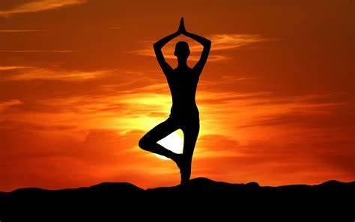

### Key Aspects of Yoga

1. **Physical Practice (Asanas):** The physical postures or poses in yoga, known as asanas, are designed to improve strength, flexibility, and balance. Some popular yoga poses include Downward Dog, Warrior, and Tree Pose. Asanas also help in stimulating the body's energy channels, enhancing circulation, and supporting overall well-being.
2. **Breathing Techniques (Pranayama)**: Pranayama refers to breath control exercises that are an integral part of yoga. Breathing deeply and consciously helps calm the mind, increase energy levels, and improve concentration. Techniques include Ujjayi breath, Nadi Shodhana (alternate nostril breathing), and Kapala Bhati.
3. **Meditation (Dhyana)**: Meditation is central to yoga practice and helps foster mindfulness, reduce stress, and enhance emotional well-being. Through meditation, practitioners learn to focus the mind, allowing for greater clarity, insight, and self-awareness.
4. **Philosophy and Ethics (Yamas and Niyamas)**: Yoga is not just a physical practice but a way of life. The ancient texts of yoga, such as the Yoga Sutras of Patanjali, describe ethical guidelines called yamas (moral disciplines) and niyamas (personal observances). These guidelines promote non-violence, truthfulness, contentment, self-discipline, and humility.
5. **Spirituality (Samadhi)**: Yoga also has a spiritual dimension, where the ultimate goal is Samadhi, a state of deep meditation and union with the divine or higher consciousness. While not all yoga practitioners aim for spiritual enlightenment, many do experience a sense of connection, peace, and greater awareness through their practice.

### Benefits of Yoga

* + **Physical Benefits**: Improved flexibility, strength, posture, and balance. It can also help manage pain, such as back pain, and reduce the risk of injury.
  + **Mental Benefits**: Reduced stress and anxiety, improved concentration, and a calmer mind. Yoga has been shown to help regulate mood and promote mental clarity.
  + **Emotional Benefits**: Enhanced emotional resilience, self-awareness, and inner peace.
  + **Spiritual Benefits**: A deeper connection to oneself, a sense of purpose, and, for some, spiritual growth.

### Variations of Virasana

Virasana is considered a meditative pose and is largely practiced by many Rishis (Saints) and there are many variations to this pose. The different variations in this pose are explained below.

* Seated on the floor on your knees and shins, place the feet with soles pointing behind you with all the toes touching the floor. This is the simple Virasana Pose.
* The second variation to this is, bring the feet close to each other and place them one upon the other with the soles pointing backwards. Placing your sit bones on the the heels of the feet brings the hip higher. This will bring more pressure to the ankles, so must be done cautiously.
* Placing the hands on the thighs one can practice Uddiyana Bandha or the Abdominal lock pushing the hands downwards on the knees and raising the chest and the upper abdomen upwards. This practice should be done with proper guidance and with mastery of this form of Pranayama.
* Virasana can also be done by raising the arms above your shoulders and head stretching upwards with fingers interlocked. This upwards stretch should help in tightening the chest and upper abdominal muscles.
* Placing the palms on the soles of the feet while seated in a simple Virasana, raise the body upwards with inhalation and as you exhale stretch forward bringing the forehead to the floor in front of you. This works on the lower abdominal muscles toning it and keeps the hips strong and brings tightness to the buttocks.

# Hero Pose (Virasana)

## Benefits of Hero Pose

* Stretches the thighs, knees, and ankles
* Strengthens the arches
* Improves digestion and relieves gas
* Helps relieve the symptoms of menopause
* Reduces swelling of the legs during pregnancy (through second trimester)
* Therapeutic for high blood pressure and asthma

## Instructions to do Hero Pose:

* Kneel on the floor (use a folded blanket or bolster to wedge between your calves and thighs if necessary), with your thighs perpendicular to the floor, and touch your inner knees together. Slide your feet apart, slightly wider than your hips, with the tops of the feet flat on the floor. Angle your big toes slightly in toward each other and press the top of each foot evenly on the floor.
* Exhale and sit back halfway, with your torso leaning slightly forward. Wedge your thumbs into the backs of your knees and draw the skin and flesh of the calf muscles toward the heels. Then sit down between your feet.
* If your buttocks don’t comfortably rest on the floor, raise them on a block or thick book placed between the feet. Make sure both sitting bones are evenly supported. Allow a thumb’s-width space between the inner heels and the outer hips. Turn your thighs inward and press the heads of the thigh bones into the floor with the bases of your palms. Then lay your hands in your lap, one on the other, palms up, or on your thighs, palms down.
* Firm your shoulder blades against the back ribs and lift the top of your sternum like a proud warrior. Widen the collarbones and release the shoulder blades away from the ears. Lengthen the tailbone into the floor to anchor the back torso.
* At first stay in this pose from 30 seconds to 1 minute. Gradually extend your stay up to 5 minutes. To come out, press your hands against the floor and lift your buttocks up, slightly higher than the heels. Cross your ankles underneath your buttocks, sit back over the feet and onto the floor, then stretch your legs out in front of you. It may feel good to bounce your knees up and down a few times on the floor.

### Deepen the Pose

Cup your hands around the knees, straighten the arms fully, and pull on the knees. Firm your shoulder blades against your back, lift the top sternum, and release your chin down onto the chest without straining the back of your neck. Hold for 10 to 20 seconds. Then let go of the knees and raise your head back to neutral without losing the lift of the sternum.

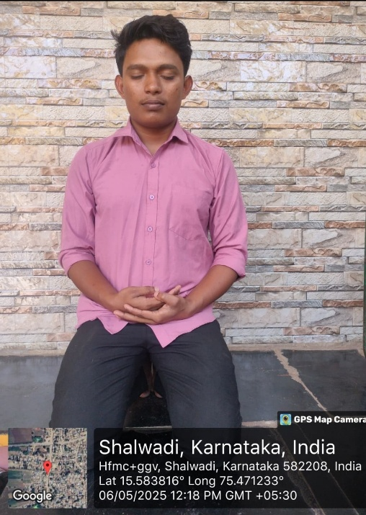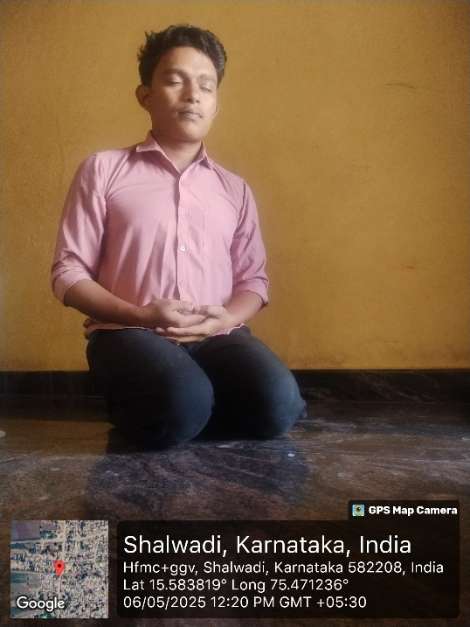

# Conclusion

We love a pose that looks easy but gives us a physical and mental challenge. On the surface, Hero Pose looks like a simple matter of coming to sit on your knees. But the position requires a specific, careful alignment of your knees and feet. You may have to adjust the pose depending on the anatomy of your calves, ankles, and quadriceps. Maintaining the pose also requires you to sit with yourself and cultivate an inner and outer stillness.

.