TRAFFIC MANAGEMENT SYSTEM

Developing a traffic management system app involves creating a platform that helps monitor, control, and optimize traffic flow. Key features could include real-time traffic updates, route planning, congestion alerts, and integration with traffic cameras and sensors. Additionally, user-friendly interfaces for both commuters and traffic authorities are crucial. Considering the complexity, it's advisable to collaborate with experienced developers and consider factors like data accuracy, user privacy, and efficient algorithms for traffic analysis.

Python can be a great choice for developing a traffic management system:

Data Collection: Python can interface with various data sources like traffic cameras, sensors, and GPS devices. Libraries like OpenCV can be used for image processing from cameras.

Data Processing and Analysis: Python's numerical libraries such as NumPy and Pandas can help process and analyze large datasets efficiently. You can analyze traffic patterns and identify congested areas using these libraries.

Real-time Updates: Python, coupled with frameworks like Flask or Django, can create web applications for real-time traffic updates. WebSockets can be employed for real-time communication between clients and servers.

Machine Learning: Python offers robust machine learning libraries like Scikit-Learn and TensorFlow. Machine learning models can predict traffic patterns based on historical data, helping in proactive management.

Geospatial Analysis: Libraries like GeoPandas and Shapely can be used for geospatial analysis. This is crucial for mapping traffic data onto geographical maps for better visualization.

Visualization: Libraries like Matplotlib and Plotly can help in creating interactive visualizations, aiding in understanding traffic data and trends.

Automation: Python can be used for automating tasks related to data collection, processing, and reporting, saving time and resources.

Python class for making HTTP requests to the Raspberry Pi's API: python

Copy code

import requests

class TrafficManagementAPI: def _init_(self, base_url):

self.base_url = base_url

def send_traffic_data(self, traffic_data): """

Sends traffic data to the Raspberry Pi's API.

Args:

traffic_data (dict): A dictionary containing traffic data to be sent.

For example: {'location': 'Street Name', 'status': 'heavy_traffic'}

Returns:

bool: True if the request was successful, False otherwise.

"""

try:

response = requests.post(f"{self.base_url}/traffic_data", json=traffic_data) response.raise_for_status() # Raise an HTTPError if the request returned an

unsuccessful status code

return True

except requests.exceptions.RequestException as e: print(f"Error: {e}")

return False

# Example Usage

if _name_ == "_main_":

raspberry_pi_api_url = "http://raspberry_pi_ip_address:port" # Replace this with your Raspberry Pi's API URL

traffic_api = TrafficManagementAPI(raspberry_pi_api_url)

# Example traffic data traffic_data = {

'location': 'Main Street', 'status': 'heavy_traffic'

}

# Sending traffic data

success = traffic_api.send_traffic_data(traffic_data) if success:

print("Traffic data sent successfully!") else:

print("Failed to send traffic data.") Model for traffic management system:



Traffic controller System:

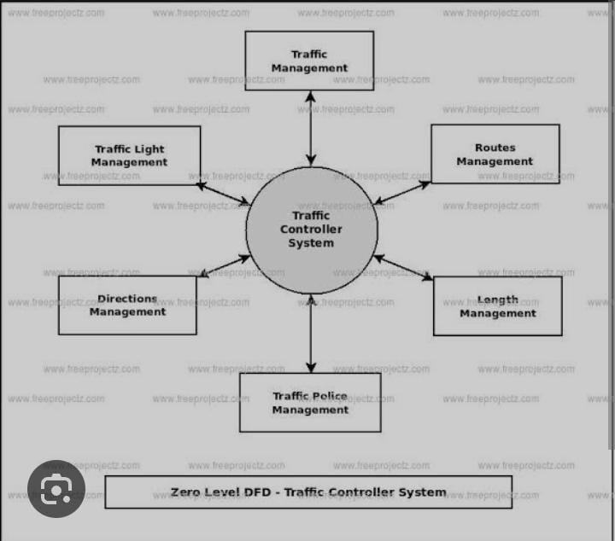

Design of traffic management:

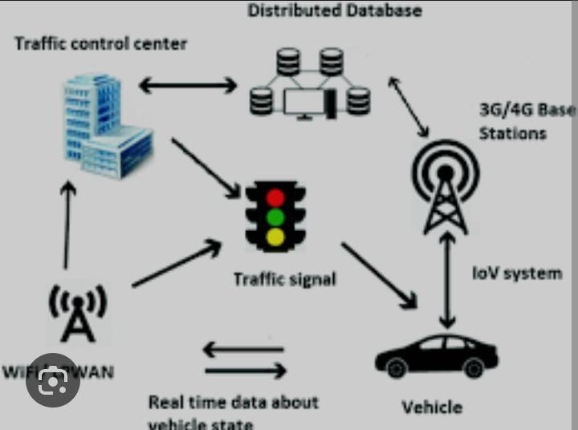

Traffic light controller with Raspberry:

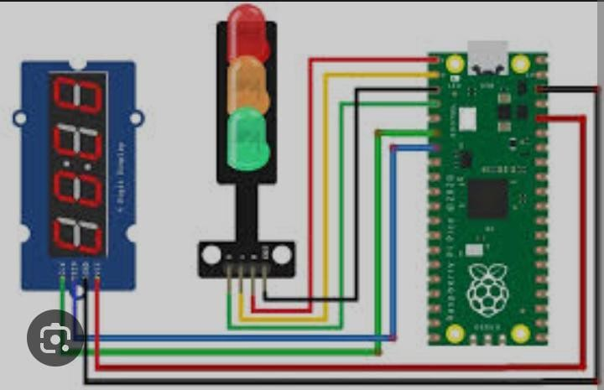

Traffic light:

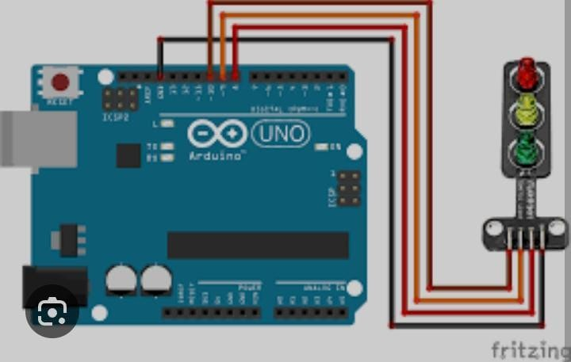

Study of Traffic management system:

