TRAFFIC MANAGEMENT

SYSTEM

# PROJECT OBJECTIVE:

A Traffic Management System (TMS) is a comprehensive solution that aims to improve traffic flow, enhance safety, and reduce congestion on roads. Such a system typically incorporates various technologies and strategies to achieve these goals. Here's an overview of a Traffic Management System project:

*1. * Traffic Monitoring: Utilizes cameras, sensors, and other monitoring devices to gather real-time data on traffic conditions, such as vehicle density, speed, and congestion levels.

1. Traffic Data Analysis: Analyzes the collected data to identify traffic patterns, peak hours, and congestion-prone areas. This analysis helps in making informed decisions for traffic optimization.
2. Traffic Signal Control: Implements adaptive traffic signal control systems that adjust signal timings based on real-time traffic flow. This optimization helps in reducing waiting times and improving traffic flow.
3. Intelligent Transportation Systems (ITS): Integrates various technologies like GPS, communication networks, and sensors to enable smart traffic management. ITS facilitates real-time communication between vehicles and infrastructure, allowing for efficient traffic coordination.
4. Incident Management: Monitors for accidents, road closures, or other incidents. Once detected, the system can reroute traffic, notify authorities, and provide alternative routes to minimize disruptions.
5. Public Information Systems: Provides real-time traffic updates to the public through digital signage, mobile apps, and websites. This ensures that drivers are aware of current traffic conditions and can plan their routes accordingly.
6. Parking Management: Integrates smart parking solutions that help drivers locate available parking spaces, reducing the time spent searching for parking and, consequently, easing traffic congestion.

# Sensors for traffic management system:

Inductive Loop Sensors: These sensors are embedded in the road surface at intersections and detect the presence of vehicles by measuring changes in inductance caused by the metal in the vehicle. They are commonly used for traffic signal control and vehicle counting.

Infrared Sensors: Infrared sensors use infrared light to detect the presence and movement of vehicles. They are often used in toll booths, traffic counting, and vehicle classification applications.

Ultrasonic Sensors: Ultrasonic sensors use sound waves to detect the distance between the sensor and an object, such as a vehicle. They are used for parking management systems to determine the availability of parking spaces.

Video Cameras: High-resolution video cameras capture real-time footage of traffic flow. Video analytics software processes the footage to monitor traffic conditions, detect incidents, and analyze vehicle movements.

Microwave Sensors: Microwave sensors emit microwave signals and measure the time taken for the signals to bounce back after hitting an object, such as a vehicle. They are used for vehicle detection and speed measurement.

Acoustic Sensors: Acoustic sensors detect sound waves generated by vehicles. They can be used to monitor traffic flow, detect vehicle speeds, and identify traffic congestion.

Lidar Sensors: Lidar (Light Detection and Ranging) sensors use laser beams to create a detailed 3D map of the surroundings. They are used for object detection, pedestrian detection, and autonomous vehicle applications.

GPS (Global Positioning System): GPS technology is used in traffic management systems to track the movement of vehicles, analyze traffic patterns, and provide real-time navigation information to drivers.

# Working of traffic management system:

Traffic Flow Optimization: TMS helps reduce congestion and traffic jams by optimizing traffic signal timings and routes, leading to smoother traffic flow.

Reduced Travel Time: Commuters experience shorter travel times as TMS can dynamically adjust traffic signals to accommodate changing traffic patterns.

Improved Safety: TMS can detect accidents or hazards and alert authorities, helping improve overall road safety.

Environmental Benefits: Reduced idling and smoother traffic flow can lead to lower fuel consumption and emissions, benefiting the environment.

Data Collection: TMS collects data about traffic conditions, which can be used for future planning and analysis

Microcontrollers:

* They are used to interfere with iot sensors,process data,and commmunicates With the data sharing platform

Used:Arduino,ESP32 Connectivity:

Wi-Fi Module:Use Wi-Fi for data transmission.

Sensors:

We have used following sensor for our project: Ultrasonic sensor

Infrared sensor Inductive sensor

Their uses:

Ultrasonic sensors :Emit ultrasonic waves and measure the time it takes for the waves to bounce back after hitting an object (such as a vehicle). This data is used to determine the distance between the sensor and the object.

Inductive Loop Sensors: These are embedded in the road surface and detect the presence of vehicles by measuringchanges in magnetic fields when a vehicle passes over them.

Infrared Sensors: Infrared sensors use infrared light to detect the presence and movement of vehicles.

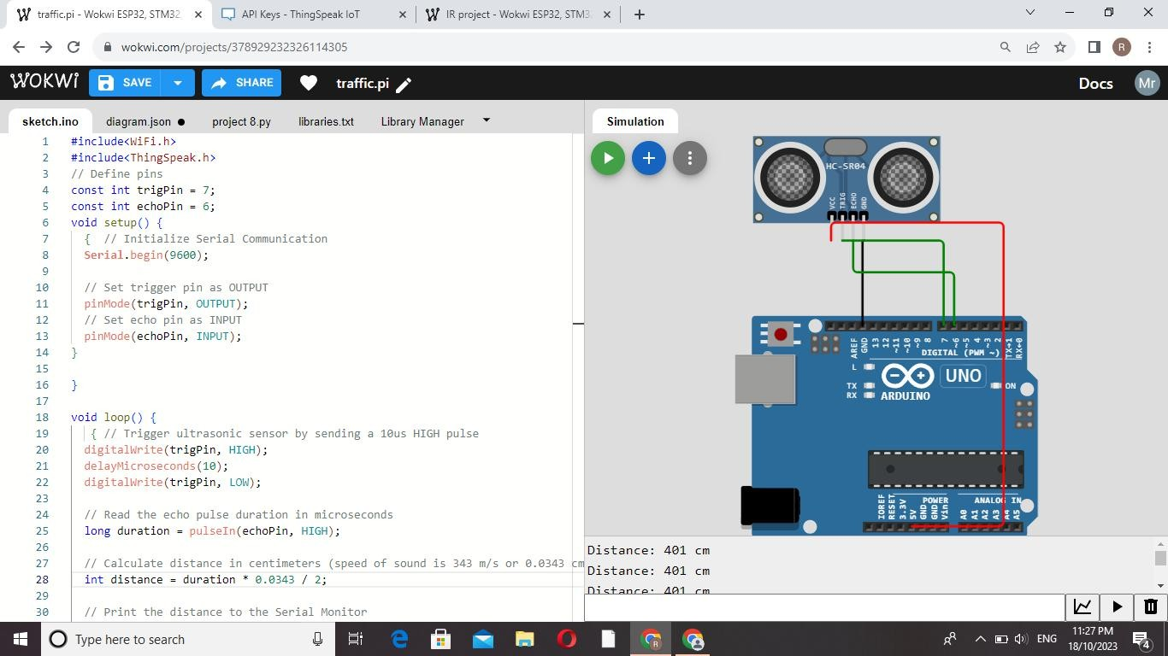Configured Sensors: Screenshot: Ultrasonic

Infrared sensor:

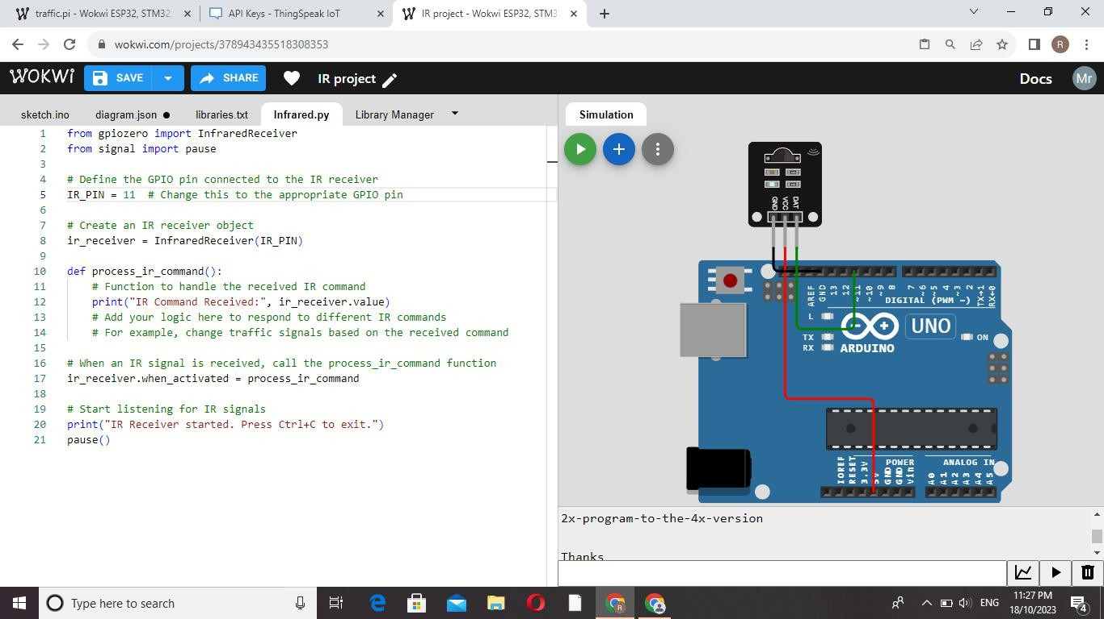

Python script for data sharing:

import requests import time import json

thingspeak_url = "https://api.thingspeak.com/update" api_key = "ROT3W9LRGCAX2LCQ"

ssid = "Wokwi-GUEST" password = ""

DHT_PIN = 15

TRIG_PIN = 13

ECHO_PIN = 12

def get_distance():

from machine import Pin import dht

dht_sensor = dht.DHT22(Pin(DHT_PIN))

while True:

try:

dht_sensor.measure()

temperature = dht_sensor.temperature() humidity = dht_sensor.humidity() distance = get_distance()

print("Temperature: {:.2f}°C, Humidity: {:.2f}%, Distance: {:.2f} cm".format(temperature, humidity, distance))

data = {

"api_key": api_key, "field1": temperature, "field2": humidity, "field3": distance

}

response = requests.post(thingspeak_url, data=data)

print("Data sent to ThingSpeak. Status code:", response.status_code)

except Exception as e: print("Error:", str(e))

time.sleep(15)

# App development:

Developing a traffic management system app involves creating a platform that helps monitor, control, and optimize traffic flow. Key features could include real-time traffic updates, route

planning, congestion alerts, and integration with traffic cameras and sensors. Additionally, user-friendly interfaces for both commuters and traffic authorities are crucial. Considering the complexity, it's advisable to collaborate with experienced developers and consider factors like data accuracy, user privacy, and efficient algorithms for traffic analysis.

Python can be a great choice for developing a traffic management system:

Data Collection: Python can interface with various data sources like traffic cameras, sensors, and GPS devices. Libraries like OpenCV can be used for image processing from cameras.

Data Processing and Analysis: Python's numerical libraries such as NumPy and Pandas can help process and analyze large datasets efficiently. You can analyze traffic patterns and identify congested areas using these libraries.

Real-time Updates: Python, coupled with frameworks like Flask or Django, can create web applications for real-time traffic updates. WebSockets can be employed for real-time communication between clients and servers.

Machine Learning: Python offers robust machine learning libraries like Scikit-Learn and TensorFlow. Machine learning models can predict traffic patterns based on historical data, helping in proactive management.

Geospatial Analysis: Libraries like GeoPandas and Shapely can be used for geospatial analysis. This is crucial for mapping traffic data onto geographical maps for better visualization.

Visualization: Libraries like Matplotlib and Plotly can help in creating interactive visualizations, aiding in understanding traffic data and trends.

Automation: Python can be used for automating tasks related to data collection, processing, and reporting, saving time and resources.

Python class for making HTTP requests to the Raspberry Pi's API: python

Copy code

import requests

class TrafficManagementAPI: def _init_(self, base_url):

self.base_url = base_url

def send_traffic_data(self, traffic_data): """

Sends traffic data to the Raspberry Pi's API.

Args:

traffic_data (dict): A dictionary containing traffic data to be sent.

For example: {'location': 'Street Name', 'status': 'heavy_traffic'}

Returns:

bool: True if the request was successful, False otherwise.

"""

try:

response = requests.post(f"{self.base_url}/traffic_data", json=traffic_data) response.raise_for_status() # Raise an HTTPError if the request returned an

unsuccessful status code return True

except requests.exceptions.RequestException as e: print(f"Error: {e}")

return False

# Example Usage

if _name_ == "_main_":

raspberry_pi_api_url = "http://raspberry_pi_ip_address:port" # Replace this with your Raspberry Pi's API URL

traffic_api = TrafficManagementAPI(raspberry_pi_api_url)

# Example traffic data traffic_data = {

'location': 'Main Street', 'status': 'heavy_traffic'

}

# Sending traffic data

success = traffic_api.send_traffic_data(traffic_data) if success:

print("Traffic data sent successfully!") else:

print("Failed to send traffic data.") Model for traffic management system:

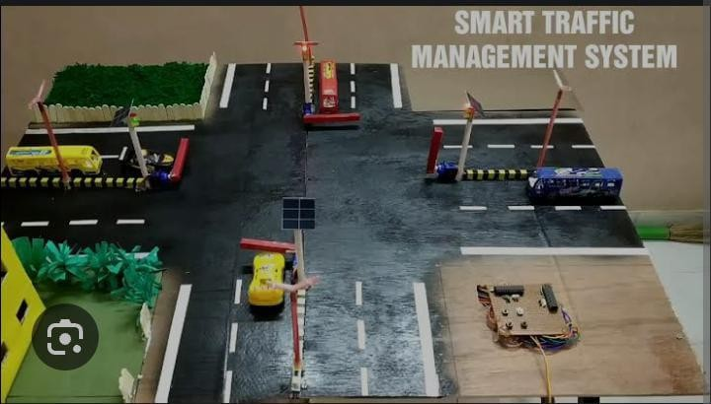

## Traffic controller system:

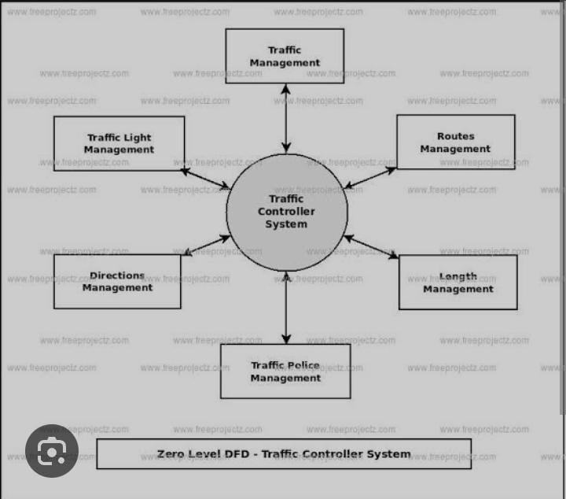

Design of traffic management system:

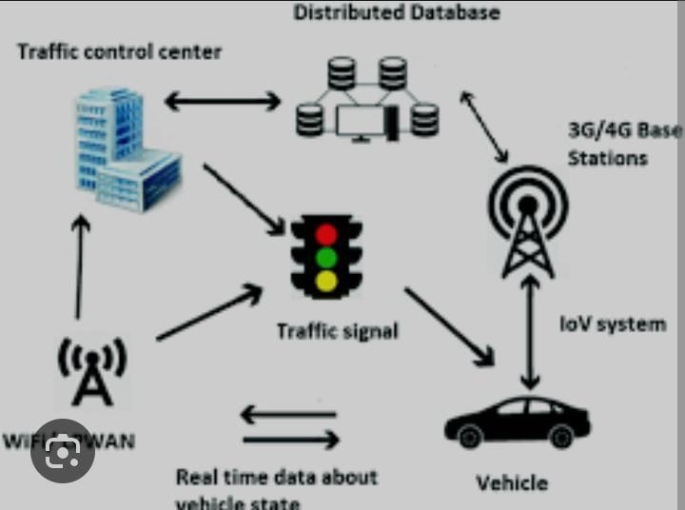

## Traffic light controller with Raspberry:

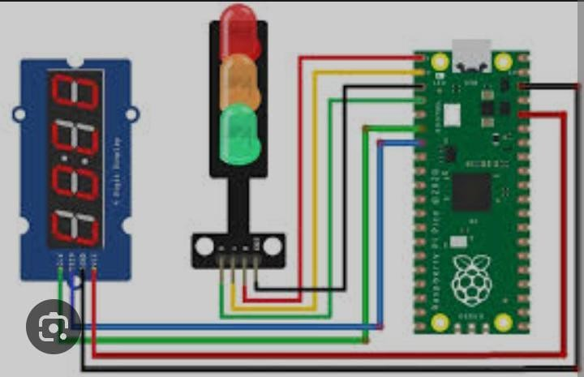

Traffic light:

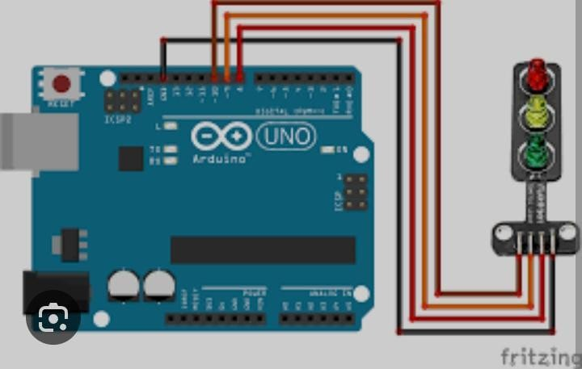

## Study of traffic management system:

