**Deliverable 1:**

Showing MLFlow running:

python -m mlflow server --host 127.0.0.1 --port 6001

Python train_model.py

🏃 View run test-run at: http://127.0.0.1:6001/#/experiments/419964404938083460/runs/658cf0f3b67343b880391c4d8e557655

🧪 View experiment at: <http://127.0.0.1:6001/#/experiments/419964404938083460>

**Deliverable 2**

Python load_model.py



**Deliverable 3**

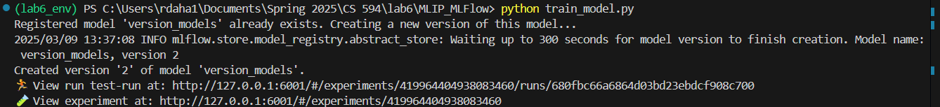

🏃 View run test-run at: http://127.0.0.1:6001/#/experiments/419964404938083460/runs/680fbc66a6864d03bd23ebdcf908c700

🧪 View experiment at: <http://127.0.0.1:6001/#/experiments/419964404938083460>

Showing new version of the model

Adding tags and description on the versioned models