Entropy:

Quantify similarity and differences

Entropy, in other words, is a **measure of uncertainty.**

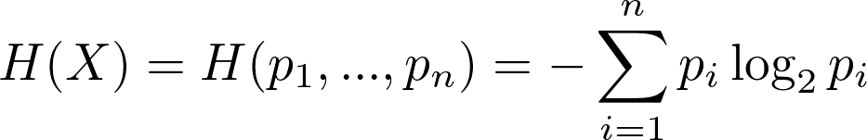

# Multiple Imputation by Chained Equations (MICE)

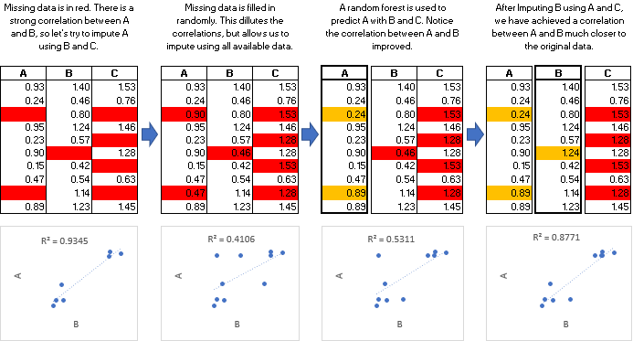

The MICE Algorithm

Multiple Imputation by Chained Equations, also called “fully conditional specification”, is defined as such:

