**IBM NAAN MUDHALAVAN PROJECT**

**CLOUD APPLICATION DEVELOPMENT**

**PHASE-3 DEVELOPMENT PART-1**

Building a chatbot using IBM Cloud Watson Assistant involves several steps, including creating an instance of Watson Assistant, designing your chatbot's dialog flow, integrating it with various channels, and training it to understand and respond to user input effectively. Here's a step-by-step guide to help you get started:

**Step 1: Sign Up for IBM Cloud**

If you don't already have an IBM Cloud account, sign up for one at <https://cloud.ibm.com/registration>.

**Step 2: Create an Instance of Watson Assistant**

1. Log in to your IBM Cloud account.

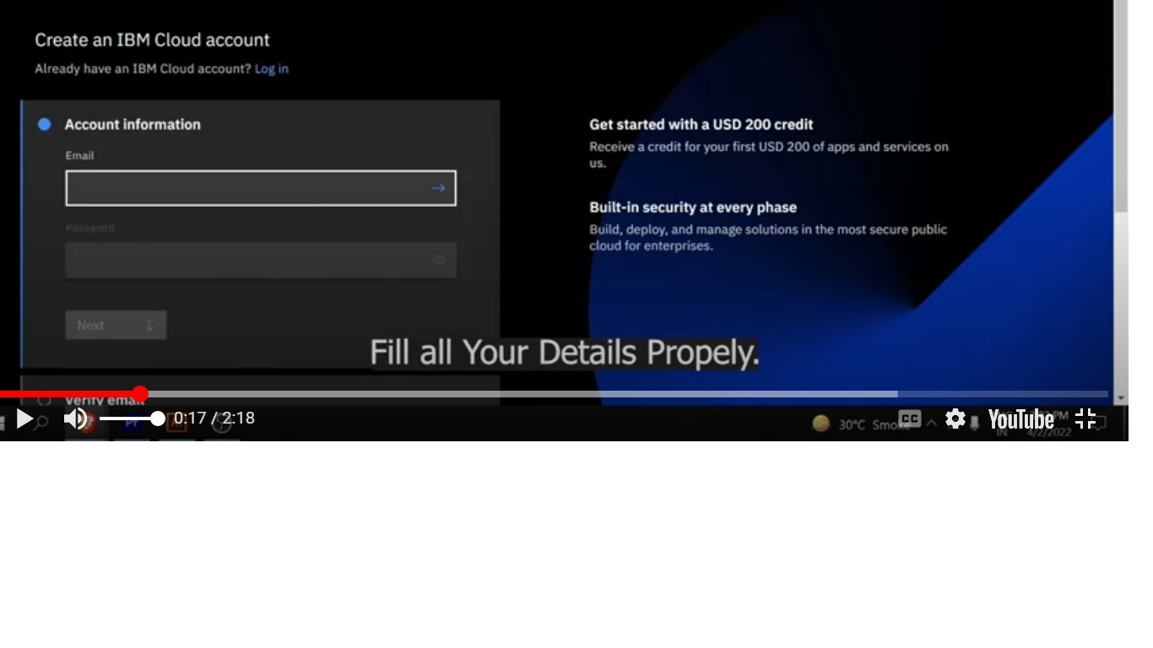

1. Go to the IBM Cloud dashboard and click "Create Resource."

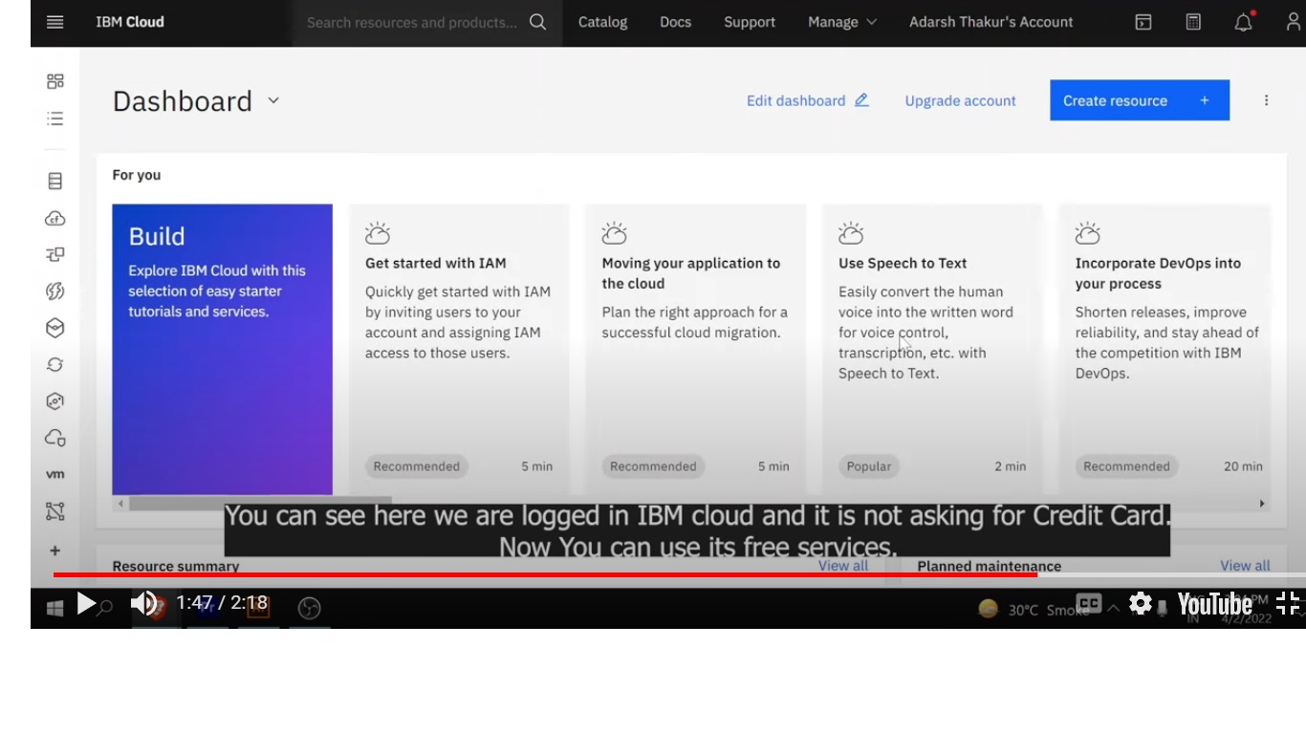3. In the IBM Cloud Catalog, search for "Watson Assistant."

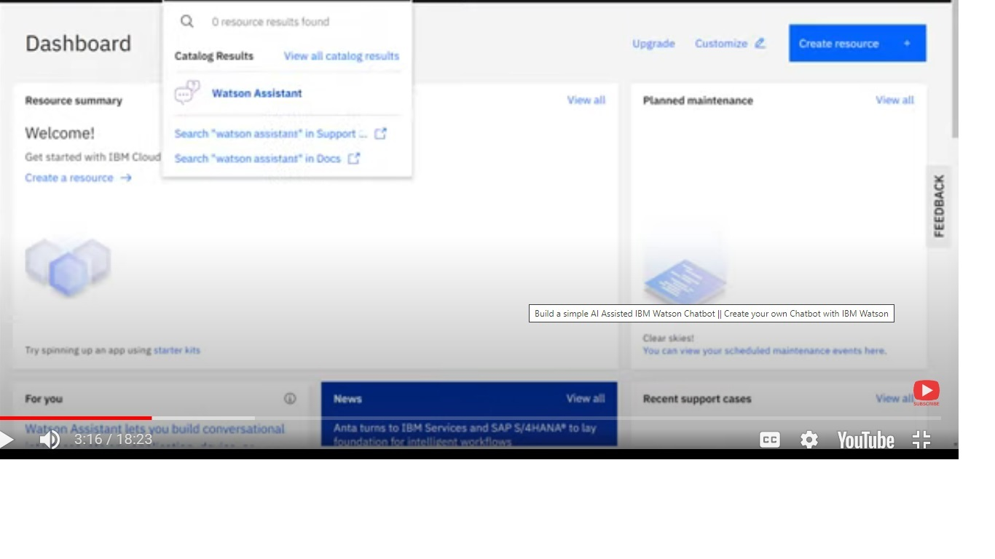

4. Select "Watson Assistant" from the search results.

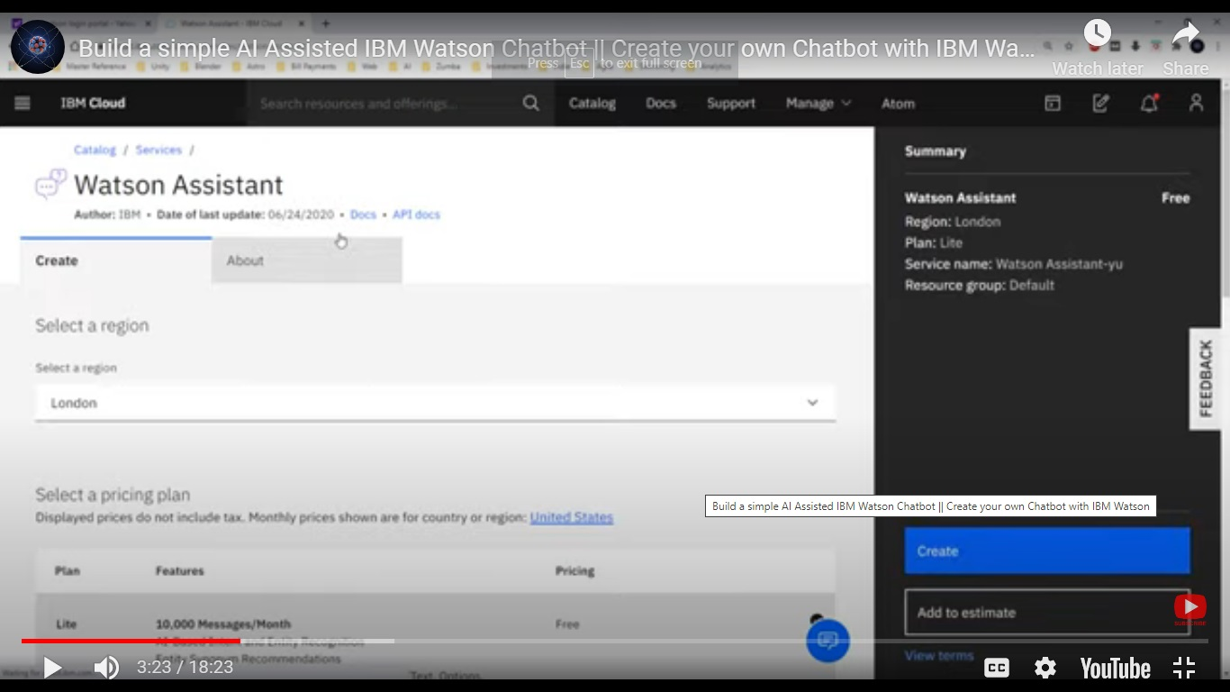

5. Configure your service by giving it a name, selecting the region, and choosing the appropriate plan (Lite plan is free to use).

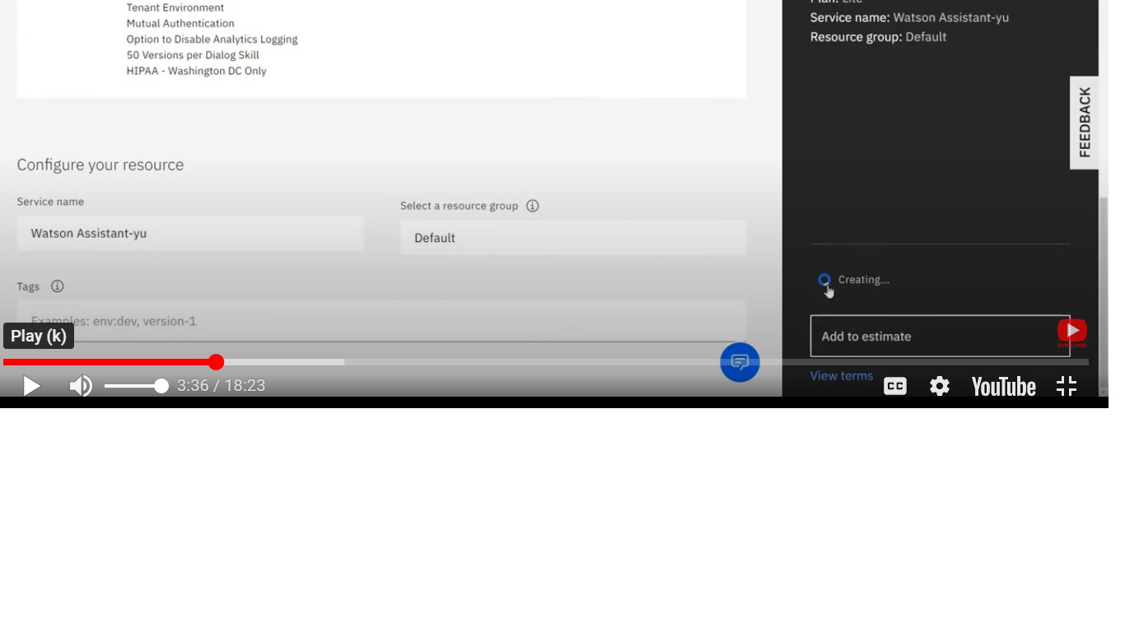6. Click "Create" to create your Watson Assistant service instance.

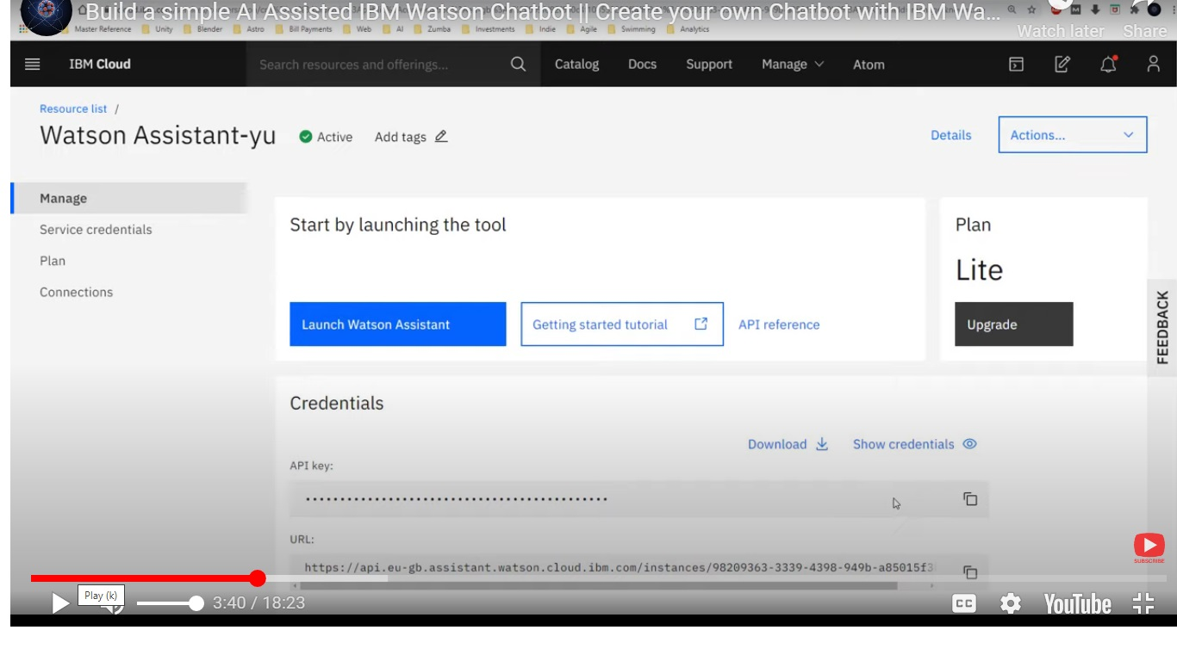

**Step 3: Create a Watson Assistant Skill**

1. Once your Watson Assistant service instance is created, click on it to open the Watson Assistant dashboard.

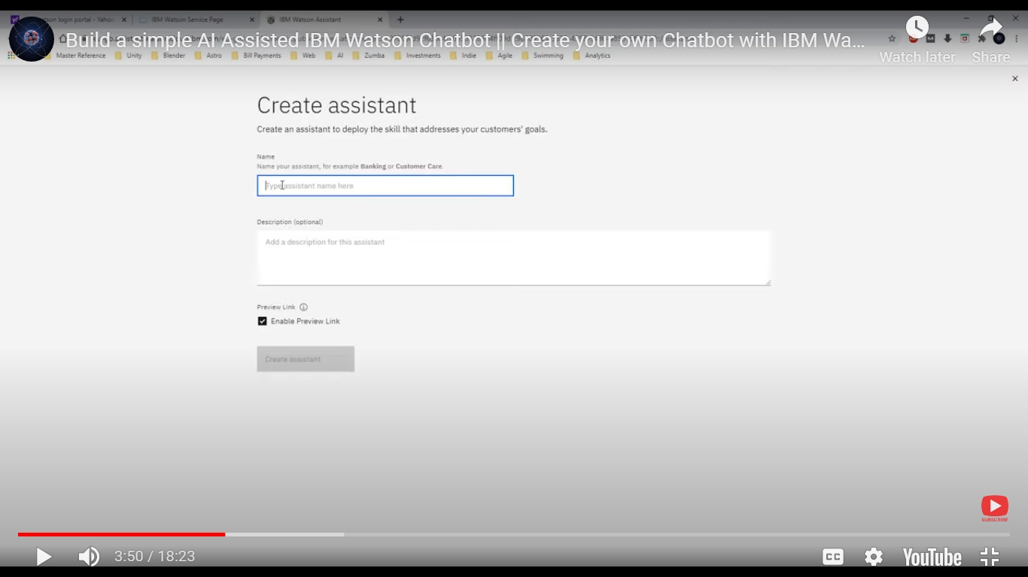

1. Inside the Watson Assistant dashboard, click on "Launch Watson Assistant" to open the Watson Assistant tool.
2. In the Watson Assistant tool, click on "Skills" in the left menu.
3. Click on "Create skill" to start building your chatbot's conversation flow.

**Step 4: Build Your Chatbot's Dialog Flow**

1. In your newly created skill, you can add Intents, Entities, and Dialog nodes to design your chatbot's conversation flow.

\***Intents**: Define the user's intentions or what they might be trying to do.

\***Entities**: Define specific terms or objects the chatbot should recognize.

\***Dialog Nodes**: Create the responses your chatbot will provide based on user input, Intents, and Entities.

1. You can use the built-in Dialog Builder to visually design your chatbot's conversation flow by creating dialog nodes and connecting them.
2. Make sure to test your chatbot as you build it to ensure it understands and responds correctly.

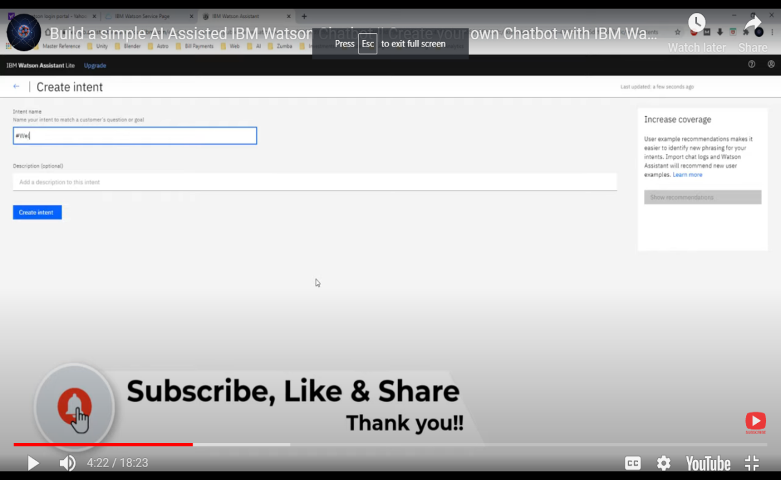

**Step 5: Integrating Your Chatbot**

1. You can integrate your chatbot with various channels, such as a website, mobile app, or messaging platform. Here's how to do it for a website:
2. In the Watson Assistant tool, click on "Options" in the left menu and select "Integration."
3. Choose the integration channel you want (e.g., Web Chat).
4. Configure the settings and customize the chat widget's appearance to match your website's design.
5. Generate the code and add it to your website to embed the chatbot.

**Step 6: Train and Deploy Your Chatbot**

1. After building and testing your chatbot, make sure it understands user input correctly and provides relevant responses.
2. Train your chatbot by providing a variety of user examples for each intent to improve its natural language understanding.
3. Once satisfied with the performance, click "Deploy" to make your chatbot live.

**Step 7: Monitor and Improve**

1. Continuously monitor your chatbot's performance, user interactions, and feedback. You can use Watson Assistant's analytics to understand how your chatbot is being used and identify areas for improvement.

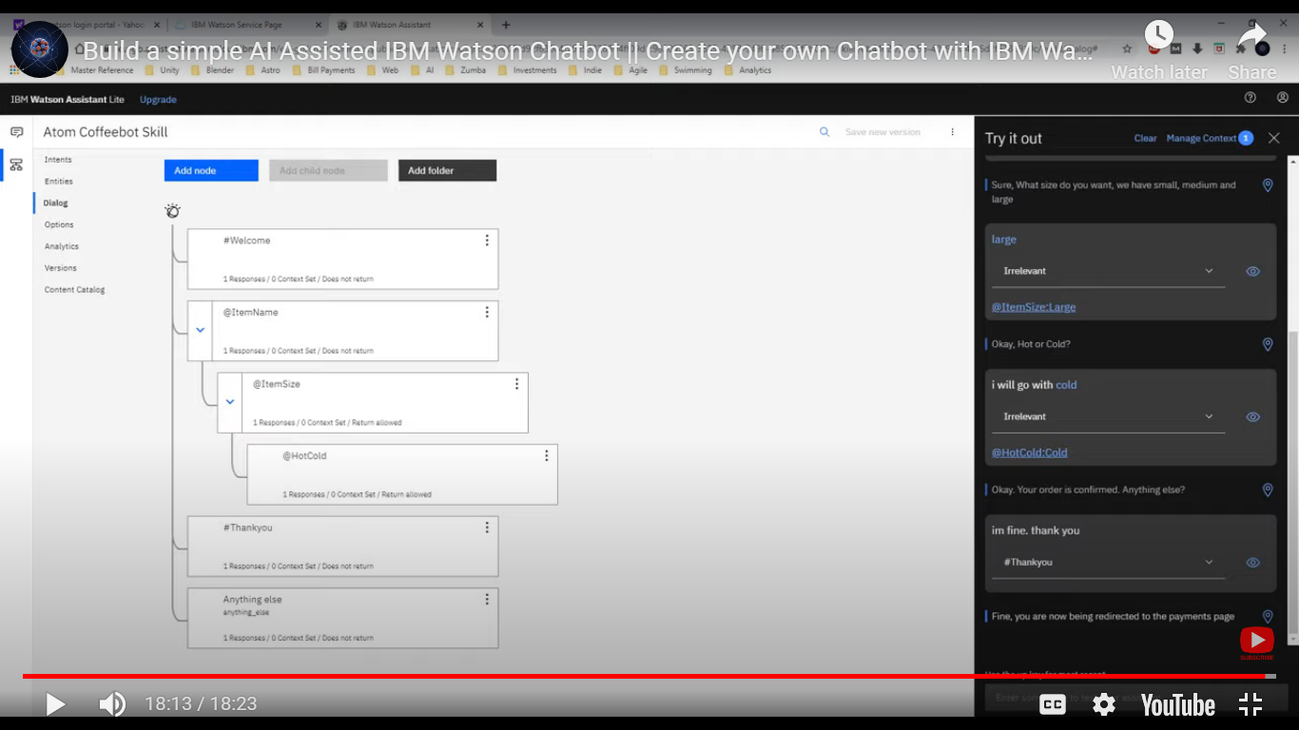

1. That's a basic overview of how to build a chatbot using IBM Cloud Watson Assistant. You can explore more advanced features like entity extraction, integration with databases, and using external APIs to enhance your chatbot's capabilities.