GET DATA
/TYPE=XLS
/FILE='D:\Data Science\stats\employee_satisfaction_survey_114.xls'
/SHEET=name 'Sheet2'
/CELLRANGE=full
/READNAMES=on
/ASSUMEDSTRWIDTH=32767.

GET DATA
/TYPE=XLS
/FILE='D:\Data Science\stats\employee_satisfaction_survey_114.xls'
/SHEET=name 'Sheet1'
/CELLRANGE=full
/READNAMES=on
/ASSUMEDSTRWIDTH=32767.
EXECUTE.
DATASET NAME DataSet3 WINDOW=FRONT.
CLUSTER Iamseekingforoverseasjobopportunities IwantajobwhereIcantakeupmanagerialorleadershiproles Iwanttoberecognisedformytalents Idon’tliketotravelalot Myjobshouldallowmetolearnnewthings Prestigestatusofjobisveryimportant
Ineedajobwhichgivesmesufficienttimetospendwithmyfam Imwillingtoworkinastartup Myjobshouldhaveflexibleworkinghoursandmoreholidays
/METHOD BAVERAGE
/MEASURE=SEUCLID
/PRINT SCHEDULE
/PLOT DENDROGRAM VICICLE.

Cluster

Notes
Output Created |  | 01-MAR-2018 06:24:41
Comments
Input | Active Dataset | DataSet3
Input | Filter | <none>
Input | Weight | <none>
Input | Split File | <none>
Input | N of Rows in Working Data File | 25
Missing Value Handling | Definition of Missing | User-defined missing values are treated as missing.
Missing Value Handling | Cases Used | Statistics are based on cases with no missing values for any variable used.
Syntax |  | CLUSTER Iamseekingforoverseasjobopportunities IwantajobwhereIcantakeupmanagerialorleadershiproles Iwanttoberecognisedformytalents Idon’tliketotravelalot Myjobshouldallowmetolearnnewthings Prestigestatusofjobisveryimportant  Ineedajobwhichgivesmesufficienttimetospendwithmyfam Imwillingtoworkinastartup Myjobshouldhaveflexibleworkinghoursandmoreholidays  /METHOD BAVERAGE  /MEASURE=SEUCLID  /PRINT SCHEDULE  /PLOT DENDROGRAM VICICLE.
Resources | Processor Time | 00:00:01.56
Resources | Elapsed Time | 00:00:07.98

[DataSet3]

Case Processing Summary^{a,b}
Cases
Valid |  | Missing |  | Total
N | Percent | N | Percent | N | Percent
24 | 96.0 | 0 | 0.0 | 25 | 100.0

a. Squared Euclidean Distance used
b. Average Linkage (Between Groups)

Average Linkage (Between Groups)

Agglomeration Schedule
Stage | Cluster Combined |  | Coefficients | Stage Cluster First Appears |  | Next Stage
Stage | Cluster 1 | Cluster 2 | Coefficients | Cluster 1 | Cluster 2 | Next Stage
1 | 11 | 14 | 5.000 | 0 | 0 | 6
2 | 7 | 24 | 6.000 | 0 | 0 | 11
3 | 20 | 23 | 7.000 | 0 | 0 | 5
4 | 12 | 13 | 8.000 | 0 | 0 | 16
5 | 18 | 20 | 8.500 | 0 | 3 | 9
6 | 1 | 11 | 8.500 | 0 | 1 | 14
7 | 3 | 5 | 10.000 | 0 | 0 | 13
8 | 10 | 17 | 12.000 | 0 | 0 | 12
9 | 18 | 19 | 12.667 | 5 | 0 | 19
10 | 16 | 21 | 13.000 | 0 | 0 | 17
11 | 4 | 7 | 13.000 | 0 | 2 | 12
12 | 4 | 10 | 14.333 | 11 | 8 | 20
13 | 3 | 9 | 16.000 | 7 | 0 | 17
14 | 1 | 6 | 16.667 | 6 | 0 | 18
15 | 15 | 22 | 17.000 | 0 | 0 | 20
16 | 8 | 12 | 20.000 | 0 | 4 | 18
17 | 3 | 16 | 22.167 | 13 | 10 | 19
18 | 1 | 8 | 22.167 | 14 | 16 | 22
19 | 3 | 18 | 24.500 | 17 | 9 | 21
20 | 4 | 15 | 25.300 | 12 | 15 | 21
21 | 3 | 4 | 30.889 | 19 | 20 | 22
22 | 1 | 3 | 35.393 | 18 | 21 | 23
23 | 1 | 2 | 36.870 | 22 | 0 | 0

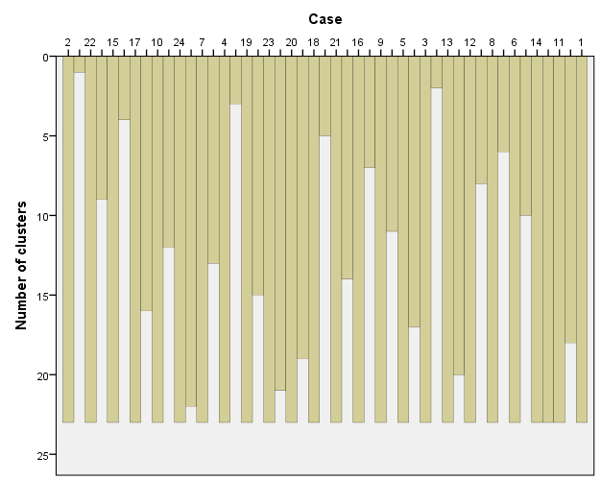

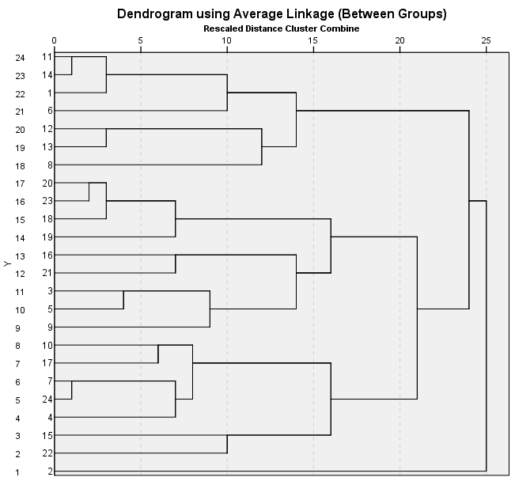

DATASET ACTIVATE DataSet2.
DATASET CLOSE DataSet1.
DATASET ACTIVATE DataSet3.
QUICK CLUSTER Iamseekingforoverseasjobopportunities IwantajobwhereIcantakeupmanagerialorleadershiproles Iwanttoberecognisedformytalents Idon’tliketotravelalot Myjobshouldallowmetolearnnewthings Prestigestatusofjobisveryimportant
Ineedajobwhichgivesmesufficienttimetospendwithmyfam Imwillingtoworkinastartup Myjobshouldhaveflexibleworkinghoursandmoreholidays
/MISSING=LISTWISE
/CRITERIA=CLUSTER(3) MXITER(10) CONVERGE(0)
/METHOD=KMEANS(NOUPDATE)
/SAVE CLUSTER DISTANCE
/PRINT INITIAL ANOVA CLUSTER DISTAN.

Quick Cluster

Notes
Output Created |  | 01-MAR-2018 06:31:05
Comments
Input | Active Dataset | DataSet3
Input | Filter | <none>
Input | Weight | <none>
Input | Split File | <none>
Input | N of Rows in Working Data File | 25
Missing Value Handling | Definition of Missing | User-defined missing values are treated as missing.
Missing Value Handling | Cases Used | Statistics are based on cases with no missing values for any clustering variable used.
Syntax |  | QUICK CLUSTER Iamseekingforoverseasjobopportunities IwantajobwhereIcantakeupmanagerialorleadershiproles Iwanttoberecognisedformytalents Idon’tliketotravelalot Myjobshouldallowmetolearnnewthings Prestigestatusofjobisveryimportant  Ineedajobwhichgivesmesufficienttimetospendwithmyfam Imwillingtoworkinastartup Myjobshouldhaveflexibleworkinghoursandmoreholidays  /MISSING=LISTWISE  /CRITERIA=CLUSTER(3) MXITER(10) CONVERGE(0)  /METHOD=KMEANS(NOUPDATE)  /SAVE CLUSTER DISTANCE  /PRINT INITIAL ANOVA CLUSTER DISTAN.
Resources | Processor Time | 00:00:00.00
Resources | Elapsed Time | 00:00:00.04
Resources | Workspace Required | 1912 bytes
Variables Created or Modified | QCL_1 | Cluster Number of Case
Variables Created or Modified | QCL_2 | Distance of Case from its Classification Cluster Center

[DataSet3]

Initial Cluster Centers
 | Cluster
 | 1 | 2 | 3
I am seeking for overseas job opportunities | 5 | 1 | 2
I want a job where I can take up managerial or leadership roles | 5 | 5 | 1
I want to be recognised for my talents | 4 | 5 | 5
I don’t like to travel a lot | 1 | 3 | 5
My job should allow me to learn new things | 4 | 5 | 3
Prestige & status of job is very important | 4 | 5 | 3
I need a job which gives me sufficient time to spend with my family | 4 | 2 | 5
I'm willing to work in a start-up | 5 | 1 | 4
My job should have flexible working hours and more holidays | 2 | 3 | 4

Iteration Historyª
Iteration | Change in Cluster Centers
Iteration | 1 | 2 | 3
1 | 2.611 | 2.398 | 2.988
2 | .361 | .000 | .414
3 | .000 | .000 | .000

a. Convergence achieved due to no or small change in cluster centers. The maximum absolute coordinate change for any center is .000. The current iteration is 3. The minimum distance between initial centers is 6.633.

Cluster Membership
Case Number | Cluster | Distance
1 | 1 | 3.524
2 | 2 | 2.398
3 | 3 | 2.468
4 | 1 | 3.476
5 | 3 | 3.048
6 | 1 | 3.547
7 | 1 | 2.723
8 | 1 | 3.905
9 | 3 | 3.360
10 | 1 | 3.731
11 | 1 | 3.403
12 | 2 | 2.398
13 | 3 | 3.780
14 | 1 | 3.096
15 | 1 | 3.969
16 | 3 | 3.727
17 | 1 | 2.021
18 | 3 | 1.972
19 | 3 | 3.534
20 | 3 | 2.809
21 | 3 | 3.534
22 | 1 | 4.193
23 | 3 | 2.548
24 | 1 | 2.598
 |  | .

Final Cluster Centers
 | Cluster
 | 1 | 2 | 3
I am seeking for overseas job opportunities | 4 | 1 | 3
I want a job where I can take up managerial or leadership roles | 4 | 4 | 3
I want to be recognised for my talents | 4 | 4 | 4
I don’t like to travel a lot | 2 | 3 | 4
My job should allow me to learn new things | 4 | 5 | 4
Prestige & status of job is very important | 4 | 4 | 4
I need a job which gives me sufficient time to spend with my family | 4 | 3 | 4
I'm willing to work in a start-up | 4 | 1 | 4
My job should have flexible working hours and more holidays | 3 | 4 | 5

Distances between Final Cluster Centers
Cluster | 1 | 2 | 3
1 |  | 4.340 | 3.548
2 | 4.340 |  | 4.212
3 | 3.548 | 4.212

ANOVA
 | Cluster |  | Error |  | F
 | Mean Square | Df | Mean Square | df | F
I am seeking for overseas job opportunities | 11.342 | 2 | 1.007 | 21 | 11.261
I want a job where I can take up managerial or leadership roles | 2.383 | 2 | 2.337 | 21 | 1.020
I want to be recognised for my talents | .029 | 2 | .694 | 21 | .042
I don’t like to travel a lot | 19.929 | 2 | .910 | 21 | 21.912
My job should allow me to learn new things | 3.208 | 2 | .925 | 21 | 3.470
Prestige & status of job is very important | .342 | 2 | 1.039 | 21 | .329
I need a job which gives me sufficient time to spend with my family | .554 | 2 | 1.453 | 21 | .381
I'm willing to work in a start-up | 5.967 | 2 | 2.162 | 21 | 2.760
My job should have flexible working hours and more holidays | 4.529 | 2 | 1.313 | 21 | 3.450

ANOVA
 | Sig.
I am seeking for overseas job opportunities | .001
I want a job where I can take up managerial or leadership roles | .378
I want to be recognised for my talents | .959
I don’t like to travel a lot | .000
My job should allow me to learn new things | .050
Prestige & status of job is very important | .723
I need a job which gives me sufficient time to spend with my family | .688
I'm willing to work in a start-up | .086
My job should have flexible working hours and more holidays | .051

The F tests should be used only for descriptive purposes because the clusters have been chosen to maximize the differences among cases in different clusters. The observed significance levels are not corrected for this and thus cannot be interpreted as tests of the hypothesis that the cluster means are equal.

Number of Cases in each Cluster
Cluster | 1 | 12.000
Cluster | 2 | 2.000
Cluster | 3 | 10.000
Valid |  | 24.000

Interpretation of the clusters :
Cluster 1 : Shows people who are willing to travel and are seeking overseas opportunities. They are also willing to take up leadership roles.

Cluster 2 : Shows people who are willing to learn new things and are interested in taking up managerial roles.
Cluster 3 : Shows people who are willing to work in start ups. They are not inclined towards status and prestige of the job. They are eager to learn new things.

