FACTOR
/VARIABLES ageBlack ageHispanic ageAsian MedianAge Unemploymentrate Percapitaincome000s
/MISSING LISTWISE
/ANALYSIS ageBlack ageHispanic ageAsian MedianAge Unemploymentrate Percapitaincome000s
/PRINT INITIAL KMO AIC EXTRACTION ROTATION
/PLOT EIGEN ROTATION
/CRITERIA MINEIGEN(1) ITERATE(25)
/EXTRACTION PC
/CRITERIA ITERATE(25)
/ROTATION VARIMAX
/METHOD=CORRELATION.

Factor Analysis

Notes
Output Created |  | 20-APR-2018 09:23:21
Comments
Input | Active Dataset | DataSet1
Input | Filter | <none>
Input | Weight | <none>
Input | Split File | <none>
Input | N of Rows in Working Data File | 49
Missing Value Handling | Definition of Missing | MISSING=EXCLUDE: User-defined missing values are treated as missing.
Missing Value Handling | Cases Used | LISTWISE: Statistics are based on cases with no missing values for any variable used.
Syntax |  | FACTOR  /VARIABLES ageBlack ageHispanic ageAsian MedianAge Unemploymentrate Percapitaincome000s  /MISSING LISTWISE  /ANALYSIS ageBlack ageHispanic ageAsian MedianAge Unemploymentrate Percapitaincome000s  /PRINT INITIAL KMO AIC EXTRACTION ROTATION  /PLOT EIGEN ROTATION  /CRITERIA MINEIGEN(1) ITERATE(25)  /EXTRACTION PC  /CRITERIA ITERATE(25)  /ROTATION VARIMAX  /METHOD=CORRELATION.
Resources | Processor Time | 00:00:00.37
Resources | Elapsed Time | 00:00:00.34
Resources | Maximum Memory Required | 5544 (5.414K) bytes

[DataSet1]

Significance of KMO & Barlett test
- The Kaiser-Meyer Olkin (KMO) and Bartlett's Test measure of sampling adequacy was used to examine the appropriateness of Factor Analysis.
- KMO should be between 0 & 1.We have 0.445 which is significant.
- Barlett Test significance should be <0.05.We have sig. 0.00.

KMO and Bartlett's Test
Kaiser-Meyer-Olkin Measure of Sampling Adequacy. |  | .445
Bartlett's Test of Sphericity | Approx. Chi-Square | 64.271
Bartlett's Test of Sphericity | df | 15
Bartlett's Test of Sphericity | Sig. | .000

Covvariance and correlation matrices are obtained here.
Anti-image Matrices
 |  | ageBlack | ageHispanic | ageAsian | MedianAge
Anti-image Covariance | ageBlack | .506 | .288 | .228 | .018
Anti-image Covariance | ageHispanic | .288 | .525 | .055 | .077
Anti-image Covariance | ageAsian | .228 | .055 | .667 | -.153
Anti-image Covariance | MedianAge | .018 | .077 | -.153 | .712
Anti-image Covariance | Unemploymentrate | -.301 | -.316 | -.105 | -.030
Anti-image Covariance | Percapitaincome000s | -.063 | .100 | -.194 | -.234
Anti-image Correlation | ageBlack | .326ª | .559 | .393 | .030
Anti-image Correlation | ageHispanic | .559 | .381ª | .094 | .125
Anti-image Correlation | ageAsian | .393 | .094 | .539ª | -.221
Anti-image Correlation | MedianAge | .030 | .125 | -.221 | .694ª
Anti-image Correlation | Unemploymentrate | -.542 | -.559 | -.164 | -.045
Anti-image Correlation | Percapitaincome000s | -.109 | .169 | -.292 | -.342

Anti-image Matrices
 |  | Unemploymentrate | Percapitaincome000s
Anti-image Covariance | ageBlack | -.301 | -.063
Anti-image Covariance | ageHispanic | -.316 | .100
Anti-image Covariance | ageAsian | -.105 | -.194
Anti-image Covariance | MedianAge | -.030 | -.234
Anti-image Covariance | Unemploymentrate | .611 | -.026
Anti-image Covariance | Percapitaincome000s | -.026 | .660
Anti-image Correlation | ageBlack | -.542ª | -.109
Anti-image Correlation | ageHispanic | -.559 | .169ª
Anti-image Correlation | ageAsian | -.164 | -.292
Anti-image Correlation | MedianAge | -.045 | -.342
Anti-image Correlation | Unemploymentrate | .249 | -.042
Anti-image Correlation | Percapitaincome000s | -.042 | .660

- Measures of Sampling Adequacy(MSA)

Highlighted factors have higher influence on the analysis compared to others.

Communalities
 | Initial | Extraction
AgeBlack | 1.000 | .891
AgeHispanic | 1.000 | .854
AgeAsian | 1.000 | .718
MedianAge | 1.000 | .641
Unemploymentrate | 1.000 | .927
Percapitaincome000s | 1.000 | .696

Extraction Method: Principal Component Analysis.

Eigen values greater than 1 are considered as important factors

Total Variance Explained
Component | Initial Eigenvalues |  |  | Extraction Sums of Squared Loadings
Component | Total | % of Variance | Cumulative % | Total | % of Variance
1 | 1.943 | 32.391 | 32.391 | 1.943 | 32.391
2 | 1.524 | 25.393 | 57.784 | 1.524 | 25.393
3 | 1.260 | 21.004 | 78.788 | 1.260 | 21.004
4 | .550 | 9.173 | 87.961
5 | .476 | 7.928 | 95.888
6 | .247 | 4.112 | 100.000

Total Variance Explained
Component | Extraction Sums of Squared Loadings | Rotation Sums of Squared Loadings
Component | Cumulative % | Total | % of Variance | Cumulative %
1 | 32.391 | 1.888 | 31.464 | 31.464
2 | 57.784 | 1.535 | 25.582 | 57.046
3 | 78.788 | 1.304 | 21.742 | 78.788
4
5
6

Extraction Method: Principal Component Analysis.

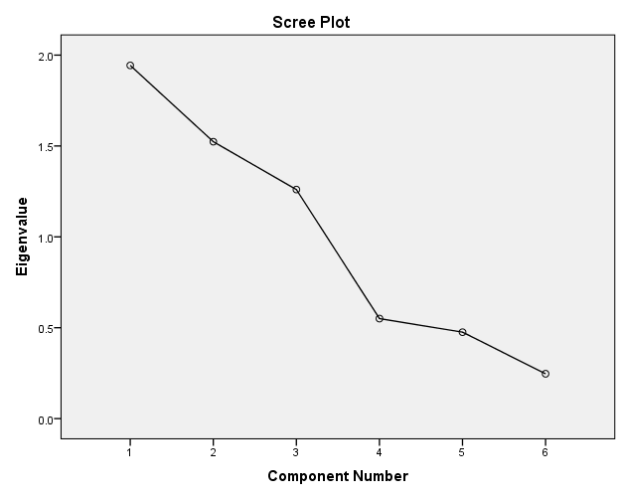

Component Matrixª
 | Component
 | 1 | 2 | 3
AgeBlack | .094 | -.901 | .265
AgeHispanic | -.536 | .587 | .472
AgeAsian | .598 | .576 | .169
MedianAge | .778 | .097 | .162
Unemploymentrate | -.157 | -.151 | .938
Percapitaincome000s | .813 | -.054 | .182

Extraction Method: Principal Component Analysis.ª
a. 3 components extracted.

Rotated Component Matrixª
 | Component
 | 1 | 2 | 3
AgeBlack | -.013 | .920 | .210
AgeHispanic | -.285 | -.636 | .607
AgeAsian | .718 | -.450 | .026
MedianAge | .798 | .051 | -.038
Unemploymentrate | .052 | .187 | .943
Percapitaincome000s | .808 | .207 | -.032

Extraction Method: Principal Component Analysis.
Rotation Method: Varimax with Kaiser Normalization.ª
a. Rotation converged in 4 iterations.

Component Transformation Matrix
Component | 1 | 2 | 3
1 | .951 | .174 | -.254
2 | .186 | -.982 | .025
3 | .245 | .071 | .967

Extraction Method: Principal Component Analysis.
Rotation Method: Varimax with Kaiser Normalization.

Conclusion:
- Using SPSS factor analysis procedure for extracting principal components reveals that there are 3 important components.
- Median Age,Unemployment Rate & Per Capita Income.

- 