DESCRIPTION
Heaven Classics successfully creates an EC2 Server Instance for Windows 2012 Server. After launching the instance on the server, the next step was to monitor the operations.
Monitoring is important to keep an eye on the performance of an EC2 instance. It helps gather data from all parts and is useful for debugging failure.
The monitoring team at Heaven Classics started monitoring activities using the CloudWatch Service in the AWS Management Console. The Heaven Classics support team were required to meet the following objectives:
- Check and observe the CPU utilization graph for the EC2 instance
- Create and configure a CloudWatch alarm that sends an email notification to HCMonitor@HeavenClassics.com if the CPU utilization goes below the threshold of 3%, consecutively three times for five minutes
- Create an IAM group named Administrator Group and attach the full administrator access policy to the group
- Create a user for an employee of the company who requires administrator access to the company's AWS account, and then add the user to the Administrator Group

- Check and observe the CPU utilization graph for the EC2 instance

Monitoring is an important part of maintaining the reliability, availability, and performance of your Amazon Elastic Compute Cloud (Amazon EC2) instances. The Amazon EC2 console displays a series of graphs based on the raw data from Amazon CloudWatch
To observe the CPU utilization graph for EC2 instance after launching EC2 instance go to monitoring section which is appear after selecting EC2. We can change utilization period which provide more clarity in observation. The blue dot at the bottom of the graph provides details information about EC2CPUutilization.
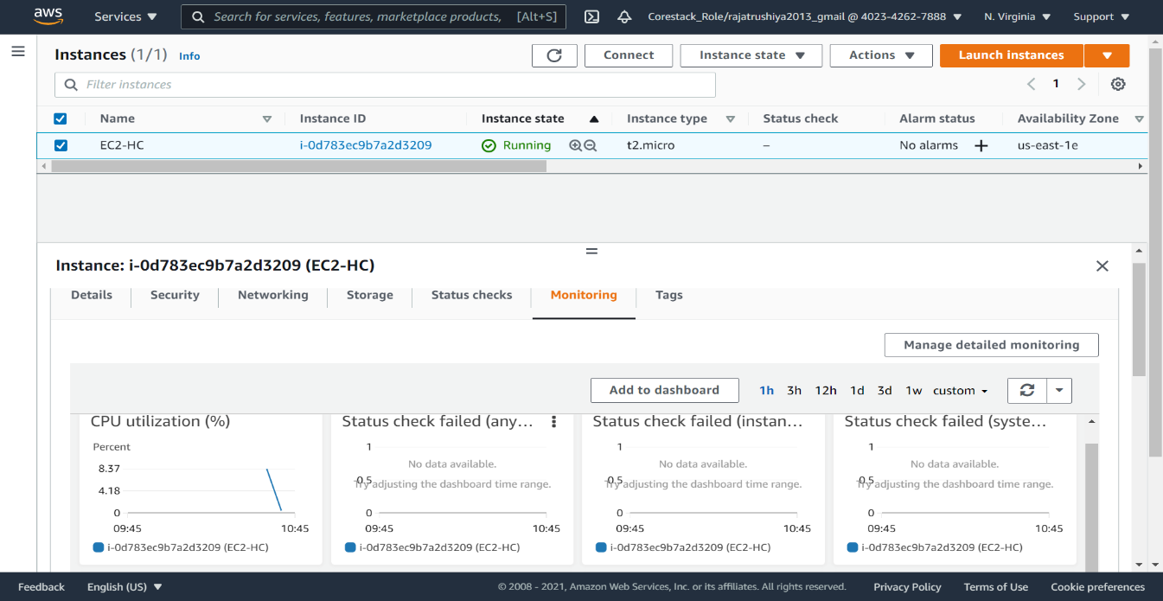
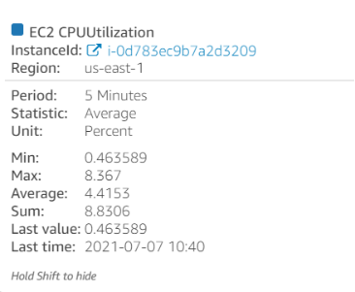
Amazon EC2 sends metrics to Amazon CloudWatch.
By default, each data point covers the 5 minutes that follow the start time of activity for the instance

- Create and configure a CloudWatch alarm that sends an email notification to HCMonitor@HeavenClassics.com if the CPU utilization goes below the threshold of 3%, consecutively three times for five minutes

Amazon CloudWatch monitor Amazon Web Services (AWS) resources and the applications you run on AWS in real time. The CloudWatch home page automatically displays metrics about every AWS service you use. You can additionally create custom dashboards to display metrics about your custom applications, and display custom collections of metrics that you choose.
You can create an CloudWatch alarm that sends a notification using Amazon SNS when the alarm changes state from OK to ALARM. The alarm changes to the ALARM state when the average CPU use of an EC2 instance exceeds a specified threshold for consecutive specified periods.
to create an alarm based on CPU usage
- Open the CloudWatch console which is present inside “Management & Governance”.
- In the navigation pane, choose Alarms, Create Alarm.
- Choose Select metric.
- In the All-metrics tab, choose EC2 metrics.
- Choose a metric category (for example, Per-Instance Metrics).
- Find the row with the instance that you want listed in the Instanced column and CPUUtilization in the Metric Name column. Select the check box next to this row, and choose Select metric.
- Under Specify metric and conditions keep the default conditions.
- Choose a period 5 minutes.
- Under Conditions, specify the following:
  - For Threshold type, choose Static.
  - For Whenever CPUUtilization is, specify less then i.e select the check box of Lower
  - For threshold value put 3
- Choose Next.
- Under Notification, choose in alarm and select an SNS topic to notify when the alarm is in ALARM state.
In case if SNS topic is not created before you can choose create new topic name the topic and provide email information as HCMonitor@HeavenClassics.com and select Add notification
- When finished, choose Next.
- Enter a name EC2CPUutilization-alaram for the alarm. The name must contain only ASCII characters. And add description in description section. Then choose Next.
- Under Preview and create, confirm that the information and conditions are what you want, then choose Create alarm.
- To satisfy the condition of consecutive three time for five minutes.
  - Go to Ec2 instance and click on plus sing (+) of alarm column.
  - In Manage CloudWatch alarms select Edit an alarm. In search for alarm, you can find your created alarm.
  - In Alarm Notification you find your created notification
  - In Alarm thresholds we can change Consecutive periods from default 1 to 3.
  - Now click on Update.

3.Create an IAM group named Administrator Group and attach the full administrator access policy to the group

AWS Identity and Access Management (IAM) is a web service that helps you securely control access to AWS resources. You use IAM to control who is authenticated (signed in) and authorized (has permissions) to use resources.
Creating an administrator IAM Group
  - Search for IAM in services it is present in Security, Identity & Compliance
  - From Access management or from IAM resources (present on dashboard of IAM) select user group.
  - choose create group.
  - Now name the group Administrator.
  - In attach permission policy section search for full administrator access policy. Attach it by selecting the check box next to this policy.
  - Now click on create group.

4.Create a user for an employee of the company who requires administrator access to the company's AWS account, and then add the user to the Administrator Group

For greater security and organization, you can give access to your AWS account to specific users—identities that you create with custom permissions. IAM users are not separate accounts; they are users within your account. Each user can have its own password for access to the AWS Management Console. You can limit the services by assigning it through the policy separately of with group at which user added.

Creating a user for an employee
  - Select users from IAM console.
  - Now select Add users.
  - Set user details name of employee.
  - In Console password you have both the option either you can choose password by your choice by selecting custom password or AWS can automatically generate password for IAM user by selecting Autogenerated password.
  - Now click on Next Permission.
  - Here Add to group select created group.
  - Select Next: Tag.
  - In tag section provided require tags.
  - Now select Next: Review.
  - Select create user

