



***PROJECT REPORT ON***

**Under Supervision-**

**Santu Purkait**

**(Director)**

**Netcamp Solutions Private Limited**

**9331090003**

[**santu@netcamp.in**](mailto:santu@netcamp.in)

[**www.netcamp.in**](http://www.netcamp.in)

***Computer Networking***



***SUBMITTED BY-***

***RAJAT SHARMA***

RAJ KUMAR GOEL INSTITUTE OF TECHNOLOGY , GHAZIABAD

*Acknowledgement*

*I would like to express my gratitude and appreciation to all those who gave me the possibility to complete this report.*

*A special thanks to my Mentor Mr. Santu Purkait, Director of Netcamp Private Solutions Limited , who has given his full effort in guiding me in achieving the goal as well as his encouragement to maintain our progress in track.*

*I would also like to acknowledge with much appreciation the crucial role of the HOD Sir and the Staff of the I.T. Department , whose help, stimulating suggestions and encouragement helped me to complete my project.*

*I also thanks the Director of Raj Kumar Goel Institute Of Technology, Dr. R. Somashekar for providing me the opportunity to embark on this project.*

Name : Rajat Sharma

University Roll No : 1703313049

College : Raj Kumar Goel Institute Of Technology , Ghaziabad

Date : 01-May-2020 to 30-June-2020

Signature :

*Netcamp Solutions Private Limited*



Certificate

*This is certify that ,* ***Rajat Sharma*** *, a student of program,* ***Android***

***With Java Program*** *has successfully completed a project on*

*Network Management under the guidance of* ***Mr. Santu Purkait***

*during the Dates : 01-May-2020 to 30-June-2020 by* ***Netcamp***

***Solutions Private Limited.***

***What is Networking ?***

Networking refers to the total process of creating and using computer networks, with respect to hardware, protocols and software, including wired and wireless technology. It involves the application of theories from different technological fields, like IT, computer science and computer/electrical engineering.

***What is Computer Network ?***

Computer networking is an engineering discipline that aims to study and analyze the communication process among various computing devices or computer systems that are linked, or networked, together to exchange information and share resources.

Computer networking depends on the theoretical application and practical implementation of fields like computer engineering, computer sciences, information technology and telecommunication.

**In this report file I will explain a networking project that how I implement it on the web server and how it is connected . It is simple project on basic networking.**

**Pre-requisite of this Project : Basic knowledge of linux and networking like ip addressing , working of mail server , DNS , Web server , file-Sharing among operating system.**

**In this project I use Linux server (on virtual machine) , Windows Xp.**

**\**From that Linux server we make two separate server (192.168.1.200) and (192.168.1.250) for the configuration. To run the project on Windows Xp you should set DNS and IP address manully.***

First of all we create one web server , DNS server and mail server for the same. We will provide a dhcp server to the mail server and implement samba on the mail server so that it can be accessed from a window machine. After that we create partition and give quota which is only accessed by the chairman and at last apply firewall on the whole according to the need.

***Let’s Start the Project !!***

***Web Server :***

A Web server is a program that uses HTTP (Hypertext Transfer Protocol) to serve the files that form Web pages to users, in response to their requests, which are forwarded by their computers' HTTP clients. Dedicated computers and appliances may be referred to as Web servers as well.

The primary function of a web server is to store, process and deliver [web pages](https://www.bing.com/search?q=Web%20page%20wikipedia&form=WIKIRE) to clients. The communication between client and server takes place using the [Hypertext Transfer Protocol (HTTP)](https://www.bing.com/search?q=Hypertext%20Transfer%20Protocol%20wikipedia&form=WIKIRE). Pages delivered are most frequently [HTML documents](https://www.bing.com/search?q=HTML%20wikipedia&form=WIKIRE), which may include [images](https://www.bing.com/search?q=Image%20wikipedia&form=WIKIRE), [style sheets](https://www.bing.com/search?q=Style%20sheet%20(web%20development)%20wikipedia&form=WIKIRE) and [scripts](https://www.bing.com/search?q=JavaScript%20wikipedia&form=WIKIRE) in addition to the text content.

Now to make web server , we go to webmin of the Linux server 192.168.1.200 by using command on the google chrome “ http://192.168.1.200:10000 ” then login with root.

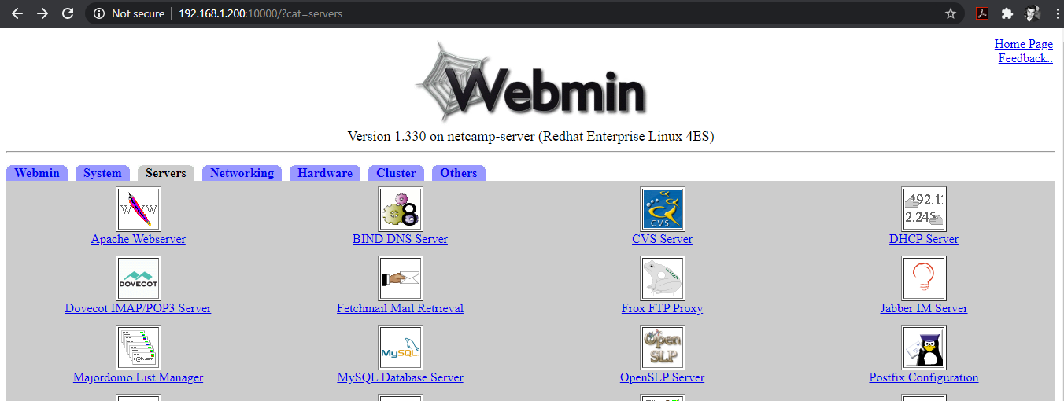

Similarly , login to 192.168.1.250 using the same command.

**DNS ( *Domain Name Server* ) :**

The Domain Name System (DNS) is the **phonebook of the Internet**.

Humans access information online through domain names, like apple.com , google.com etc. Web browsers interact through Internet Protocol (IP) addresses. DNS translates domain names to IP addresses so browsers can load Internet resources.

In simple terms, a **Domain Name System** (**DNS**) is a collection of databases that translate hostnames to IP addresses.

How to Create DNS Server-

Go to server 🡪 Bind DNS Server 🡪 Create Master Zone

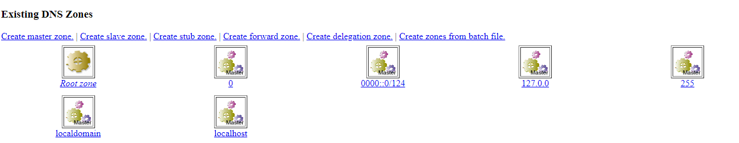

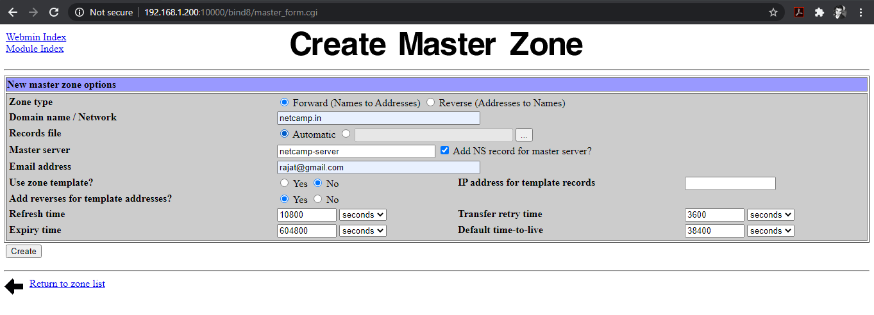

Click on the Create Button and master zone is created.

Similarly create in 192.168.1.250

Now, we have to create subdomains for this netcamp.in. in 192.168.1.200 .Click on the netcamp.in server in the master zone which we have created earlier then click on the address.

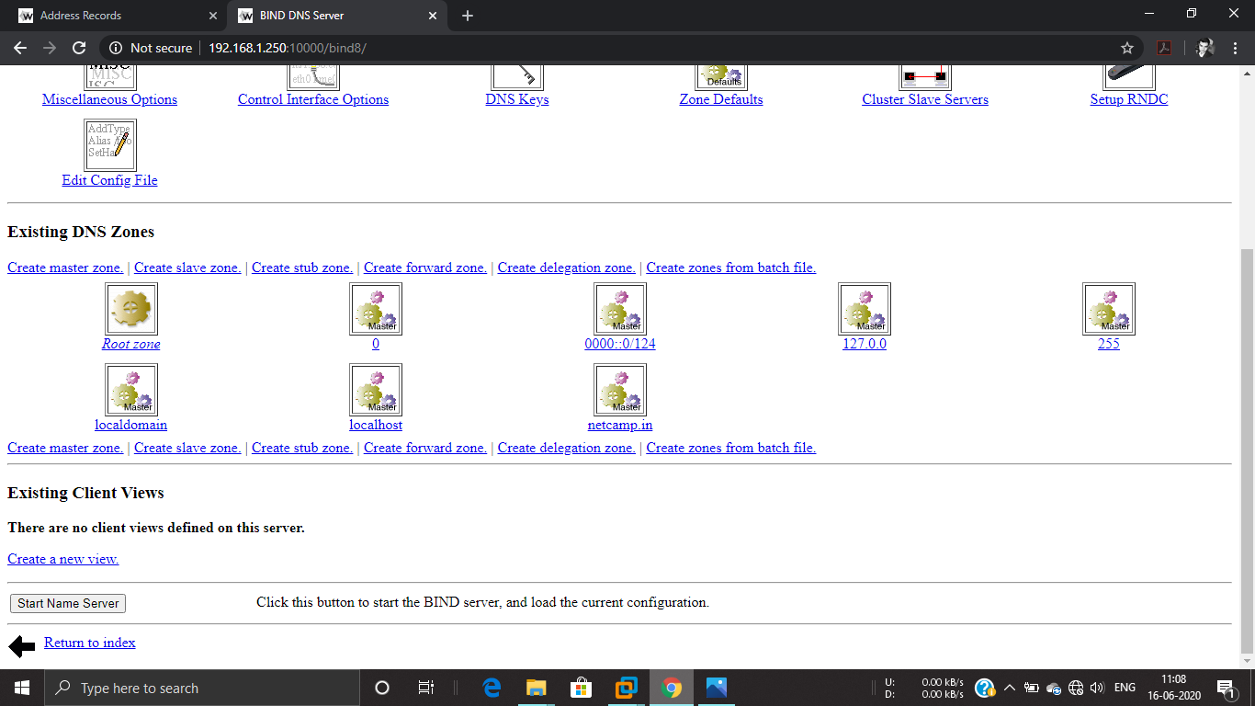

**Add address record:** How ?? (See the example)

Name:

Address: 192.168.1.200 (Click on create button)

Name: www

Address: 192.168.1.200 (Click on create button) //Similarly others

Name: mail

Address: 192.168.1.250 (Click on the create button,remember the ip is different in mail)

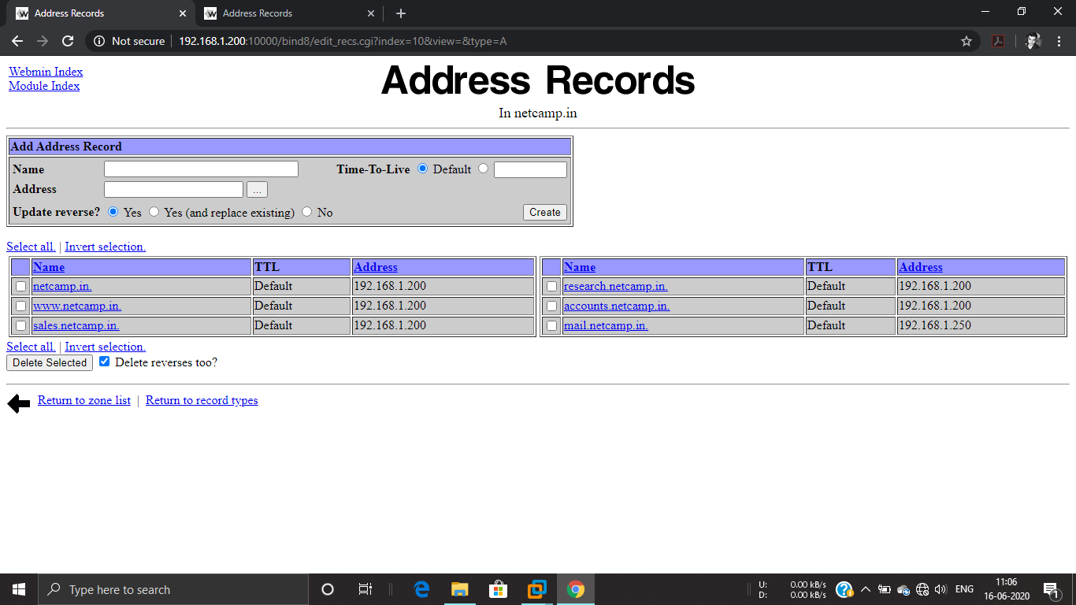

Return back 🡪 Start name Server 🡪 Apply Changes

Now, the webserver and DNS Server are created. Hence , we have to host these server.

To host these server we have to create web page / index page for each server in the linux server.

In linux server of 192.168.1.200 , login with root , make index page for other webservers except mail server .

The commands are here -

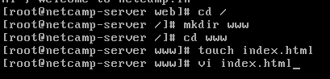

Create separate web pages for every server , the process is same.

When the index file is created come to webmin and start Apache Server. How??

In 192.168.1.200 -

Webmin 🡪 Servers 🡪 Apache Server 🡪 Create a virtual server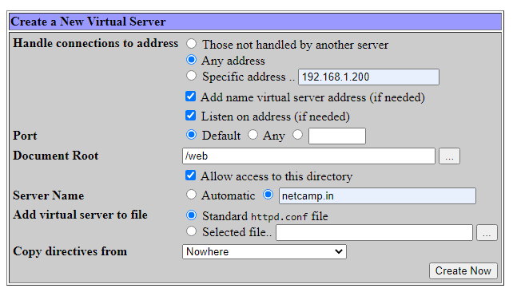

Similarly , create server for every domain which we have created earlier.

Create Now 🡪 Start Apache Server 🡪 Apply Changes

After creating the apache server check your webserver whether it is hosted or not.

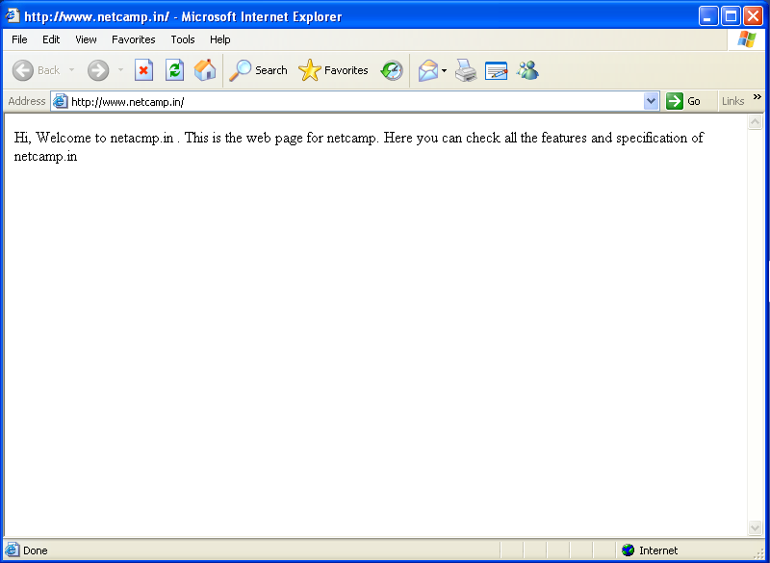

Now , we have to create a mail server for netcamp.in which will provide email service for the company.

***Mail Server :***

A mail server (sometimes also referred to an e-mail server) is a server that handles and delivers e-mail over a network, usually over the Internet. A mail server can receive e-mails from client computers and deliver them to other mail servers. A mail server can also deliver e-mails to client computers. A client computer is normally the computer where you read your e-mails, for example your computer at home or in your office. Also an advanced mobile phone or Smartphone, with e-mail capabilities, can be regarded as a client computer in these circumstances.

How to create Mail Server ??

First we have to create a DNS server for the mail. For web server and DNS server repeat the above step in 192.168.1.250.

It looks like this –

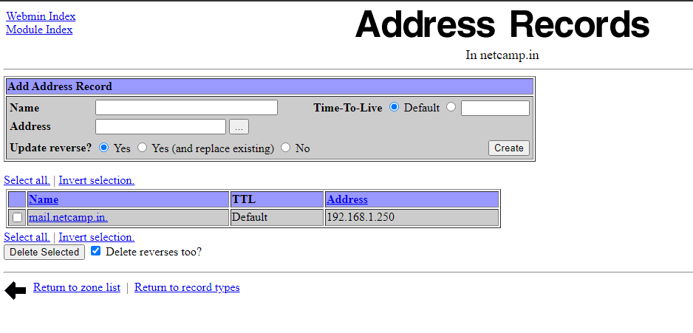

The DNS Server for mail is created then we work on mail server and create a mail server for netcamp.in .

Follow these steps carefully to make mail server.

**First Step :**

Webmin 🡪 Bind DNS Server 🡪 netcamp.in 🡪 Mail Server

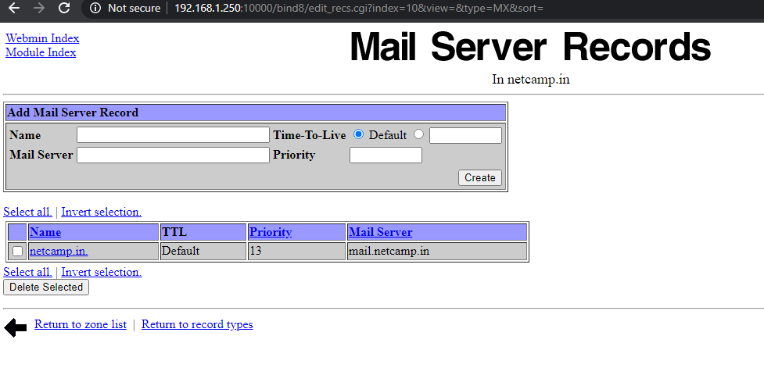

Fill the box with the given information and create the mail server then apply changes.

**Second Step:**

192.168.1.250 🡪 Webmin 🡪 Networking 🡪 Network Configuration 🡪 Host address

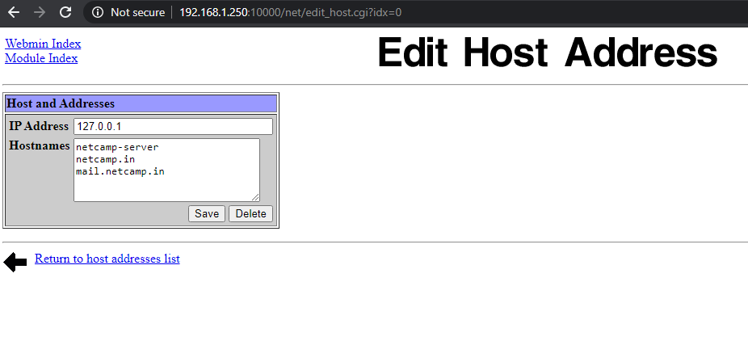

Save and apply configuration.

**Third Step :**

Servers 🡪 Apache Servers

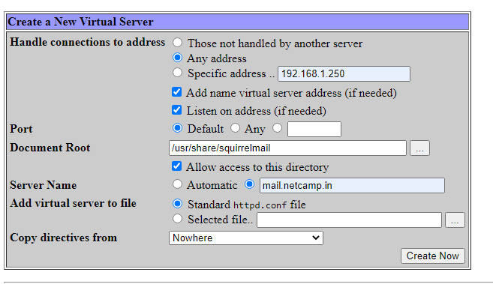

Create 🡪 Start Apache Server 🡪 Apply Changes

**Fourth Step :**

Servers 🡪 Send Mail Configuration 🡪 Send Mail Option

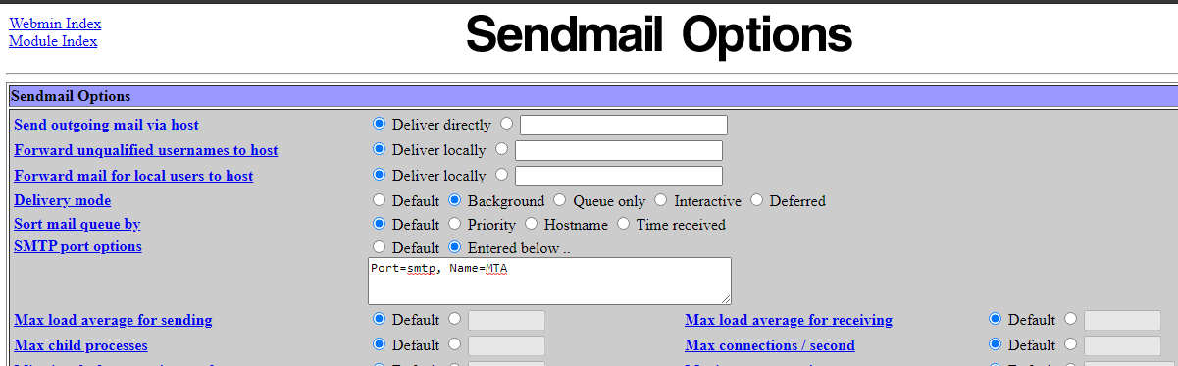

Save and apply.

**Fifth Step :**

Servers 🡪 Send Mail Configuration 🡪 Local domain (at the top)

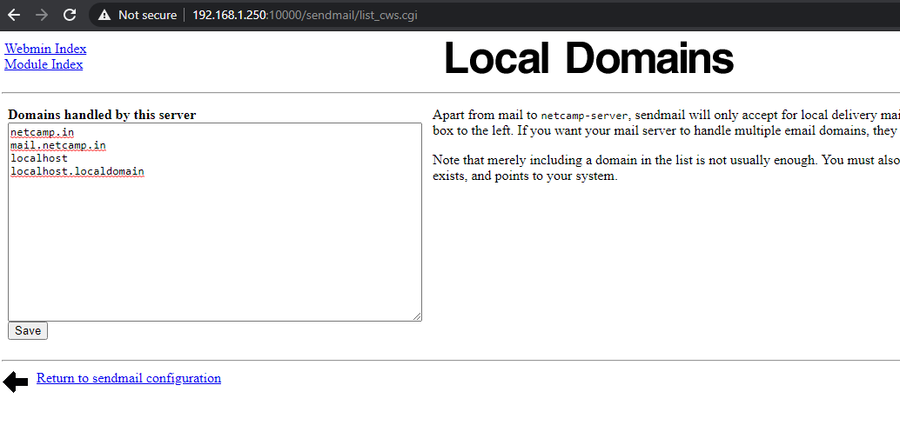

Save then start Send Mail.

**Sixth Step :**

Servers 🡪 Dovecot IMAP/POP3 Server 🡪 Networking and Protocol

Select all the servers and then start the server.

When the mail server is created go to browser and search for mail.netcamp.in if the mail server is created successfully then it looks like the below -

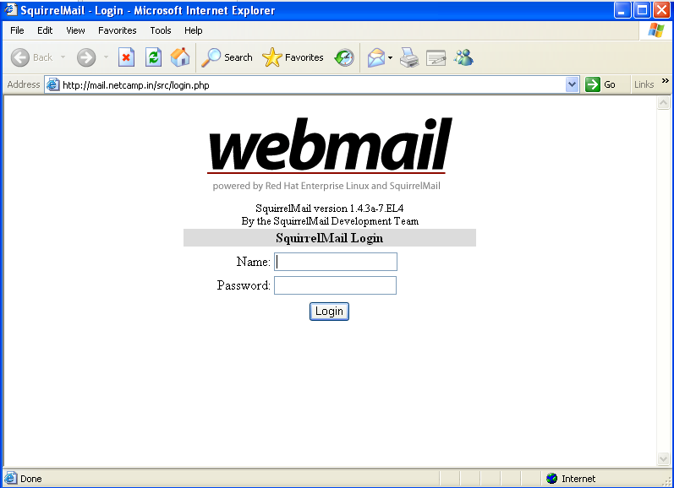

Now the mail server is created . Now who login in this mail server ?? Let’s we create some user in netcamp company who can login in this mail server

These users are like Sales , Accounts , RandD and also set permission for every user that how much information he/she will use or change. You can add the user in the server and from those user you can login in the mail server using same username and password.

Like hereby I add a user RAJAT and gives its password , by this username and password I login in the mail server .

Go to server 192.168.1.250 , and follow steps carefully –

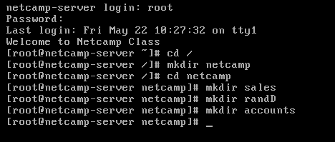

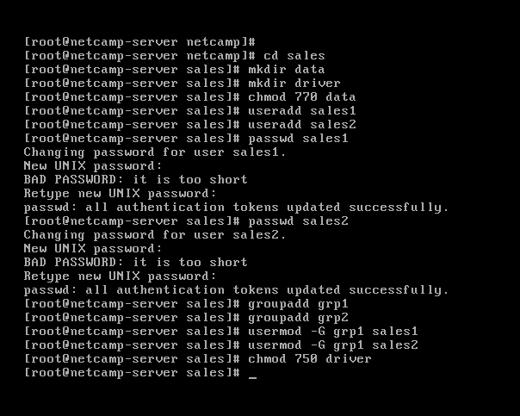

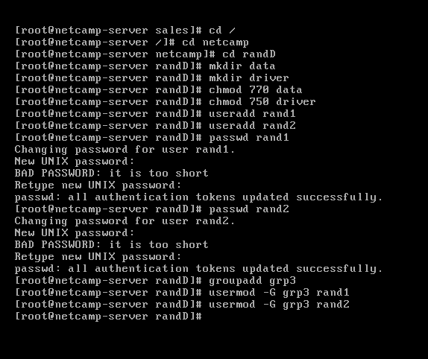

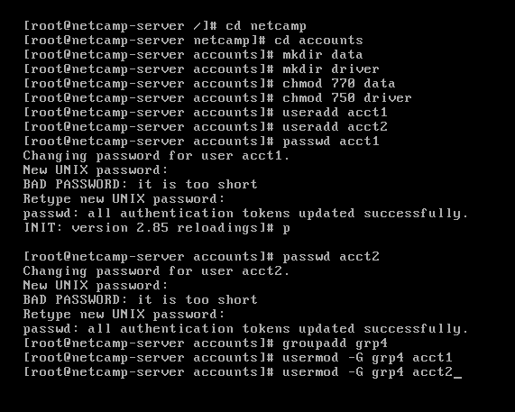

Add main user of the company like here is “RAJAT” set password for them and change permission for the owner for every folder regarding to your use.

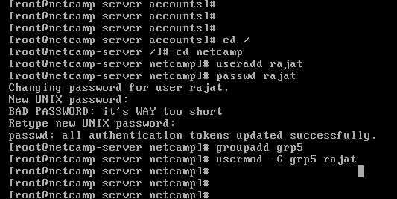

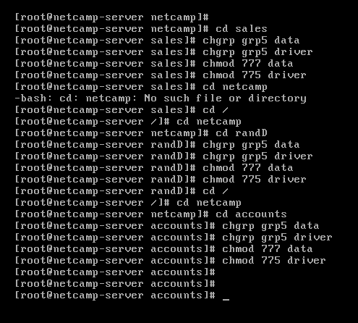

***DHCP (Dynamic Host Configuration Protocol) :***

DHCP (Dynamic Host Configuration Protocol) is a protocol that provides quick, automatic, and central management for the distribution of [IP addresses](https://www.lifewire.com/what-is-an-ip-address-2625920) within a network. DHCP is also used to configure the [subnet mask](https://www.lifewire.com/internet-protocol-tutorial-subnets-818378), default gateway, and [DNS server](https://www.lifewire.com/what-is-a-dns-server-2625854) information on the device.

On a home network, DHCP can be set up by purchasing a home router, [wireless](https://www.computerhope.com/jargon/w/wireless.htm) router, or switch with [NAT](https://www.computerhope.com/jargon/n/nat.htm)/DHCP and connecting each computer to it. If the network has a [firewall](https://www.computerhope.com/jargon/f/firewall.htm), ports 67 and 68 need to be open for devices to function properly.

**How DHCP works ?**

A DHCP server issues unique IP addresses and automatically configures other network information. In most homes and small businesses, the [router](https://www.lifewire.com/what-is-a-router-2618162) acts as the DHCP server. In large networks, a single computer might act as the DHCP server.

To make this work, a device (the client) requests an IP address from a router (the host). Then, the host assigns an available IP address so that the client can communicate on the network. When a device is turned on and connected to a network that has a DHCP server, it sends a request to the server, called a DHCPDISCOVER request.

After the DISCOVER packet reaches the DHCP server, the server holds on to an IP address that the device can use, then offers the client the address with a DHCPOFFER packet. Once the offer has been made for the chosen IP address, the device responds to the DHCP server with a DHCPREQUEST packet to accept it. Then, the server sends an ACK to confirm that the device has that specific IP address and to define the amount of time that the device can use the address before getting a new one.

If the server decides that the device cannot have the IP address, it will send a NACK.

How will you create a DHCP server in your netcamp.in . Follow the steps-

In webmin server of 192.168.1.250 –

Server 🡪 DHCP Servers 🡪 Add a new subnet

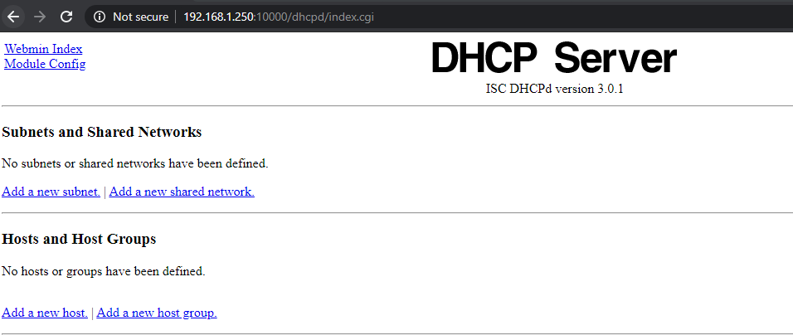

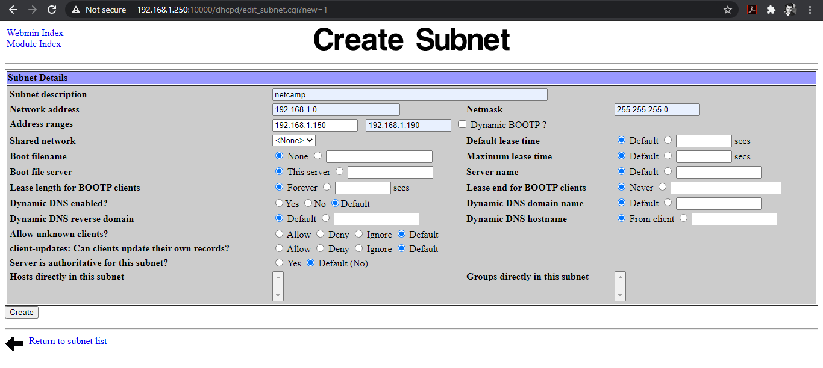

Fill the box and create subnet for DHCP then edit client option.

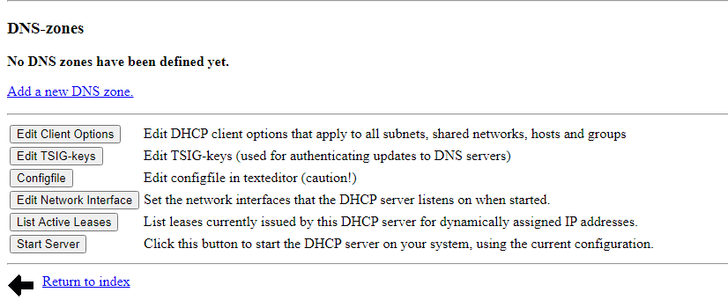

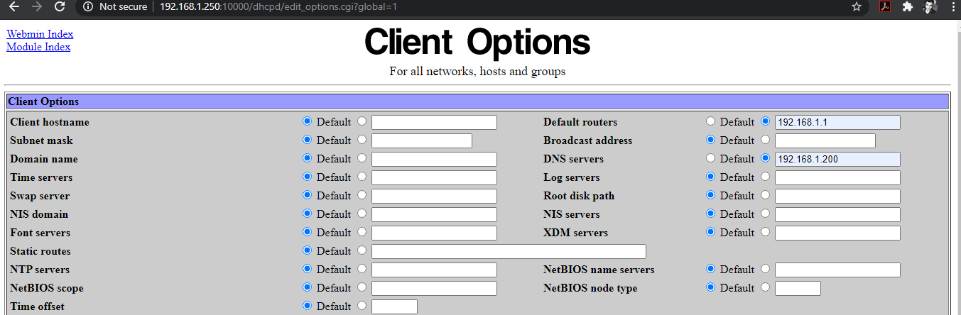

Fill the box and save , after that when you start the Server of DHCP it shows an error , we have to fix out that issue in linux server .

Go to cmd in 192.168.1.250 and fix it .

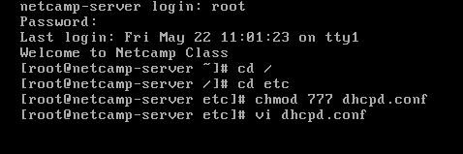

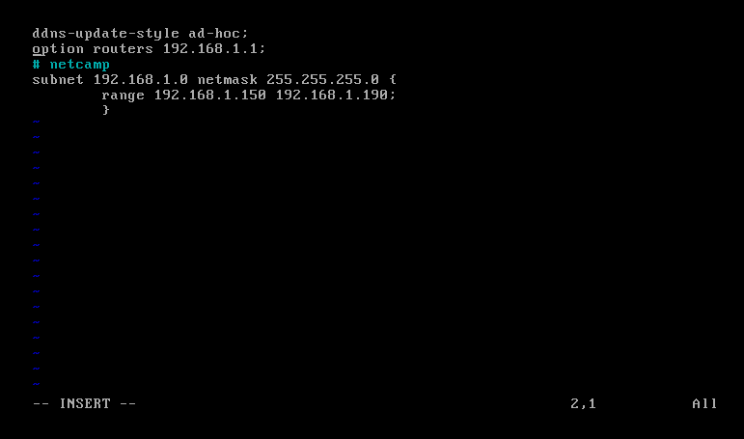

When you fix the issue and add the line “ ddns-update-style ad-hoc;” then again start the DHCP Server , it work and in your netcamp.in the server works .

***SAMBA :***

**Samba** is [client/server technology](https://www.lifewire.com/introduction-to-client-server-networks-817420) that implements network resource sharing across operating systems. With Samba, files and printers can be shared across Windows, Mac and Linux/UNIX clients.

Samba can be utilized in several different ways. On an [intranet](https://www.lifewire.com/intranets-and-extranets-in-corporate-portals-816364) or other private networks, for example, Samba applications can transfer files between a Linux server and Windows or Mac clients (or vice versa). Anyone using Web servers running [Apache](https://www.lifewire.com/tips-on-installing-apache-on-linux-3464022) and Linux may consider using Samba rather than [FTP](https://www.lifewire.com/file-transfer-protocol-817943) to manage Web site content remotely. Besides simple transfers, SMB clients can also perform remote file updates.

Let’s Start , Follow the steps carefully –

Webmin 🡪 Servers 🡪 Samba Windows File Sharing

There are two files by-default get shared -  
1. All homes directory

2. Printers

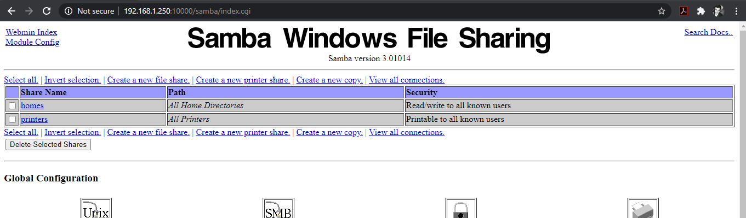

Chose Option , Create a new file share.

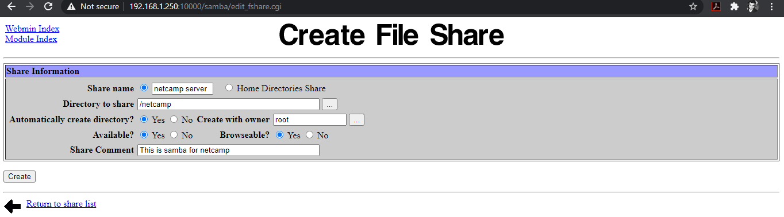

SAVE.

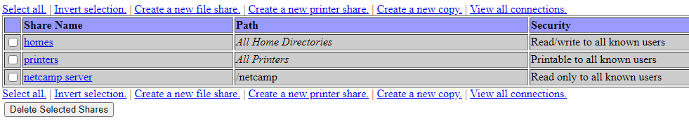

Open netcamp server 🡪 Security and Access Control

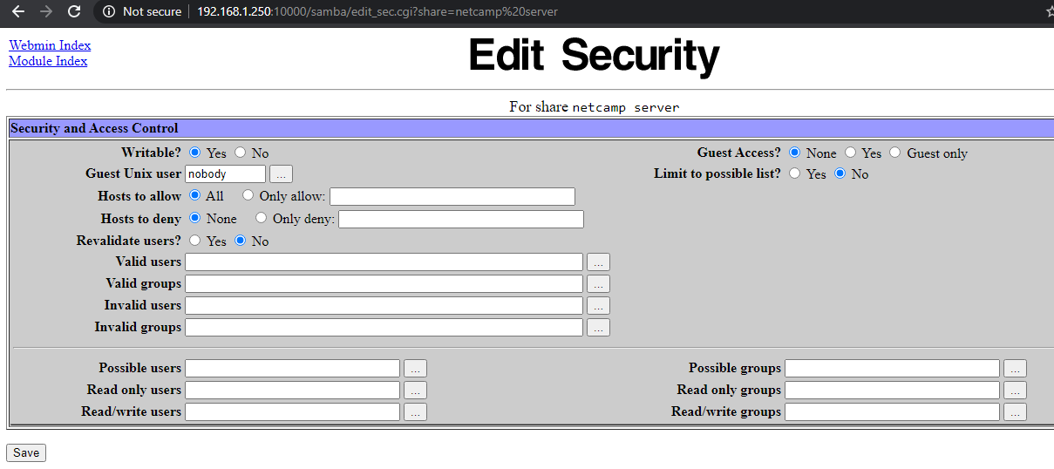

SAVE

Samba User 🡪 Convert Unix Users to Samba users

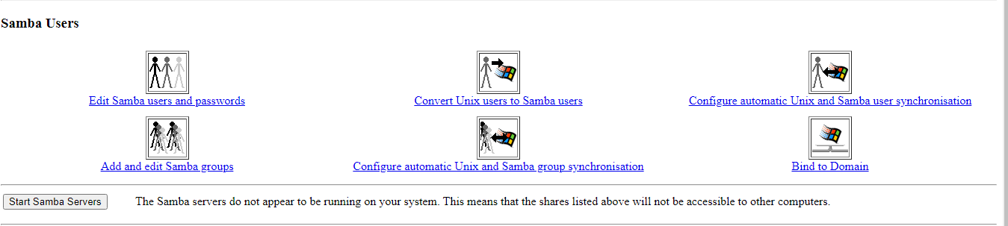

Choose the use this password and give your password then convert users.

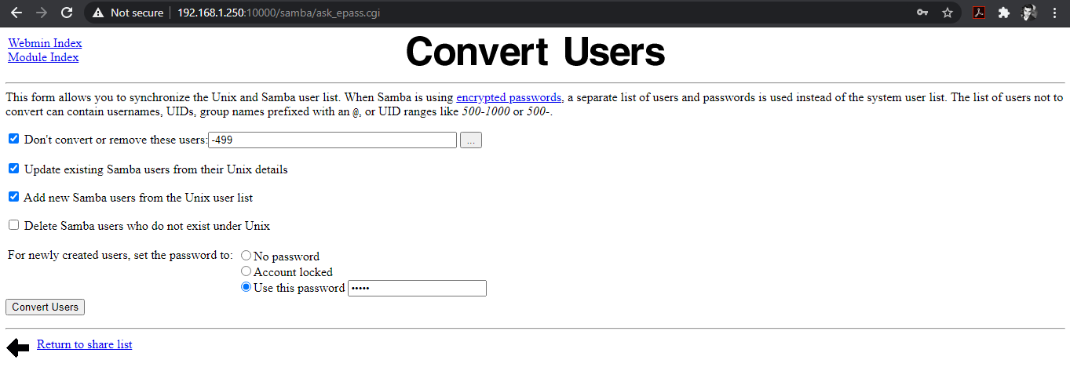

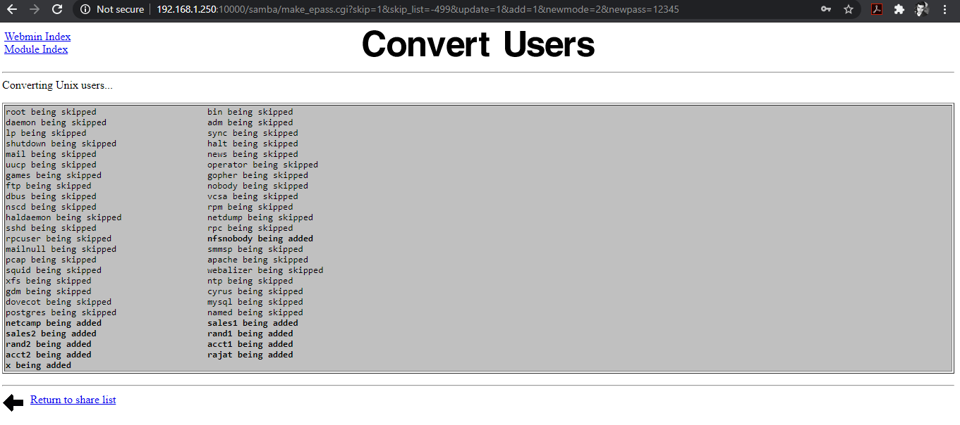

Return back.

Edit samba user and passwords 🡪 Choose rajat 🡪 Give password

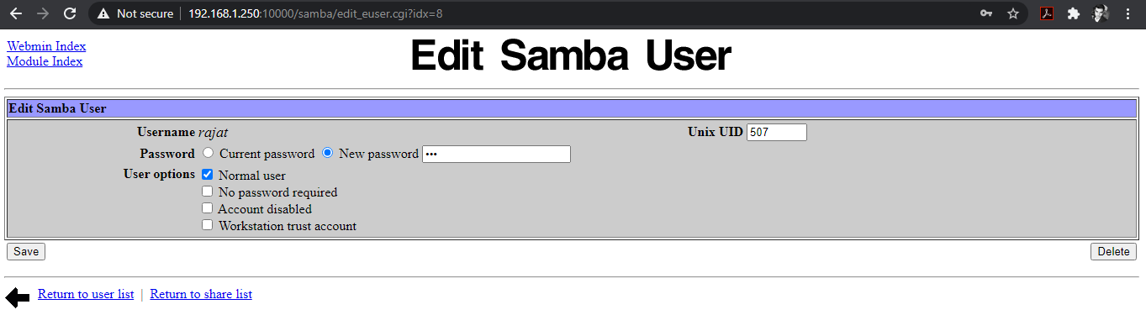

Save and Start Samba Server.

Your Samba Server is start on your server . Check it out.

Go to Windows XP 🡪 Start 🡪 RUN 🡪 \\192.168.1.250

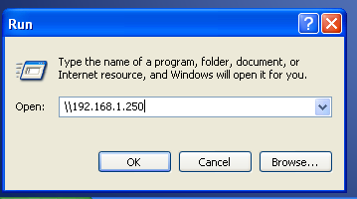

Give your username and password then you login.

Enjoy Samba And share file fastly and easily.

Let’s do something interesting with Samba. Earlier you see in mail server the logo is of webmail since we created our company netcamp.in so there must be a logo of netcamp.

Let’s do that , as we added a user RAJAT in the server so using that user create a different samba server in which you share /usr file to other server so that we can chage the logo. Create a samba server and start that server , when the server is created and started login to it. It looks like –

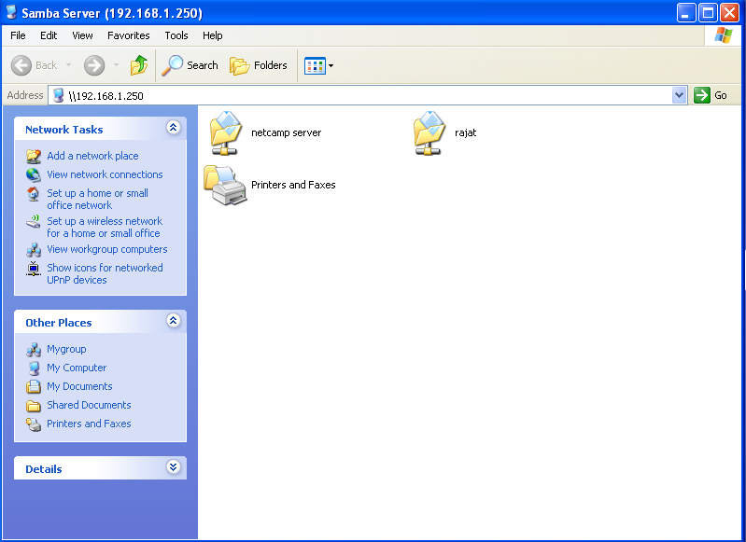

Now go to linux server 192.168.1.250 and perform some command it will give access to the file and changement in them.

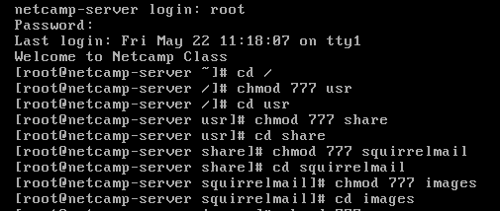

After this follow these steps sequentially-

Netcamp-server 🡪 share 🡪 squirrelmail 🡪 images

Copy the image which you want to your logo and paste in the images folder . you saw there is a image named sm_logo delete that image and rename your image as “sm_logo”.

Now go to browser and search for mail.netcamp.in .

Here you go , you saw that the logo of the mail server is changes . You can also change various things in this mail server just explore the things.

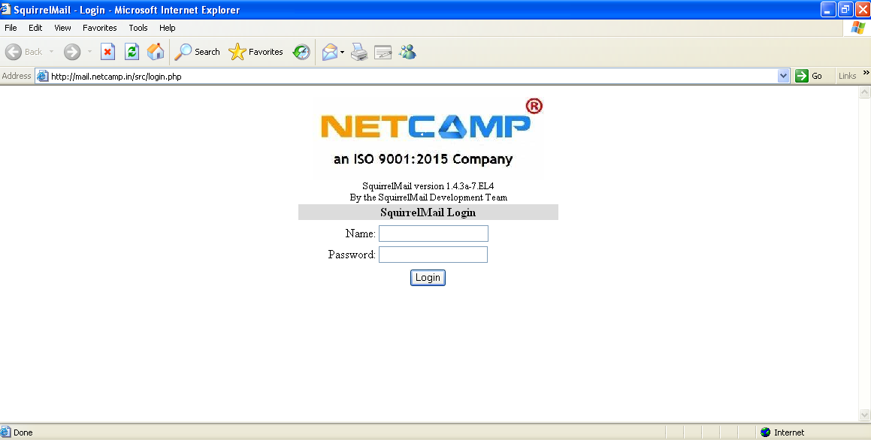

***Quota And Partition :***

Disk quotas allow Windows administrators to control and manage the size of the disk space used by users on the file systems of servers and workstations. Windows Server supports two types of quotas: File Server Resource Manager quotas and NTFS quotas

Now, we create a server netcamp.in , it’s mail-server and apply samba on it . Let’s create some partition for chairman i.e. here “RAJAT” , where the chairman can only access that folder and do whatever with it . We also give some amount of quota to this folder to save / delete files, documents etc.

Let’s start , follow the steps carefully –

First we do partition in the linux server , go to server 192.168.1.250.

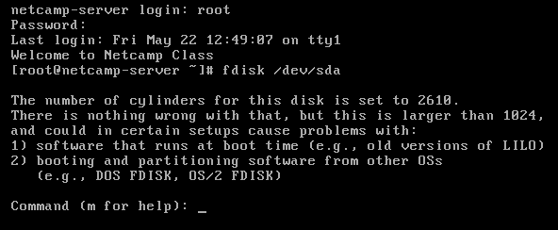

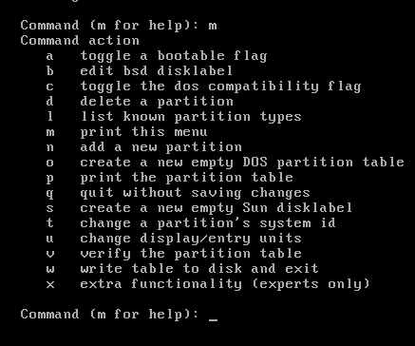

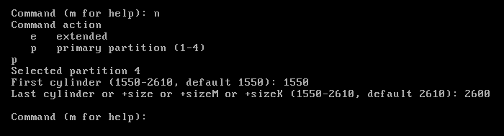

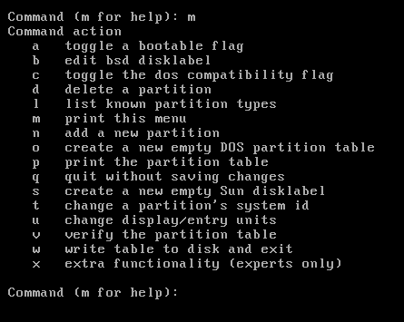

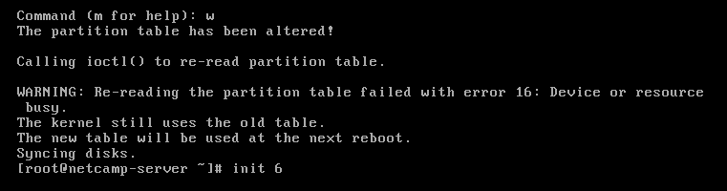

By pressing command init 6 , the system get reboot.

After rebooting successfully give the file system to that disk which we have created.

Webmin 🡪 Hardware 🡪 Partitions on local disks

Open that partition which you have created.

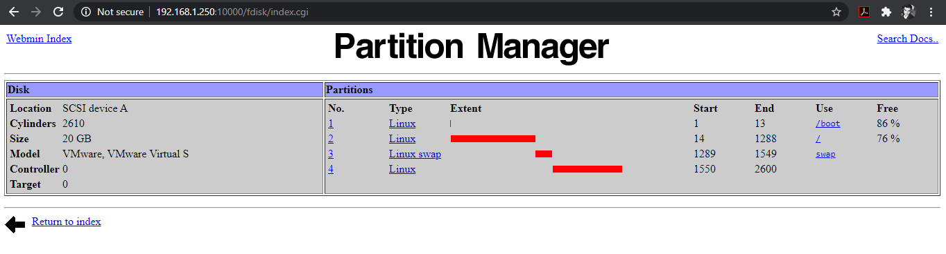

Choose , New Linux Native (ext3).

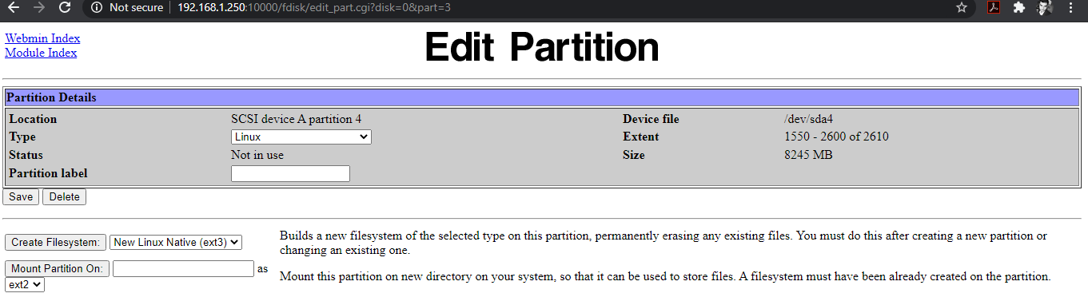

Create file system 🡪 Create file system

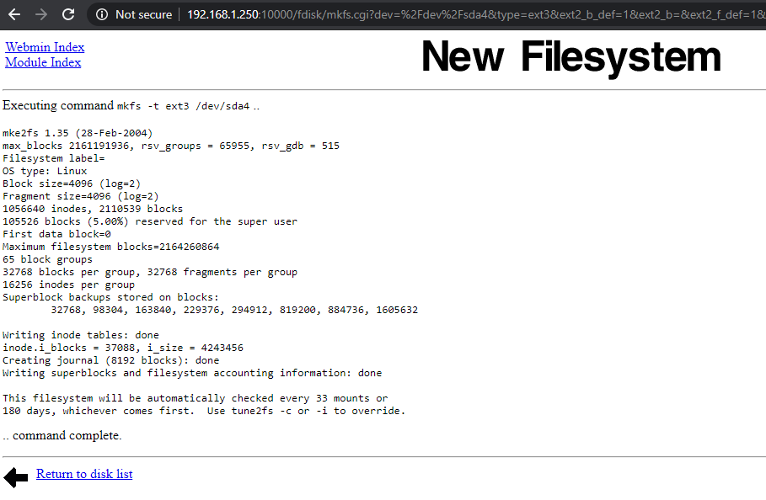

Now, we make a folder chairman in / and give quota to RAJAT for that folder chairman.

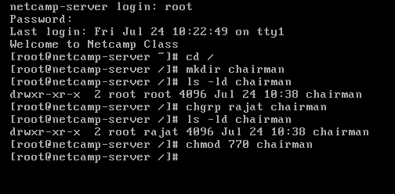

Carefully fill the boxes and follow the steps –

Webmin 🡪 System 🡪 Disk and Network FileSystems

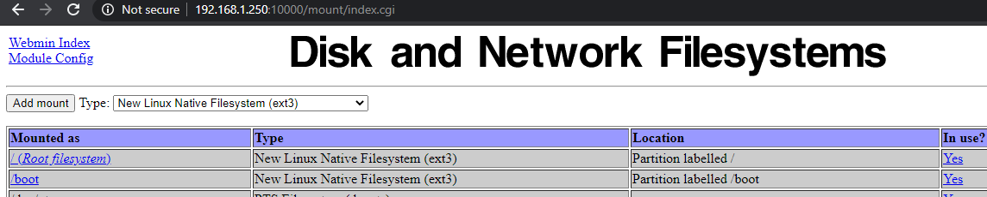

Add Mount.

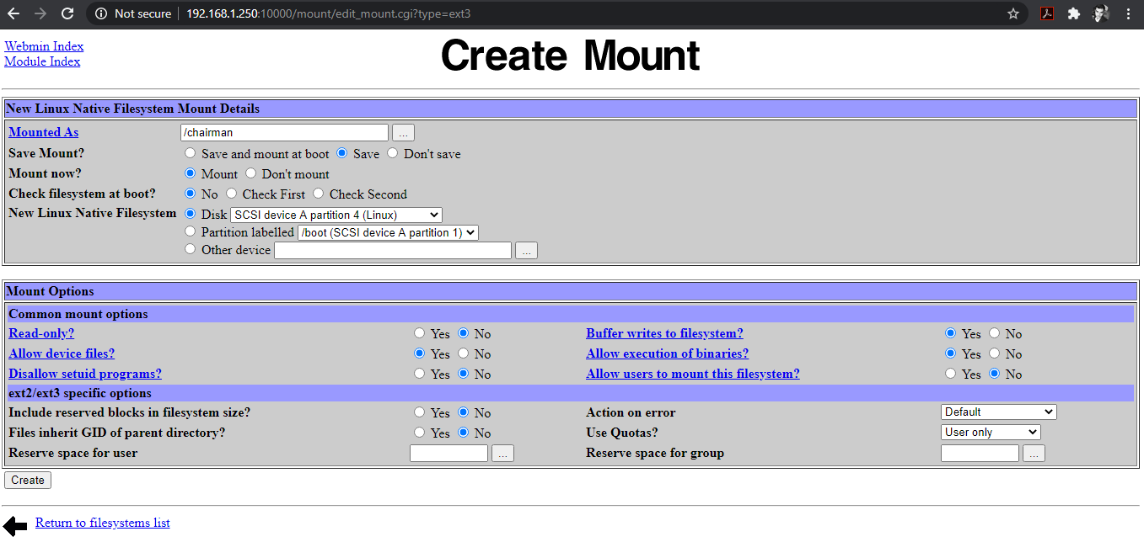

Click on Create.

System 🡪 Disk Quotas 🡪 Enable Quotas

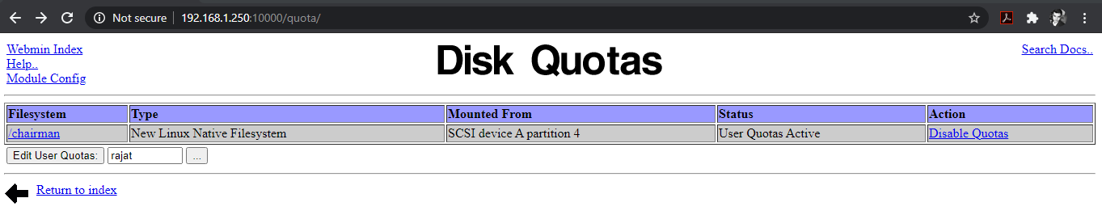

Click on Edit User Quotas

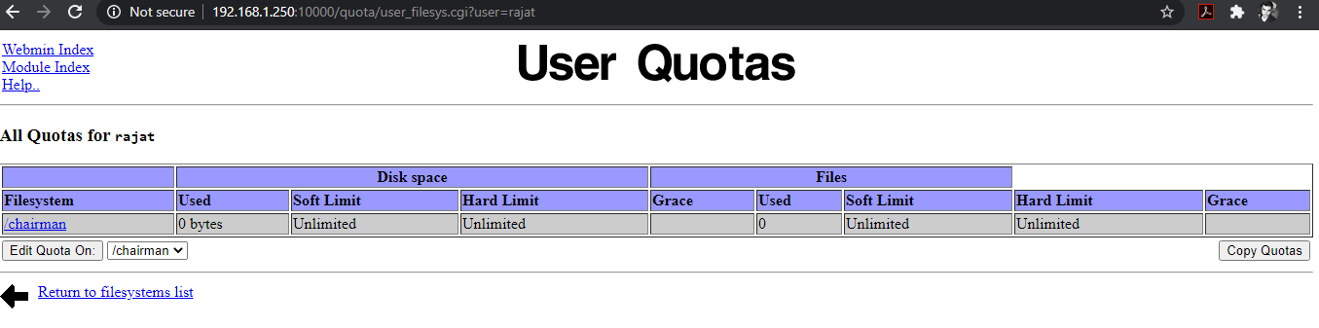

Click on Edit Quota On.

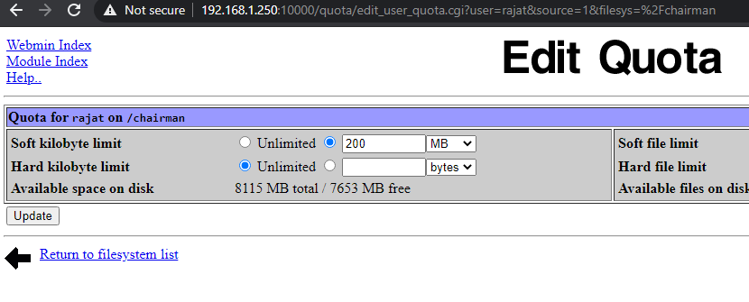

Update.

***Firewall:***

In [computing](https://www.bing.com/search?q=Computing%20wikipedia&form=WIKIRE), a firewall is a [network security](https://www.bing.com/search?q=Network%20security%20wikipedia&form=WIKIRE) system that [monitors](https://www.bing.com/search?q=Network%20monitoring%20wikipedia&form=WIKIRE) and controls incoming and outgoing [network traffic](https://www.bing.com/search?q=Network%20traffic%20wikipedia&form=WIKIRE) based on predetermined security rules. A firewall typically establishes a barrier between a trusted internal network and untrusted external network, such as the Internet.

The important part is firewall, since we created a company netcamp.in , its our duty that other users from another company do not breach the security of our company so we created a firewall , which block external user to enter in company database without permission.

Let’s there is a private ip 192.168.1.150 of the company netcamp.in where all the users works using this address. We created a firewall that only using this address you can do ftp, telnet or ssh etc, other Ips are block.

Go to the server 192.168.1.250 –

Webmin 🡪 Networking 🡪 Linux Firewall

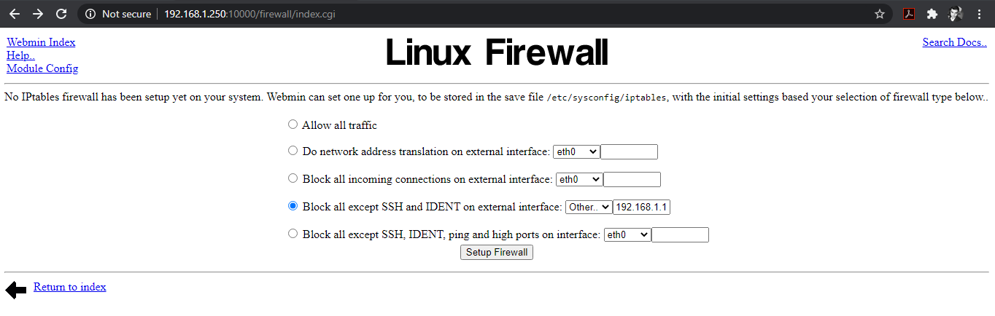

Choose the option according to the type of firewall you want on your network or server then Setup Firewall.

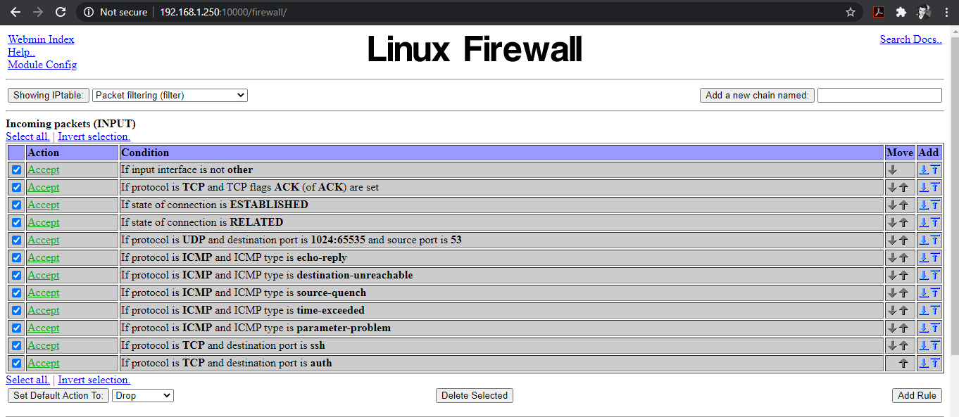

Check the box according to need then apply configuration.