**ACHARYA NARENDRA DEV COLLEGE**

**University of Delhi**



**ELITE PROJECT REPORT**

**On**

**B.A.T (Blind Assistance Toolkit)**

Submitted By:- Submitted To:-

* Rajat Mann(xo-466) * Dr. Ravneet Kaur Electronics (Honours) (Assistant Professor)

5th Sem.

* Lokender (xo-462) * Dr. Anita Kumari Electronics (Honours)

5th Sem.

**ACKNOWLEDGEMENT:**

First of all, we would like to thank our principal Dr. Savithri Singh for providing us with an opportunity to explore our ideas through summer fellowship ELITE program. Then, we would like to thank  Associate Professor Ms. Anuradha Sarin for accepting our idea of project and allowing us to be a part of Elite project 2018.We would like to thank our mentor Assistant Professor Dr. Ravneet Kaur and Dr. Anita Kumari for guiding us at every stage of our project. We would like to thank Dr. Monika Bhattacharya for supporting us every time we need her either in report writing or in improving our project. We would like to thank Ms. Gauri Ghai for helping us during our project. We would like to thank Associate Professor Dr. Amit Garg and Mr. Shani Kumar for allowing us to use resources from SPIE Lab for hardware assembling and testing of B.A.T. We would like to thank our Non-Teaching Staff Mr. Ranvindra Kumar and Mr. Pankaj for helping us in issuing different hardware items from Departmant of Eectronics. And at last we would like to thank our parents and friends for supporting us.

**CERTIFICATE**

**This is to certify that the project entitled “B.A.T (Blind Assistance Toolkit)” has been undertaken under the ELITE scheme of ACHARYA NARENDRA DEV COLLEGE, UNIVERSITY OF DELHI and implemented by us in the Electronic Laboratory. This work has not been submitted anywhere earlier, partially or fully.**

**Supervisor**

**Dr.Ravneet Kaur**

**Date:**

**Supervisor**

**Dr.Anita Kumari**

**Principal**

**Dr. Savithri Singh**

**ABSTRACT:-**

# The primary aim of the project is to develop a robust and cost-effective wearable obstacle detecting device named B.A.T (Blind Assistance Toolkit) for visually impaired people. This device contains ultrasonic sensor for detecting obstacles and gives warning with the help of vibrations and buzzer sounds to the user. This device aims to provide better navigation for blind person, indoors as well as outdoors. Device is very simple to use and does not require any special skills to use it. It is also small in size and easy to handle.

**INTRODUCTION:-**

An estimated 253 million people live with vision impairment: 36 million are blind and 217 million have moderate to severe vision impairment [1]. It is estimated that there is a per-decade increase of up to 2 million persons over 65 years with visual impairments. This group is growing faster than the overall population.It is estimated that by the year 2020, all blind-related numbers will double[4].

Visual impaired people have to face many difficulties in a day. One of them is navigation. Blind people use assistance devices which help them in navigation. Most common device is white cane. It is used to scan their surroundings for obstacles or orientation marks.

Another option is navigation using blind guided dogs. These dogs are better choice for navigation as in this case the need to take care of reference markings from cane is eliminated and navigation through different shape and size obstacles becomes more convenient. It helps the user to navigate easily through the obstacles which are below waist. But for the obstacles which are above the waist example like an opened window in a street, both, white cane and blind guided dog don’t serve the required purpose.

So in order to overcome this limitation we will discuss further, development of new device named “B.A.T” to deal with such situations.

B.A.T (Blind Assistance Toolkit) uses ultrasonic sensors to identify the obstacle in a given range and warns the user through buzzer and vibration motor to change his/her course.

There are other devices available in the market for the aid of the blind but most of them are expensive for a common person. We have made a device which is very cheap yet provide the best aid possible.

Further in this section, Block Diagram and its application is given.  
In Section-2, detailed literature survey carried in order to conceptualise and realise this device is discussed. Further section-3 contains the architecture of the B.A.T which includes its material required, dimensions, sensors, actuators etc.Section-4 contains Working principle and working of the B.A.T. Section-5 contains the Future Scope .Section-6 contains Discussion and result.

**Block Diagram:-**

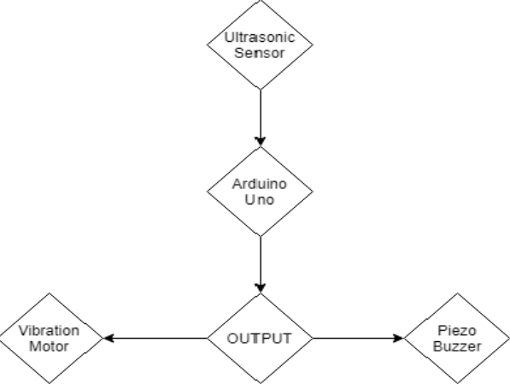

* **Explanation Of Block Diagram:-**
* Ultrasonic Sensor collects the data (Input) from environment and sends it to the Arduino Uno for processing.
* Arduino Uno process the data and gives instructions accordingly to the output devices.
* Output devices (Piezo Buzzer and Vibration Motor) works according to the signals which are received from the Arduino Uno.

**2) Literature Survey:-**

There have been many great inventions in history to aid the blind. Some of them include :

**The Guide Cane** provides aid for obstacle detection and navigation which uses an ultrasound sensor. The sensor head is mounted on a steerable axel to detect obstacles and steer the device around it. Its drawback is that it required GPS system for navigation [2].

**Brain Port V100** is a solution that includes glasses with embedded camera and a tongue array that contains 400 electrodes and is connected to the glasses via a flexible cable. Glasses capture real time images and images are mapped into the tongue array in terms of gray scale. White level has a strong stimulation, gray level has a medium stimulation and black level has no stimulation at all. However, this solution is invasive and demands a big period of time for adaptation[5].

**The C-5 Laser cane** is embedded with a laser beam which is aimed above and ahead. After collision with the obstacle the laser beam is reflected back, which is acquired by three photodiodes as receivers [2].

**The Binaural Sonic Aid (Sonicguide)** is a device which furnishes much information about aspects of the milieu which lies outside the immediate path of the user. The device is incorporated in the pair of spectacle with two receivers mounted on left and right side, while, the transmitter faces straight piercing the environment via pulsed ultrasound. An obstruction visualised on the left side is detected by the receiver, which, will provide a signal to left ear and similarly for right ear. Hence, allowing the user to determine the direction of obstacle [2].

**The Smart Cane[2]** uses feedback from ultrasonic sensors and provides the output in the form of vibrations to the user.

**The BuzzClip[3]** is a portable device which is light weight, very small in size, easily attachable to the user’s cloth and guide the user through vibrations through the obstacles but it is very costly.

We have other device to aid the blind also but generally we face many common problems in making of these devices. Such as:-

# 1) The size of the device.

# 2) The cost of the device.

# 3) Weight of the device.

# 4) Compatibility with the user.

# There are some devices which are very good in compatibility but a common person have to face many difficulties in affording it or the affordable device is too bulky for the user to adjust in his/her daily lifestyle.

# So while making this device(B.A.T) we thought of all the possible problems and decided to make a device which is light weight provide great feedback with environment for the compatibility and is very cheap than other electronic aid devices.

# 3) Architecture:

# 3.1)Materials:

|  |  |
| --- | --- |
| 1) | Ultasonic Sensor |
| 2) | Arduino Uno R3 |
| 3) | Piezo Buzzer |
| 4) | Vibration Motor |
| 5) | 9 v Battery |
| 6) | Soldering Machine |
| 7) | Glue Gun |
| 8) | Perforated Board |
| 9) | Connecting Wires |
| 10) | Cardboard |
| 11) | Ribbon |

# 3.2) Dimensions:

|  |  |
| --- | --- |
| Length (in cm) | 12.7cm |
| Breadth (in cm) | 10.16 cm |
| Height (in cm) | 3.175 cm |
| Weight (in g) | 145 g |

# 3.3) Range and Angle:

# It can cover obstacles which are in front of sensor only within range of 1.5 metre which can be extended by programming to maximum distance of 4 metre.

# 3.4 ) Sensors:

# The B.A.T system works on a Ultrasonic sensor and uses a HC-SR04 ultrasonic sensor which provides 2cm-400 cm range and have accuracy upto 3mm. The module includes ultrasonic transmitters, receiver and control circuit. The basic principle of work:

# (1) Using IO trigger for at least 10us high level signal,

# (2) The Module automatically sends eight 40 kHz and detect whether there is a pulse signal back.

# (3) IF the signal back, through high level, time of high output IO duration isthe time from sending ultrasonic to returning.

# Test distance = (high level time×velocity of sound (340M/S) / 2 .And it requires a dc 5V operating voltage and a 15 mA current.

# 3.5) Data Processing:

# The B.A.T uses Arduino Uno R3 as a data processing unit for the system. Arduino Uno R3 have an Atmega328 microcontroller and have 32 KB of flash memory.It has 14 input/output pins(of which 6 provide PWM output) and 6 analog pins.Its operating voltage is 5V(recommended) though 7v-12v input voltage can be provided. Clock speed is 16MHz.

# It computes the data collected from the physical world with the help of the ultrasonic sensor and provides further commands accordingly to the actuators.

# 3.6) Actuators:

# 3.6.1) Piezo Buzzer:

# It requires minimum 3.3 V as operating voltage and can produce different sounds according with the change input frequency by the data controller or in the B.A.T system by Arduino Uno R3.

# 3.6.2) Vibration motor:

# In the B.A.T system 10mm diameter flat button type vibration motor is used which provides enough vibration to be felt by the user and uses 3V as minimum operating voltage. Speed of it can be controlled by the voltage provided as input in it according to our requirement. The more voltage supplied the faster are vibrations.

# 4) B.A.T Working:

# 4.1) WORKING Principle and formula used:

## An ultrasonic signal generates travels to and fro (i.e. from echo to receiver and back). Therefore, the measured ‘time’ is actually the total travelling time for a single pulse. For distance measurement, we need only half of this. Therefore ‘Time’ is taken as(total travelling time)/2.

## **Distance = Speed * Time/2**

## Speed of sound at sea level = 343 m/s or 34300 cm/s

## Thus, **Distance = 17150 * Time (unit cm).**

## **After calculating the distance using the above formula, programming is done with the help of arduino to move the actuators accordingly based upon the distance between the obstacle and the B.A.T device.**

## **Actuators work as follows:**

## **Initially when the obstacle is 1.5 m ahead there will be only a single vibration as warning.**

## **When obstacle comes closer and is 1 m ahead vibration motor starts vibrating in pattern and buzzer starts beeping in synchronisation with the vibration motor. Both of them have low intensity.**

## **Likewise, 1m obstacle distance has been divided in 5 parts:**

## **100-85cm, 85-70cm,55-45cm,45-30cm and less than 30 cm**

## **With the decrease in distance between B.A.T and obstacle, the speed and intensity of vibration motor increases . In addition to this , the frequency of the beeping sound produced by the buzzer also increases with decrease in obstacle distance. Through this, the user can easily differentiate between different levels of distance.**

# 4.2) WORKING:

# B.A.T is made to be hung in the neck due to its light weight and small size.

# When user walks with the help of a cane and B.A.T device, cane helps the user to avoid the lower waist region obstacle whereas B.A.T helps the user to avoid obstacles above the waist.

# When user comes near any obstacle, B.A.T sends a warning signal as a single vibration when the obstacle is 1.5 m ahead. After that its upto the user whether he/she wants to change his/her course of direction or not. If not then B.A.T is designed in such a way that it helps the user to avoid obstacle within range of 1 m with the help of different patterns of vibration and sound with the help of vibration motor and Piezo buzzer.

# User has choice whether he/she wants to use the buzzer or not with the help of a switch which is connected to it but vibrations is mandatory.

**5) Program Code Logic**:

|  |  |  |
| --- | --- | --- |
| Distance Range | Control used in Programming(Piezo Buzzer) | Control used in Programming(Vibration Motor) |
| ≥1.5 m | Not used any control  (OFF) | Analog Control |
| 1.5m - 40 cm | Analog Control | Analog Control |
| < 40 cm | Digital Control | Digital Control |

# 6) Tests and Results:

# 6.1) Test:

|  |  |  |  |
| --- | --- | --- | --- |
| DISTANCE | TESTS(Error in Device Response distance) | AVERAGE(Error in Device Response distance) | ERROR %( Error in Device Response distance) |
| 1.5 m | Test 1 = +6.1 cm | +6.1 cm | +4.01% |
| Test 2 = +6.1 cm |
| Test 3 = +6.1 cm |
| 1m | Test 1 = +3.2 cm | +2.733 cm | +2.733 % |
| Test 2 = + 2.1 cm |
| Test 3 = + 2.9 cm |
| 40 cm | Test 1 = +-0 cm | +-0 cm | +-0.1% |
| Test 2 = +-0 cm |
| Test 3 = +-0 cm |

# 6.2) Result:

A working model of B.A.T has been successfully implemented.

Accuracy of B.A.T at 1.5 m= + 6.1 cm

Accuracy of B.A.T at 1 m = + 2.733 cm

Accuracy of B.A.T at 40 cm = + 0 cm

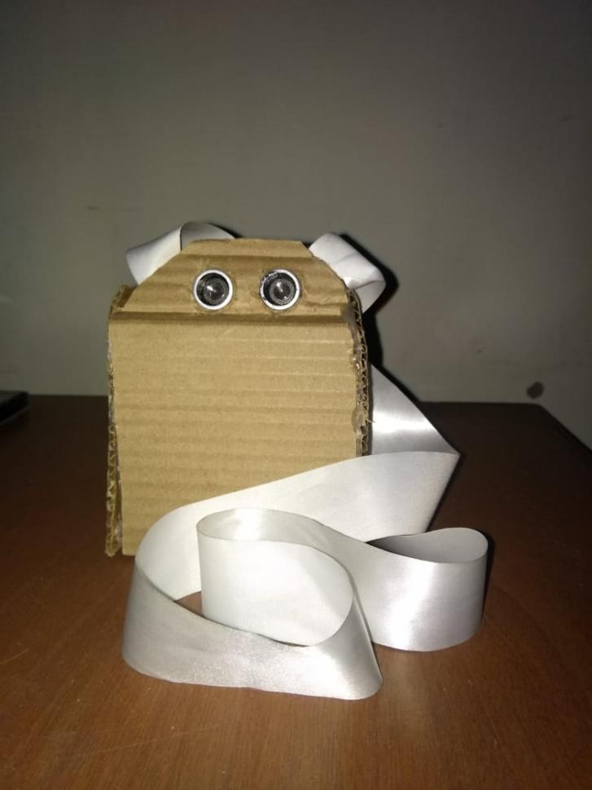

(Picture Of B.A.T)

# 6.3) Discussion:

B.A.T was initially designed to provide obstacle detection ideally upto 1 m distance but then the model was further improved to detect even lower obstacle distances. The current model of B.A.T gives a warning at when the obstacle is at 1.5 meter distance through a single vibration and then additional actuators work further forobstacle detection from a distance of 1 meter down to 2 cm.The device was tested for actual distance for which it provides obstacle detection. From the tests and demonstrations conducted it was found that the device works properly as it was designed for by giving a single vibration at 1.5 m. Thereafter, vibrations occur in intervals as the obstacle distance is further reduced from 1 m upto 2 cm. With change in every 15 cm obstacle distance the vibration pattern becomes faster and the speed of vibration motor also increases from 1 m upto 40 cm. The frequency of the buzzer beep also increases as the obstacle distance is reduced from 1 m to 40 cm. When obstacle is at distance less than 40 cm the buzzer starts making a continuous beeping sound and the vibrations produced by vibration motor.

# 6.4) Conclusion:

## A novel and commercially viable Blind Assistance Toolkit (B.A.T) serves its purpose as a blind aid device. It is affordable for almost all and very compatible with the user due to its light weight and small size.

## It works very efficiently when used with a traditional cane. It is very cheap and can be used easily of it with existing traditional cane . Fusion of this new technology device with the existing tool makes the device even more reliable and trustworthy for the blind community.

## In future B.A.T can be improved further by reducing more of its size and weight and by covering larger area.

## But for now B.A.T is a device which is good enough to provide good feedback of environment to the user for obstacles . Moreover, the main purpose of providing a blind assistance device at a very low price is also served.

**7) Future Scope:**

B.A.T can be improved in future with reduction of its size and weight . Response time of it can be also improved by improving the processor, sensors etc. It can be made splash proof with the help of waterproof ultrasonic sensor. Actuators size can be reduced. More actuators can be added for example headphone jack for earphones, so that user can get the description of details more accurately. Range of B.A.T can be improved by improving the sensor or by adding a stepper motor to existing sensor to cover a larger area .There are many scopes of improvement as the technology is advancing day by day. With even better electronic devices having reduced size and better speed, B.A.T. can be improvised further to make it better.

**REFERENCES:**

[1]World Health Organization. Visual impairment and blindness, 11 October 2017.Available:<http://www.who.int/en/news-room/fact-sheets/detail/blindness-and-visual-impairment>.

[2] Jayant Sakhardande, Pratik Pattanayak, Mita Bhowmick.” Smart Cane Assisted Mobility for the Visually Impaired”. World Academy of Science, Engineering and Technology International Journal of Electrical and Computer Engineering Vol:6, No:10, 2012.

[3]The BuzzClip: IMerciv. Wearable Assistive Technology. http://[www.imerciv.com/index.shtml](http://www.imerciv.com/index.shtml)

[4] R. Velázquez, Wearable Assistive Devices for the Blind. Chapter 17 in A. Lay-Ekuakille & S.C. Mukhopadhyay (Eds.), Wearable and Autonomous Biomedical Devices and Systems for Smart Environment: Issues and Characterization, LNEE 75, Springer, pp 331-349, 2010.

[5] António Pereiraab*, Nelson Nunesa, Daniel Vieiraa, Nuno Costaa, Hugo Fernandesc, João Barrosoc ,Blind Guide: an ultrasound sensor-based body area network for guiding blind people ,6th International Conference on Software Development and Technologies for Enhancing Accessibility and Fighting Infoexclusion (DSAI 2015), Procedia Computer Science 67 ( 2015 ) 403 – 408