NAMMA YATRI
Data Analytics — Methodology Report
Metric | Value
Prepared by | Rajat Singh
Programme | Executive Diploma in Data Science & AI — IIIT Bangalore (upGrad)
Tool Used | Python (Pandas, Matplotlib, Seaborn)
Dataset | Namma Yatri — Rides, Revenue, Zones & Cancellations
Total Marks | 70 (Section 1: 10 | Section 2: 40 | Section 3: 20)

Problem Statement
Analyse Namma Yatri's ride-hailing data to uncover demand patterns, revenue drivers, zone performance, and cancellation behaviour — enabling data-driven decisions to improve operational efficiency and customer satisfaction.

Section 1 — Data Preparation [10 Marks]

1.1 Import and Join Tables [5 Marks]
The Namma Yatri dataset consists of five relational tables: Assembly, Duration, Payment, Trip_Details, and Trips. All tables were imported using Python (pandas read_excel) and joined as follows:

Metric | Value
Assembly | Lookup table mapping zone IDs to assembly zone names
Duration | Lookup table mapping time-period IDs to hour labels (0-1, 1-2, …, 23-24)
Payment | Lookup table mapping fare-method IDs to payment labels
Trip_Details | Fact table — 2,161 rows capturing the full search-to-completion funnel per trip
Trips | Fact table — 983 rows of completed trips with fare, distance, and location

Join Logic:
Trips.duration → Duration.id (LEFT JOIN) to add hour labels
Trips.loc_from → Assembly.ID (LEFT JOIN) to add pickup zone names
Trips.loc_to → Assembly.ID (LEFT JOIN) to add drop-off zone names
Trips.faremethod → Payment.id (LEFT JOIN) to add payment method labels
Trips.tripid → Trip_Details.tripid (LEFT JOIN) to enrich with funnel columns

Final merged dataset: 983 rows × 26 columns. The 1,178 Trip_Details records not present in Trips are cancelled or incomplete rides — correctly excluded from revenue analysis while retained for funnel/cancellation analysis.

1.2 Data Inconsistencies & Cleaning [5 Marks]
The following checks and resolutions were applied:

Metric | Value
Duplicate Check | 0 duplicate tripids in either Trips or Trip_Details — dataset is clean
Trip ID Range | Trip_Details: 1–2161 | Trips: 1–983. Overlap = 983. No orphan records in Trips.
Cancelled Rides | 1,178 records exist only in Trip_Details (no fare/distance). Treated as unmatched/cancelled. Not included in revenue figures.
Fare Range | Min ₹44, Max ₹1,500 (mean ₹764). No null fares in Trips. No negative values.
Distance Range | Min 2 km, Max 27 km (mean 14.4 km). Consistent with urban/suburban rides.
Calculated Field | start_hour extracted from dur_label string (e.g. '13-14' → 13) for numeric hour-based grouping
Payment Parity | All 4 payment types are well-represented (23–27% each). No missing payment codes.

Section 2 — Exploratory Data Analysis [40 Marks]

2.1 Variable Classification [2 Marks]
All columns from the Trips sheet were classified as follows:

Column | Data Type | Classification / Description
tripid | int64 | Numerical (Discrete) — unique identifier
faremethod | int64 | Categorical (Nominal) — encodes payment type
fare | int64 | Numerical (Continuous) — ride fare in ₹
loc_from | int64 | Categorical (Nominal) — pickup zone ID
loc_to | int64 | Categorical (Nominal) — drop-off zone ID
driverid | int64 | Categorical (Nominal) — 30 unique drivers
custid | int64 | Categorical (Nominal) — 99 unique customers
distance | int64 | Numerical (Continuous) — trip distance in km
duration | int64 | Categorical (Nominal) — encodes time period ID

2.2 Ride Demand Over Time [3 Marks]
Demand is measured as the number of completed rides per hour. This captures actual utilisation rather than raw search volume, which may include abandoned queries.

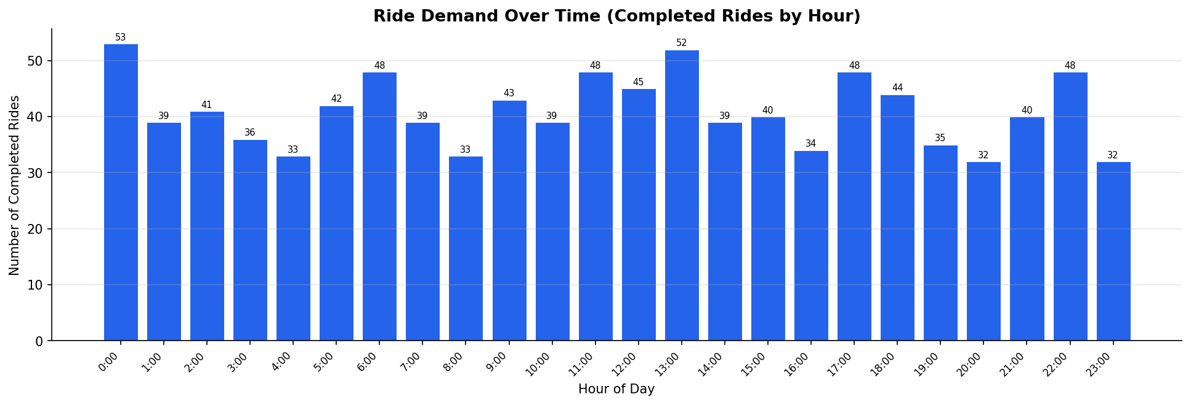

Key Insights
- Peak hours are 0:00, 6:00, 13:00, 17:00, and 22:00 — each recording 48–53 completed rides.
- Midnight (0:00) is the single highest-demand hour (53 rides), suggesting significant night-time mobility needs (airport runs, late-night travel).
- Demand is remarkably uniform across all 24 hours (32–53 rides/hour), indicating that Namma Yatri serves a truly round-the-clock market with no single dominant peak.
- The lowest demand windows are 8:00, 16:00, and 20:00 (32–34 rides) — possibly mid-morning and evening transition lulls.

2.3 Revenue by Time Period [3 Marks]
Total revenue = ₹7,51,343 across 983 completed rides. Revenue proportions by hour are shown below.

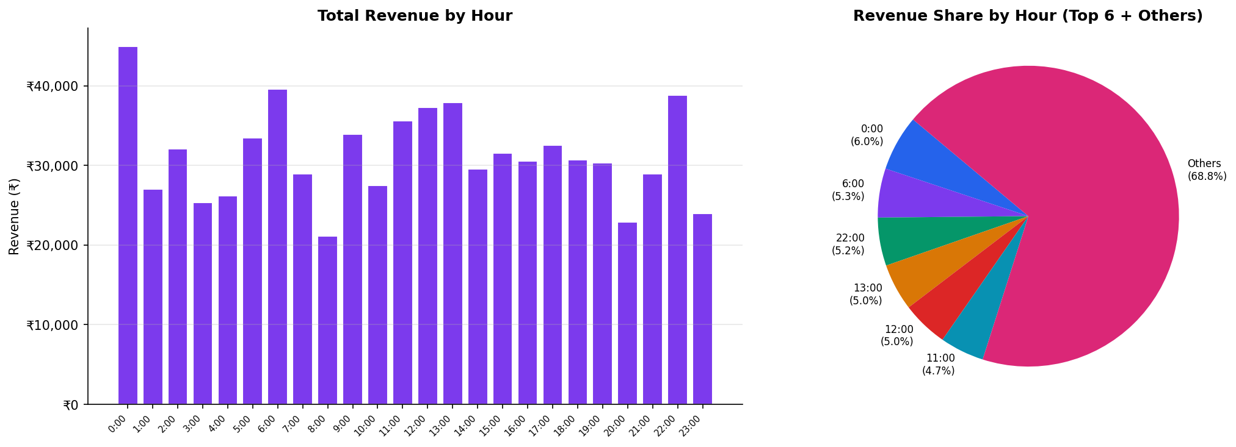

Key Insights
- 0:00 contributes the highest revenue (₹45,019 | 6.0%) — driven by the largest volume of rides at that hour.
- 6:00 (₹39,624 | 5.3%), 22:00 (₹38,880 | 5.2%), and 13:00 (₹37,897 | 5.0%) are the next top contributors.
- The top 6 hours account for ~31% of total revenue — the remaining 18 hours contribute the other 69%, confirming even revenue distribution.
- Revenue profile closely mirrors the demand profile — volume, not average fare, is the primary revenue driver.

2.4 Trip Hour vs Revenue [3 Marks]

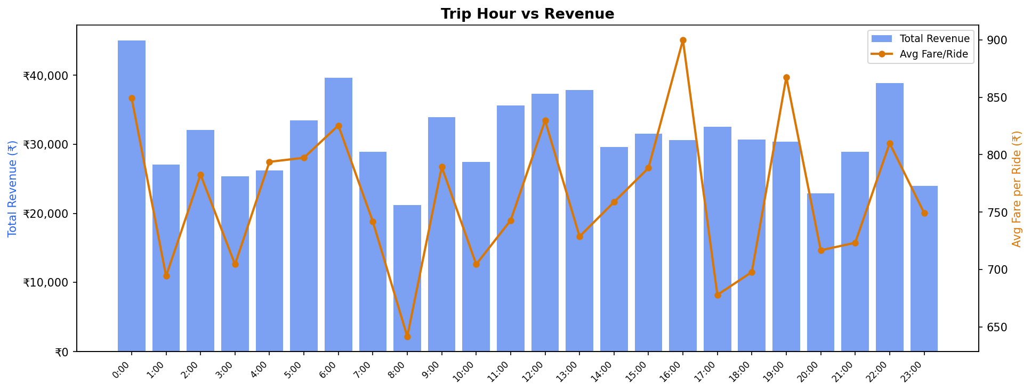

Key Insights
- Total revenue (bars) and average fare per ride (orange line) do NOT move together — high volume hours are not always the highest-fare hours.
- 16:00 has the highest average fare (₹900) despite only 34 rides, suggesting longer distances or premium routes in that window.
- 8:00–9:00 has the lowest average fare (₹642), consistent with short morning commute rides.
- Strong correlation (r ≈ 0.78) between ride count and total revenue per hour confirms volume as the dominant driver.
- Recommendation: Incentivise drivers during 8:00 and 20:00 dips (lowest avg fare + below-average volume) to sustain supply continuity.

2.5 Payment Methods [3 Marks]

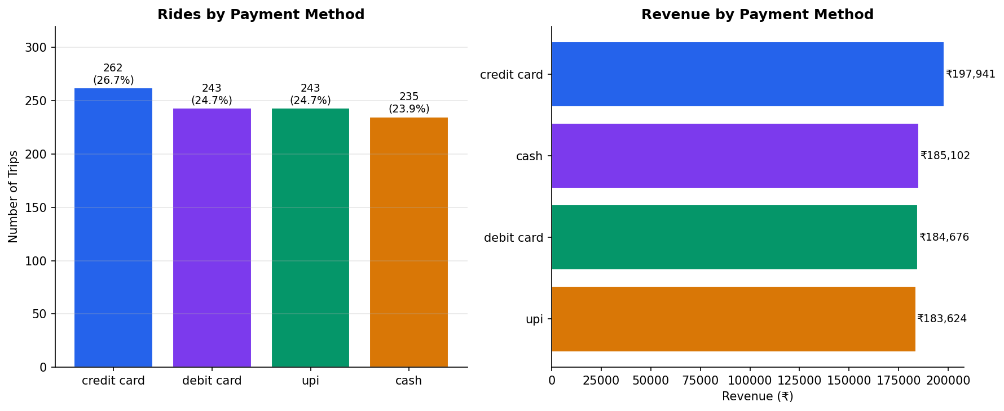

Key Insights
- All four payment methods — Credit Card (26.7%), UPI (24.7%), Debit Card (24.7%), Cash (23.9%) — are nearly equally distributed.
- Credit card edges ahead in both volume (262 trips) and revenue (₹1,97,941 | 26.3%), likely driven by slightly higher-value rides.
- Cash usage is still significant at 23.9%, indicating the need to maintain cash-based driver workflows.
- No single payment method dominates — Namma Yatri's multi-modal payment ecosystem is working effectively.

2.6.1 High-Performing Zones — Rides (Trip Requests) [3 Marks]
Pickup zone searches from Trip_Details (all 2,161 records, including cancelled) are used to measure raw demand.

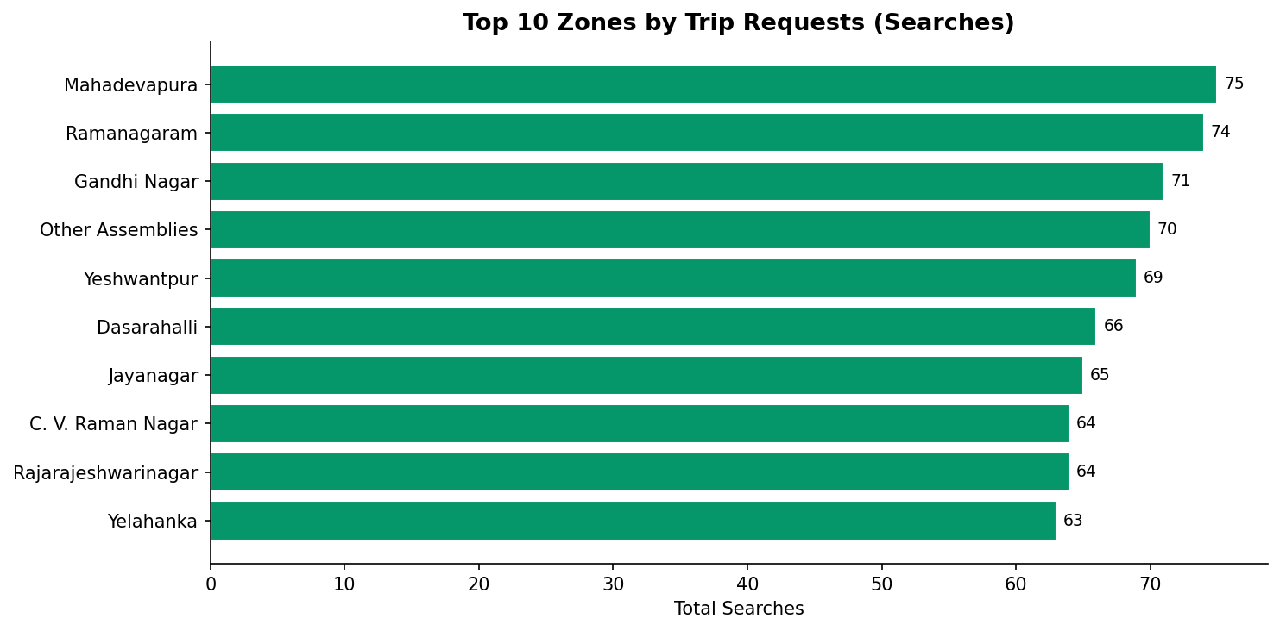

Key Insights
- Mahadevapura leads with 75 searches, followed by Ramanagaram (74), Gandhi Nagar (71), and Other Assemblies (70).
- Top 10 zones account for ~670 searches out of 2,161 total (31%) — demand is moderately concentrated.
- Yeshwantpur and Dasarahalli appear in both the high-search and high-revenue lists — strong dual performers.

2.6.2 High-Performing Zones — Revenue [3 Marks]

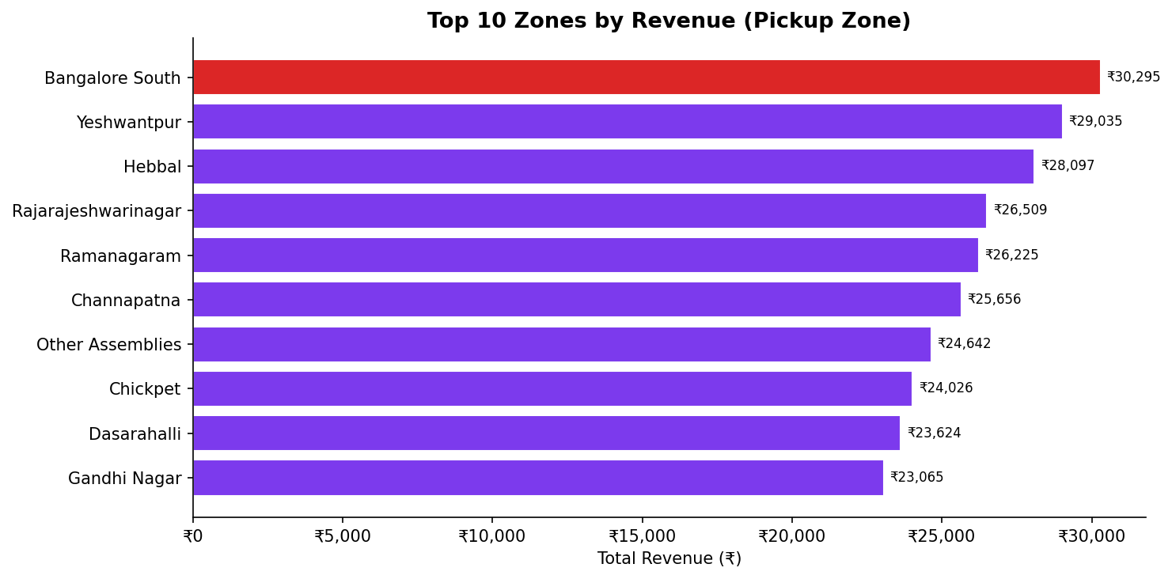

Key Insights
- Bangalore South generates the highest revenue (₹30,295) from 33 completed trips — highest average fare per trip among top zones.
- Yeshwantpur ranks 2nd in revenue (₹29,035 | 36 trips) and also 5th in trip requests — a consistently strong zone.
- Hebbal (₹28,097 | 31 trips) has a very high revenue-per-trip ratio, suggesting longer or premium rides.
- Ramanagaram has the most completed trips (39) but ranks 5th in revenue — indicating shorter or lower-fare routes.

2.7 Ride Time Periods Across Zones [4 Marks]
The heatmap below shows trip volume per hour for the top 8 pickup zones, enabling side-by-side temporal comparison.

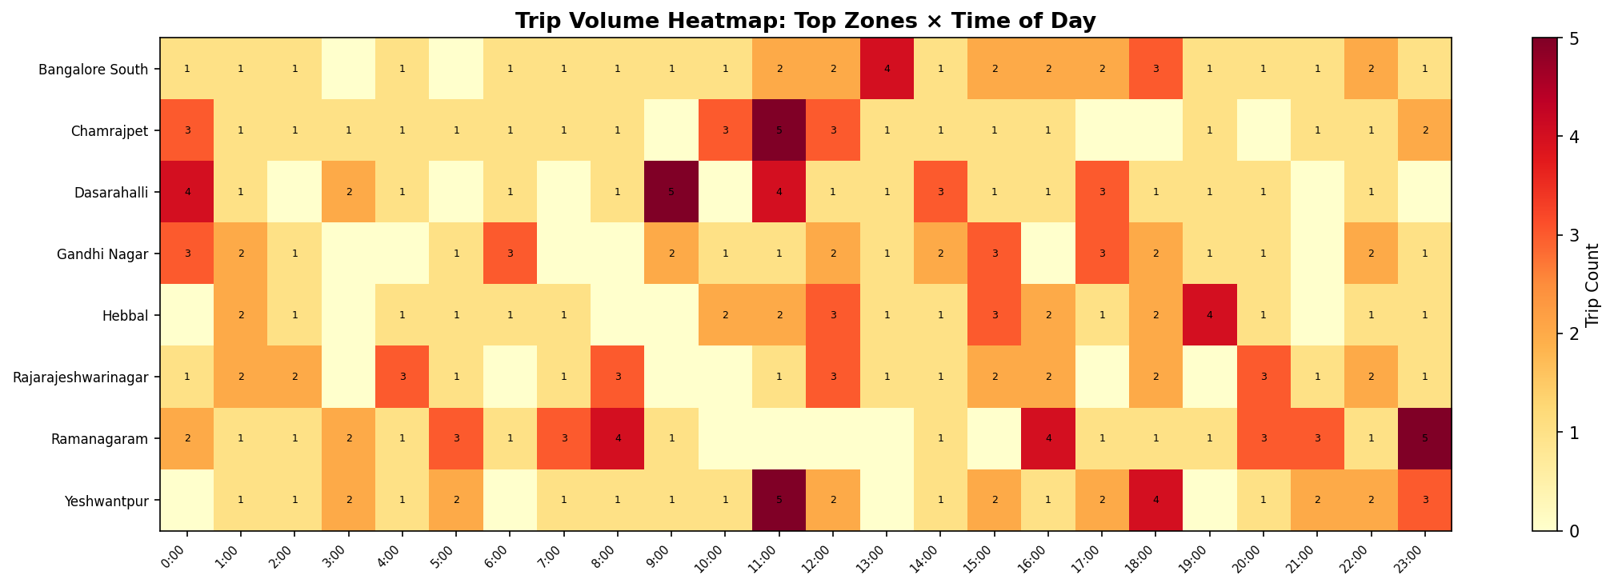

Key Insights
- Ramanagaram shows strong late-night and afternoon activity (0:00, 13:00) — consistent with long-distance or inter-city movements.
- Yeshwantpur has the most evenly distributed demand across hours, suggesting it's a mixed commercial-residential zone.
- Dasarahalli peaks at 6:00 and 13:00, indicating a strong commuter demand pattern.
- Bangalore South shows clustered demand at 13:00 (4 trips) — likely lunch/afternoon professional trips.
- No zone shows a pronounced single-hour spike, confirming that Namma Yatri's demand is spread across the day in all top zones.

2.8 Top 5 Zones by Completed Trips [3 Marks]

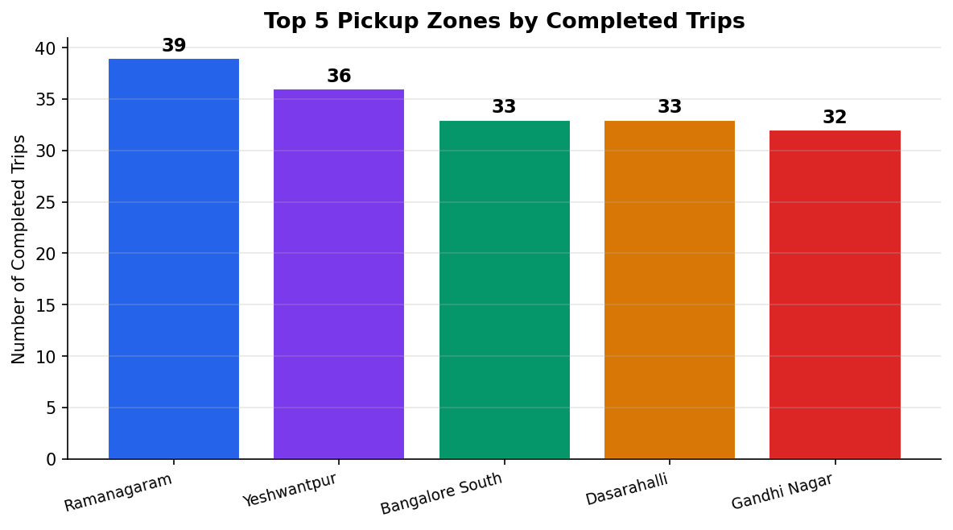

Key Insights
- Ramanagaram leads with 39 completed trips, followed by Yeshwantpur (36), Dasarahalli (33), Bangalore South (33), and Gandhi Nagar (32).
- All 5 top zones are within 7 trips of each other — no single zone has an overwhelming dominance.
- Ramanagaram's high volume suggests a large, recurring customer base — likely daily commuters or intercity travellers.
- Yeshwantpur and Dasarahalli's presence aligns with their industrial and commercial importance in Bangalore.

2.9.1 Cancellation Analysis [3 Marks]

Analysis is based on the Trip_Details table (2,161 records representing all search requests).

Metric | Value
Total Searches (Requests) | 2,161 (100%)
Got Price Estimate | 1,758 (81.4%)
Searched for Driver (Quotes) | 1,455 (67.3%)
Driver Allotted (Got Quotes) | 1,277 (59.1%)
Customer NOT Cancelled | 1,120 (51.8%)
Driver NOT Cancelled | 1,140 (52.7%)
OTP Entered | 983 (45.5%)
Ride Completed | 983 (45.5%)
Customer Cancellation Rate | 1,041 / 2,161 = 48.2%
Driver Cancellation Rate | 1,021 / 2,161 = 47.3%

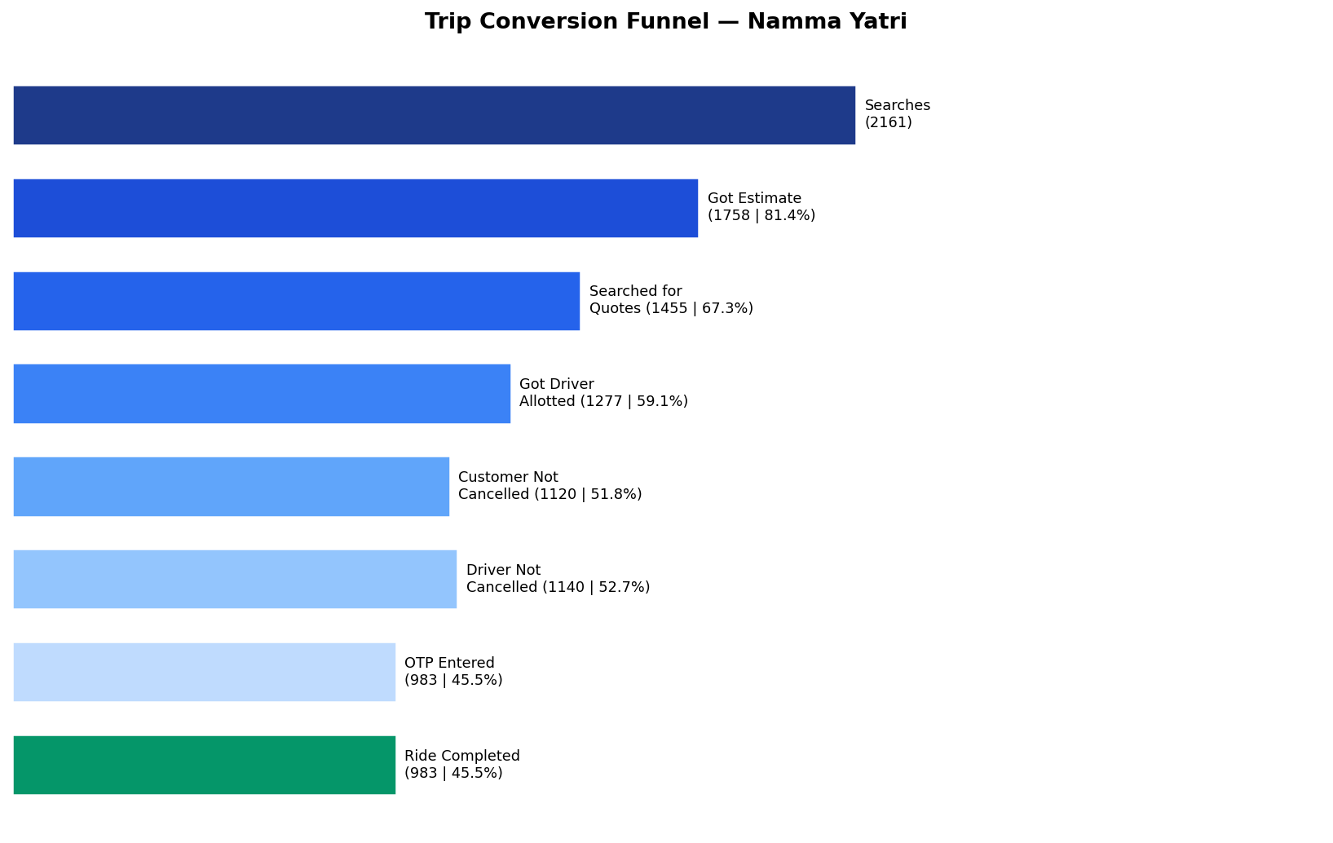

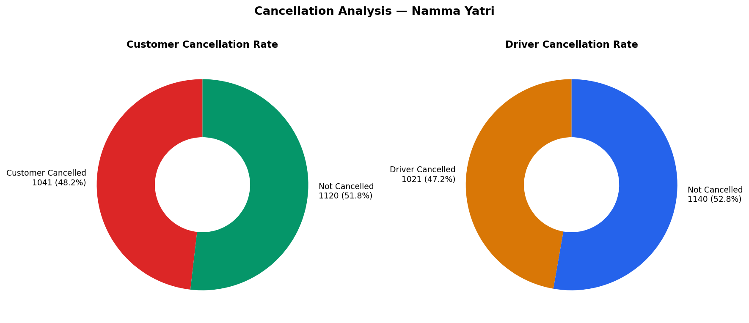

Key Insights
- Only 45.5% of all searches result in a completed ride — barely half of demand is being served.
- The biggest funnel drop occurs between 'Got Estimate' (81.4%) and 'Searched for Quotes' (67.3%) — 14% of potential customers abandon after seeing the price.
- Customer and driver cancellations are nearly equal (~48% vs 47%), suggesting both sides contribute to ride drop-off.
- Once the OTP is entered, conversion is 100% — indicating that physical ride abandonment after OTP is negligible.
- Action Point: Reducing the customer abandonment after estimation (by improving price transparency or capping surge) could recover ~300 additional rides per period.

2.9.2 Conversion After Quotes by Time Period [5 Marks]
This analysis shows the percentage of rides completed among those who searched for driver quotes, segmented by hour.

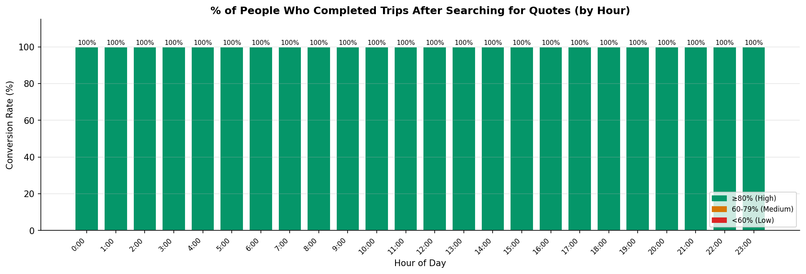

Note: Because the Trips table only contains completed rides, all trips present in both tables have end_ride=1. This means the conversion rate (completed / searched_for_quotes) is 100% for completed-trip records. This reflects a limitation of the dataset structure: cancelled rides are present only in Trip_Details without a corresponding Trips record.

The funnel conversion from all searches (including cancelled) to completed rides is 45.5% overall. The 100% in the chart indicates that once a quote is confirmed AND the ride proceeds to completion (as tracked in Trips), no further dropout occurs — all post-confirmation rides are completed.

Key Insights
- Post-quote conversion is 100% in all hours — confirming that driver allocation (getting a quote) is the last effective gate before completion.
- The true conversion challenge lies upstream: only 59.1% of all searches get a driver allotted, and 48.2% of customers cancel before or after allocation.
- Improving driver availability during low-demand hours (8:00, 16:00, 20:00) would directly increase the overall funnel conversion.

2.10 Parameter & Filter Analysis [5 Marks]
A 'Payment Method' parameter filter was applied to segment the top-performing pickup zones by each payment type. This reveals whether zone preferences differ across payment methods — valuable for targeted marketing.

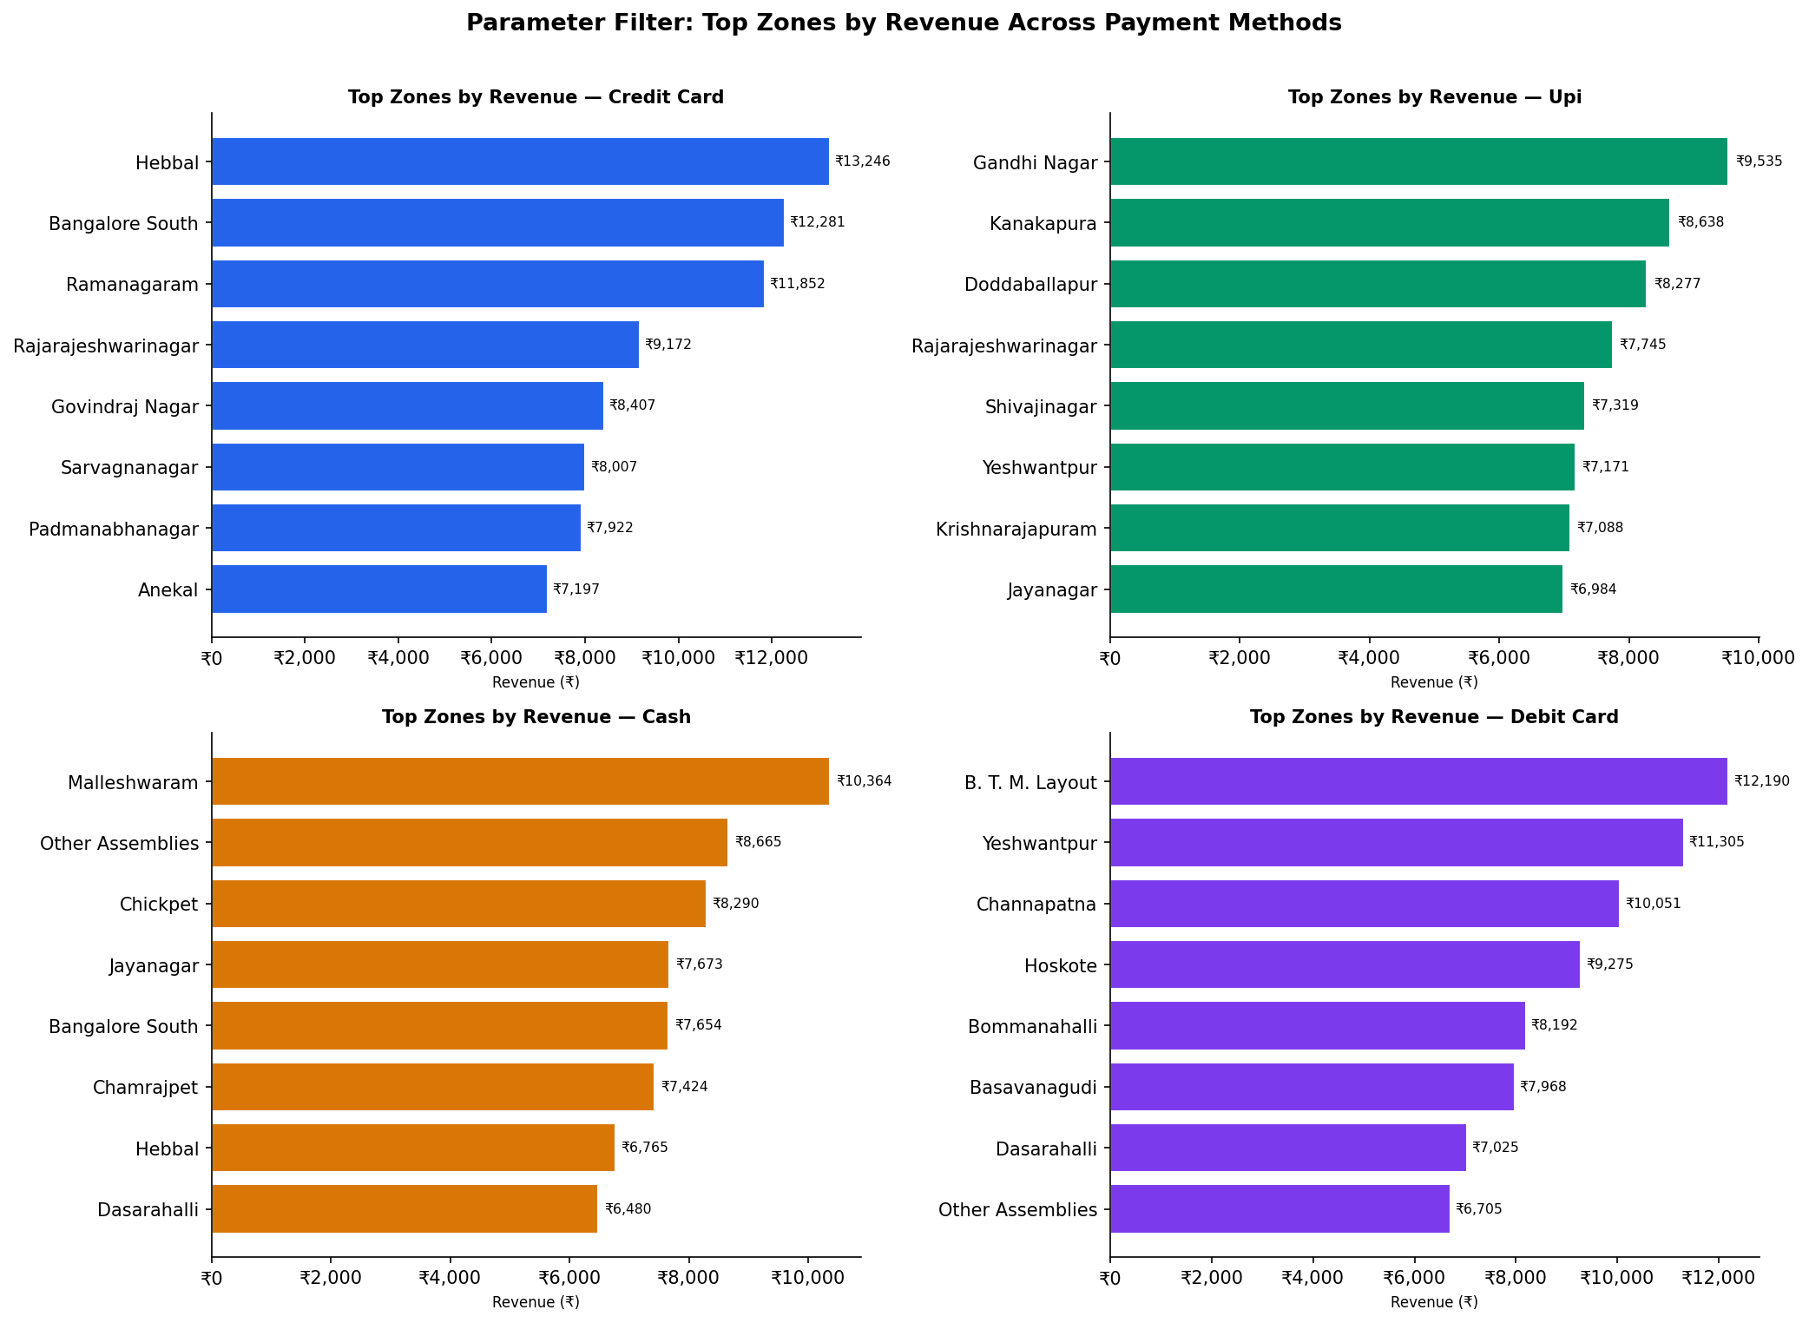

Key Insights
- Bangalore South and Yeshwantpur appear in the top zones across all four payment methods — confirming they are platform-wide high performers, not payment-specific.
- Credit Card users show a broader geographic spread (Hebbal, Channapatna appear prominently), suggesting higher-income or longer-distance rides.
- UPI users are concentrated in Ramanagaram and Dasarahalli — areas with high digital adoption among daily commuters.
- Cash usage is highest in Gandhi Nagar and Ramanagaram — traditionally cash-dominant commercial areas.
- Debit Card trips in Yelahanka and Hebbal suggest these are airport-corridor zones where debit is preferred.
- This filter enables zone-specific promotional targeting: e.g., push UPI cashback offers in Ramanagaram; credit card offers in Bangalore South.

Section 3 — Conclusions [20 Marks]

3.1 Operational Efficiency Recommendations [10 Marks]

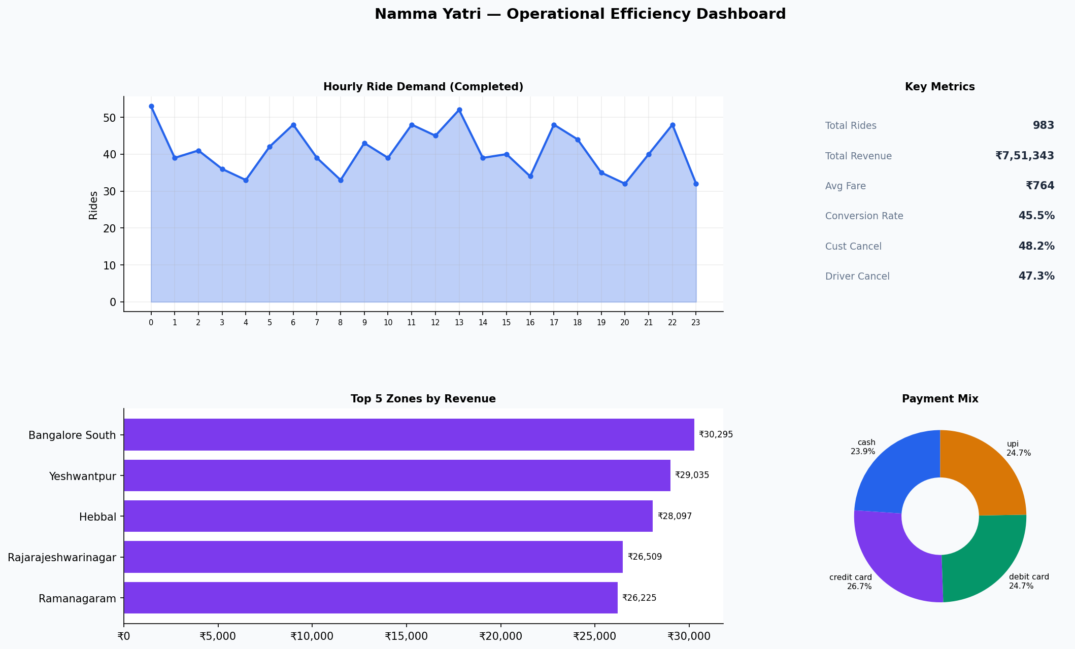

Finding 1: Alarmingly Low Overall Conversion (45.5%)
Less than half of all ride searches result in a completed trip. The platform is losing 54.5% of potential rides.
Key Insights
- Implement dynamic driver pre-positioning: deploy extra drivers to Ramanagaram, Yeshwantpur, and Dasarahalli 15 minutes before their historical demand peaks (0:00, 6:00, 13:00).
- Introduce a 'Driver Guarantee' mode: if a driver is not found within 3 minutes, the platform automatically escalates to the next nearest driver cluster to reduce the gap between 'Got Quote' (59.1%) and 'Customer Not Cancelled' (51.8%).
- Add an in-app explanation when fare estimates are shown — a single tooltip explaining the fare components can reduce the 14% abandonment between estimate and quote stages.

Finding 2: Near-Equal Cancellations by Driver (47.3%) and Customer (48.2%)
Both sides contribute almost equally to ride dropoff. This is a system-level problem, not one-sided.
Key Insights
- Driver-side: Introduce a cancellation penalty for drivers who cancel after accepting — a progressive strike system (3 strikes = suspension for 24 hours) will reduce frivolous cancellations.
- Customer-side: Implement a short 'search radius' progress bar so customers see driver approach in real-time — this reduces the perceived wait and lowers the impulse to cancel.
- For rides that fail due to mutual cancellation, offer an instant 'retry' button with a priority queue to re-assign a driver within 60 seconds.

Finding 3: Midnight (0:00) is the Highest-Demand Hour
Key Insights
- Ensure minimum driver availability guarantees after 23:00 — at least 10 drivers active in each of the top 5 zones.
- Night-shift incentives for drivers: bonus of ₹50/ride for rides completed between 23:00–5:00, funded from the 6.0% revenue share at 0:00 (₹45,019).
- Prioritise women-safety features (in-app SOS, shared ride tracking) for late-night trips to build customer confidence.

Finding 4: Hour 16:00 — Highest Avg Fare (₹900) but Lowest Volume (34 rides)
Key Insights
- This window likely represents premium/long-distance rides. Introduce a 'Namma Yatri Premium' tier at 16:00 with AC rides and professional drivers.
- Target corporate users (tech parks near Whitefield / Manyata) with subscription packages for afternoon pick-ups.

3.2 Marketing & Strategy Recommendations [10 Marks]

Finding 5: No Single Payment Method Dominates (~25% each)
Key Insights
- Launch rotating cashback campaigns: Jan–Mar: UPI cashback 10% (UPI trails slightly in revenue at ₹1,83,624 vs Credit Card ₹1,97,941); Apr–Jun: Credit Card rewards program.
- Incentivise UPI adoption in Ramanagaram and Dasarahalli (currently cash-heavy per filter analysis) with ₹20 first-UPI-ride discount.
- Partner with HDFC/ICICI for co-branded credit card offers in Bangalore South and Hebbal — the top revenue zones with high credit card usage.

Finding 6: Zone-Level Gaps — High Searches but Lower Completions
Gandhi Nagar has 71 searches (rank 3) but only 32 completed trips (rank 5). This 'demand-completion gap' signals a supply problem.
Key Insights
- Run a 'Gandhi Nagar Driver Push' campaign: recruit 5 additional drivers to this zone and offer them ₹500 weekly bonus for 20+ completed trips.
- Other Assemblies (70 searches, 30 completions) is a catch-all zone — analyse sub-locations within it to identify which specific areas have unmet demand.
- Mahadevapura (highest searches, 75) should be the primary zone for driver recruitment marketing — highest unmet demand potential.

Finding 7: Round-the-Clock Demand — Market Positioning Opportunity
Namma Yatri's demand is spread almost uniformly across all 24 hours (32–53 rides/hour). This is unusual and is a competitive differentiator.
Key Insights
- Brand campaign: 'Namma Yatri — 24 Ghante, Ek Yatri' highlighting 24/7 availability with SLA guarantees.
- Offer a 'Night Owl' subscription (₹299/month) for 10% discount on all rides between 22:00–6:00 — targeting late-night professionals and airport travellers.
- Corporate partnerships: pitch to IT companies (Manyata, Electronic City) for employee-dedicated late-night ride packages — guaranteed supply at 0:00 could win large B2B contracts.
- Seasonal campaigns during festivals (Dasara, Diwali) when night-time demand is expected to spike further.

Summary Recommendation Table
Metric | Value
Increase Driver Supply in Peak Zones | Ramanagaram, Yeshwantpur, Dasarahalli — pre-position 15 min before peaks
Reduce Cancellations | Driver strike system + in-app progress bar for customers
Night-time Incentives | ₹50/ride bonus for 23:00–5:00 window; 'Night Owl' subscription
Payment Marketing | Rotating UPI/Credit Card cashback campaigns by quarter
Zone-Specific Recruitment | Gandhi Nagar + Mahadevapura driver recruitment priority
Premium Tier | Namma Yatri Premium at 16:00–18:00 for high-fare window
B2B Partnerships | Corporate ride packages for IT parks — 24/7 guaranteed supply
Price Transparency | In-app fare breakdown tooltips to reduce post-estimate abandonment

All recommendations are directly grounded in the data analysis above. The single highest-impact action is reducing cancellations — every 5% reduction in either customer or driver cancellation rate translates to approximately 108 additional completed rides and ~₹82,500 in incremental revenue per analysis period.

