

Project Report

Project Name – Software Project Management System

Submitted By: Submitted To:
Rajat Kumar (2016ucp1460) Dr. Namita Mittal
Adit Mathur (2016ucp1454) Dept. Computer Science & Engineering
Rahul Kumar (2016ucp1412)
Batch: 2016-2020

1. Introduction

1.1 Purpose
The main objective of this document is to illustrate the requirements of the ‘Software Project Management System’. The document gives the detailed description of the both functional and non-functional requirements proposed by the client.

1.2 Scope
The purpose of this project is to provide an Effective management portal for management of the software projects ongoing in the company and making the management of the employees and projects easier as compared to conventional paper works .The main purpose of this project is to maintain the details of ongoing projects, team members and make it accessible to all the employees working in the company. This project aims effective communication among all its users in an easy way too. This document describes the hardware and software interface requirements of the project. The abstractions and basic structure of the project is described using ER diagrams and UML diagrams.

1.3 Definitions, Acronyms, and Abbreviations
PHP - language used for development
SQL - Structured query Language (Language used for manipulation of
Database)
ERD - Entity Relationship Diagram
UML - Unified Modelling Language
HTML - Hypertext Mark-up Language
JS – JavaScript

1.4 References
Refer to Appendix-1 for all references and direct links.

1.5 Overview
The SRS contains:-
- General description
- Specific requirement
- Appendices

2. The Overall Description

2.1 Product Functions
The Employee Management system is a hierarchy based software which categorizes all employees of company in -
- Admin
- Super Head
- Head
- Managers
- Employees

We have following Phases of a Software Project in a company
- Analysis
- Design
- Coding
- Testing
- Deployment
- Maintenance

These are the common functionalities among all Employees of the company
- They can update their personal Details.
- Can update and reset their password.
- Can send or receive the email
- Can ask for technical help from admin.
- Can see general Project Details except admin.
- Can see current Project Details except admin.
- All of them can track progress of a project except admin.

Specific Features for all kinds of users of the project

- Admin
- Handles localhost E-mail Server
- Has full control over database
- Add other members except Superhead
- Can resolve all the requests made by users.
- Superhead
- Superhead handles all project related details.
- Superhead decides head for particular phase.
- Superhead can track overall project progress.
- Superhead updates general project details for everyone.
- Superhead can access all submissions made by Heads.
- Superhead give commands to Admin before manipulation of database.

- Head
- Head decides the team members
- Head can directly check the phase details of other Head’s too.
- Head can only put the notifications and delete as well.
- Head can see all submissions by Managers.
- Head can report final submission to Superhead.
- Head puts the details of a particular phase of a project.

- Manager
- Manager puts the task for every employee under it directly.
- Manager can view submissions of its employee directly.
- Manager can report to head for the submissions for a particular phase.
- Manager can view all tasks assigned to employee.

- Employee
- Employee can view his current tasks.
- Employee can view his pending tasks.
- Employee can view his upcoming tasks.
- Employee can directly submit his task to manager.
- Employee can view his submissions.

2.3 User Characteristics
All the intended users of this system must have a basic knowledge of using a web application. The admin of the system must have a deep knowledge of database and database management system.

2.4 Constraints
There are certain constraints involved, Admin credential is provided with this software. Admin cannot add Superhead account in the database. Admin needs direct permission from Superhead in order to alter database for changes as per request made by either manager or head. Admin need to look after directory and has to decide read or write decision on various files by priority of working people.

2.5 Assumptions and Dependencies

Adding Admin and Superhead profile into database:-
The Client will contact directly to the developers to add admin and Superhead profile into database. After company received the software, Admin first need to update his/her details personal email is compulsory and same for Superhead account. After these changes has been made company can fully rely on this software, Vendor will then only responsible for maintenance as per requirements.
3. Specific Requirements

3.1 Functional Requirements

3.1.1 Feature – 1: User Login

Purpose | User logs in to system using existing Profile
User | A user with existing Profile
Input Data | Profile username and password and phase except  admin and Superhead
Output Data | Corresponding page data
Invariants | Profile tale data and user information
Pre-Conditions | User is not logged in to a profile, input profile exists in database, user password matches profile
Post-Conditions | User’s computer has been supplied with appropriate cookie, page data is appropriated for selected profile.
Basic flow | Webpage looks up profile data and returns the matching cookie, Webpage is updated to match new user data.
Alternative flow | Invalid password, invalid username or mismatched username and password display error message
Business rules | This allows users to log in to their profile from localhost computers only.

3.1.2 Feature – 2: Add Members

Purpose | Add a user’s Profile to database
User | Only admin is authorized to add the member
Input Data | Profile username and password ,phase, position and personal e-mail of employee
Output Data | None
Invariants | Profile table data and user information
Pre-Conditions | User is not logged in to a profile, input profile does’nt exist in database
Post-Conditions | Usser’s computer has been supplied with appropriate cookie, page data is appropriated for selected profile.
Basic flow | Webpage adds up the profile to database and returns to admin_ profile page
Alternative flow | Username already exists, personal e-mail already in use
Business rules | This allows only admin from localhost computers only to add new members.

3.1.3 Feature – 3: Update profile

Purpose | Modify the profile of user.
User | A user with existing profile who is logged in.
Input Data | New profile details input by user
Output Data | New Profile details are displayed on the page.
Invariants | None
Pre-Conditions | User is logged in to a profile.
Post-Conditions | User’s computer has been supplied with appropriate cookie, page data is appropriated for selected profile.
Basic flow | Webpage updates the profile into database
Alternative flow | If inappropriate details are filled in so appropriate message is shown

3.1.4 Feature – 4: Mark attendance

Purpose | User marks his attendance
User | A user with existing Profile
Input Data | Profile username and password and phase except  admin and Superhead
Output Data | A pop-up confirming marking of attendance
Invariants | Profile table data and user information
Pre-Conditions | User is not logged in to a profile, input profile exists in database, user password matches profile
Post-Conditions | User’s computer has been supplied with appropriate cookie, page data is appropriated for selected profile.
Basic flow | Webpage looks up profile data and returns the matching cookie, Webpage is updated to match new user data.
Alternative flow | Invalid password, invalid username or mismatched username and password display error message
Business rules | This allows users to mark his attendance from localhost computers only and the design of this functionality only marks attendance once a day.

3.1.5 Feature – 5: Submissions (Content Sharing)

Purpose | A user (only employee, Manager and head are allowed to share some files regarding project) wants to share some data.
User | A legitimate user logged into the system.
Input Data | File in form of .png or .jpeg format
Output Data | File ready to be viewed
Invariants | The file
Pre-Conditions | User is logged in, file should be present on computer
Post-Conditions | Any other person to whom content is made available is logged in.
Basic flow | The user uploads the file and according to the position of the user the file is saved into local host and made available to download for intended user to whom the logged user reports.

3.1.6 Feature – 6: Assign Project

Purpose | Superhead receives project from clients and decides overall budget, start and finish date and Manpower and he also appoints head for each phase of the project
User | Superhead of company
Input Data | All project details mentioned in purpose
Output Data | Project details in all project details
Invariants | Project details
Pre-Conditions | Superhead is logged into profile, Project name should not exist in database.
Post-Conditions | User’s computer has been supplied with appropriate cookie, page data is appropriated for selected profile.
Basic flow | The project details are uploaded in database
Alternative flow | Project details if already in database are not added back to database and appropriate message is shown
Business rules | Only Superhead is allow to assign project

3.1.7 Feature – 7: Track Progress

Purpose | A user can track the progress of the project he is part of.
User | Superhead of the company.
Input Data | The name of project and Number of submissions of valid reports by head of each phase to Superhead
Output Data | A bar graph showing the progress of each project
Invariants | None
Pre-Conditions | System must be connected to internet to access java-script files
Post-Conditions | None
Basic flow | The number of submissions get incremented after a submission is approved by Superhead and the graph is plotted after each submission

3.1.8 Feature – 8: Request

Purpose | If a user is facing technical difficulty then he may ask admin for help.
User | All users except admin.
Input Data | A request/help statement to be entertained by admin.
Output Data | The request statement to be displayed to user
Invariants | The uploaded request
Pre-Conditions | User is logged in.
Post-Conditions | User’s computer has been supplied with appropriate cookie, page data is appropriated for selected profile.
Basic flow | The request is written into database and is shown to user on his working page

3.2 External Interface Requirements

3.2.1 User Interfaces

- The entire user interface is designed using HTML, CSS and JavaScript
- The fonts used in the GUI are standard fonts packaged with the default CSS Layout.
- The pop-ups and button layout are generalized for different browsers.
- The minimum screen resolution to be supported is 460x768.

3.2.2 Hardware Interfaces
- The Application is supported onto various hardware platforms like Intel,
AMD etc.

3.2.2.1 Server Side
The web application will be hosted on a web server which is listening on the web standard port, port 80.

3.2.2.2 Client Side
All the information intended to display is displayed on the user’s system

3.3 Software Interfaces
This software is supported on Windows, Linux and Mac OS platforms
The following dependencies are must for a system for smooth functioning of the software:-

3.3.1 Web server
- Apache will be used as web server.
- The user inputs data is the web server using HTML forms.
- The web server executes the PHP as a module and PHP script retrieves the post data if available.
- The web server receives information back from the PHP script.
- The web server displays a HTML page as result to the end- user.

3.3.2 PHP Application
- The actual program that will perform the operations is written in PHP.

3.3.3 MySQL Database
- It is an open source SQL database to store all data which communicates with the application on server.

3.4 Communicational Interfaces
- The HTTP or HTTPS protocols will be used to facilitate communication between client and server.
- Hmail server is used as e-mail server for sending and receiving information through e-mail.

3.5 Memory Constraints
At least 512 MB RAM and 500 MB space of hard disk will be required to run the software.

3.6 Other Requirements
Active Internet connection for password reset feature & for tracking progress of each user and also for Project Overall Progress chart. Chart feature is for trail version only and hence company need to pay additional money to have this feature active for all time.

Appendix – 1:
https://en.wikipedia.org/wiki/Software_project_management
http://php.net/manual/en/intro-whatis.php
https://canvasjs.com/php-charts/column-chart/
https://www.w3schools.com/html/
https://www.w3schools.com/css/
https://www.javascript.com/
https://en.wikipedia.org/wiki/Project_management_software
https://www.apachefriends.org/download.html
https://www.hmailserver.com/documentation/v5.6/?page=overview
http://squirrelmail.org/documentation/
https://www.webslesson.info/2018/07/live-chat-system-in-php-using-ajax-jquery.html

Appendix-2
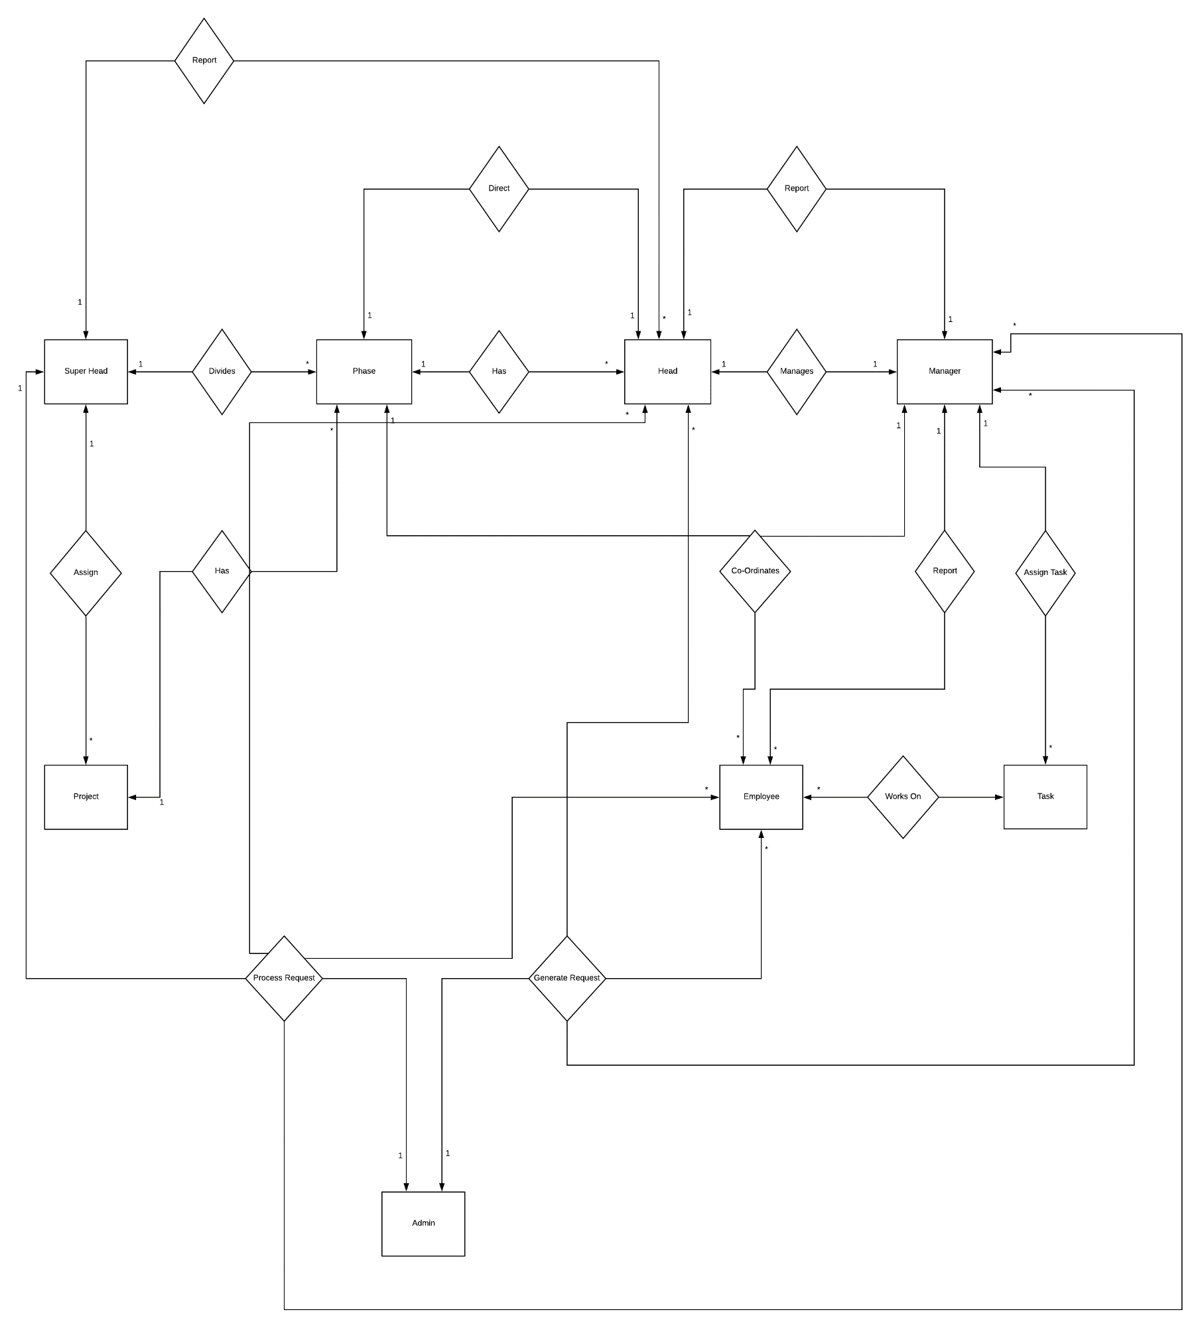
Entity-Relationship Diagram
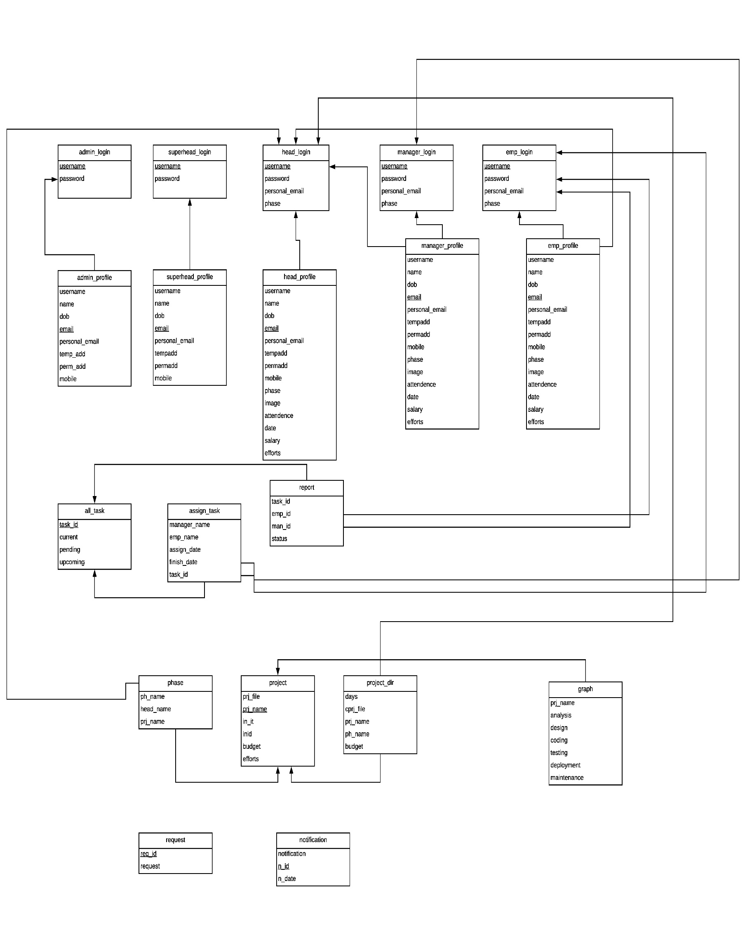
Relation Schema Diagram

