Tent House Rental
Functionality Description Document

This document is a property of Mindfire Solutions and contains some confidential information and hence no part of this document should be distributed or copied elsewhere without permission of PL/TL/AL. This document is for internal purpose only.

Change Log
# | Description | Author | Date
1 | Backend Project Setup | Rajat Verma | 01/12/22
2 | Frontend Project Setup | Rajat Verma | 01/12/22
3 | DB Creation and integration | Rajat Verma | 01/12/22
4 | UML Design | Rajat Verma | 01/12/22
5 | Create Model on User, Product, Transaction | Rajat Verma | 02/12/22
6 | Create README.md file | Rajat Verma | 02/12/22
7 | Create Login/Signup API for user | Rajat Verma | 02/12/22
8 | Create Rent Product API | Rajat Verma | 05/12/22
9 | Create the Inventory Summery API | Rajat Verma | 05/12/22
10 | Create Add Product, Delete Product, Get Product API | Rajat Verma | 06/12/22
11 | Create the Transaction Details API | Rajat Verma | 06/12/22
12 | Create the Out Product API | Rajat Verma | 07/12/22
13 | Create Sign UI | Rajat Verma | 08/12/22
14 | Create Login UI | Rajat Verma | 09/12/22
15 | Create Product table UI (with sorting and pagination) | Rajat Verma | 12/12/22
16 | Create Inventory summary UI | Rajat Verma | 13/12/22
17 | Create Transaction UI | Rajat Verma | 13/12/22
18 | Create Profile Page UI | Rajat Verma | 14/12/22
19 | Implement the Pop for Validation | Rajat Verma | 14/12/22
20 | Implement the PDF Button download | Rajat Verma | 14/12/22

Table of Contents
1. Overview 4
2. Features 4
Milestone 1 : worked on Basic Features.............................................................................5
Milestone 2 :
3. Technologies Used …............................................................................................................6

1. Overview
This project is the Tent house rent project. where user can take the different items on rent. User can see the their transaction , which he already done in the past.

2. Features
Milestone 1: Worked On the Basic Features
- User can create new account.
- User can login their account.
- Here is the product list , where user can see all the products and their price and stock quantity.
- User create new transaction , where user take new item for the rent.
- User can return the product.
- User can see the their transaction , which he done in the past.
- User can see their profile details like (name, email, transaction history).
- User can download the table of inventory with pdf format.
- In the table shows the pagination where next and previous button implemented.

3. Login -

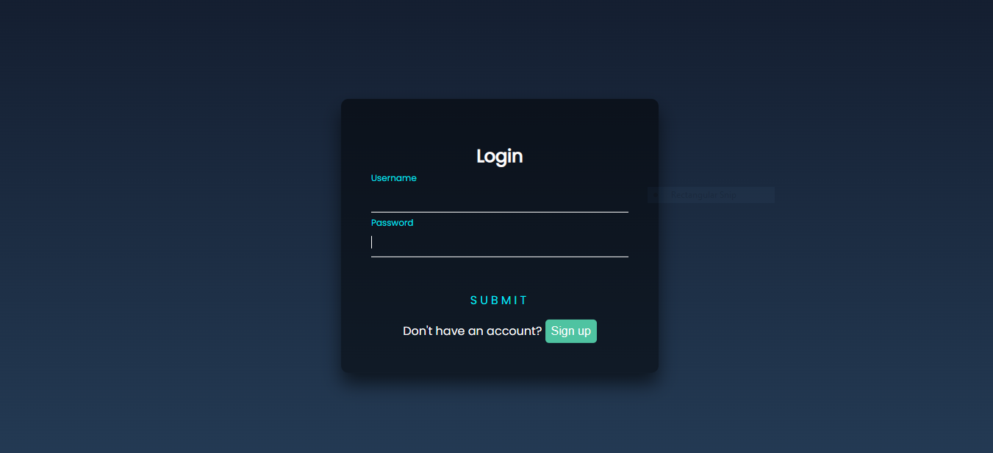
- Sign in -
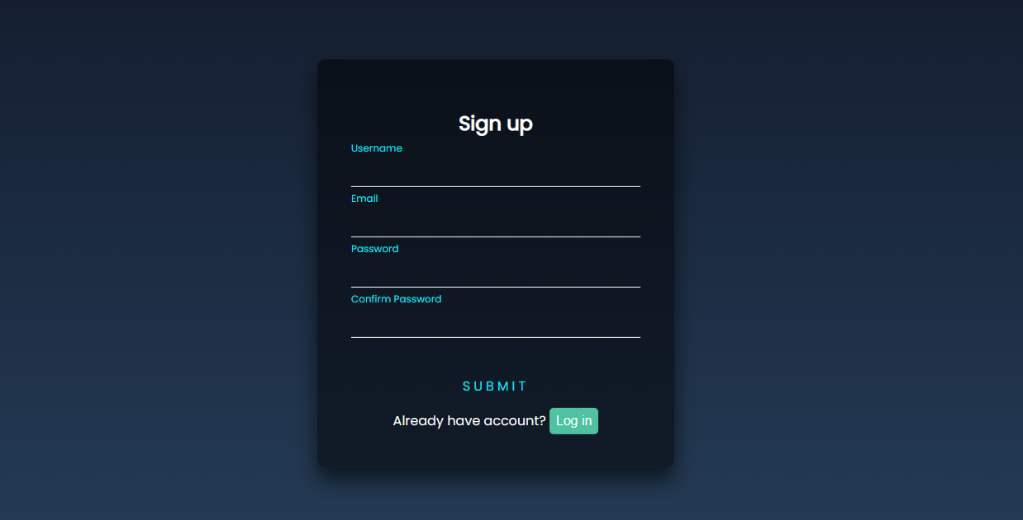

- Dashboard -
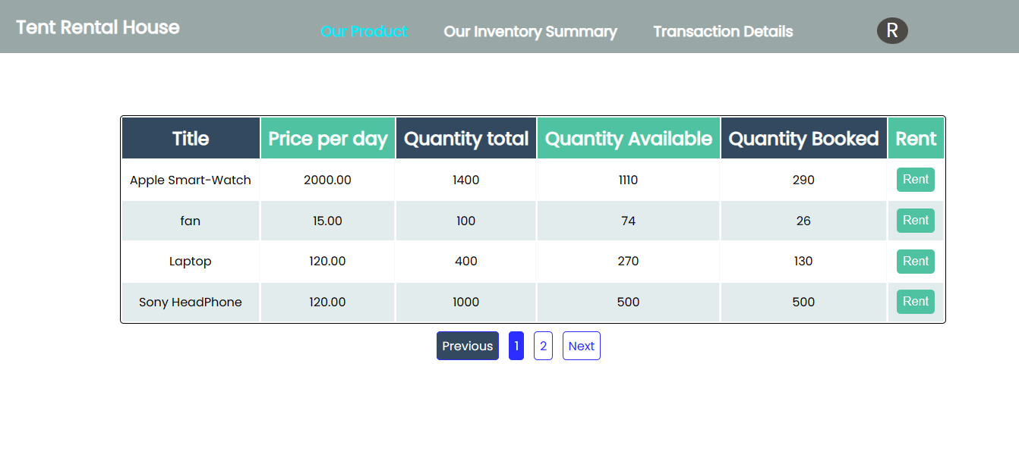

- Inventory -
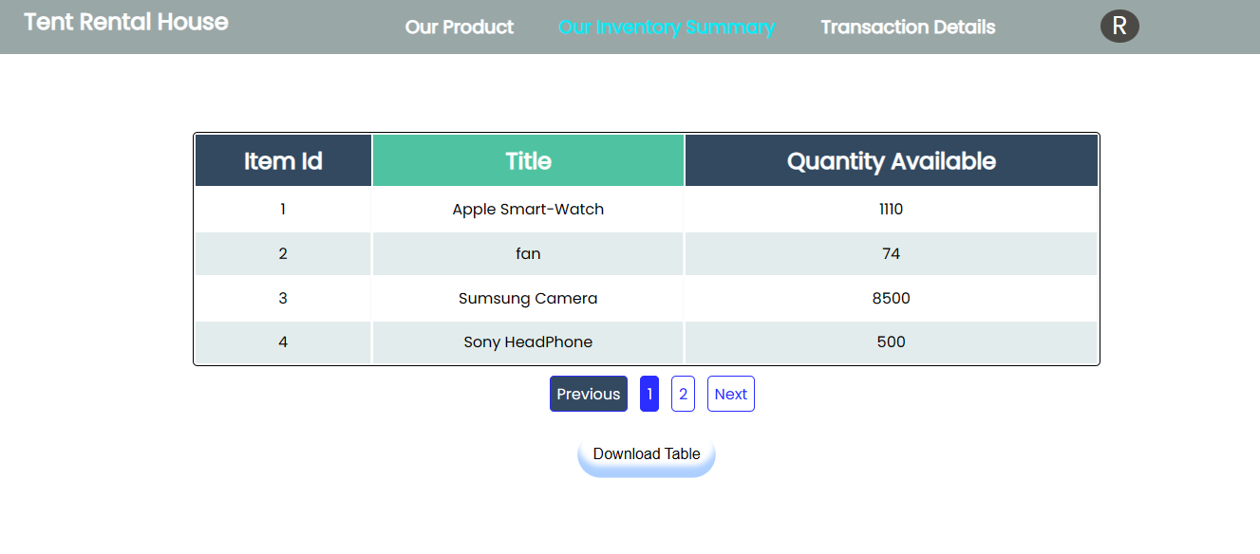

- Transaction Page -
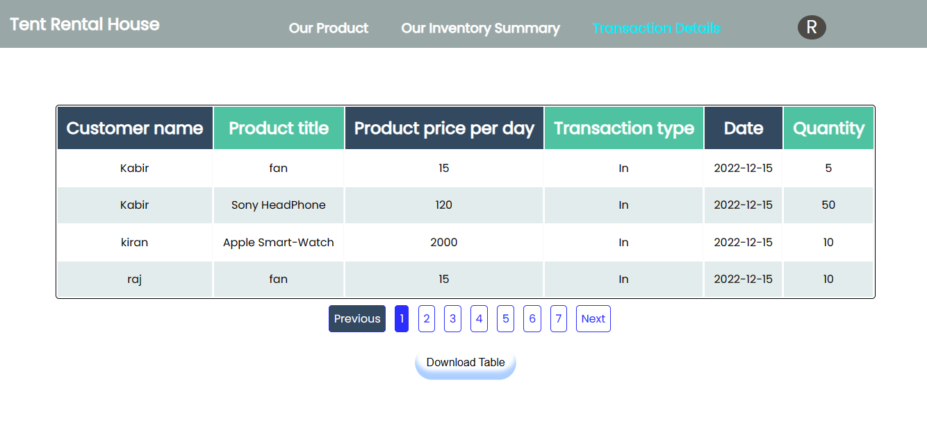
- Profile Page -
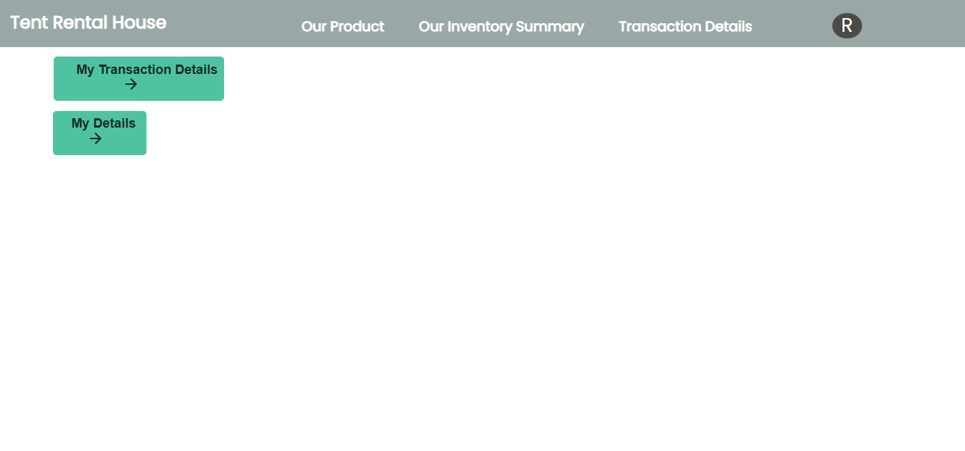

  - Profile page with table -
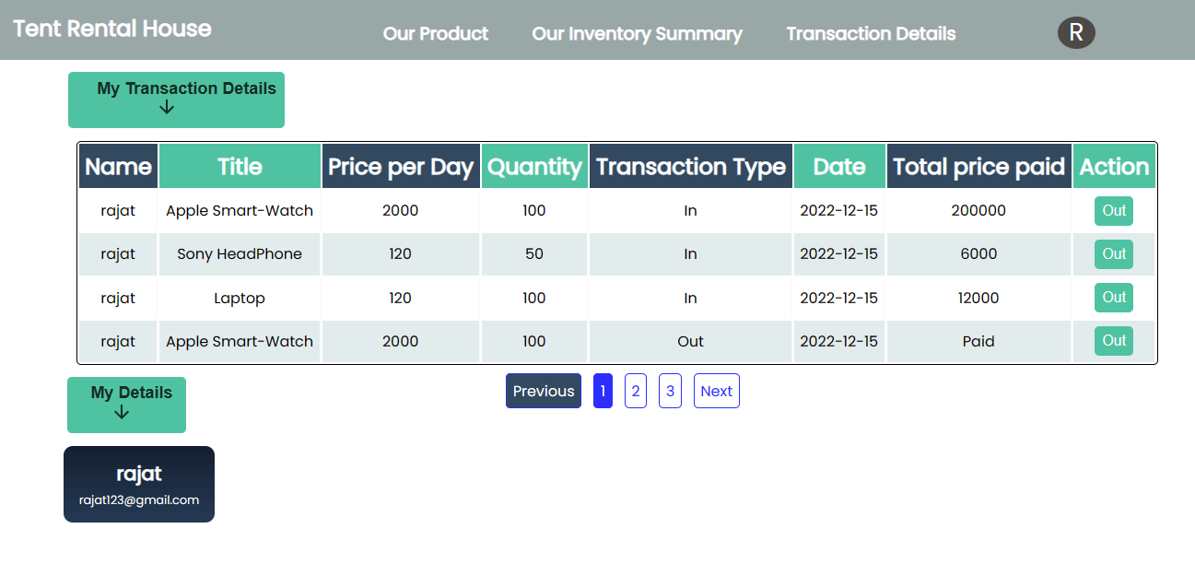

- Order Rent Page-

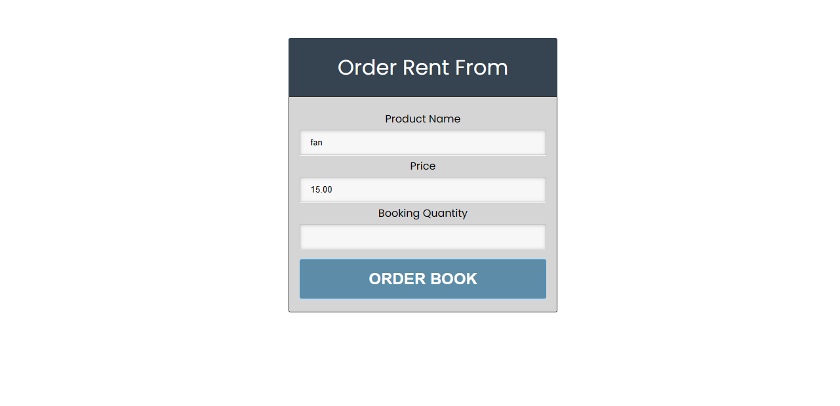
  - Product Return Page -
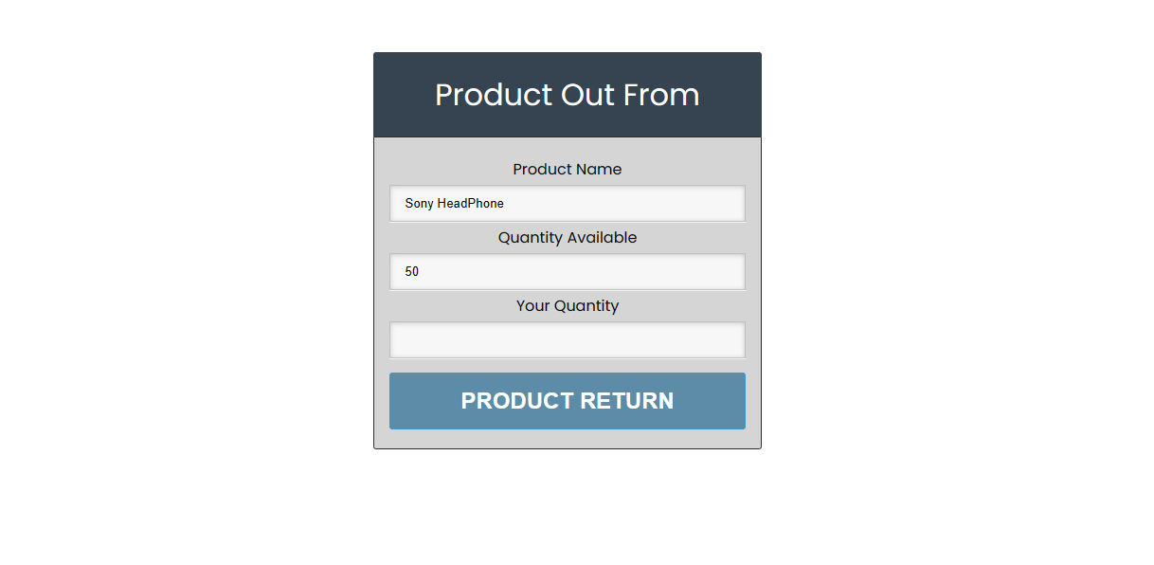
- Thanks Page -

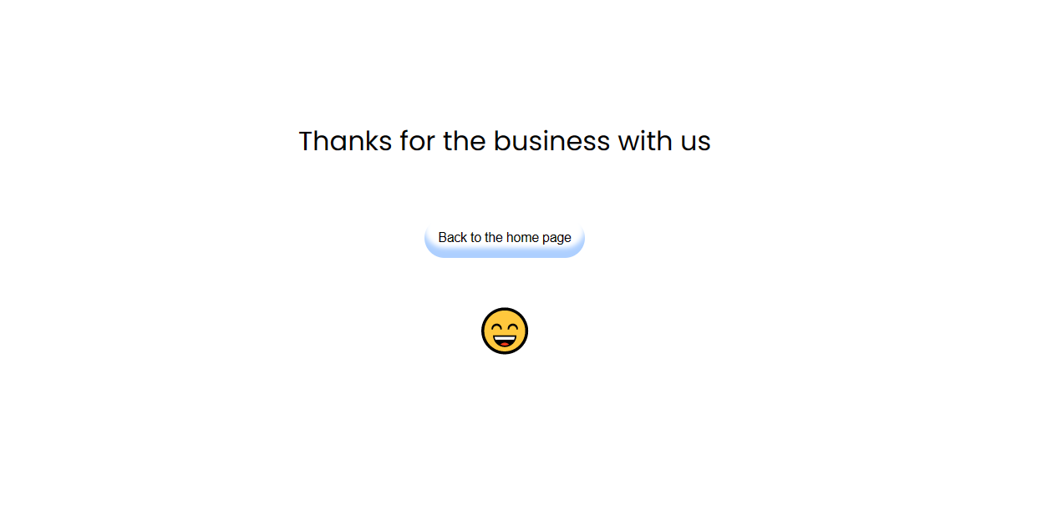

3. Technologies Used
- Python
- Django
- React JS
- PostgreSQL (Database)
- Package in React JS
- Material UI
- React-paginate
- jspdf
- react-router-dom
- axios

