**CSK**

**Pre-processing of dataset:**

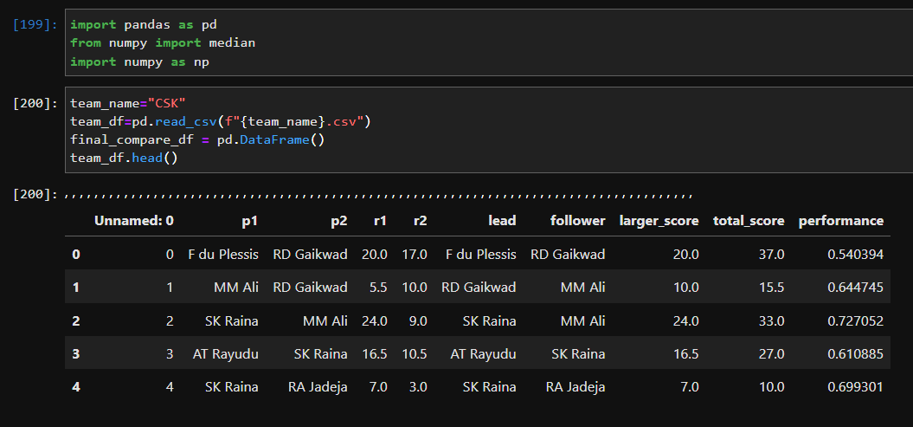

**Creating undirected graph from the csv file**

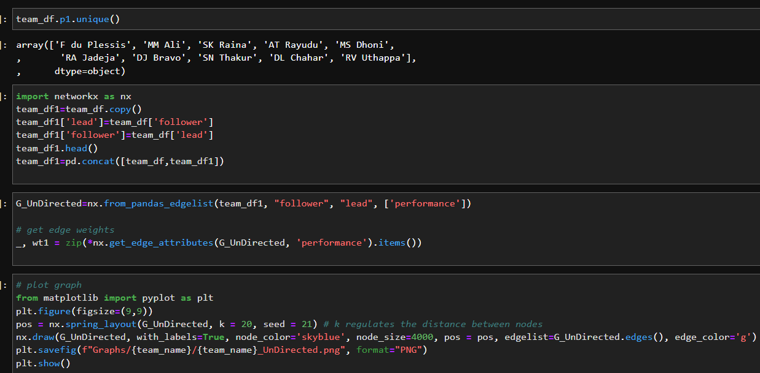

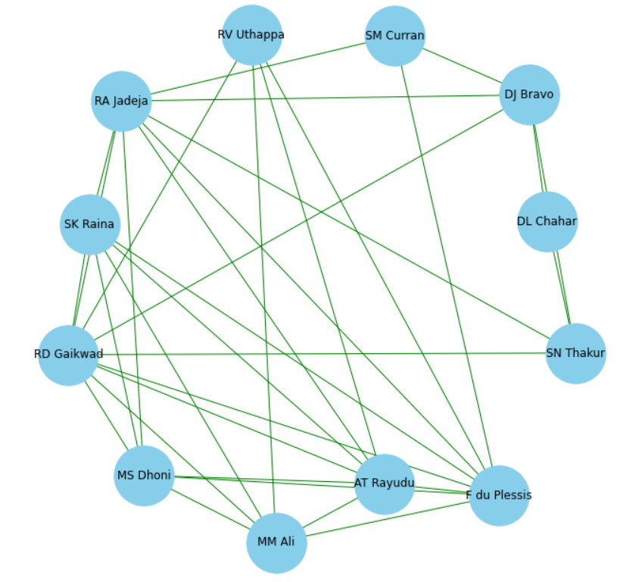

**Creating directed graph from csv file**

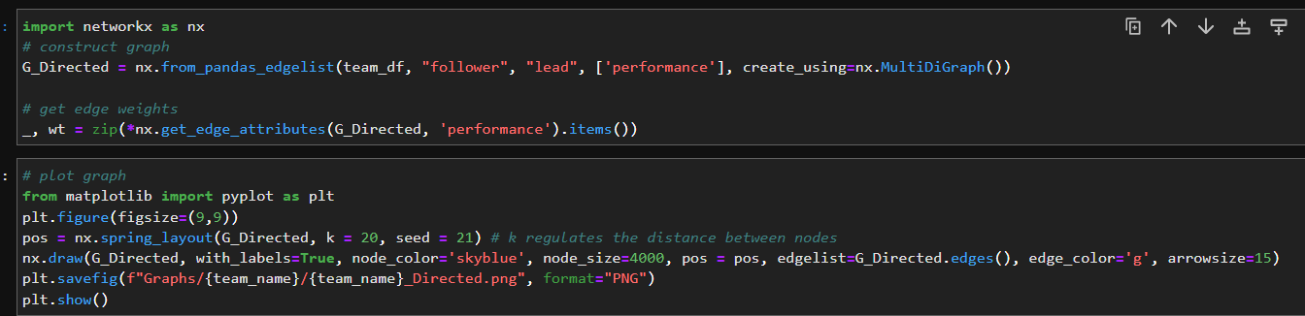

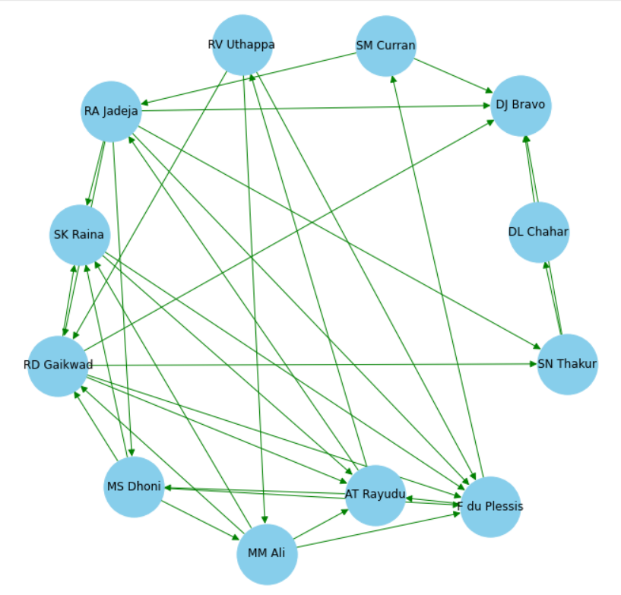

**Measures:**

**Degree of each node of graph**

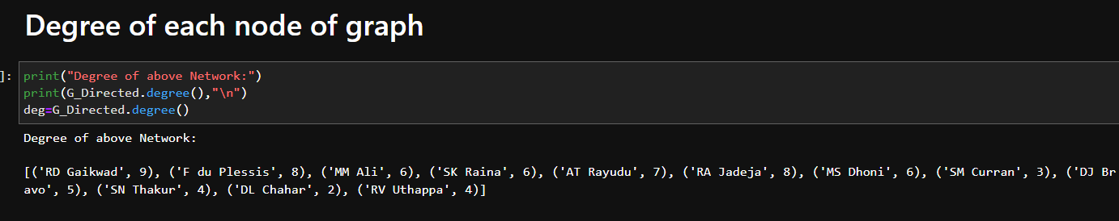

**In-degree of each node of the graph**

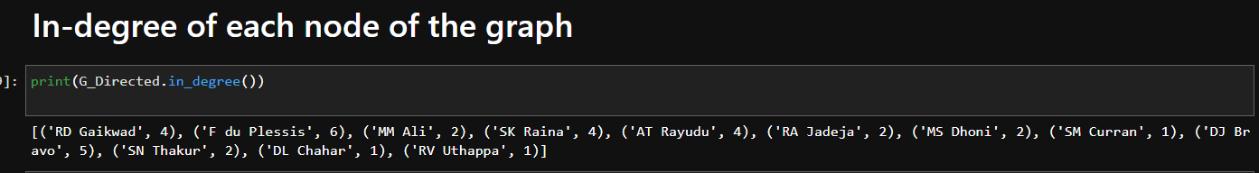

**Out-degree of each node of the graph:**

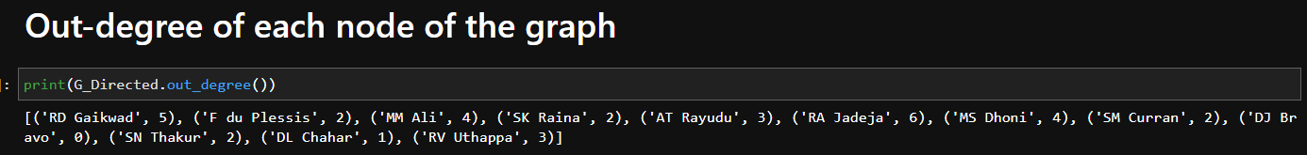

**Normalized Degree Centrality:**

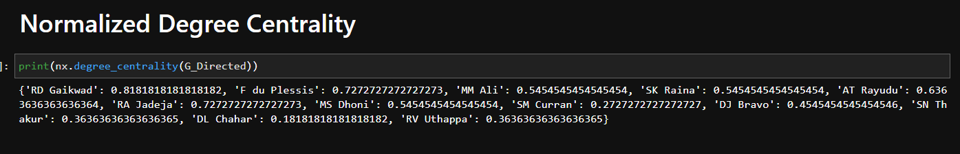

**Closeness Centrality:**

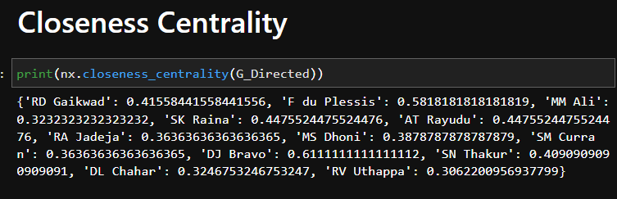

**Betweenness Centrality:**

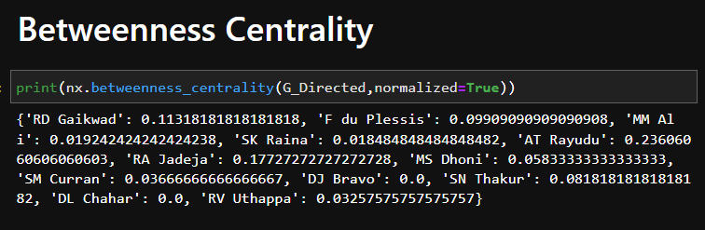

**Reciprocity:**

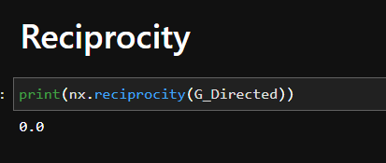

**Density:**

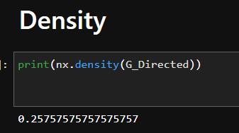

**Complement of a graph (Graph Visualization):**

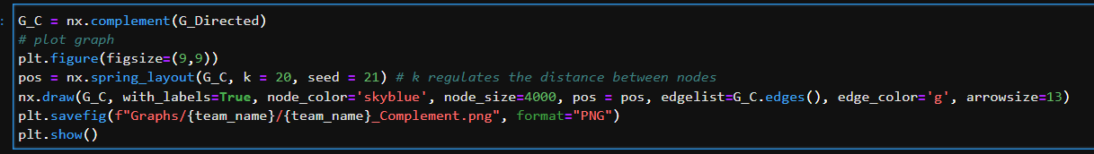

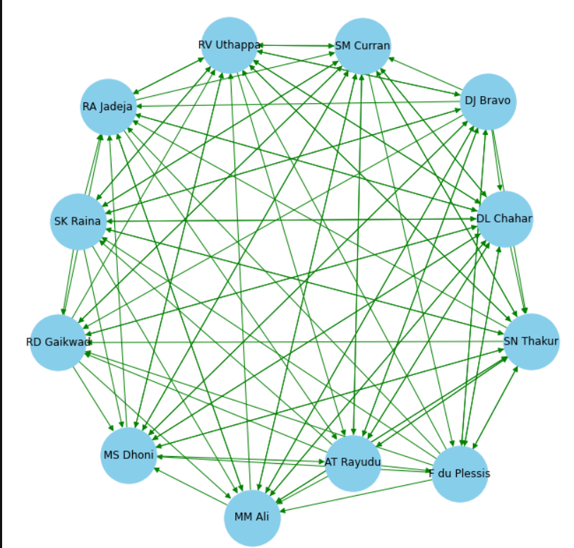

**Shortest path lengths between all pairs:**

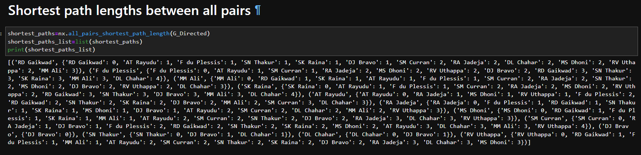

**Diameter of the graph:**

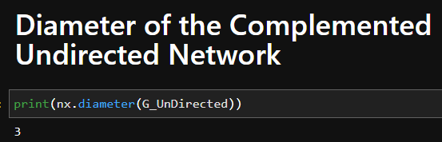

**Eccentricity of all the nodes of the graph:**

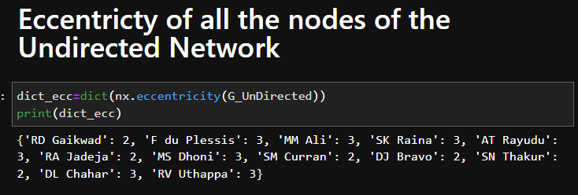

**Implementing the Girvan-Newman Algorithm for Community Detection in Python:**

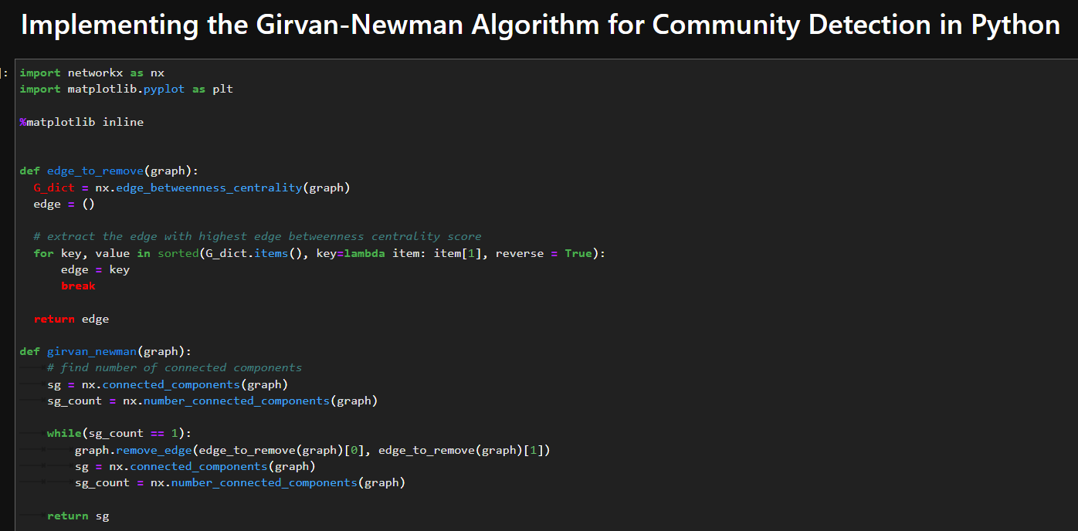

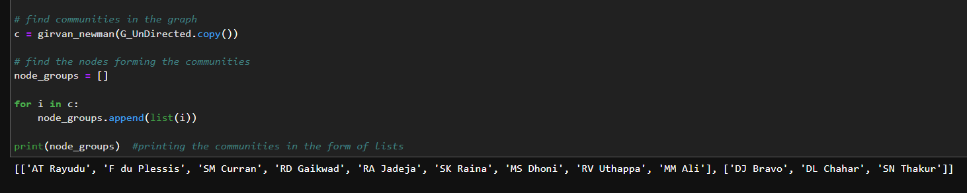

**Plotting the Communities:**

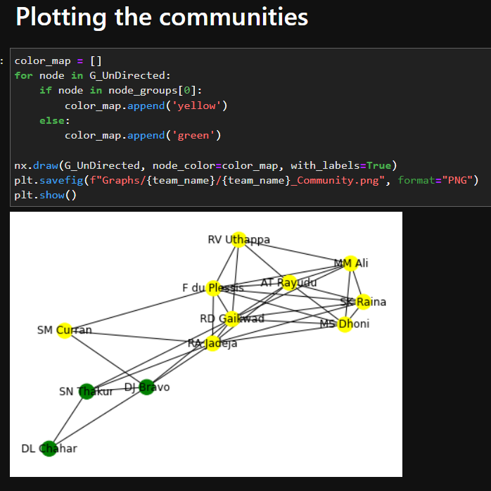

**Clustering:**

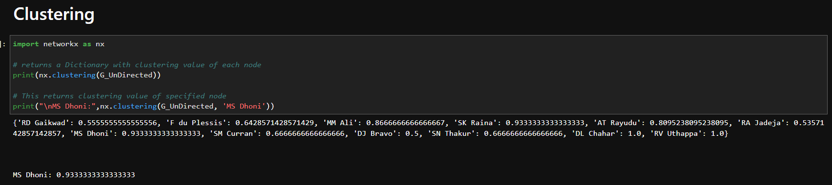

**Graph connectivity measures:**

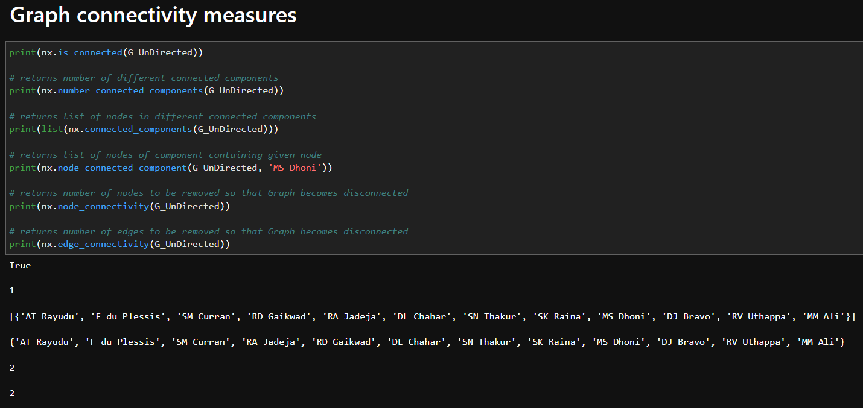

**Modularity of the graph:**

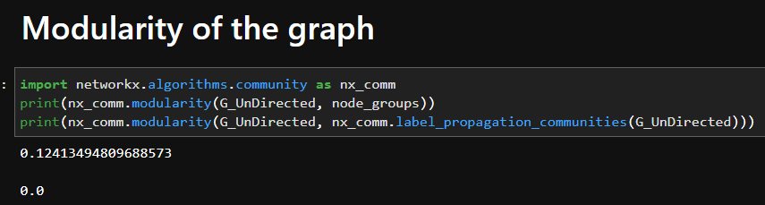

**PageRank:**

