Download:

* NPM (node j)s🡪 <https://nodejs.org/en/download/>

**Npm -version**

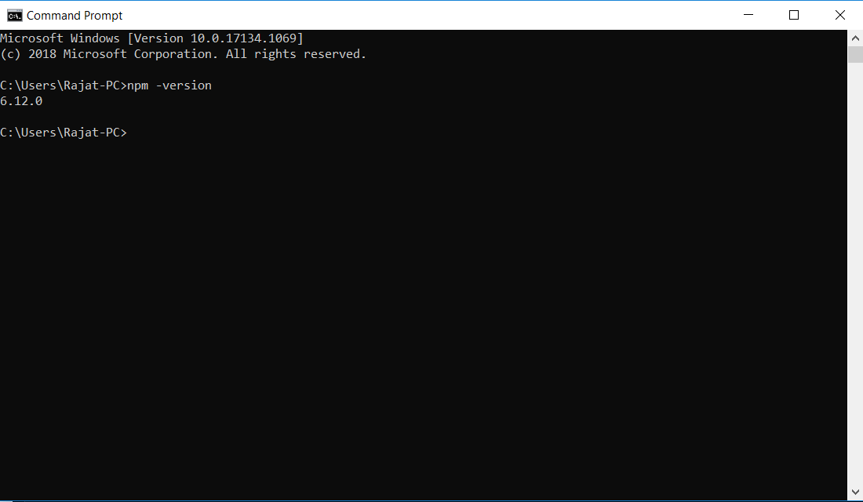

* protractor 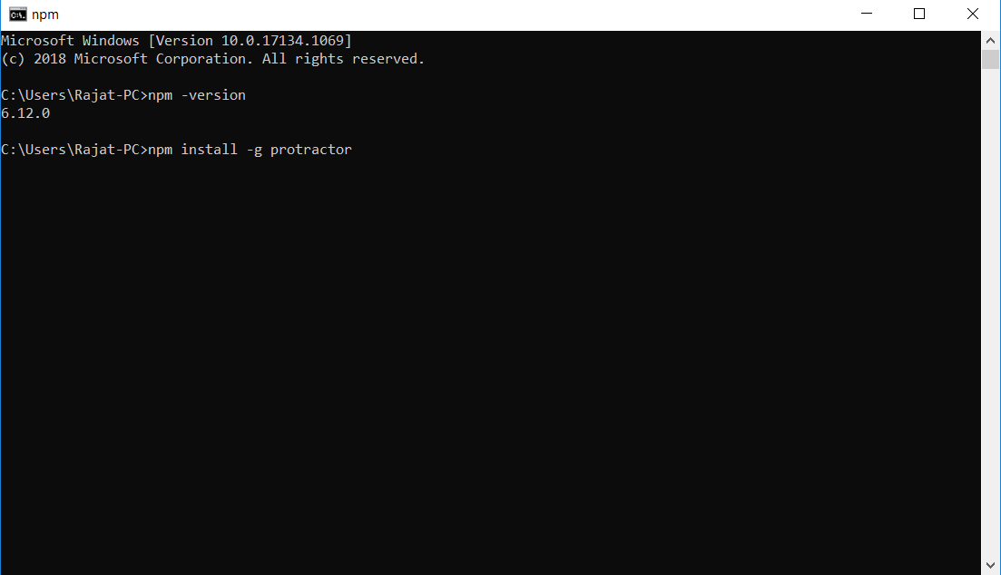
* WebDriver Manager

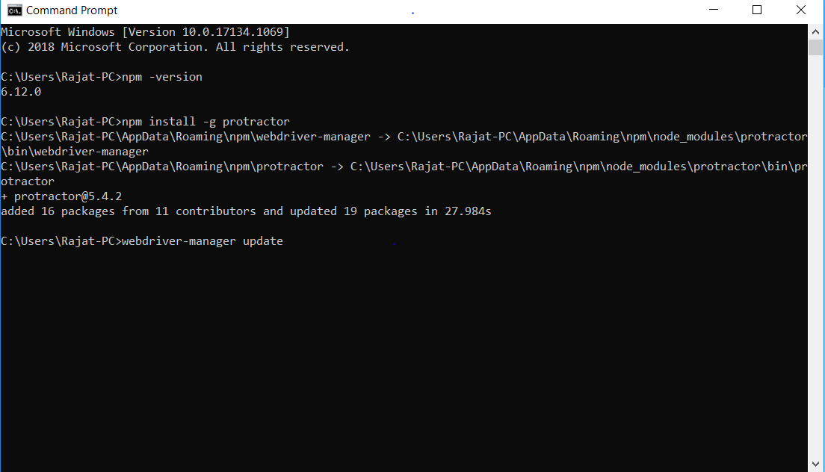

* JDK
* Webdriver manager start

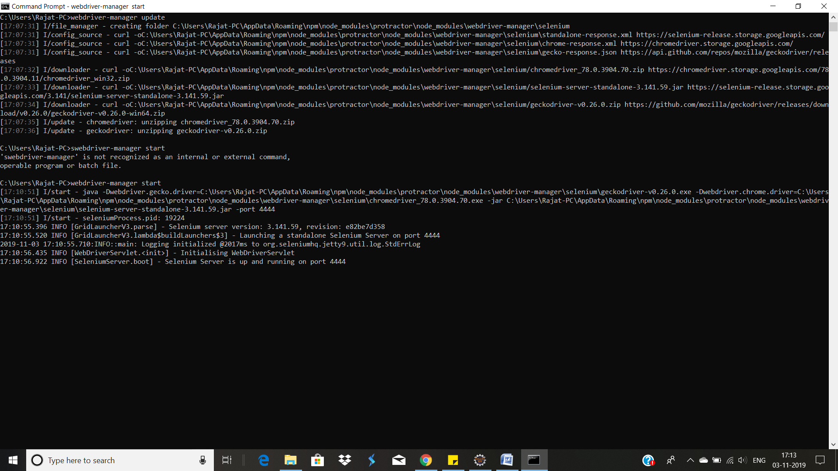

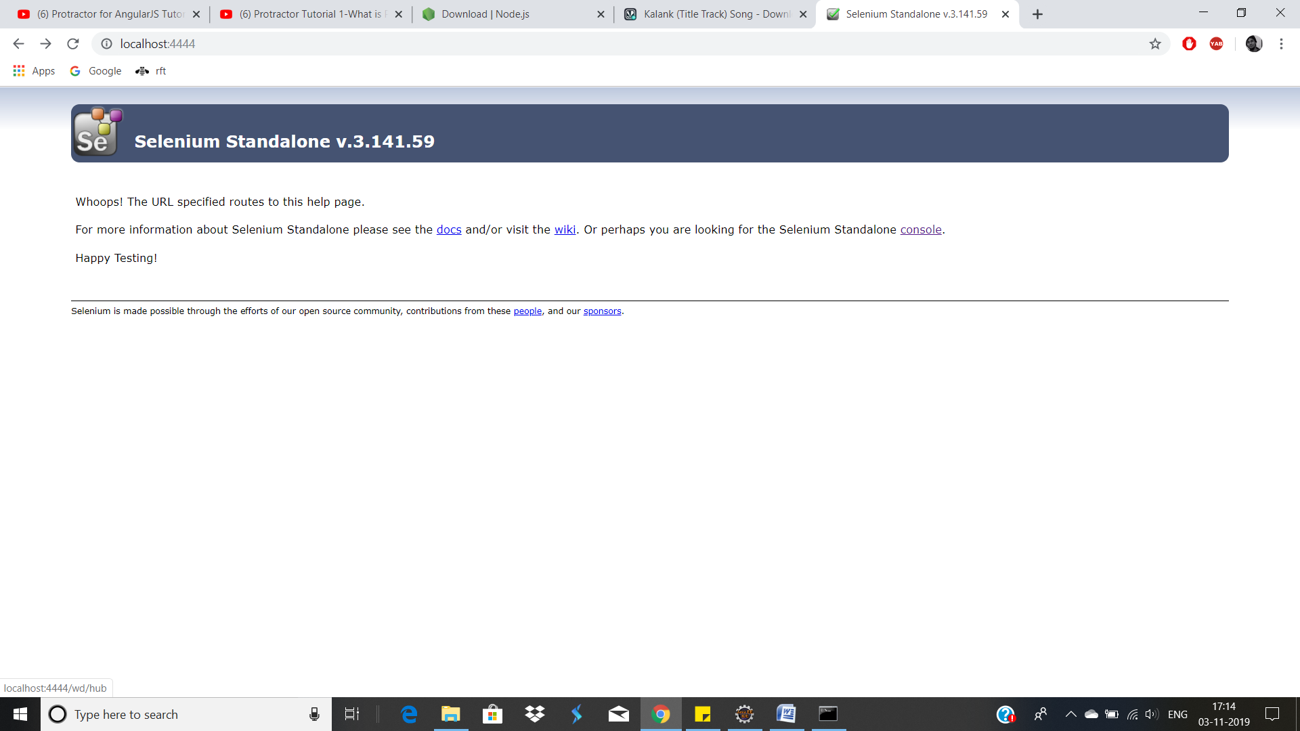

* Visula studio code

**Project Setup**

* Npm init 