**Analog Gauge Reader**

**User Guide**

* Unzip the folder

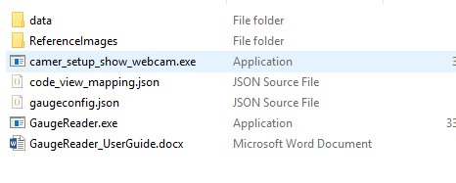

* You will find:
  + data folder - all test images and videos are in this folder

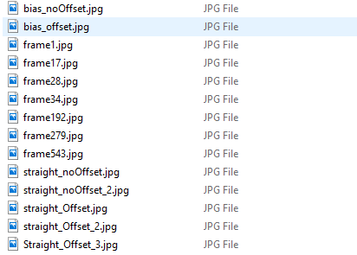

* + ReferenceImages folder has a reference image, it is used to process image.
  + config files - there are 2 config files
    - gauge config - these are used to configure Gauge Reader settings
    - code_view_mappings maps the loc_code to image names
* Camer_setup_show_webcam.exe can be used to select the input camera in case there are multiple camera available, it will give the input device number which then then be fed to camera attribute in gaugeconfig.json config file
  + GauageReaderAPi.exe is the api exe double click the executable, this will start the service. [Some users might face issues with launching this due to Symantec Endpoint Protection blocking the app, you can try marking this app as safe/ take no action in the Symantec settings]
  + The service will take some time and create a local end point, the address will be displayed on the app’s black command prompt type window.
* Open a browser and launch the local site
* http:/127.0.0.1:5000
* Use the below query string
  + <http://127.0.0.1:5000/?functional_loc_code=PL22-LAB-MG&path=test/17.07.19-09.49&frames_to_process=10>
  + functional_loc_code, path and frames_to_process are the parameters
* You can use different values for functional_loc_code available in code_view_mappings json file to test different files
* While in debug mode, which can be changed from gaugeconfig.json config file’s debug attribute, for live feed we have special functionality to show the input live feed so that the user can adjust the gauge position and distance from camera.
  + When you hit the url with parameters for processing live feed, a input feed window will be launched
  + User can adjust the camera by using the live feed show, the processing will not be started at this time
  + User must press ‘s’ key to start processing the frames in this mode.
  + When debug mode is False there will be no input feed video to assist the gauge placement and the program will start capturing frames as soon as you hit the url
* The "path" query string is where the output will get saved. you can examine the files and detailed reading values in the Logdir folder
* The frames_to_process is used to get the frame count when Video is processed, the specified number of frames will be processed in the video file mentioned as functional_loc_code in query string.

