San Francisco - Admin Guide: Overview & Login Instructions
This document provides a comprehensive overview of the hackathon environment, including instructions on how to use the provided credentials and securely access all enabled services that are part of the setup.
User & Access Structure 1
License Allocation 1
Access Copilot Studio 1
Access the M365 Portal 2
Support Contact 3
Environment Access and Licensing Summary

User & Access Structure
- A total of 50 users are organized into 6 teams, with 5 users per team.
- Additionally, 4 admins are created.

License Allocation
License Type | Number of Licenses
Copilot Studio GCC | 54
M365 Copilot GCC | 54
Microsoft 365 G3 GCC | 54

Note for the Trainers / Admins:
It is important that you test the hack environment end-to-end at least one week before the actual hack. This will help ensure there are no issues, misconfigurations, or missing setup items, including anything that may have been overlooked during the initial requirements. This preparation is critical to avoid last-minute issues and to ensure a smooth and seamless experience for the attendees.
Access Guide: Overview & Login Instructions
This document provides a comprehensive overview of the hackathon environment, including instructions on how to use the provided credentials and securely access all enabled services that are part of the setup.

Access Copilot Studio
- Open the following link: 👉 Copilot Studio
- Sign in using the same credentials.
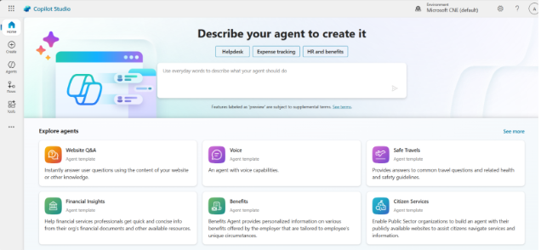

Access the M365 Portal
- Go to the portal using the following link:
👉 M365 Portal
- Log in with the credentials provided by your trainer.
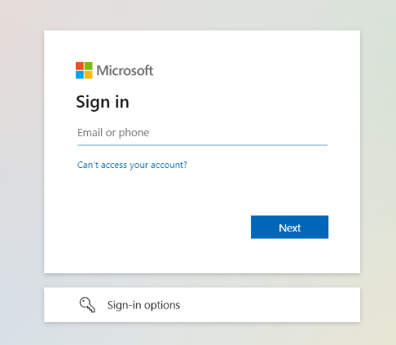
- On the "Stay signed in" page, click Yes.
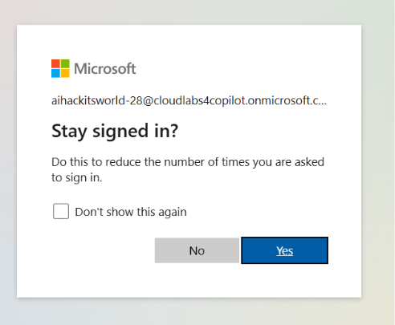
- Upon login you will see M365 Copilot window that you will be using throughout the hack.
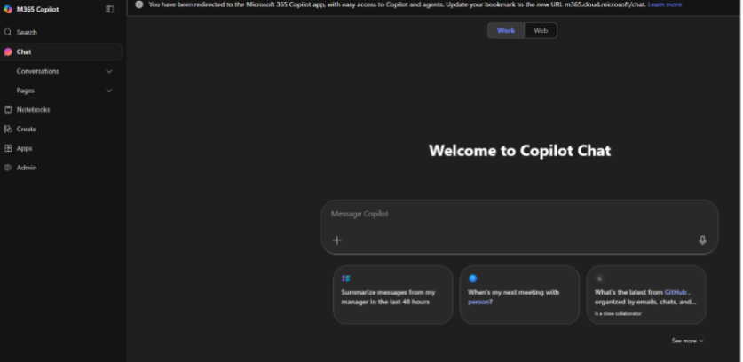

Support Contact
Teams Channel Setup (Will be created by: Rajat) to be used for the purpose of issue reporting, escalation and real time coordination.
Members to include
- Technical Team
- Support Team
- Cynthia
- Melanie
- Local Microsoft team
- Pre-event call attendees

Scenario | Response Time
Teams/email acknowledgment | 24 business hours
Live ongoing event issue | 15 minutes

Urgent requests must use subject: “Immediate Support Required” and sent to below email
Email Support: cloudlabs-support@spektrasystems.com
For Live Chat Support: https://cloudlabs.ai/ms-support

