Consider the disk characteristics in Figure 12.9, which appears to match the characteristics of the Toshiba MQ01ABD032. For this disk, the sectors are 4096 bytes each. Although the number of sectors per track will change based on the recording zone (see below for a generic diagram of zoned recording), assume 200 sectors per track, and assume that reading a sector requires 1/200th of the full revolution time (note: this is after any required seek and rotational latency).

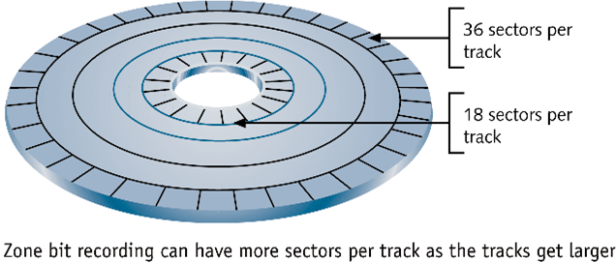

1. What is the average rotational latency?

5400 rpm = 5400 / 60 rps = 90 rps = 1/90 seconds/rotation = 11.11 milliseconds/rotation

Average Rotational Latency = ½ rotation = **5.55 milliseconds**

2. What is the time to read 1000 random sectors in FIFO order, assuming that each seek takes the average seek time?

1000 sectors * (12 ms avg seek + 5.55 ms avg rot + 11.11 ms per track/200 sectors per track) =

17600 ms = **17.6 seconds**

3. What is the time to read 1000 independent sectors, assuming that they are ordered such that each seek after the first one takes only the track-to-track seek time?

1000 sectors * (2 ms t-to-t seek + 5.55 ms avg rot + 11.11 ms per track/200 sectors per track) + 10 ms extra for 1st seek = 7610 ms = **7.61 seconds**

4. Assume that 1000 related sectors are allocated contiguously such that they are contained on five adjacent tracks on one surface. What is the time to read the five tracks, assuming one average seek time and four track-to-track seek times, and assuming that full-track buffering is used so that there is no (or negligibly little) rotational latency?

12 ms + 4 * 2 ms + 5 * 11.11 ms = **75.6 ms**