Use the following FAT diagram to answer questions 1-5. Assume each disk block is 1 KiB in size. The encoding in the FAT is “x” for cannot be used, dash for free, 0 for last block in file, and a number 2-31 for the next block in a file. Treat "Start Sector" in a directory entry as a synonym for "First Block".

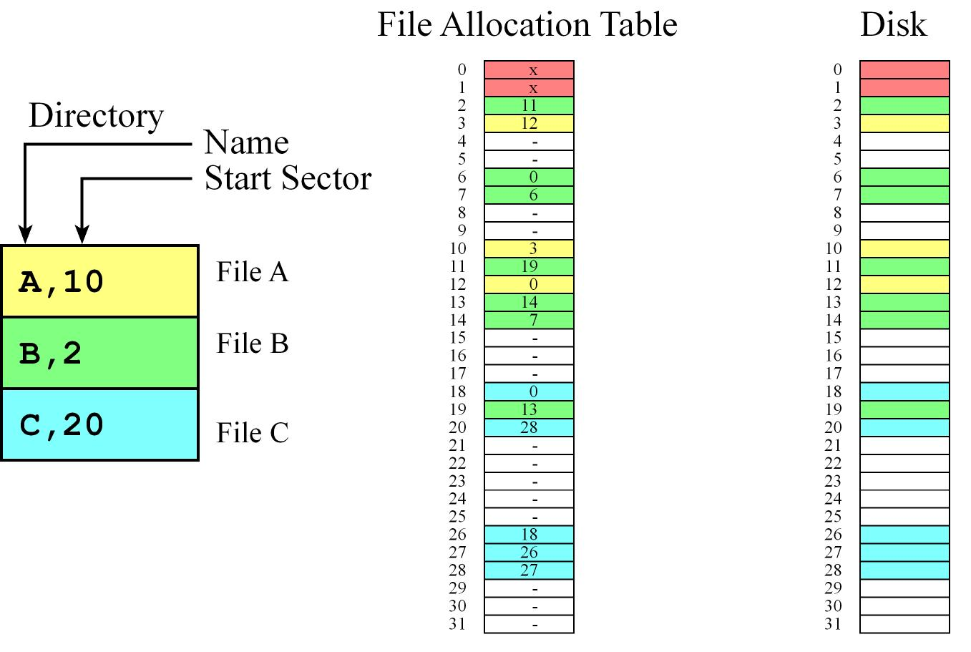

1. What is the disk block number of the disk block that holds the first byte of file A?

10

2. What is the disk block number of the disk block that holds the last byte of file A?

12

3. Assuming file A uses only 512 B of its final disk block, what is the size of file A in bytes?

2.5 KiB

4. If you open file B and read 2048 bytes, from which disk block(s) will you be reading?

2, 11

5. If you open file C, seek to byte 2500, and read 16 bytes, from which disk block(s) will you be reading?

27

6. Give at least one reason why the tree structure in an FFS inode is asymmetric.

Better storage organization for small files (in particular, you don’t have to traverse indirect blocks).