Rajat Sethi – CPSC 3500 – Assignment 5

1a.) 011 and 0000

1b.) 0 and 10

1c.) This FA contains all strings from the alphabet {0, 1} that does not end in “10” – Not including the empty string and “0”

2a.) An NFA with the parameters described in P would have a “start” state, followed by a 1-transition, and then “m – 1” amounts of “0, 1” transitions, looking something like this.

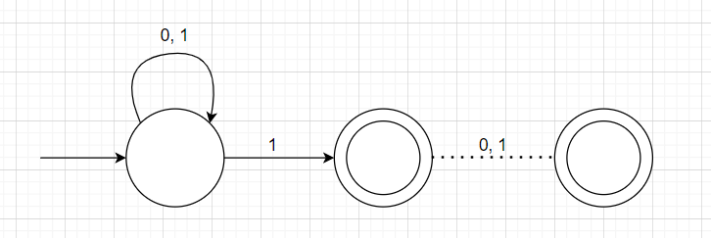

Where the dotted line represents “m – 1” states and “m” transitions of “0, 1”.

Side Note: The state right after the “1” only accepts in the case of P1. For m>1. it should be a reject state.

2b.) For every “0, 1” transition in the NFA, the DFA would have to split into a separate 0 and 1 transition like a BST. Once it reaches the accept states at the tree’s bottom, the transitions out of those states will have to go back into the tree based on what original path it took from the “mth to the last ‘1’ character” (Shown in 2c). As such, for every level of the tree, the number of states multiply by 2, which means that the tree has a total size of $\sum_{i=0}^{m-1}{2^{i}} = 2^{m} – 1$. Since the start state is detached from the tree (demonstrated in 2c), the total size of the finite automata increases by 1 for a result of $2^{m}$

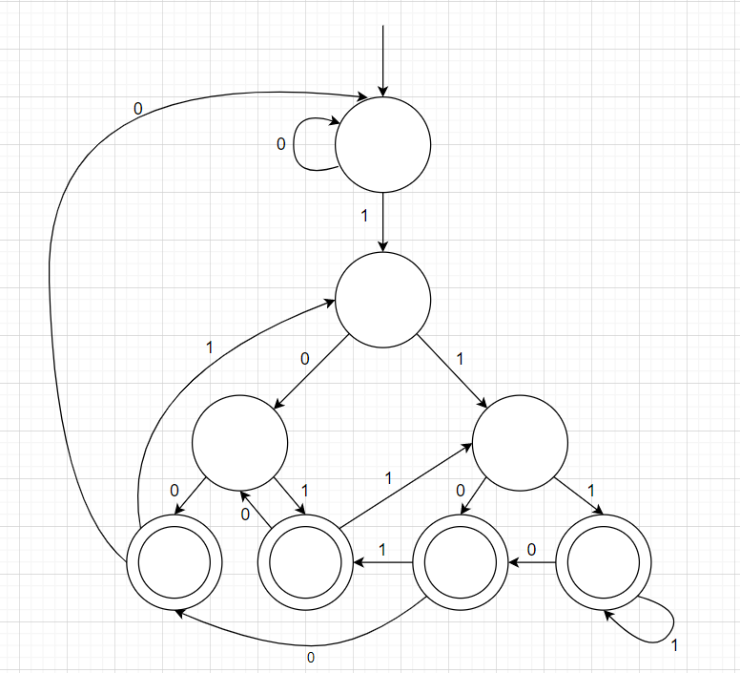2c.) This is a “tree” made after using subset construction on an NFA for P3.

This tree has a detached node at the start to create an infinite looping 0 and the original “mth to the last ‘1’ character” transition (Looks like a star on a Christmas tree). The rest of the tree splits down to get every possible combination of 0s and 1s until it hits the accept states at the bottom. Once at the accept states, the transitions leaving those states must go back to the other nodes in the tree, corresponding on whether they had a ‘1’ character prior to use as a new “mth to the last ‘1’ character.”

2d.) The largest set of pairwise distinguishable strings for any positive value “m” is as follows; 0, 1, and 1 concatenated with every string of (0, 1) with size less than m (i.e., if m=4, then the largest set would be {0, 1, 10, 11, 100, 101, 110, 111, 1000, 1001, 1010, 1011, 1100, 1101, 1110, 1111}). In other words, the largest set will have a size of 2 (For the original 0, 1) \* 2^(m-1) (Which represents every string with a 1 concatenated with a string of size less than m). As such, since the size of largest set of pairwise distinguishable strings is 2^m, so is the minimum number of states.

3a.) {0, 00, 1, 11, 110, 1100}

3b.) {11, 1111, 111111 … (11)(11)\*}

3c.) {0, 1, 001, 11}

3d.) {0, 000, 00000 … 0(00)\*}