Rajat Sethi – CPSC 3500 – Assignment 6

1a.)

* S 🡪 A | B
* A 🡪 0A | 00A1 | 0
* B 🡪 B1 | 0B11 | 1

1b.)

* S 🡪 0S0 | 1A1
* A 🡪 0A0 | 1

2a.) cc

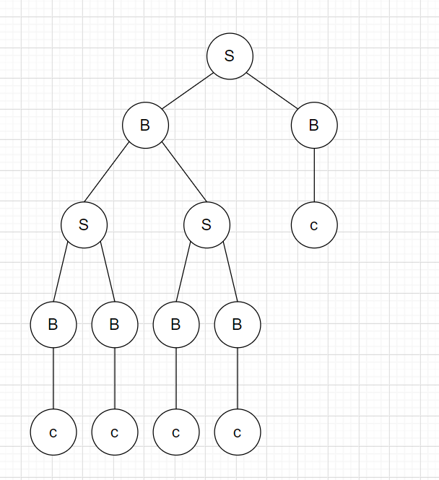2b.)

2c.) Yes, this language is ambiguous. Every root node in the derivation tree can swap its children and still have the same CFG. Basically, this tree can reflect horizontally and still represent the CFG

2d.) This CFG generates all strings that start with two c’s followed by an arbitrary amount of 3 consecutive c’s (cc, ccccc, cccccccc)

2e.) This CFG generates a regular language because there is a regular expression that also generates the same language; cc(ccc)\*

3.) This CFG generates all strings that either end with a “yy” or “x”

4.) This PDA takes in any amount of 0’s, then accepts an amount of 1’s with a lower bound of (half the # of 0’s) and an upper bound of (double the # of 0’s).