Rajat Sethi – CPSC 3500 – Assignment 8

1.)

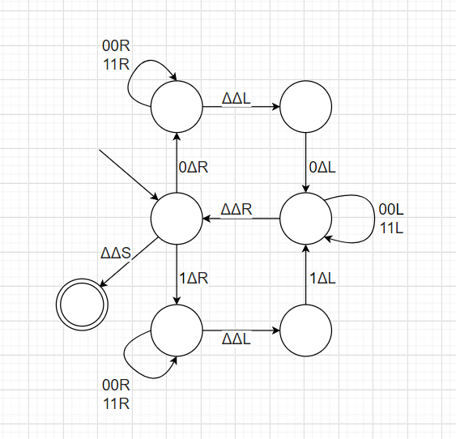

2.) This TM accepts all binary strings in the form $\{0^{{(2}^{n})} : n >= 0\}$. (2 Zeroes, 4 Zeroes, 8 Zeroes, 16 Zeroes, etc.)

3a.) 011

3b.) 000

3c.) This TM accepts all binary strings where all consecutive instances of ‘1’ have an even length, (11, 1111, 111111…) and there must be at least one substring of ‘1’s that is length >= 2.