Rajat Sethi – CPSC 4240 – Activity 1

**Question 1.)**

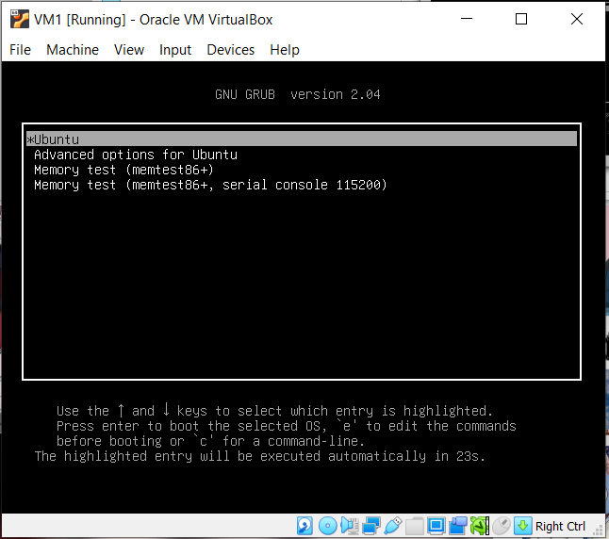

I opened the GRUB menu by holding the “Shift” key before the BIOS boot-up.

To open GRUB automatically during the boot, set the “GRUB_TIMEOUT_STYLE” variable to “menu” instead of “hidden.”

**Question 2.)**

I changed the menu color by editing the colors in these variables (white/black to white/blue)

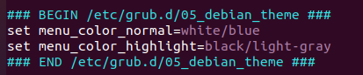

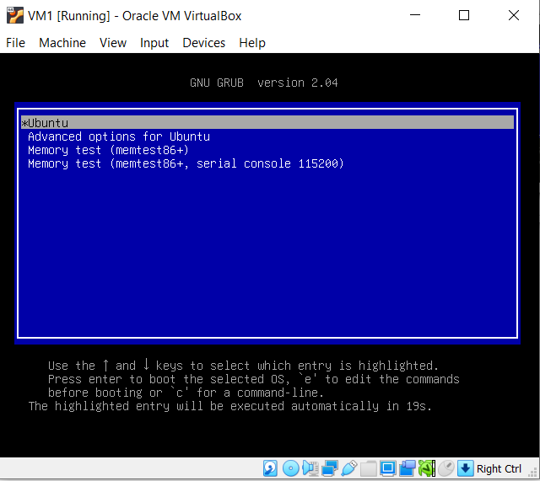

**Question 3.)**

Copyleft is when an intellectual property can be freely distributed and modified, under the conditions that any of those modifications are also copyleft.

**Question 4.)**

More takes a long file and pages it. The only problem is that the user can scroll down, but they cannot scroll back up.

Less takes a long file and pages it. This time, the user can scroll down AND up.

**Question 5.)**

Through “initrd”, the boot process works in the following manner (according to kernel.org).

First, the boot loader loads the kernel and converts the initial RAM disk into a “normal” RAM disk. The system then mounts the new root device. Once that’s done, the system runs “init” and replaces the “initrd” root file system with the “real” root file system.

**Question 6.)**

Unix options:

ps -e: List out information about running processes.

ps -eLf: List out information about running threads.

BSD options:

ps aux: List out all processes (even those not connected to a terminal) and display their owners too.

GNU long options:

ps --context: Display security context format for each process.