Rajat Sethi – CPSC 4240 – Discovery 3b

1.)

Image: pfSense running on Virtual Box

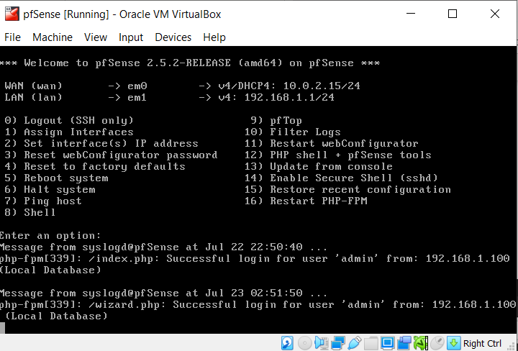

Image: Rule created that rejects ICMPs on the LAN.

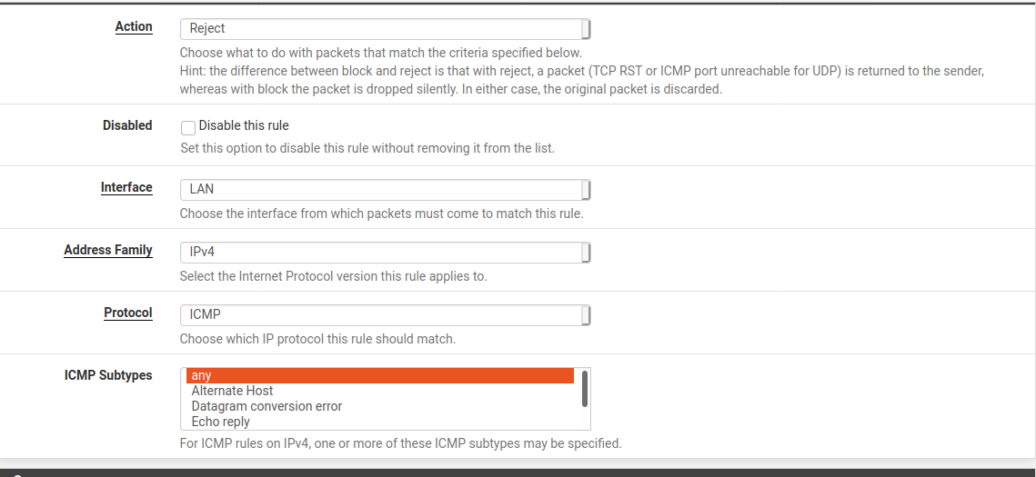

Image: GUFW system (Alternative Choice to PFSense)

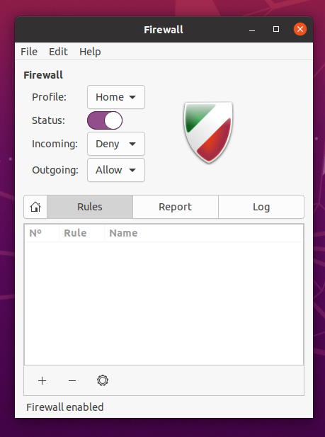

Better Choice?: I think that the GUFW system is better simply because it was easier to set up. PFsense was too complicated and full of errors, which makes me question the overall integrity of the application. It took me around 3 hours just to get PFSense to work.

GUFW on the other hand took about 15 minutes and does the exact same as PFSense. In addition, GUFW comes pre-installed with ubuntu, which suggests that its more compatible than PFSense.

2.)

Surveillance System 1:

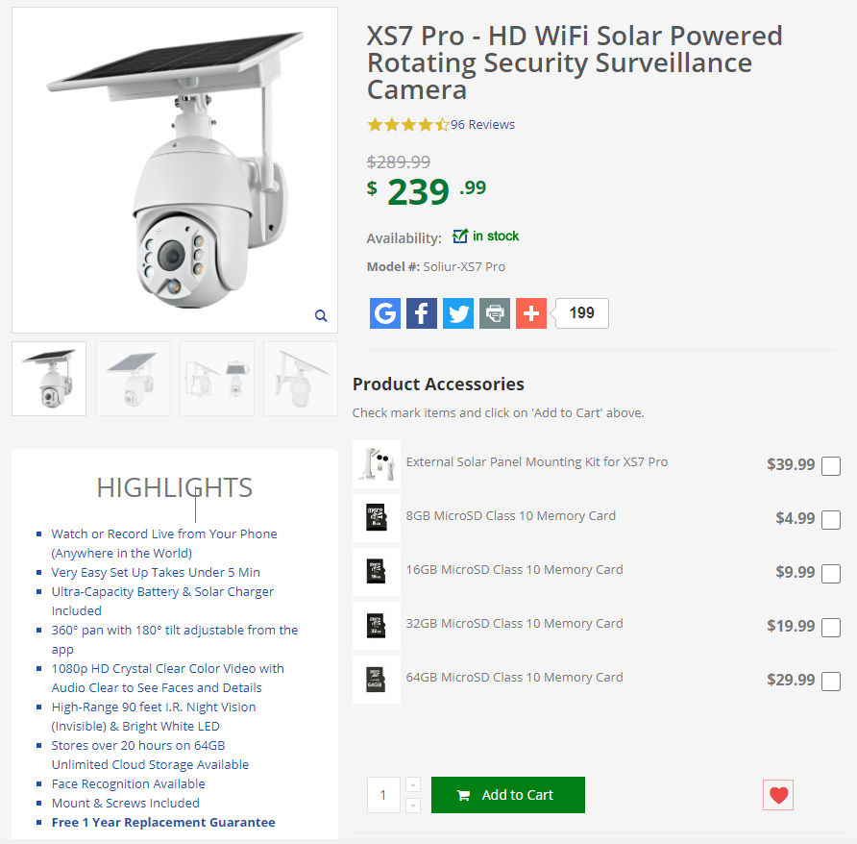

Surveillance System 2:

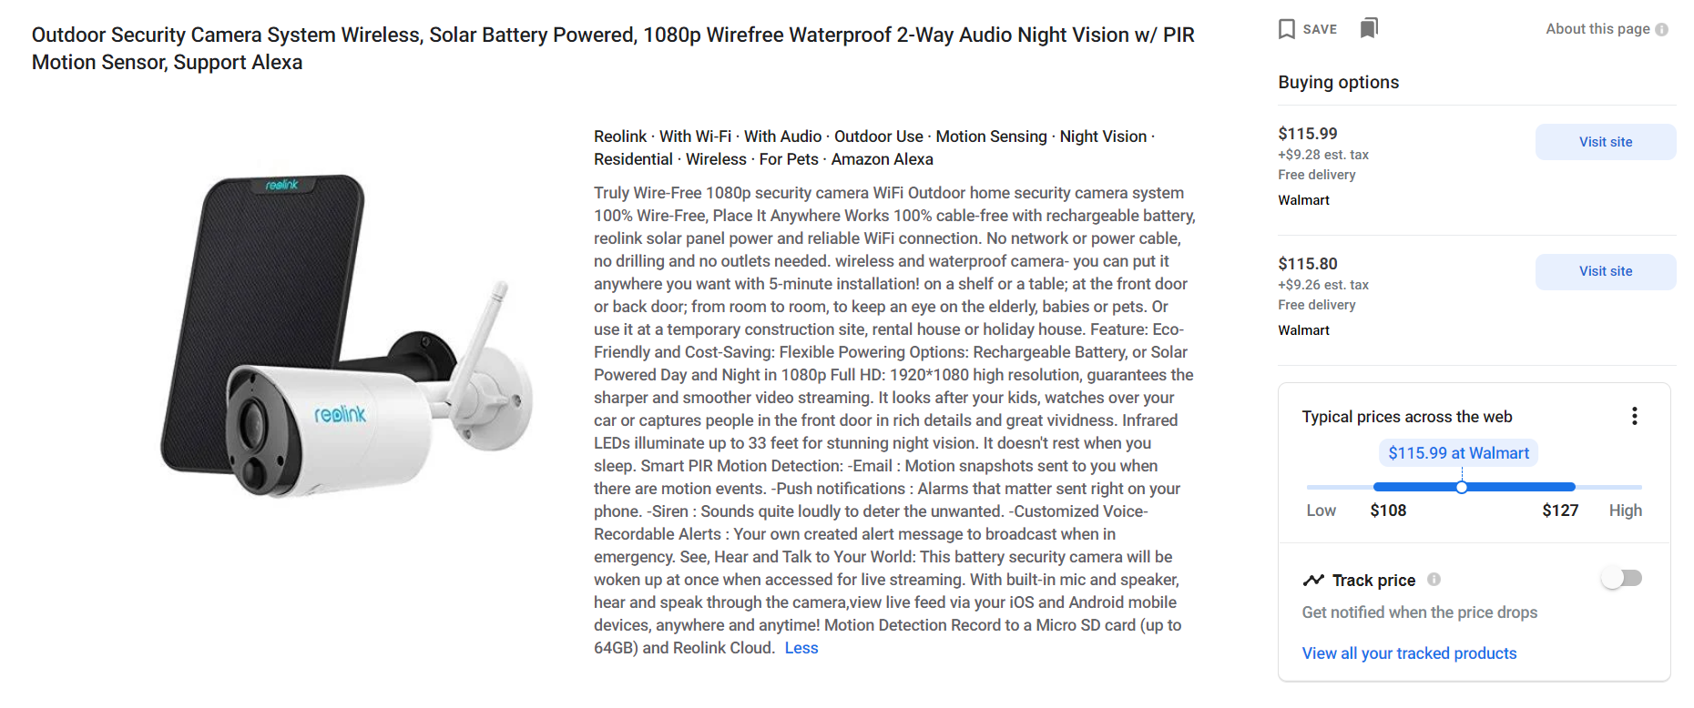

|  |  |  |
| --- | --- | --- |
|  | XS7 Pro | Reolink |
| Less than $1000 | $239.99 | $115.99 |
| Motion Activated | Yes | Yes |
| Recording Capabilities | Up to 64 GB | Up to 64 GB |
| Solar Powered | Yes | Yes? (Weird Advertising) |
| Internet Monitored | Phone (Possible others) | Phone, Computer, Alexa |
| Ease of Installation | 5 minutes | 5 Minutes |

Conclusion: The “Reolink” security camera seems better than the “XS7 Pro” in almost every criterion, especially the price. That being said, some of the advertising on the “Reolink” feels sketchy, especially with the solar battery. I am unsure whether or not the camera comes with a solar panel. If the advertising is true, then the Reolink is better, but I would feel more comfortable if it had some reviews.