Rajat Sethi – ECE 4380 – HW1

1. **t(x, y) = 8,192y / 1,000,000x**

1 KB = 1,024 B = 8,192 b

1 Mb = 1,000,000 b

2a.) 40,000 bits / 100,000,000 bps = 400 [μ](https://en.wikipedia.org/wiki/%CE%9C)s

A 🡪 S += 400 µs + 25 µs = 425 µs

S += 35 µs = 460 µs

S 🡪 B += 400 µs + 25 µs = **885 µs**

2b.)

A 🡪 S += 400 µs + 25 µs = 425 µs

1st Packet S += 35 µs = 460 µs

1st Packet S 🡪 B += 200 µs + 25 µs = 685 µs

(2nd Packet S += 10 µs 🡪 695 µs)

2nd Packet S 🡪 B += 200 µs + 25 µs = **920 µs**

3a.) Packet Size = 10,000 + 150 bits = 10,150 bits

A 🡪 S += (10,150 bits / 15,000,000 bps) / (10^-6 s/µs) + 25 µs = 701.67 µs

S += 25 µs = 726.67 µs

S 🡪 B += (10,150 bits / 60,000,000 bps) / (10^-6 s/µs) + 50 µs = **945.83 µs (One-Way)**

Throughput = 10,150 bits / (945.83 µs * 10^-6 s/µs) = **10.731 Mbps**

3b.)

ACK Transmission and RTT:

B 🡪 S += (150 bits / 60,000,000 bps) / (10^-6 s/µs) + 50 µs = 998.33 µs

S += 25 µs = 1,023.33 µs

S 🡪 A += (150 bits / 15,000,000 bps) / (10^-6 s/µs) + 25 µs = **1,058.33 µs (RTT)**

Throughput = 10,150 bits / (1,058.33 µs * 10^-6 s/µs) = **9.591 Mbps**

Pipe Size = Throughput * RTT = 10,150 Bits

3c.)

The order of the hosts does not matter when determining pipe size, as the packets still need to go through both the 15 Mbps and 60 Mbps links. Therefore, both the RTT and Throughput remain the same, and so does the pipe size.

4.) I am assuming that incomplete packets are rounded up.

**1,000 Byte Packet:**

1,000,000 data bytes / 900 data bytes per packet = 1,111.11 packets ≈ 1,112 packets

One packet lost 🡪 1,113 packets.

Total bytes = 1,113 packets * 1,000 bytes per packet = 1,113,000 bytes

**5,000 Byte Packet:**

1,000,000 data bytes / 4,900 data bytes per packet = 204.08 packets ≈ 205 packets

One packet lost 🡪 206 packets.

Total bytes = 206 packets * 5,000 bytes per packet = **1,030,000 bytes**

**10,000 Byte Packet:**

1,000,000 data bytes / 9,900 data bytes per packet = 101.01 packets ≈ 102 packets

One packet lost 🡪 103 packets.

Total bytes = 103 packets * 10,000 bytes per packet = **1,030,000 bytes**

**20,000 Byte Packet:**

1,000,000 data bytes / 19,900 data bytes per packet = 50.25 packets ≈ 51 packets

One packet lost 🡪 52 packets.

Total bytes = 52 packets * 20,000 bytes per packet = 1,040,000 bytes

**Both the 5,000-byte and 10,000-byte packets are approximately ideal in this scenario.**

5a.)

300 bytes = 2400 bits: (2400 bits / 100,000,000 bps) * (200,000,000 m/s) = **4,800 meters**

5b.)

(100 m / 200,000,000 m/s) * 100,000,000 bps = 50 bits

Each 100 meters can only hold 50 bits:

Let x = # of hosts

50 bits per host * x + 10 bits per host * x = 2,400 bits

60 bits per host * x = 2,400 bits

**x = 40 hosts = 4,000 meters**

6a.)

Unlike Synchronous TDM, which assigns each host to their own slot, the Round-Robin approach assigns the next-available slot to the next host with data to send. This helps ensure that most of the slots are used, even if some of the hosts aren’t sending anything.

Unlike Statistical TDM, which dynamically allocates multiple slots for one host whenever they need it, Round-Robin only gives a host one slot at a time, then let the others have a turn. While STDM gives busy hosts faster networking, Round-Robin allows every host a turn in sending their data. While Round-Robin can help fight congestion, it also has to spend a little bit of time asking idle hosts.

6b.)

I think Statistical TDM will have the highest utilization, since slots are dynamically allocated to whoever needs it, even if they end up hogging it. I think Synchronous TDM will have the lowest utilization, as there may be several times where a slot goes unused due to an idle host.

7a.)

Total Time for 15 KB (15 * 8192 bits) = 300 ms (Handshake) + (15 * 8192 b / 2,500 bpms) + 75 ms + 75 ms (ACK) = **499.15 ms**

7b.)

Total Time = 300 ms (Handshake) + 15 * ((8192 b / 2,500 bpms) + 75 ms + 75 ms (ACK)) = **2,599.15 ms**

7c.)

Total Time = 300 ms (Handshake) + (75 ms + 75 ms (ACK)) = **450 ms**

7d.)

Total Time = 300 ms (Handshake) + (150 ms) (1st Packet) + (150 ms) (2nd-3rd Packet) + (150 ms) (4th-6th Packet) + (150 ms) (7th-10th Packet) + (150 ms) (11th + 15th Packet) = **1,050 ms**

8a.)

ucsd.edu avg time = **18.530 ms**

google.com avg time = **32.513 ms**

uni-heidelberg.de avg time = **128.734 ms**

8bi.)

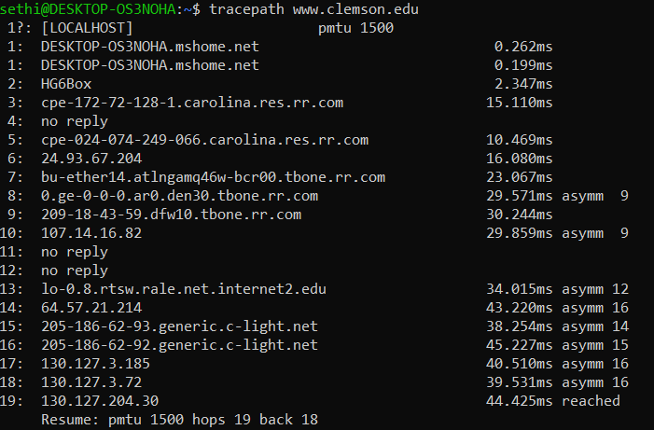

The output shows the user each host/router that the packet goes through before being redirected to [www.clemson.edu](http://www.clemson.edu). The numbers on the right display how long it took for the packet to go from the prior host to the current one. The word “asymm” means that the packet had to take a detour due to some network jam or redirection.

8bii.) Tracepath didn’t work so I went to a windows computer.

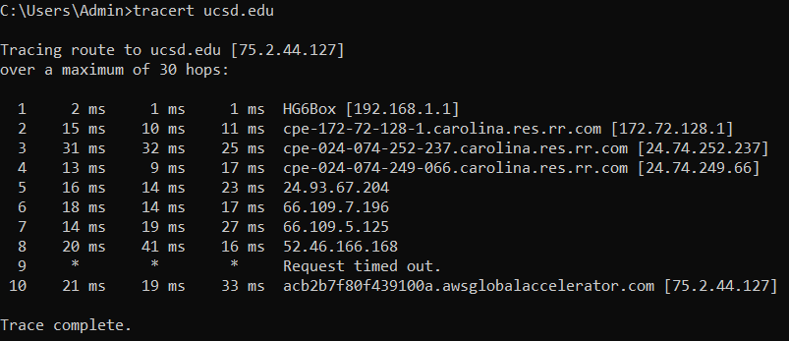

Backbone networks:

carolina.res.rr.com: Spectrum/Charter Communications host

awsglobalaccelerator.com: Amazon Web Services host

8c.)

North American Avg. Response Time: 21 ms

Minimum Time: 

Maximum Time:

