Rajat Sethi – ECE 4380 – HW5

1.)

|  |  |  |  |  |  |  |  |  |  |  |
| --- | --- | --- | --- | --- | --- | --- | --- | --- | --- | --- |
| S1 | |  | S2 | |  | S3 | |  | S4 | |
| Def. | 3 |  | Def. | 2 |  | Def. | 1 |  | Def. | 1 |
| A | 1 |  | A | 1 |  | C | 2 |  | D | 2 |
| B | 2 |  | B | 1 |  | D | 3 |  |  |  |
|  |  |  | C | 3 |  |  |  |  |  |  |
|  |  |  | D | 3 |  |  |  |  |  |  |

2.)  
A 🡪 B

A 🡪 D

B 🡪 E

3.)

Append ports (2, 3, 0) to the front of Host A’s original list. This will create a port list (2, 3, 0, 3, 0, 1). That way, when the packet reaches Host B, the pathway to Host A is immediately ready. (I assume the ports are read right-to-left, like in the textbook).

4a.)

|  |  |  |
| --- | --- | --- |
| S2 | | |
| **Host** | **Port** | **Cost** |
| Def. | 0 | 10 |
| A | 0 | 1 |
| B | 1 | 0 |
| C | 0 | 10 |
| D | 0 | 7 |

4b.)

New Virtual Circuit Routing Tables:

|  |  |  |  |  |  |  |  |  |
| --- | --- | --- | --- | --- | --- | --- | --- | --- |
| S1 | | | |  | S3 | | | |
| Portin | VCIin | Portout | VCIout |  | Portin | VCIin | Portout | VCIout |
| 0 | 0 | 1 | 0 |  | 0 | 0 | 3 | 0 |
| 1 | 0 | 0 | 0 |  | 0 | 1 | 3 | 0 |
| 2 | 0 | 1 | 1 |  | 3 | 0 | 0 | 0 |

|  |  |  |  |  |  |  |  |  |
| --- | --- | --- | --- | --- | --- | --- | --- | --- |
| S2 | | | |  | S4 | | | |
| Portin | VCIin | Portout | VCIout |  | Portin | VCIin | Portout | VCIout |
| 0 | 0 | 2 | 0 |  | 0 | 0 | 2 | 0 |
| 0 | 1 | 1 | 1 |  | 0 | 1 | 2 | 1 |
| 2 | 0 | 3 | 0 |  | 0 | 2 | 1 | 0 |
| 2 | 1 | 1 | 2 |  | 2 | 0 | 0 | 0 |
| 3 | 0 | 1 | 0 |  |  |  |  |  |

4c.)

(0, 2, 3, 3)

5a.)

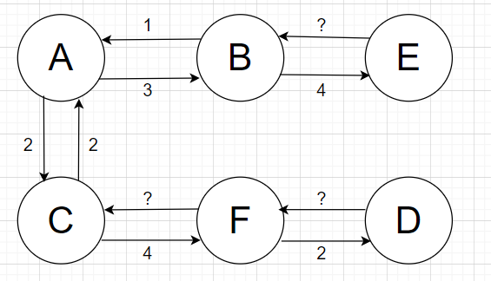

5b.)

The link from C 🡪 B = 1

The link from F 🡪 D has increased to a cost >7.

The link from E 🡪 D = 6

5c.)

A lot of the new links create new paths that are lower cost than the originals. That means almost all of the paths have to be re-updated to find the shortest path. And since path-finding algorithms are quite time-complex, re-determining them all could take a long time for a large network.

6a.)

|  |  |  |  |
| --- | --- | --- | --- |
| LAN | LAN 1 | LAN 2 | LAN 3 |
| 1 | R | 1/2R | 1/3R |
| 2 | 2/3R | R | 2/3R |
| 3 | 1/3R | 1/2R | R |

LAN 1: NR + NR/2 + NR/3 = 11NR/6

LAN 2: 2NR/3 + NR + 2NR/3 = 7NR/3

LAN 3: NR/3 + NR/2 + NR = 11NR/6

7 * N * (100 Kbps) / 3 = 8 Mbps.

**N = 34 Hosts**

6b.)

|  |  |  |  |
| --- | --- | --- | --- |
| LAN | LAN 1 | LAN 2 | LAN 3 |
| 1 | R | 3/8R | 3/8R |
| 2 | 3/8R | R | 3/8R |
| 3 | 3/8R | 3/8R | R |
| Backbone | 3/4R | 3/4R | 3/4R |

14N * (100 Kbps) /8 = 8 Mbps

**N = 45 Hosts**

6c.)

Same answer as 6b.) = **45 Hosts**