Rajat Sethi – ECE 4380 – MP1

a.)

./server

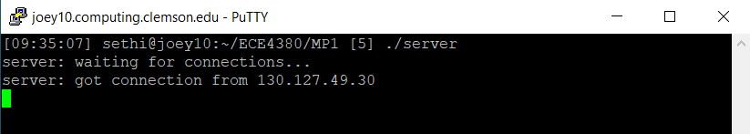

./listener

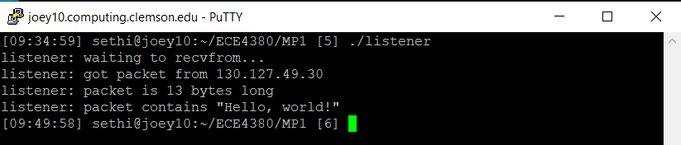

./client joey10

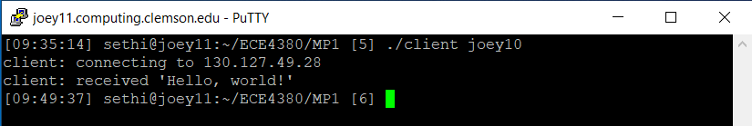

./talker joey10 “Hello, World!”

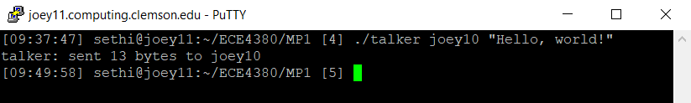

1. The pairs of programs do NOT interfere with each other. This is likely because both pairs use a different port connection.

b.)

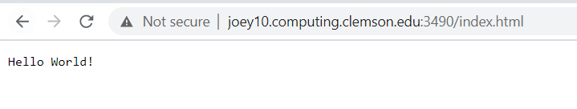

Changes made to server.c

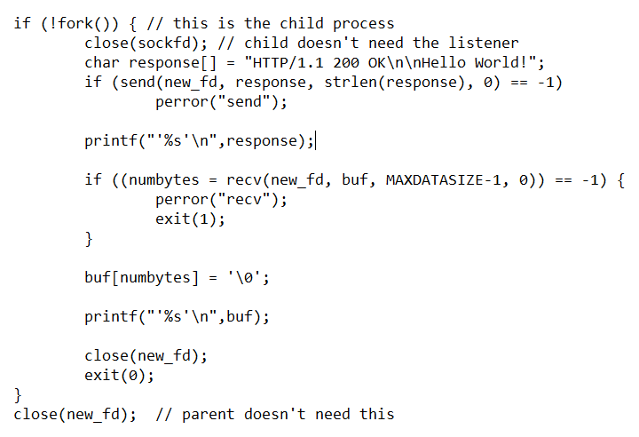

New Server Print-Out

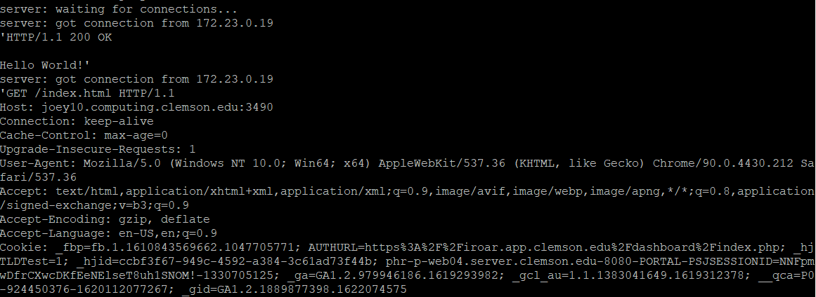

START_LINE



MESSAGE_HEADER



c.)

Table of “valid/arbitrary” identification numbers that the server can receive, along with their respective messages to show a successful send.

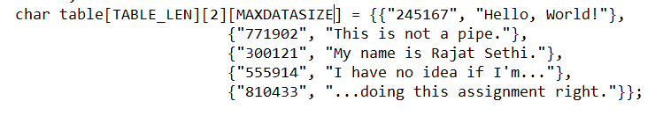

How the server protects itself from invalid id-numbers:

The first if-statement receives the data from the client.

The second if-statement verifies that the id-number is exactly six digits.

The third if-statement verifies that all of the characters are numerical digits.

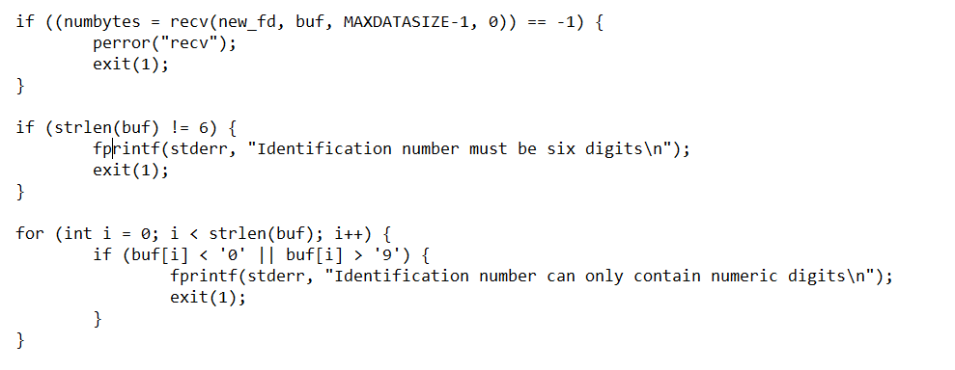

Limit to data that the server can send and receive:



Since the server can only receive 100 bytes from the client, it is implied that the client can also receive 100 bytes from the server.

In the situation that the server sends too much data, the client places a delimiter on the string for however much memory it can hold.



Credit for original server and client programs go to Brian “Beej” Hall.