Rajat Sethi

ECE-4380: Computer Communications

Machine Problem 2

Submitted: 7/2/2021

**Summary:**

This machine problem was designed to teach us about how to use GENI. Specifically, the goals were to display a virtual network using a series of virtual machines. With this virtual network, we were expected to utilize the spanning tree algorithm in practice.

This process involved:

* Preparing a virtual network with GENI resources.
* Accessing bridges and hosts using SSH.
* Locating the Ethernet Interfaces, Subnets, and their Connections to other VMs.
* Configuring nodes in the network.
* Using tcpdump to determine which ethernet ports were (and were not) used to send data.
* Sending pings to several hosts concurrently with tcpdump.
* Locating the root node and priority levels with “ovs-vsctl link bridge”
* Discovering what happens when a node goes down (or back up).
* Discovering what happens when priority levels are changed.

**Implementation:**

I created my network on GENI with 6 nodes, 6 hosts, and 3 loops (as designated in the specifications). At first, I tried to use Wisconsin’s resources, but not all the nodes would light up, so I scrapped the entire slice. Using the same Rspec file, I tried again with Rutgers, which worked quickly.

Once I set up the network, I SSHed into the bridges and hosts, then configured them accordingly. Using ifconfig, I determined the ethernet interfaces for each bridge, and how they connected to other bridges.

Next, I used tcpdump and ping to find which paths were blocked off by the spanning tree algorithm. By sending pings to various hosts, I checked every path in the network. Any of the connection paths that were not used were marked orange in the diagrams. In addition, I also used “ovs-vsctl link bridge” on each bridge to determine which one was the designated root node.

After that, I tested what happened when a bridge suddenly goes down by running two simultaneous pings, shutting down the bridge, and watched the network recalculate while it failed to send messages.

Finally, I changed the priority level of one of the bridges to change some of the paths. This ended up revamping the entire network, changing the locations of the blocked paths, routes and the root node.

**Results: (Question 1)**

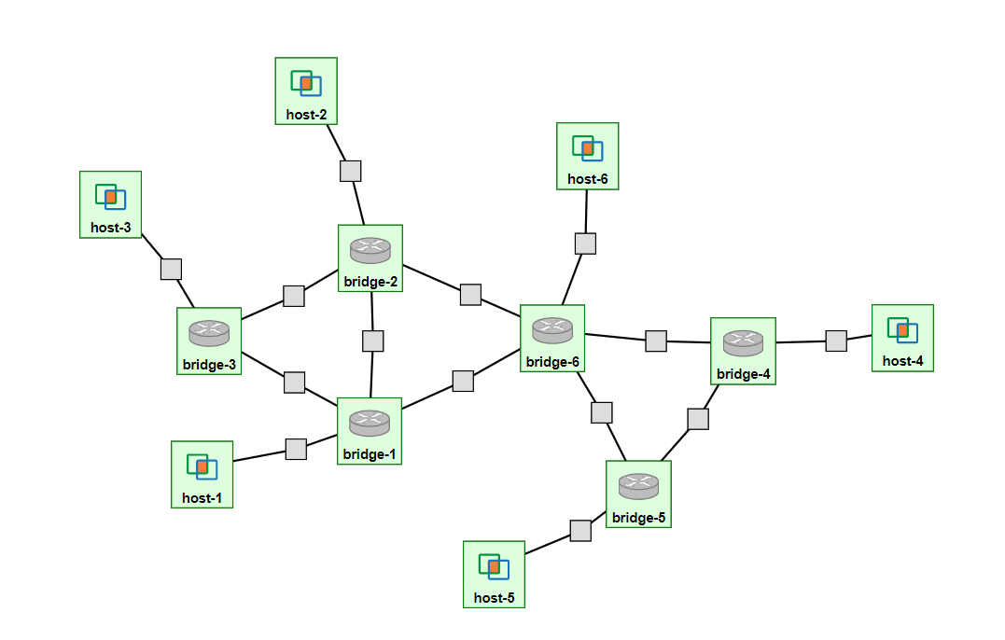Figure 1.) Resources Reserved on Rutgers

Figure 2.) All Ethernet Interfaces and Subnets



host6: @pc3:26018

eth1: IP 14.1

bridge2: @pc3:26011

eth1: IP 8.1

eth2: IP 3.1

eth3: IP 2.2

eth4: IP 11.2

host2: @pc3:26016

eth1: IP 11.1

bridge6: @pc3:26014

eth1: IP 7.2

eth2: IP 8.2

eth3: IP 14.2

eth4: IP 1.2

eth5: IP 5.1

host3: @pc1:26011

eth1: IP 10.1

host4: @pc1:26012

eth1: IP 12.2

bridge3: @pc3:26012

eth1: IP 10.2

eth2: IP 3.2

eth3: IP 4.2

bridge4: @pc1:26010

eth1: IP 12.1

eth2: IP 7.1

eth3: IP 6.2

bridge1: @pc3:26010

eth1: IP 9.1

eth2: IP 4.1

eth3: IP 1.1

eth4: IP 2.1

host1: @pc3:26015

eth1: IP 9.2

bridge5: @pc3:26013

eth1: IP 13.1

eth2: IP 5.2

eth3: IP 6.1

host5: @pc3:26017

eth1: IP 13.2

Figure 3.) Interface Mappings



eth1

eth4

eth1

eth2

eth3

eth1

eth1

eth4

eth3

eth1

eth1

eth2

eth2

eth1

eth2

eth3

eth4

eth3

eth5

eth2

eth1

eth2

eth1

eth1

eth3

eth3

eth1

eth1

Figure 4.) Spanning Tree

Root

Question 2.) Link Failure and Recovery

Leaf Bridges: 1, 3, and 4

Host-4: ping 10.123.21.1

Host-3: ping 10.123.21.4

Bridge-6: sudo ifconfig eth5 down

Host-3 loses 48 packets when the link goes down.

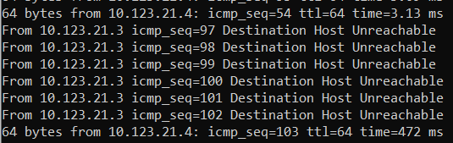

Host-4 loses 47 packets when the link goes down.

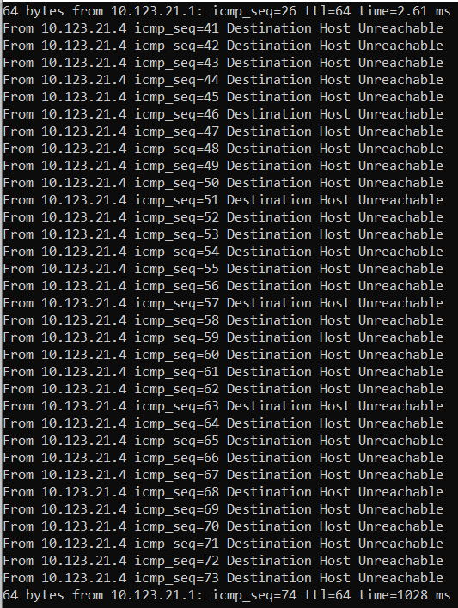

Host-3 loses 30 packets when the link goes back up.

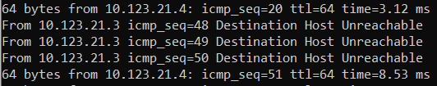

Host-4 loses 29 packets when the link goes back up.



Question 3.)

The longest path (that is not the minimum path) is between Host 3 and Host 4

Path Taken: 6 Steps (H3 🡪 B3 🡪 B2 🡪 B6 🡪 B5 🡪 B4 🡪 H4)

Minimum Path: 5 Steps (H3 🡪 B3 🡪 B2 🡪 B6 🡪 B4 🡪 H4)

By setting Bridge 5’s priority value to the max, the nodes recalculate and use the minimum path.

Figure 5.) New Spanning Tree

Root

**Conclusion:**

In general, I learned a great deal about networking now that I have first-hand experience with creating a network. I understood how to set up and connect the hosts, how they interacted with each other, and how they reacted to administrative changes. I was also able to visualize the spanning tree algorithm in a more organized fashion, especially with the importance of removing loops from the system while also optimizing the routes. The only suggestion I would like to make is a little more elaboration on the “arp” section. I did not fully understand what was happening and ended up ignoring that portion.