CPSC 4240/6240 Discovery 1 50 points
Due date: 6/10/2021 before 11:59 pm.
Instructions:
This homework is done individually, not in teams. You are allowed to use search engines, textbook/s, lecture notes, and any other non-human sources you wish. BUT you are not allowed to consult others, or help other students with their work, give hints or solutions to anyone in the class. The reason it is called a Discovery is because you will do some hands-on exercises and show what you have accomplished. Each exercise may have several questions, so please read carefully. Please do not take shortcuts. Thoroughly explain what you have discovered. This is not the case when “less is more”.
You may need to take a screenshot or two (no, not with your phone, with your keyboard) to illustrate your work. All screenshots should be clearly legible and illustrate without a doubt what you are doing. You can open them in an image editor and trim off the parts you do not need, so that they take less space. Insert them when answering the question, do not submit them separately as image files. Make space between the questions in this document and type your answers there. Please do not type in red.
Computer Science is attention to detail, so let’s make your work look nice and professional, even though it does not have to conform to MLA, APA, or ACM format.
What and how to submit
Submit your .doc, .odt or .pdf file to canvas before the due date. All screenshots illustrating your work should be part of the document, not submitted separately.
Grading and Points
Every question indicates how many points it is worth. 4000-level and 6000-level are graded differently, with points indicated as (x/y), where x is 4240 and y is 6240.
Exercises
- Please explore SetUID/SetGID programs. What are they, and what is special about them? Find two such programs that run on Linux. Are these programs a security risk? Why yes, or why not? (7/6)
SetUID – Programs/Executables that temporary elevate the current user’s permission levels to that of the file’s owner, essentially setting the user’s UID to that of the owner.
SetGID – Programs/Executables that temporary elevate the current user’s permission to that of the file’s group permission, essentially setting the user’s GID to that of the owner.
Examples of SetUID/SetGID programs:
Sudo
Passwd
If implemented incorrectly, a SetUID/SetGID program can easily be a security risk. These types of programs could easily give a regular user too much power if not checked properly. This might end up damaging the system or even expose information that should not be public.

- Run several commands with sudo. What is being logged, and if it is, where? Show a screen shot of the log page. Explain what the entry contains. Now create a privileged user Bob, su to that user and run some privileged commands. What is logged and where? Please insert a couple of screenshots to illustrate what you are doing here. (7/6)
In the file /var/log/auth.log, all of the sudo commands are being logged. Each entry contains information about the user, where the command was executed, which user was the command run under (often the ROOT user), and the command itself.
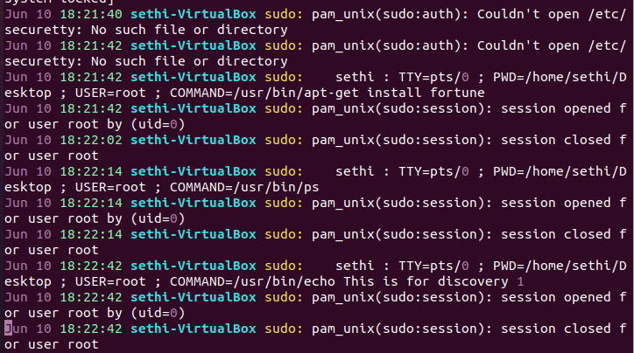
For su, the only recorded information is who logged in and out.
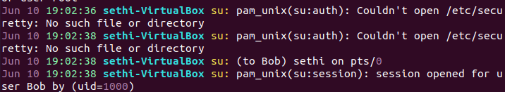
(Apologies for using vim instead of visudo, I did not know how to wrap the text in visudo, I had to scroll instead).

- Research aliases. Create aliases that persist across boots that do the following: (6/5)
- Alias list will list all files/subdirectories in the current directory (should work in any directory, so do not hard-code the path), even hidden files that start with a dot, in long format, with a slash indicating if an entry is a directory.
- Alias fhidden lists only hidden files in your home directory in long format
- Place these aliases into the appropriate file, so that they work every time you boot the system. What file is this? Open that file in an editor, take a screenshot and insert below.

These files are stored in ~/.bashrc, which will work every time the system gets booted.
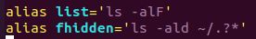

- Investigate these files: .profile, .bashrc, and .bash_profile. Why do they start with a dot? What is the role of each of these files, and when do they get executed. What are the contents of those files? Screenshots please. (8/6)
These files start with a dot to show that they’re hidden.
.profile = Executed by the command interpreter for login shells
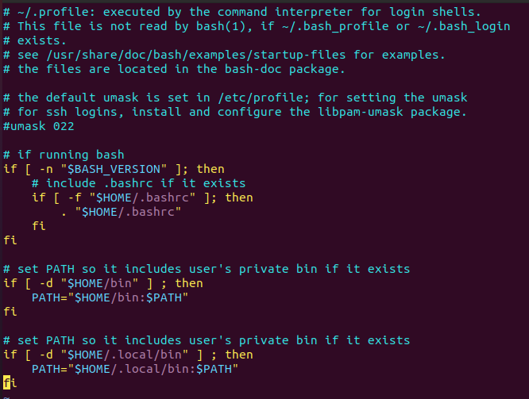

.bashrc = Executed for non-login shells
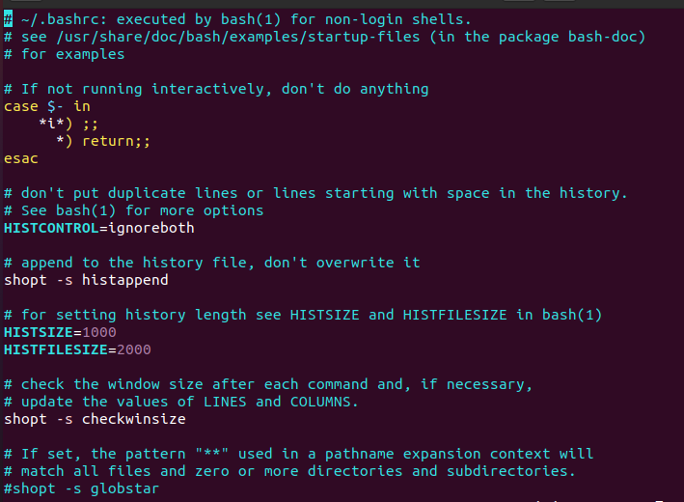
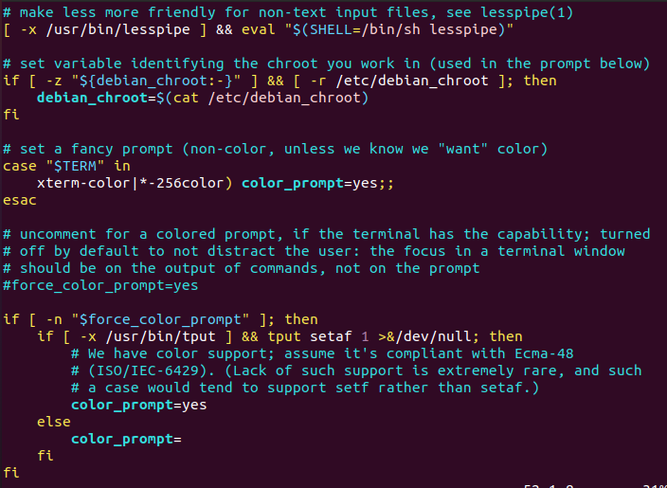

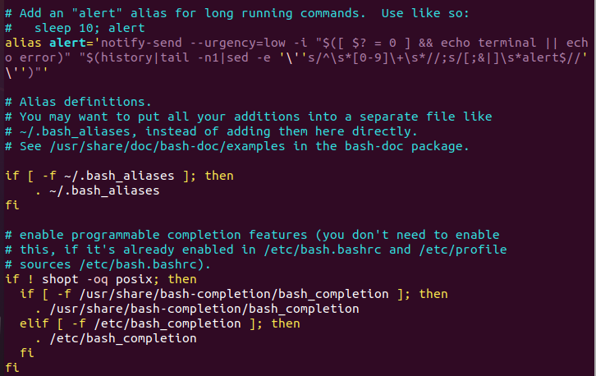
.bash_profile = A form of .profile used on Mac terminals (I don’t have a picture since I don’t use a Mac).
- Please research two processes - cron and anacron. What are their functions? Now figure out how to schedule periodic tasks using cron, a good one to try is periodic backups of some directory. You can schedule it to be done daily, or weekly, your choice. Schedule two different tasks of your choice to run at a certain interval. Show a screenshot of how/where you have accomplished it and show proof that it worked. (8/8)
cron = Automatically run scheduled tasks at a periodic rate.
anacron = Automatically run scheduled tasks at a periodic rate. If the system is not on when the command is supposed to run, then the command will still run when it gets back online.
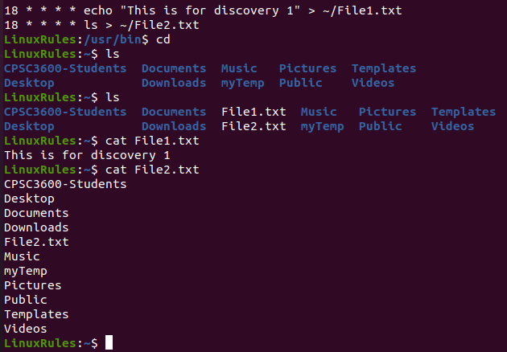
In the above picture, I used cron to set up two commands, one to echo and one to ls. Both of their outputs are redirected to some arbitrary files in my home directory. These commands will now run whenever the system is on and the time is **:15.
- This one is a fun and useful exercise. Change the login prompt that will last across boots, so that instead of the default user@user-VirtualBox:~$ (or whatever your default prompt is) it shows: LinuxRules:~$ (you can change it back afterwards) (6/5)
I changed this line in the ~/.bashrc file.
The end result:
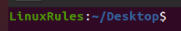
- Please research the sticky bit and explain what it is used for. Show some examples of how/where it would be useful. (8/8)
The sticky bit is a permission bit that prevents anyone but the owner and the root user from deleting or moving the file.
Sticky bits are useful on systems with multiple users on them (Like the SoC servers). It prevents regular users from maliciously or unintentionally deleting the files of other regular users.
It also is helpful for a wide-range purge command. Set the sticky bit on all important files, switch to a different user account, and purge.
Graduate students have one additional exercise:
- How does SHA-512 algorithm work? Please include a brief explanation below, half a page to a page should be enough. What makes is secure? (0/6)

Extra credit question for everyone (2/2)
What does the course textbook cover represent? Examine the details, what do you see? Why is there a boat there? Do you know why this may be? (2)
My guess is that it’s a combination of several security related things. There are a few flags on the top, including a Finland flag for Linus Torvalds. There’s a python somewhere to represent the python language, a file cabinet to represent files, a Windows Gorilla, a penguin for Tux, etc. My guess for the boat is that it represents piracy (like a pirate ship), where it’s possible to steal the data and why we need security in place.

