WEEKLY TASKS DOCUMENTATION

This week I did in a total of 3 tasks that involve tasks done in gitLab, Kubernetes, and Terraform.
I will put light on every task I have completed in this documentation.

- GitLab(CI/CD)
Before going directly into the gitLab ci/cd first have to gather the knowledge of what CI and CD means and what are their functionalities.

CI(Continuous Integration):

Continuous Integration in simple terms means, putting all the essential information which could be needed by the people related with a project which includes codes, configuration and many more, into centralized storage from where anyone having proper access to that storage could easily fetch and push their information for the review and execution purpose.
So for that, the optimal solution came out to attain a version control system which will fetch the data from various developers and push that onto the shared repository so that other people could also review that.
The main motive of ci is to provide a common ground where every person related with a project should be knowing of what is being done in the project at that moment so for that we needed something which could help in gathering codes and information from various sources.
When once all the thorough review gets completed, you could also build the code which is present and also test that built code which enhances the ability of feedback and early error catching so that when the code reaches production, it should be optimized and reviewed.

CD(Continuous Delivery):
Continuous Delivery means once intgerating all the data from various sources is done, you have the ability to deploy it onto the production so as to deliver the project provided by the client and that is totally the choice of the company/user whether they want to deploy it or not. It helps in gaining the confidence over the software/project and put your project into the ready-to-go state for production.
While in the case of Continuous Deployment, the whole process of deployment gets optimized, which means once the process of Continuous Integration is done the software gets automatically triggered for the deployment and will go into the productions efficiently.

So, I think you will get some idea about what CI/CD means. Now, where could you practically implement these functionalities? There are various tools and platforms available which includes Jenkins, gitLab (CI/CD) and many more. Each have their own uniqueness but the focus remains the same i.e to provide CI/CD functionality.

What is gitLab?
It is basically a part of git which is a version control system that helps you to push your code and information on the repository and also helps in tracking changes in the code so that as to boost up the process of error detection.
And if you have heard about GitHub it is similar to that but the main difference is it could be limited to a particular company or organization so as to provide the self-hosted Git- repository management system that helps in tracking the changes.

In gitLab, there is a particular open source project which is gitLab Runner which gets used in side by side with gitLab CI/CD, which helps to run your jobs over multiple machines and send back the result to the gitLab. In short, it is used to build instance which helps in running your jobs.
You can check and register your own runner from your project settings, in settings look for CI/CD and expand the runner. From there you could edit your runner’s settings and even set up your own runner. And you can also install the runner on your own system so as to access it.

For practical implementation, you should be registered on gitLab or you could log in through gitHub as well. So the first task is to log in to your account.

Steps,

- In gitLab, first you have to create a project .

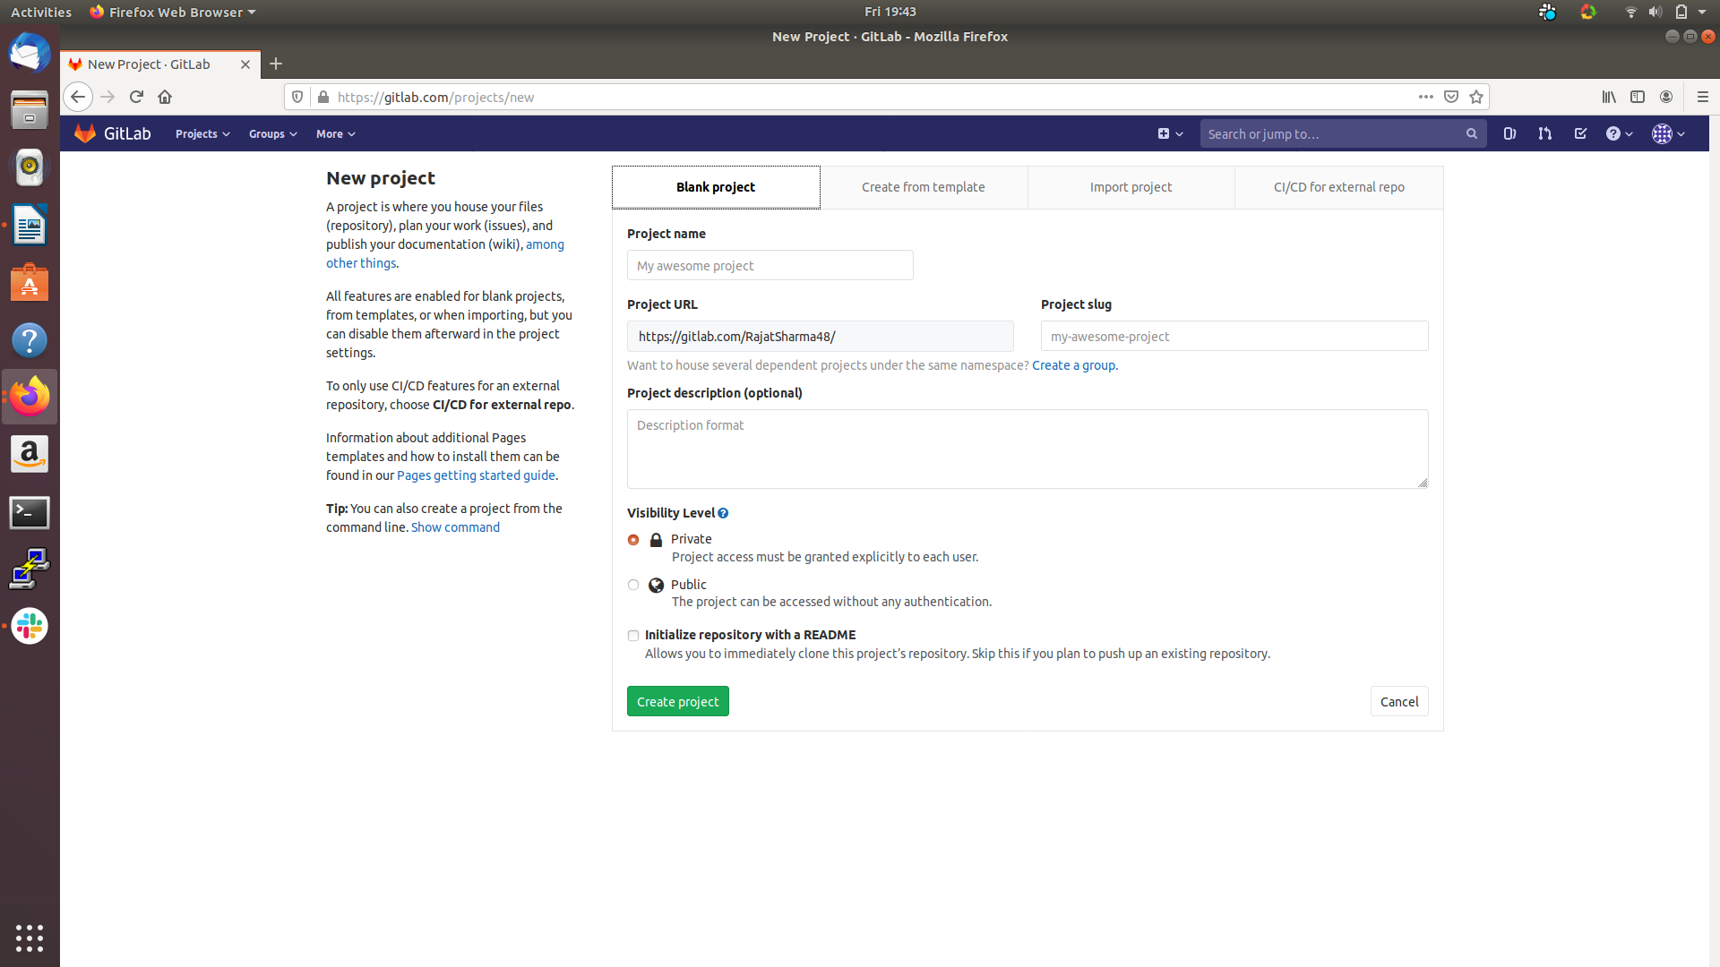

You can choose from various choices available on top be it blank project, import project, creating a project from a template or from external CI/CD.
For now, use blank project and fill the necessary details as per your choice.

- Once done creating repository, create a file and choose the file template from there of .gitlab-ci.yaml.
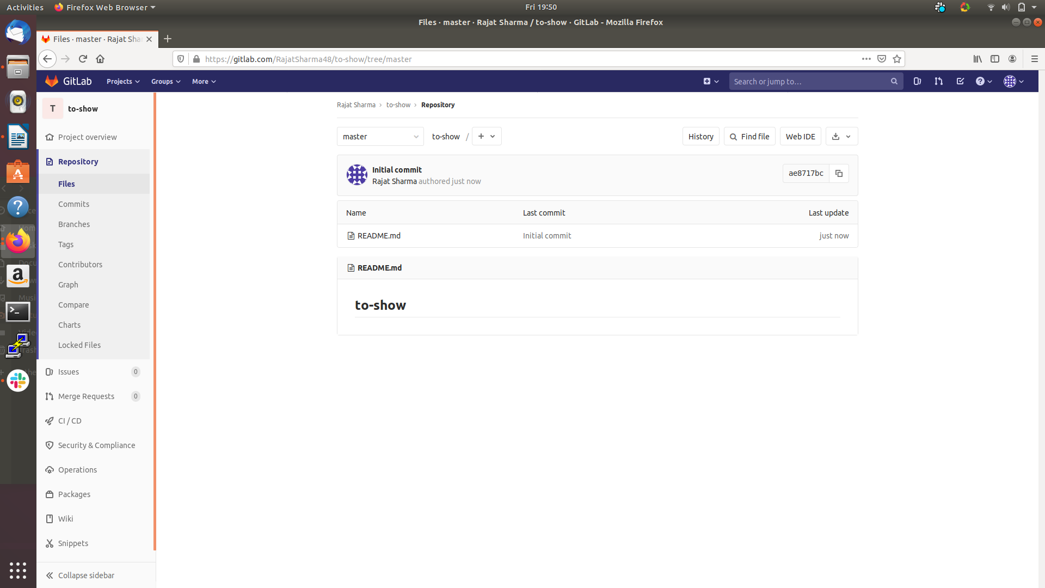

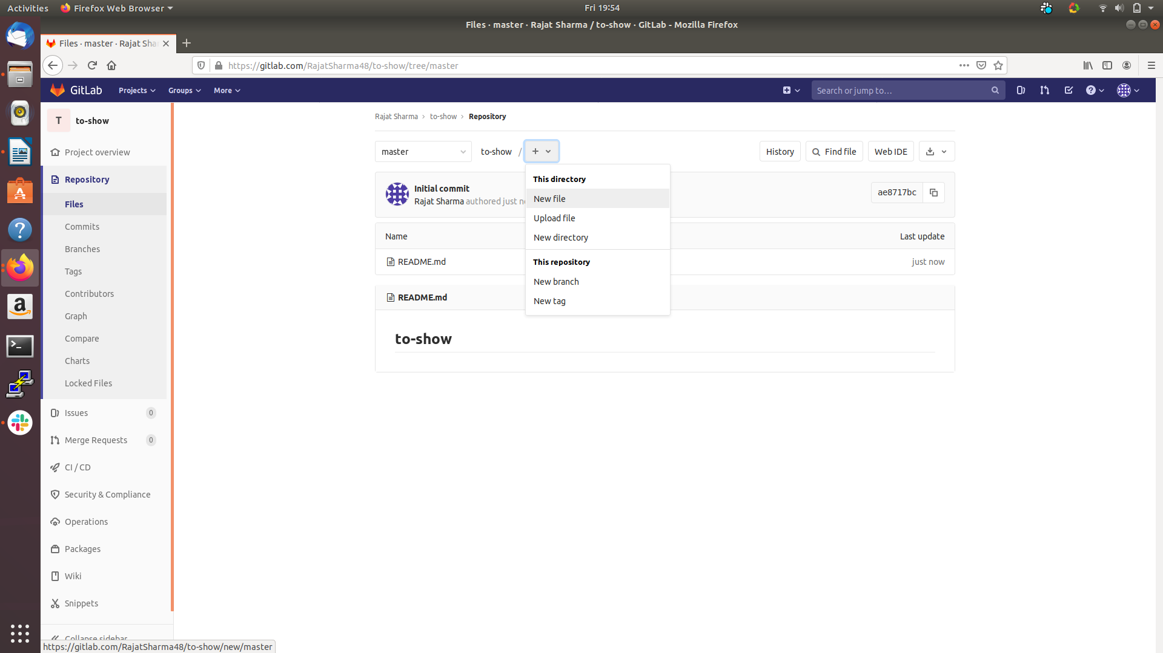

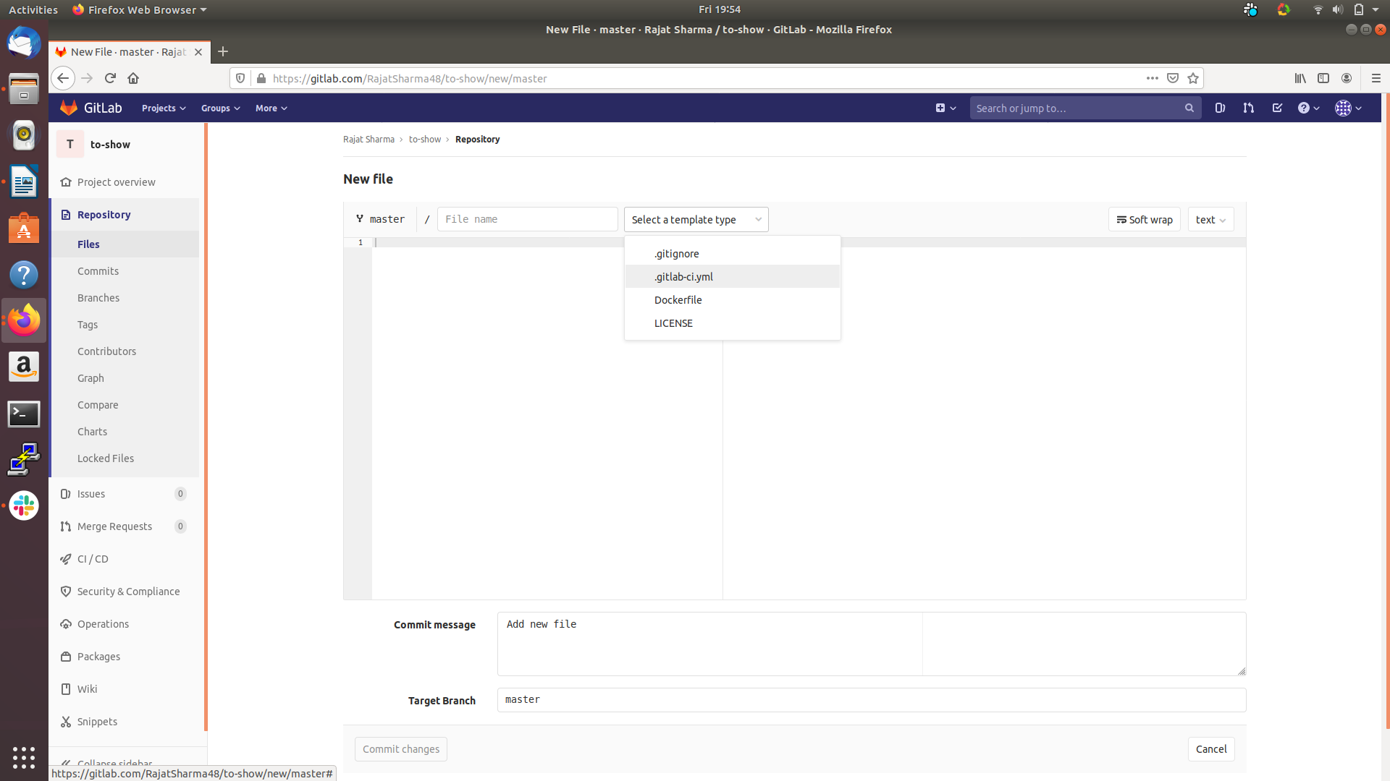

You can also choose a template of your choice whether you want to create Dockerfile or any other file, you just have to select the template and when you are done with selecting the file template, you can also choose you programming template in which you are comfortable enough.

- Write your code, for example review the code and I’ll explain what is being done step by step.

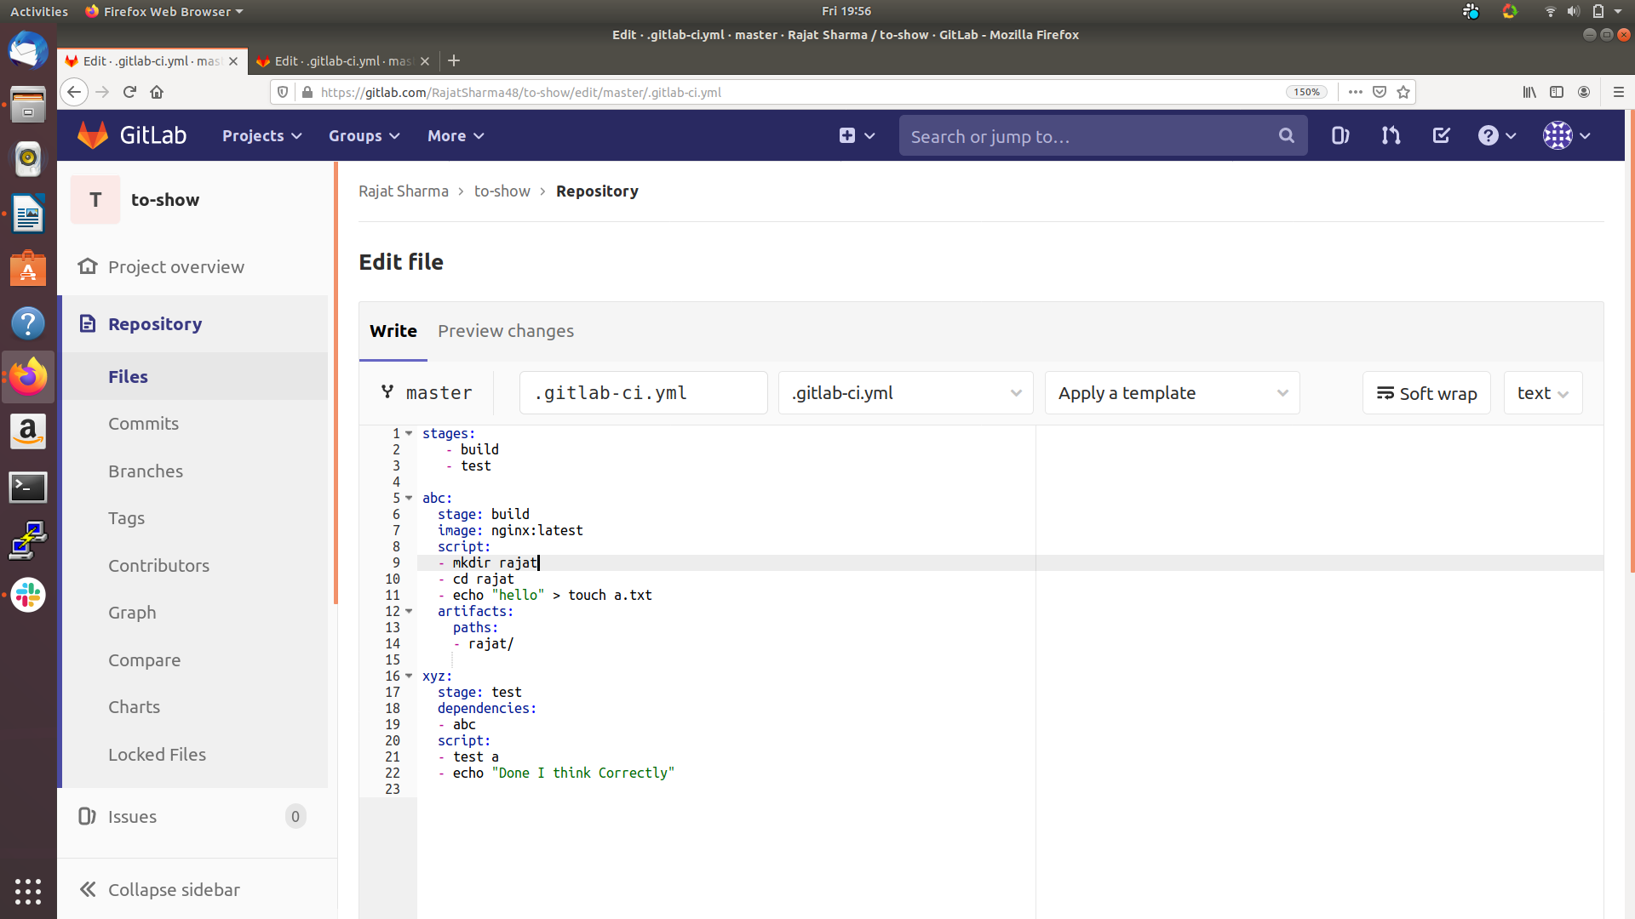

This is a sample program that could provide you a well enough upper hand if you are a beginner. I’ll discuss each and every keyword mentioned.

Key-Note,

- stages: It helps to define the stages you want to add in your pipeline and you could add new stages as per your requirements and needs.

- jobs: It helps to run your task in association with the stage or could say you mention your data your want to execute in a stage here.

- stage: To have to specify which stage your particular job belongs.

- image: In this you add your image that would pulled from the dockerHub.

- script: In this you have to write the script (execution steps) that your job have to execute so as to become successful.

- artifacts: If you want to add a resource which could be used and downloaded later
to provide you with the reference and knowledge about the stage, artifacts are used. The cache is also present to provide you with temporary storage. With cache, you have to provide a key and the path same as that of artifacts.

- dependencies: It helps in building the dependencies between the jobs because there could be a situation where you want to execute a job only after a particular job is executed.

- Once done, please commit the changes and if the code which you have added is proper than the gitLab will verify and will start the pipeline.

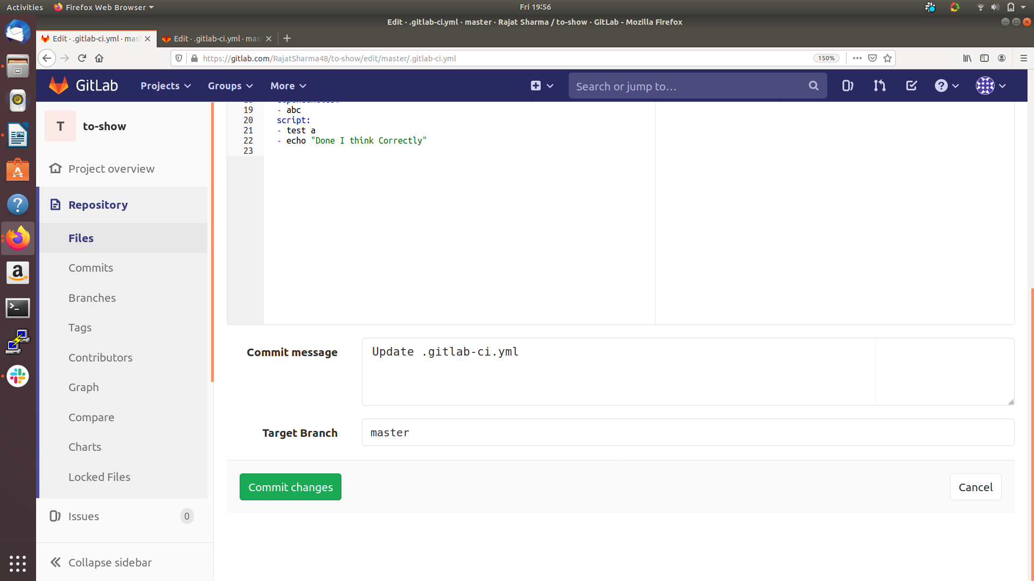

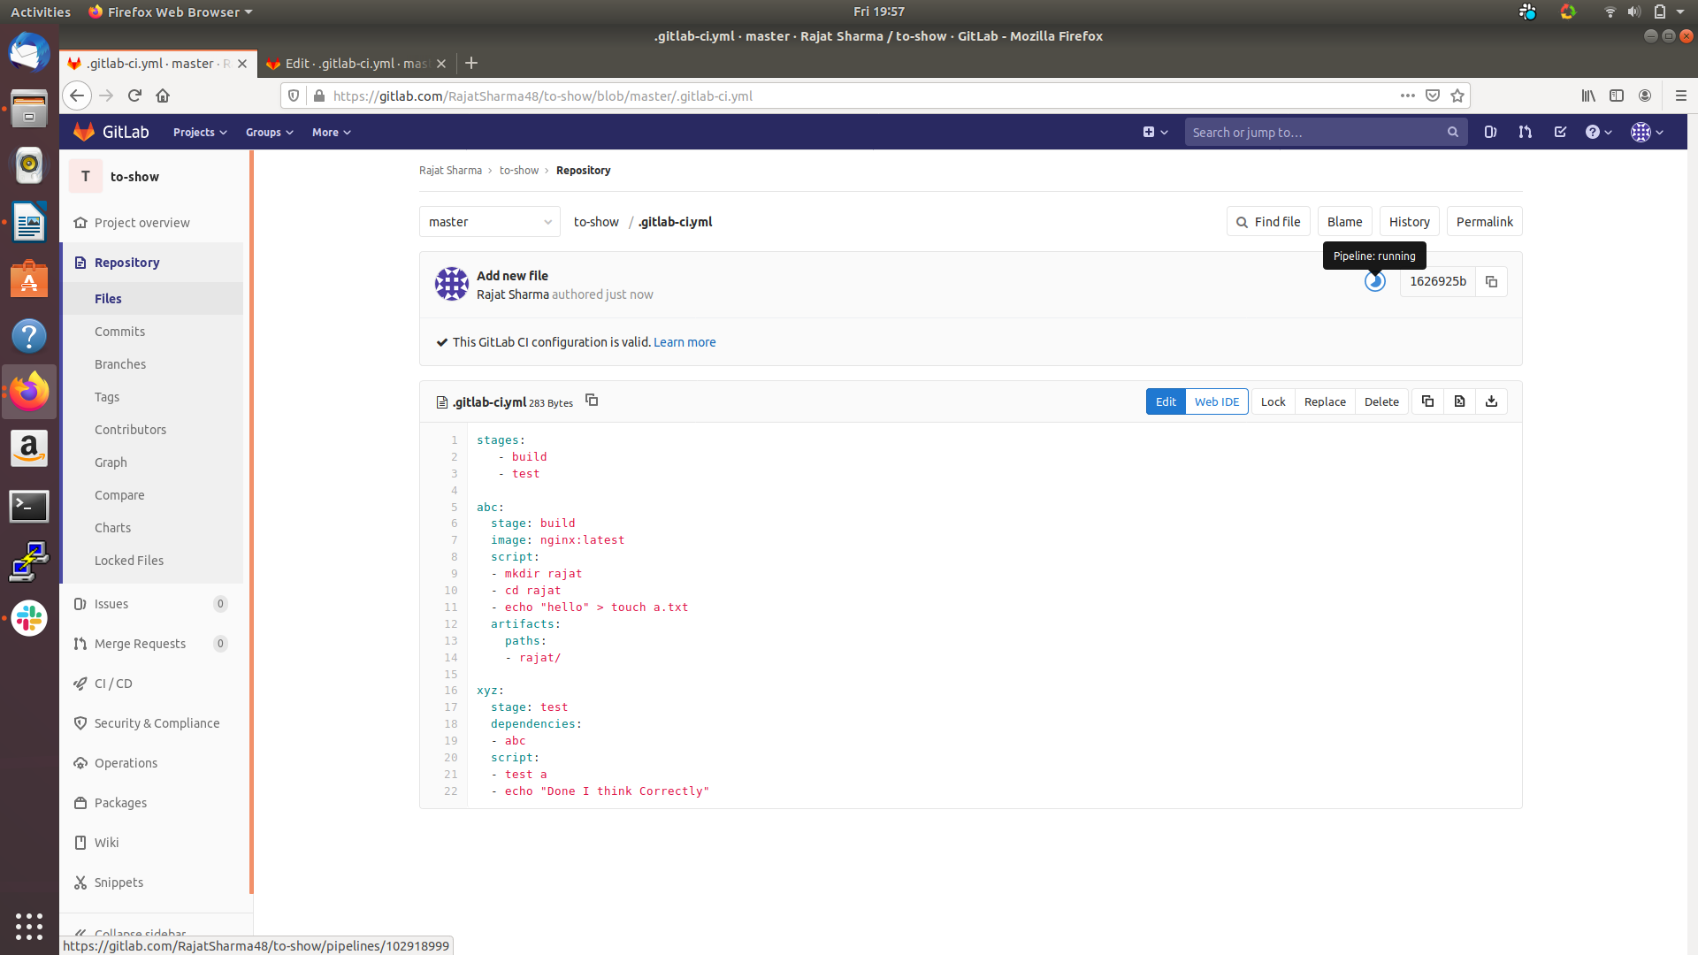

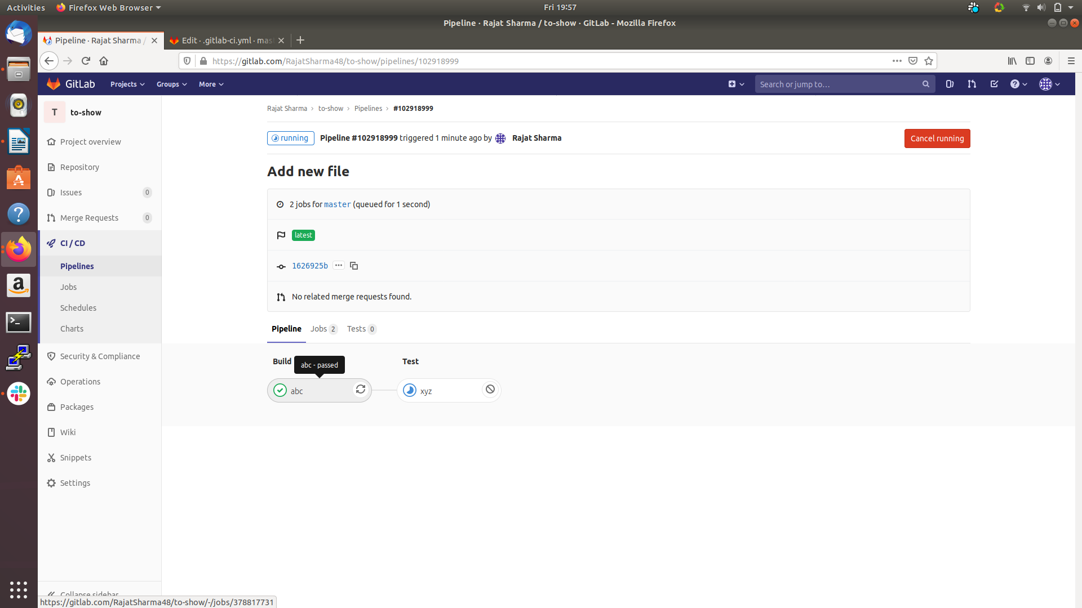

- You could see the process on the console of the job present in gitLab which is being executed and review if any error occurs and you could download the artifacts as well.
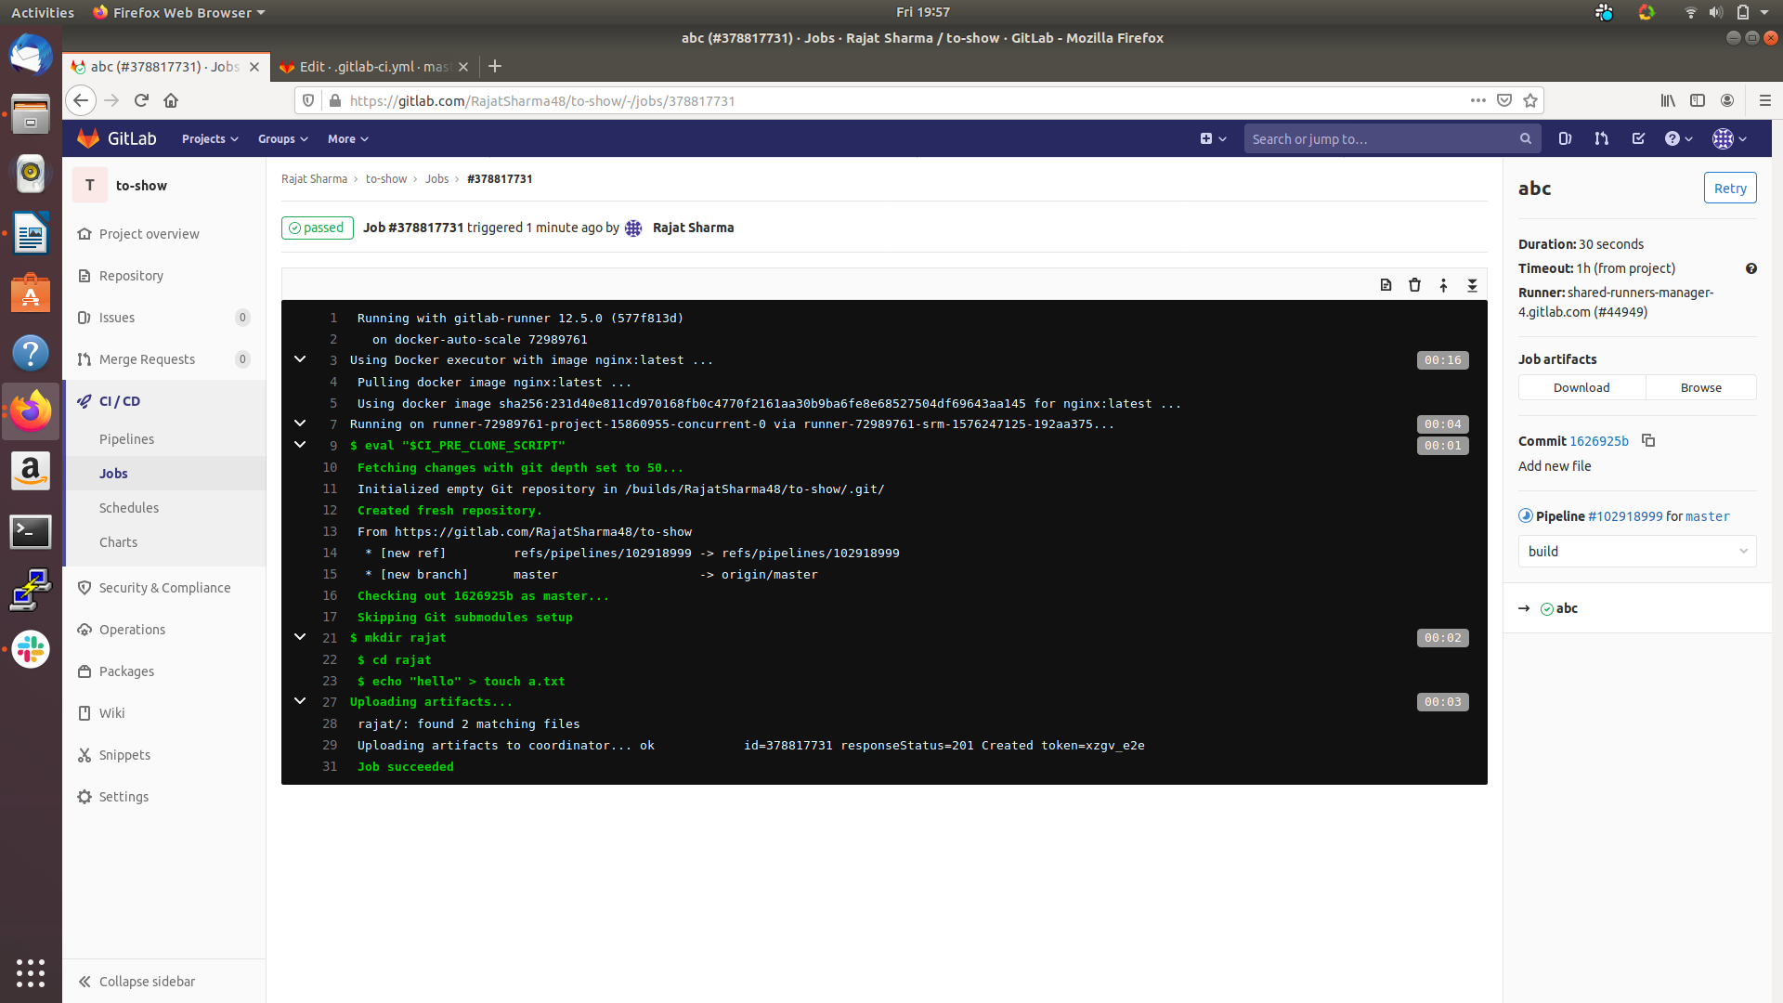
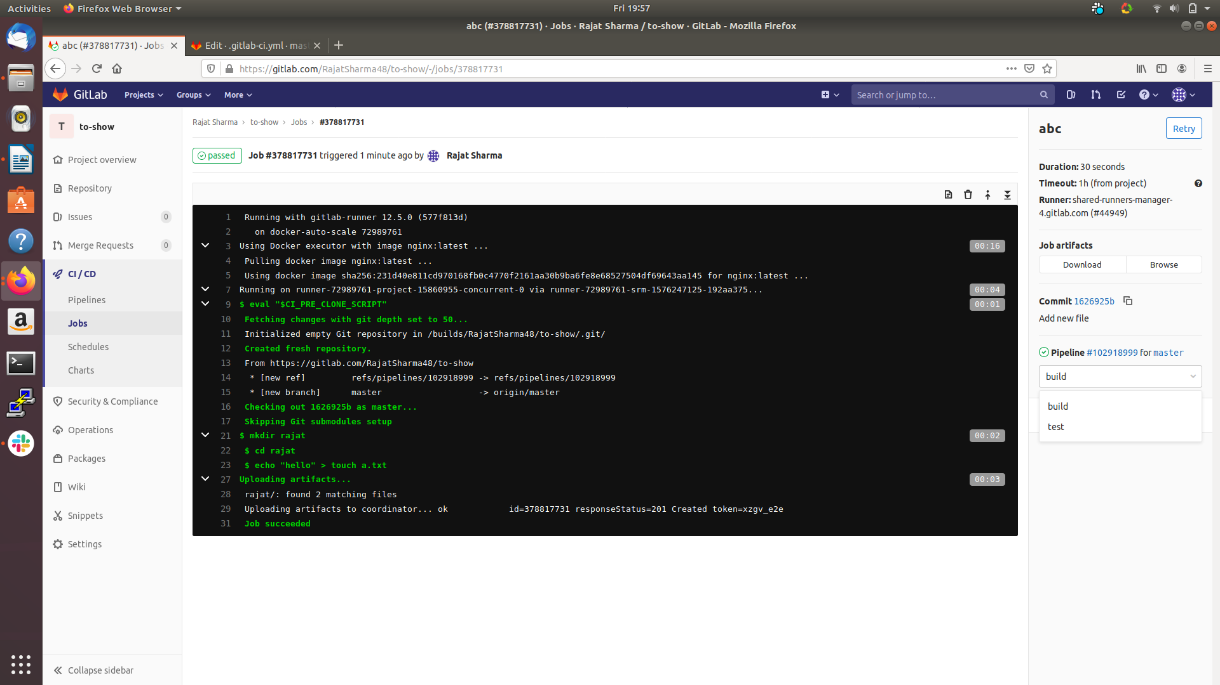
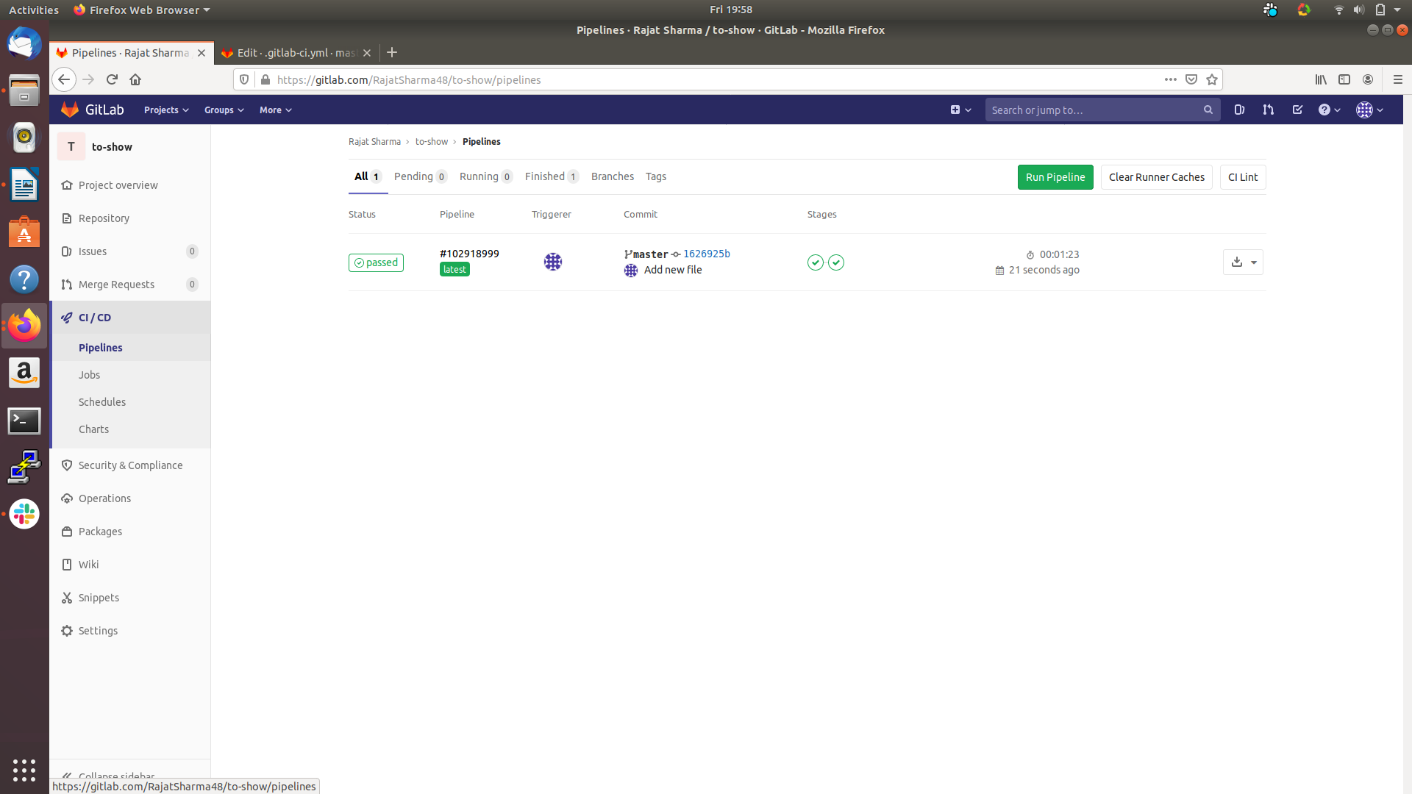

2. Ingress in Kubernetes,

As we all know that Kubernetes follow a rich object model that means everything inside Kubernetes cluster is an object be it a node or a pod. So when you talk about ingress first you have to consider ingress as an object which resides inside the Kubernetes cluster as per the user demand whose sole motive is to provide secure communication. By definition, you can consider ingress as an object which contains rules and regulations to connect and begin the communication between the cluster and the outside world.

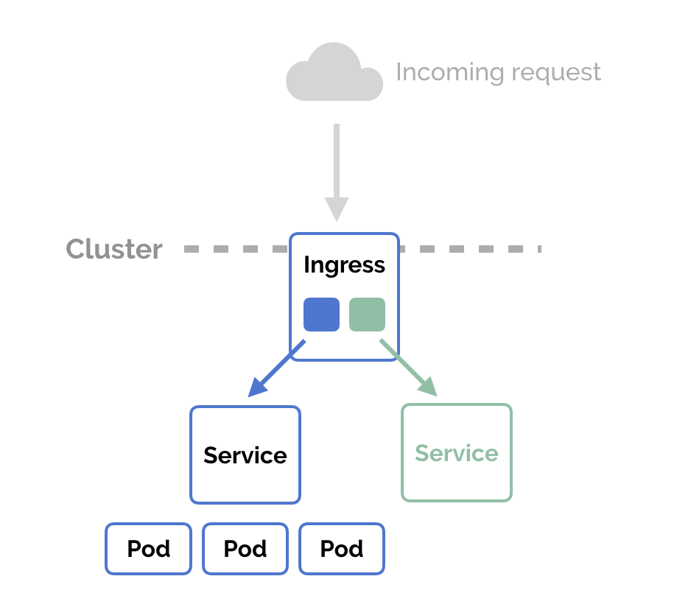

The main question is it the only way to create a communication bridge with the cluster and outside world. The answer is no, Kubernetes do have other objects as well which also fulfills the same conditions but they have their ways to communicate which sometimes is very risky at the organization level or very costly. For example, we do have NodePort and LoadBalancer which fulfills the same conditions but has some drawbacks associated with them. If you talk about NodePort, the communication is very much open which means your IP-address could easily be tracked that too with your service port and also you have to add a NodePort per Service so it is also an overhead. But if you are working locally then you could consider this an option but if you have plans to move to the production than it is not the best suited. If you talk about LoadBalancers, they follow the same functionality in which they build the communication bridge with the outside world but they are very costly as you should be having a well-maintained cloud provider and if you want this to be used in your company at the production than be ready for the associated charges.

While if you talk about the case of Ingress, ingress holds up the information about the service and whenever any request is triggered it looks for the appropriate service and forward the request to the appropriate user and tries to satisfy the user's need.

Now lets come to its practical implementation and I will inform you about the tags which are being used and their functionalities.

Steps,

- First create a .yaml file be it a pod or a deployment, which you want to expose to the outside world.

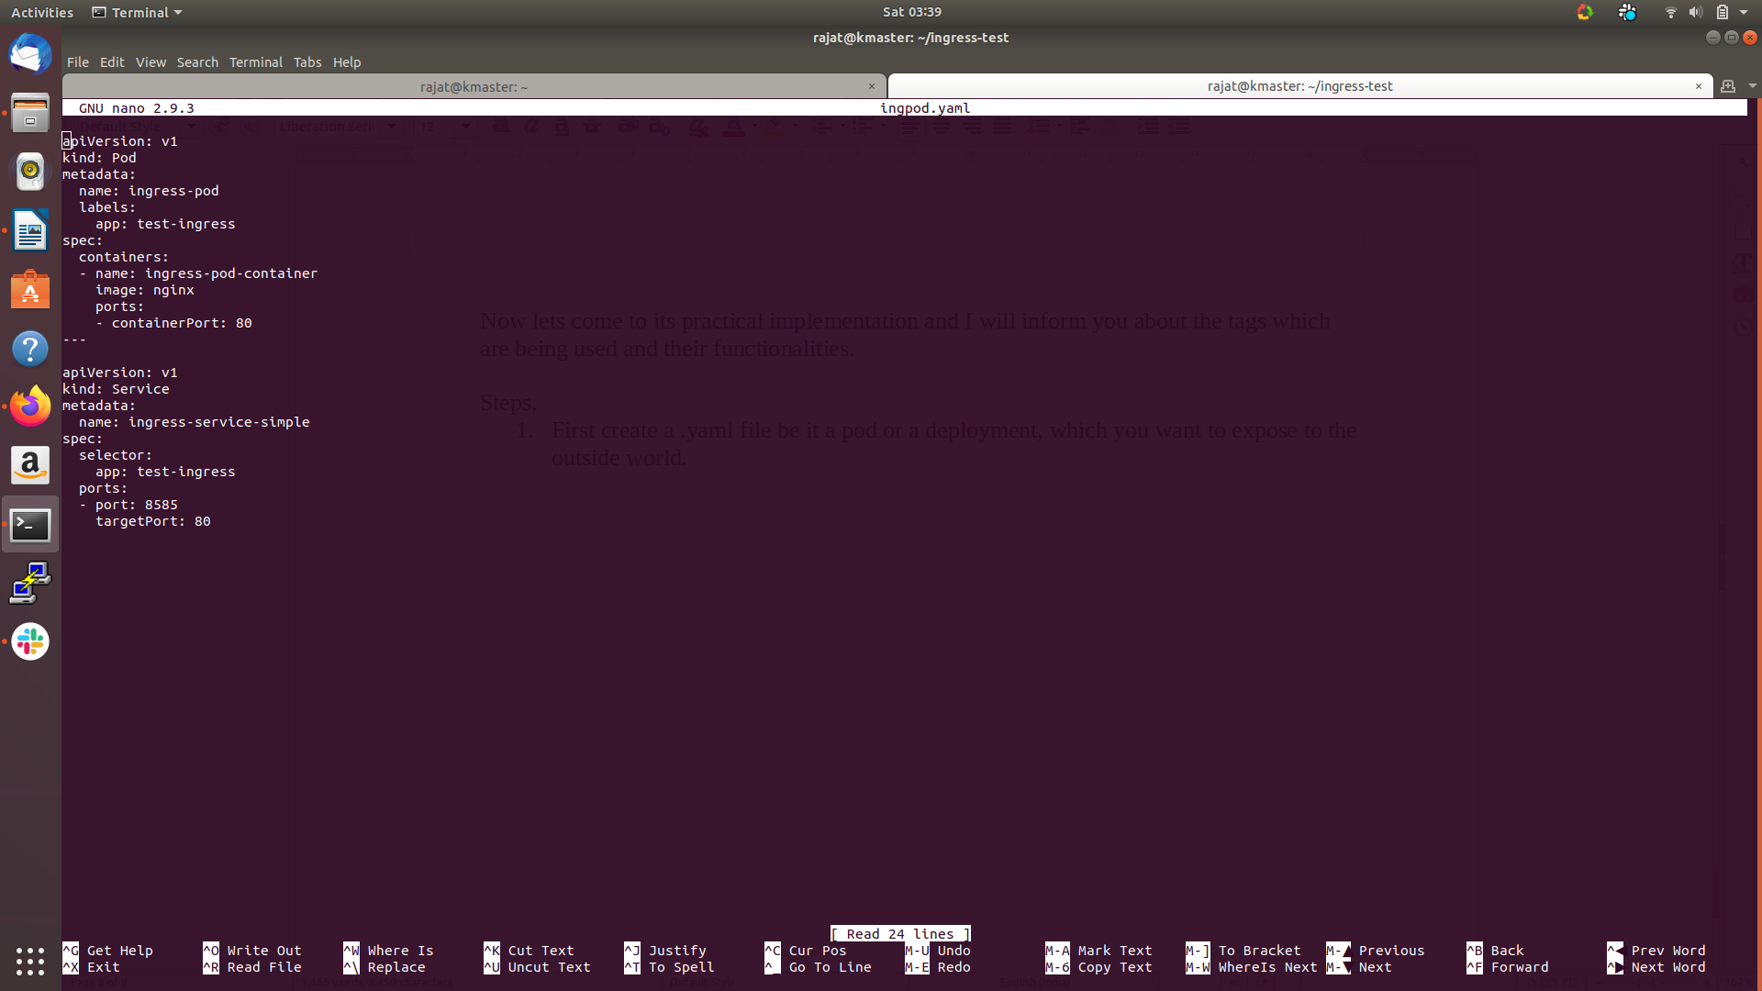

Key-Note,
- apiVersion: Tells you about the version and they are different for deployment and pod, so be careful. (For deployment: apps/v1). The category of v1 considers being stable as we also have beta and alpha version as well which are not that efficient.
(You can use kubectl explan to gather more about an object.)
- kind: It tells you what you are making(Deployment, Pod, Service, PersistentVolume etc) and add the apiVersion as per the kind.
- metadata: Metadata is used for the purpose for providing a reference to your object so that the object could be easily identified. It includes name, labels, annotations, etc which helps in identification in the cluster.
- spec: It is used for specification and it is where the most important things happens. This is the place where you put specification so as to achieve the desired state.
- containers: When you want to specify from where the container part starts you have to add the containers array, which includes information that includes image and the ports.
- image: Here you mention the image name you want to have inside your container.
- ports: Here you write the port which needs to be targeted by the assigned service.

- Create a service for the same deployment and be very careful with its name as it will used with the ingress as well.

Key-Note,
The upper part follows the same essentials as we had in the Pod section. I will put some light on the new tags which is being used in the service area.

- selector: It helps to catch the appropriate pod on which service needs to be hosted.
- port: It is specified for the service port on which ingress should be targetting and adding this information into its specification.
- targetPort: It needs to be same as that of the containerPort so that service could be target and attached with the pod.

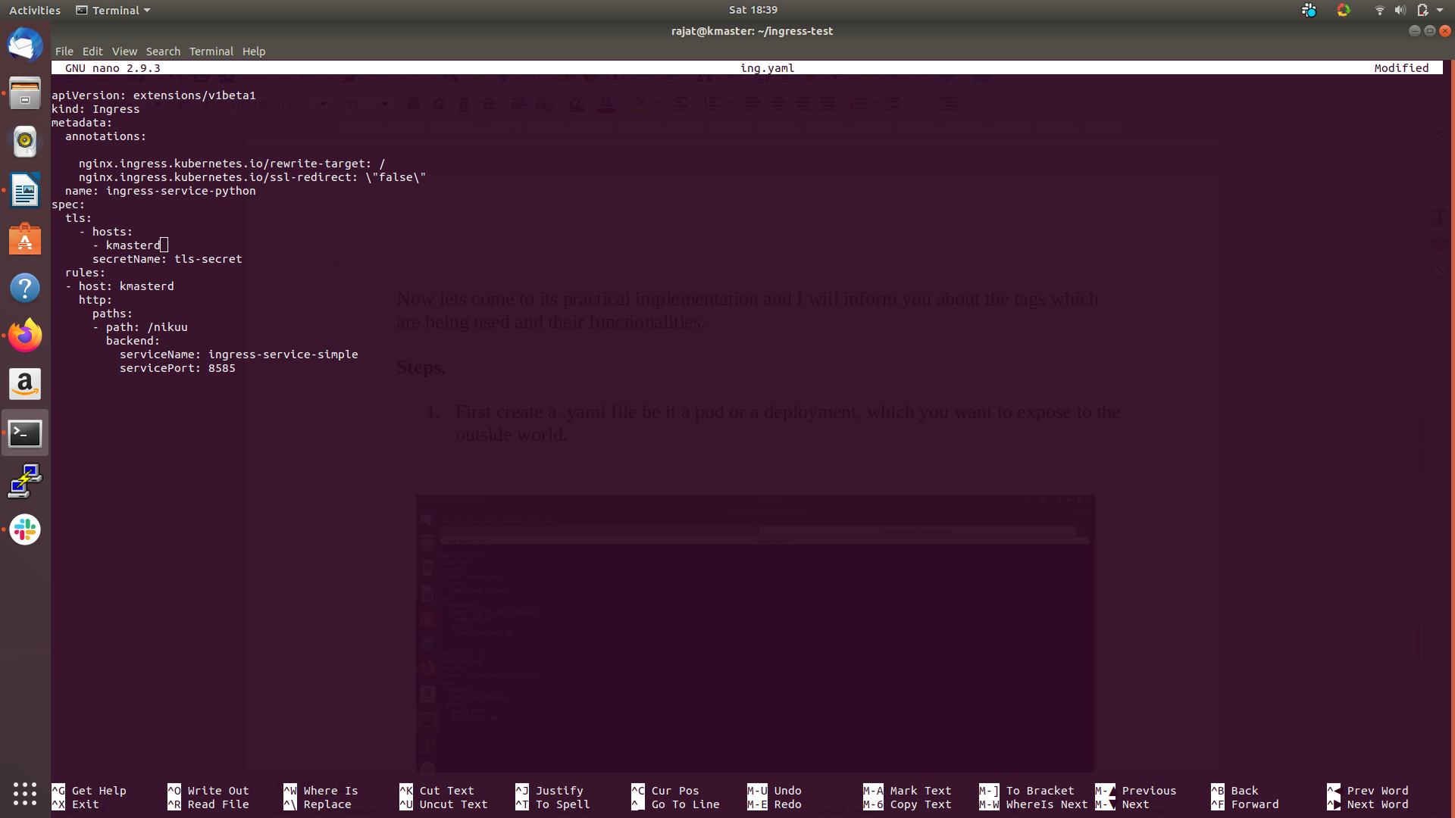
- Create an ingress service .yaml file and fill your neccessary requirements.

Key-Note,
- tls: It provides Transport Layer Security, in this you add hosts available and from the list of hosts, you then forward them to a particular service.
(Before writing any name, do check whether you have mentioned the same name in your “/etc/hosts” file.)
- secretName: For identification purpose, please put some name for the tls as well.
- host: Mention the host name for which you want to asscoiate ingress with and it also helps in creating your path.
- path: Mention the path you want to add to your service so that service could be identified by this path name which you have mentioned.
- backend: In the backened, be very carefull. Add your serviceName and your servicePort(not targetPort) which you have assigned to the pod while creating the service for that pod.

Now you could access any service just by the hostname/path of the service given in the file.

3. Terraform

Before running directly onto the terraform, you first be having a broad idea of what Infrastructure as Code is. In very simple language, whatever infrastructure you have rather than managing and building manually, you have configuring them programmatically which some way or other reducing the failure rate and increasing the efficiency of the resources. Whatever resource you have and you want to configure it in your infrastructure, you could do that very easily by writing the codes.

By definition, Infrastructure as Code is the process of maintaining and configuring the data centers programmatically. I hope you have got some idea about what IaC is.
Moving forward, Terraform is a tool for achieving IaC, it helps is managing, changing, configuring and building the infrastructure very easily and most importantly very fastly and efficiently. It is an open-source IaC tool created by HashiCorp to providing provisioning and versioning of the infrastructure. Because as well all know companies are getting bigger and bigger day by day so, managing all the infrastructure could be a very big overhead. For that, Infrastructure as Code tools came up to ease up the process.

Architecture,

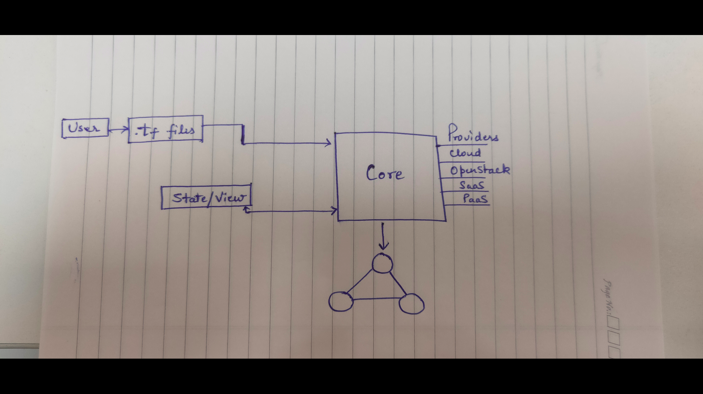

As a user, you have to provide the config files with extensions “.tf”. In these files, you add the configuration you have vision for the infrastructure of yours. There could be multiple .tf files or you could merge all the files into one big .tf but it is not recommended because of so much of information at a single place looks untidy and also any error generation could lead to entire file getting affected.
The core handles the main part of the terraform as it provides the graph showing how will the components looks after everything is set up and ready to be applied. The graph also shows the dependencies of the components on each other. As it follows the declarative approach, the connection and building up the dependencies between the components get taken care of by the terraform core. Core also handles the state/view of the configuration or resources, so that it would ease up the entire process by storing some information from the previous configuration.
It does have a list of providers which includes 46+ cloud providers, PaaS, OpenStack, and SaaS. In short, covering most of the sectors.

Flow,

The simple workflow starts from the refresh stage where the user adds their configuration into the files. After that planning happens, which gives us the idea of how would our infrastructure be looking once all the configuration is done. The last stage is the applying stage where you are satisfied with the current plan and want to move ahead for the same. Once applied, your resources would start build and showing up in your respective cloud provider console.
But the problem with writing your own configuration could lead up to many errors so to counter that HashiCorp gives the support of module which is attached to the central registry of the terraform, where pre-configured modules are present in a ready-to-use state. Registry also has the feature of attaching version control system with it so if you want to add your git to the registry of terraform (HashiCorp) you could do so.

I think you have got the broad idea of what IaC and its tool is doing so by keeping that in mind we will move forward for the pratical part.

Steps,
- Please install terraform on your system by downloading the package .(Go for the official site of HashiCorp for download purpose).

- Please do install “aws cli” for command line purpose.

- Now set up your AWS account(you could use cloud of your choice but be careful on writing the correct provider name at various stages.)
You need to setup your Identity and Access Manager(IAM) in your AWS, you basically have to create a user and provide adminAccess to it for now but could change as per the requirements and demands.
Once done with creating the user through IAM, please do copy the Access key and Secret key which would be shown after successfully creating your user.
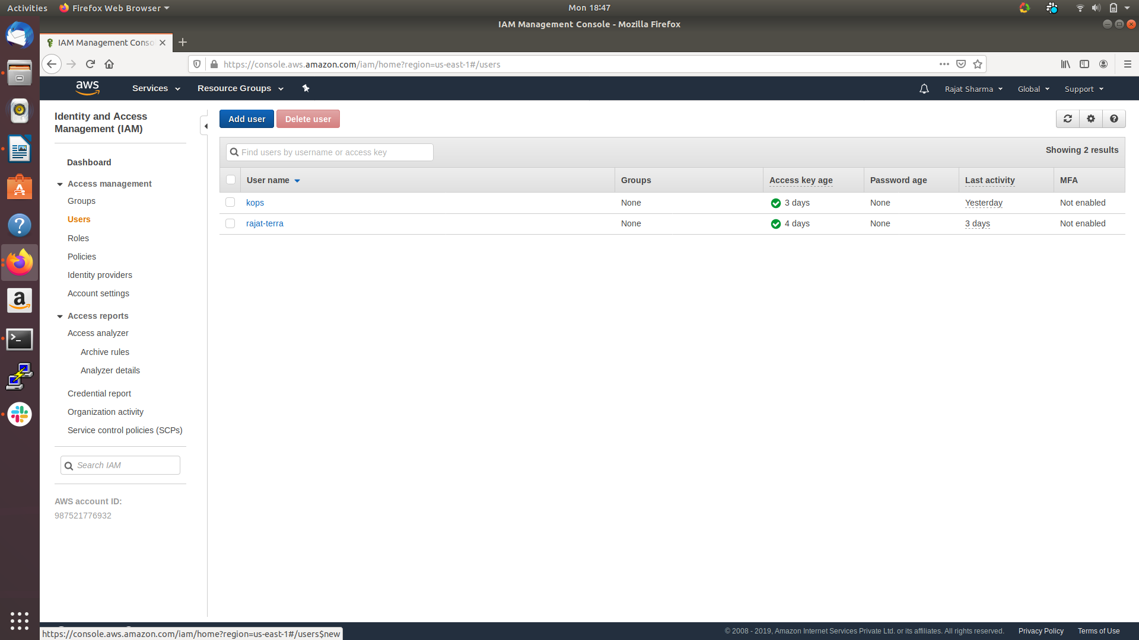

- Now you could configure the credentials by using the command, “aws configure”
and mention your details there.
You can review your configuration files in ~/.aws/credentials file.

- Create a folder where you want to have the configuration files.
For now, create only a single “.tf” where you should be mentioning about cloud providers so that terraform could be initialized.
By using the command, “terraform init”.
It will automatically install all the necessary plugins needed by the cloud provider.

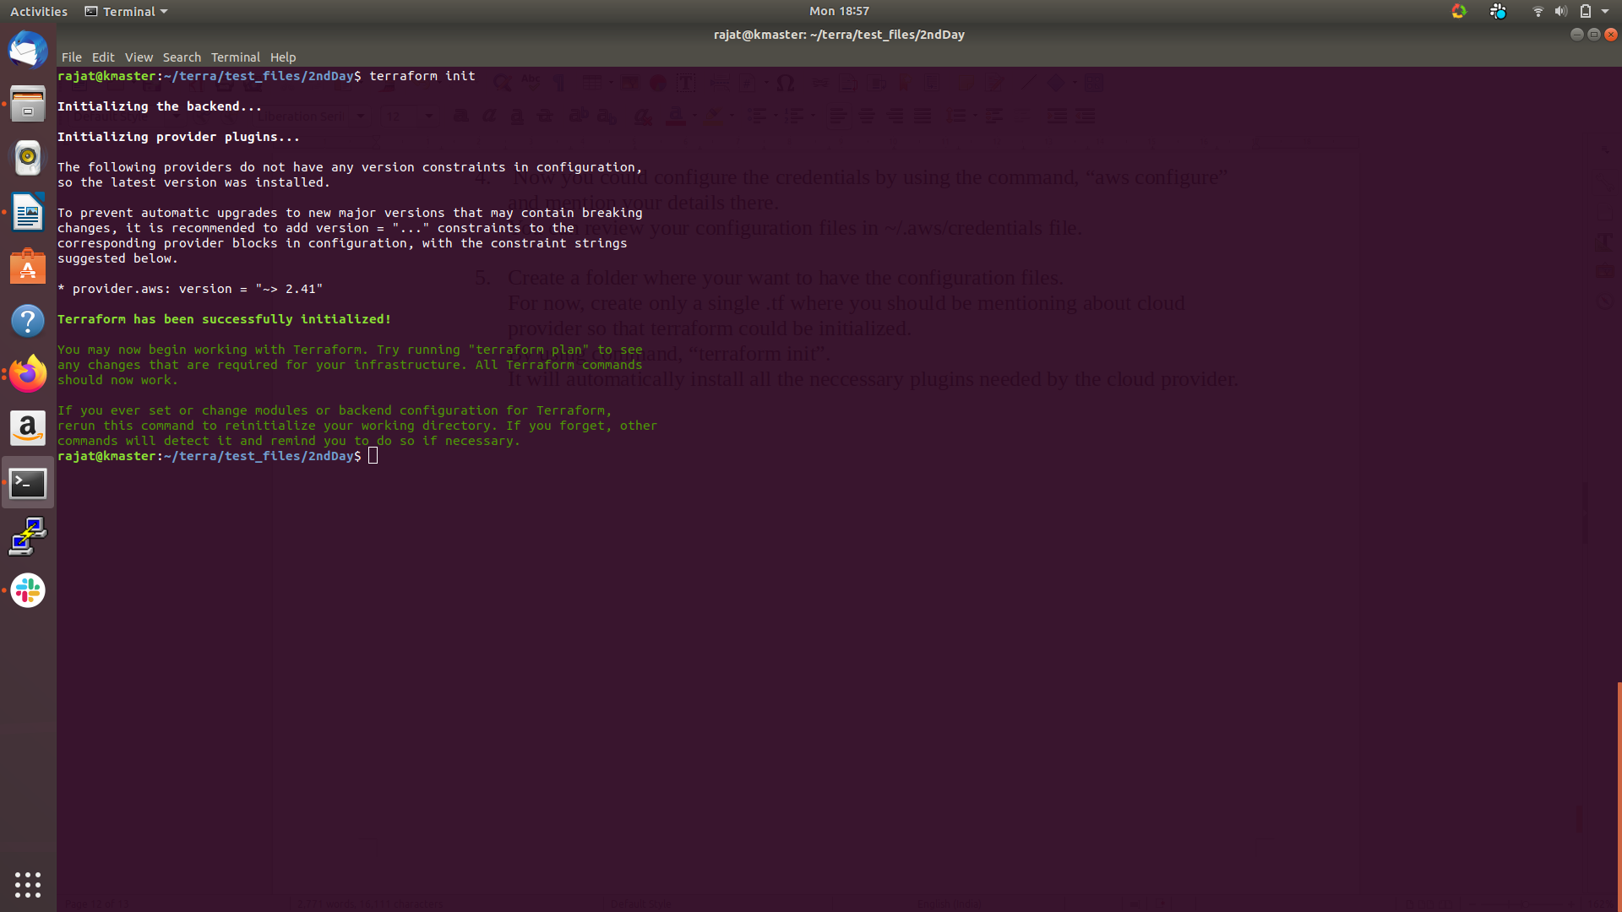

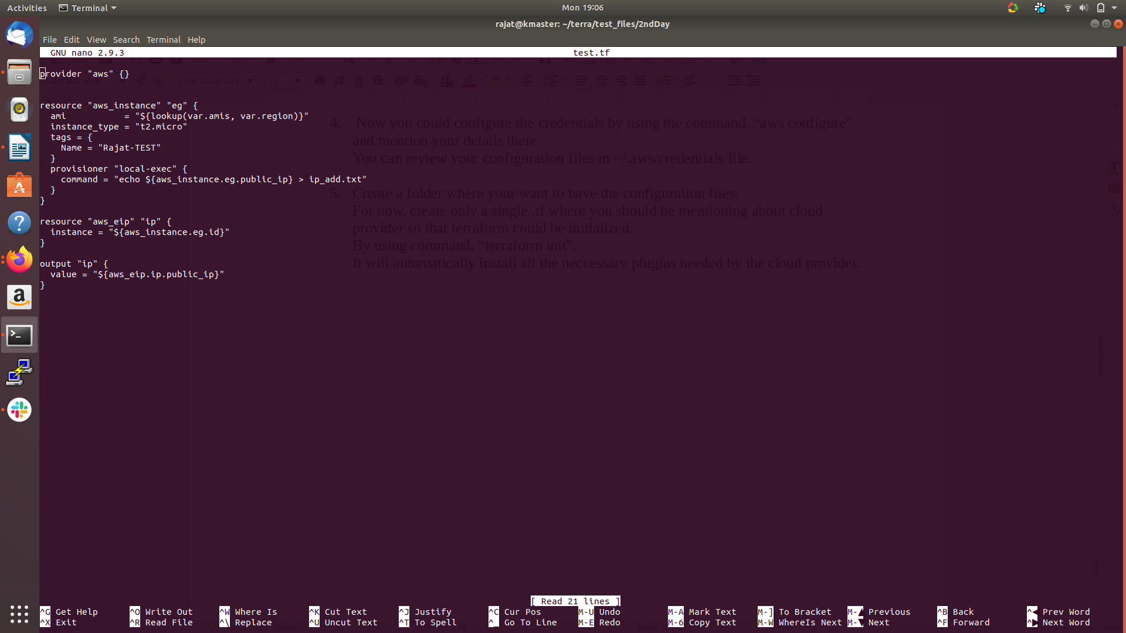

For the variable purpose you could also create a separate file for variable information storage.

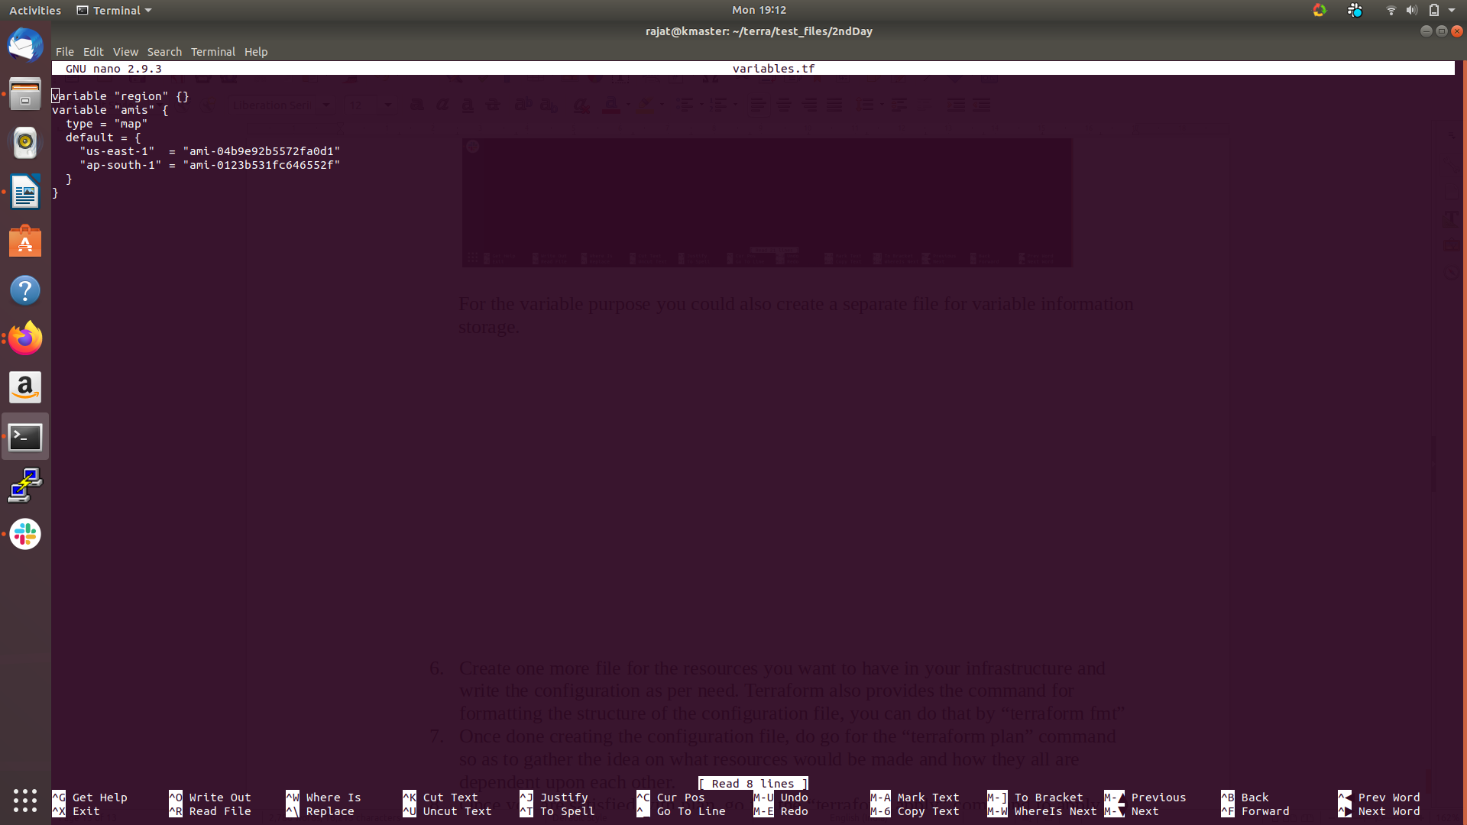

- Create one more file for the resources you want to have in your infrastructure and write the configuration as per need. Terraform also provides the command for formatting the structure of the configuration file, you can do that by “terraform fmt”.

- Once done creating the configuration file, do go for the “terraform plan” command so as to gather the idea on what resources would be made and how they all are dependent upon each other.

- Once you are satisfied with the plan, go for the “terraform apply” command to apply the planning and move forward. It will ask for the various information for example, like regions if not mentioned.

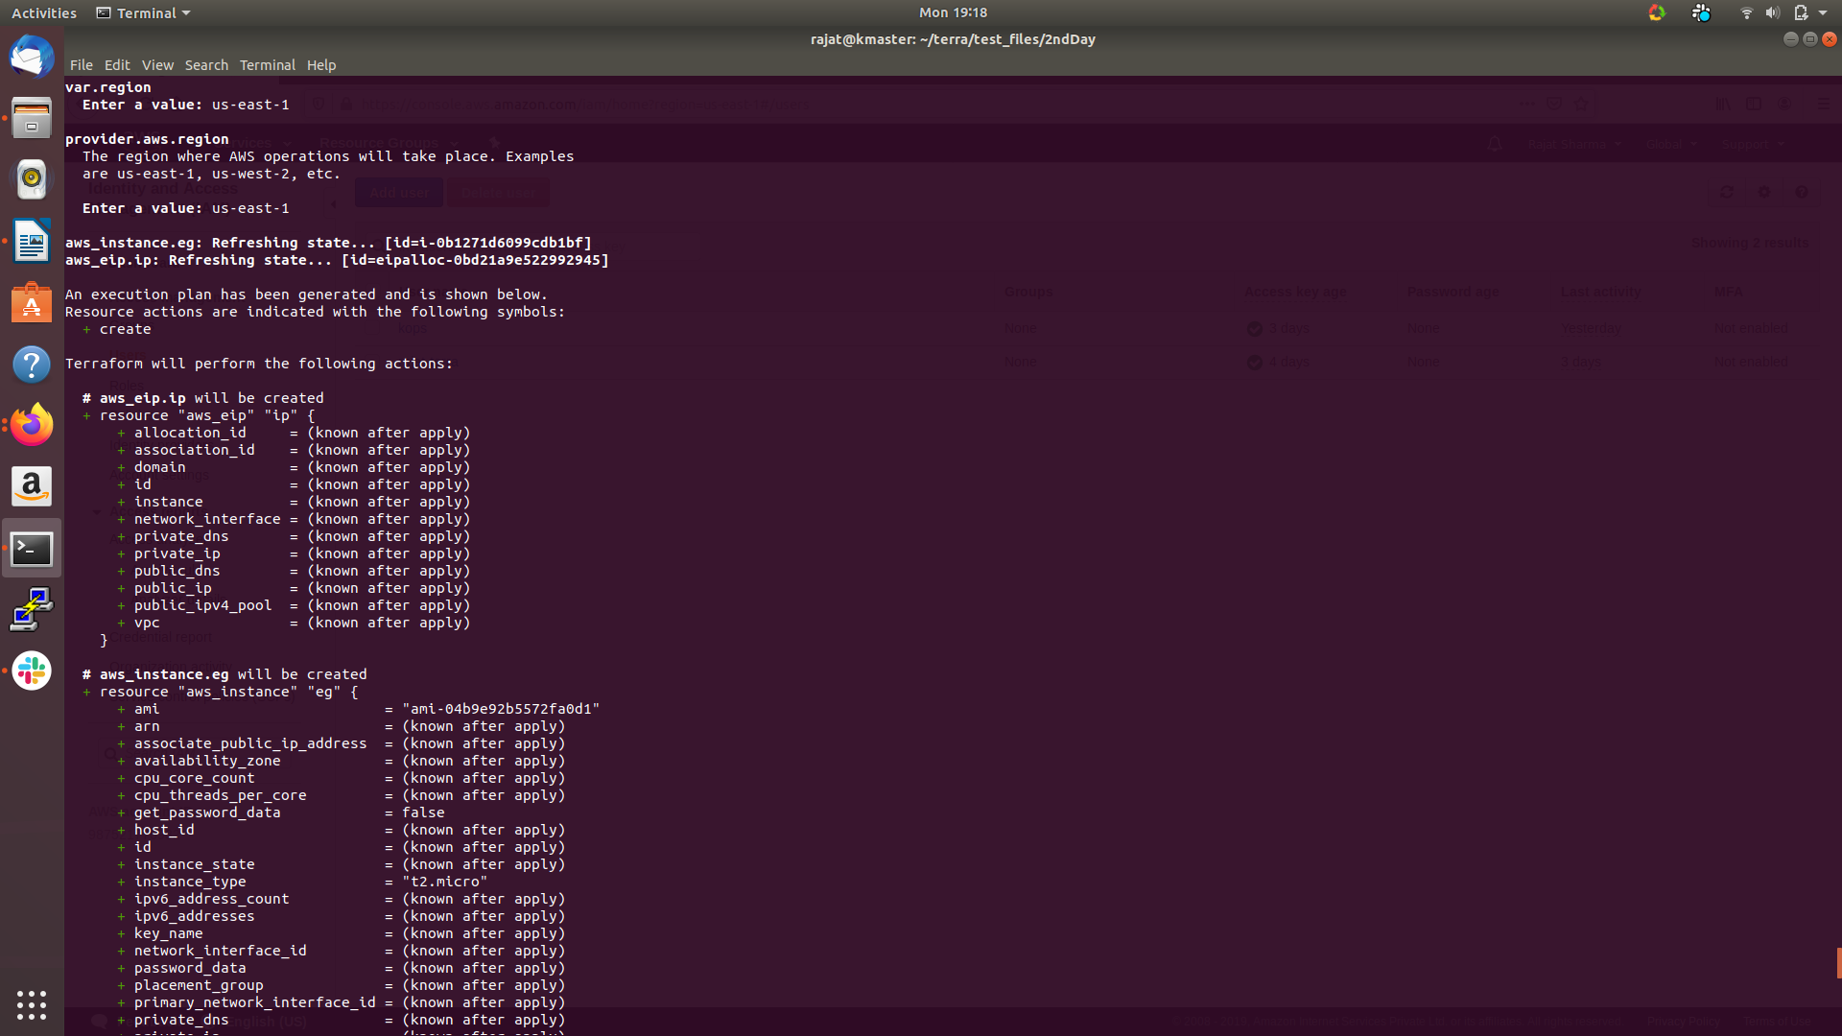

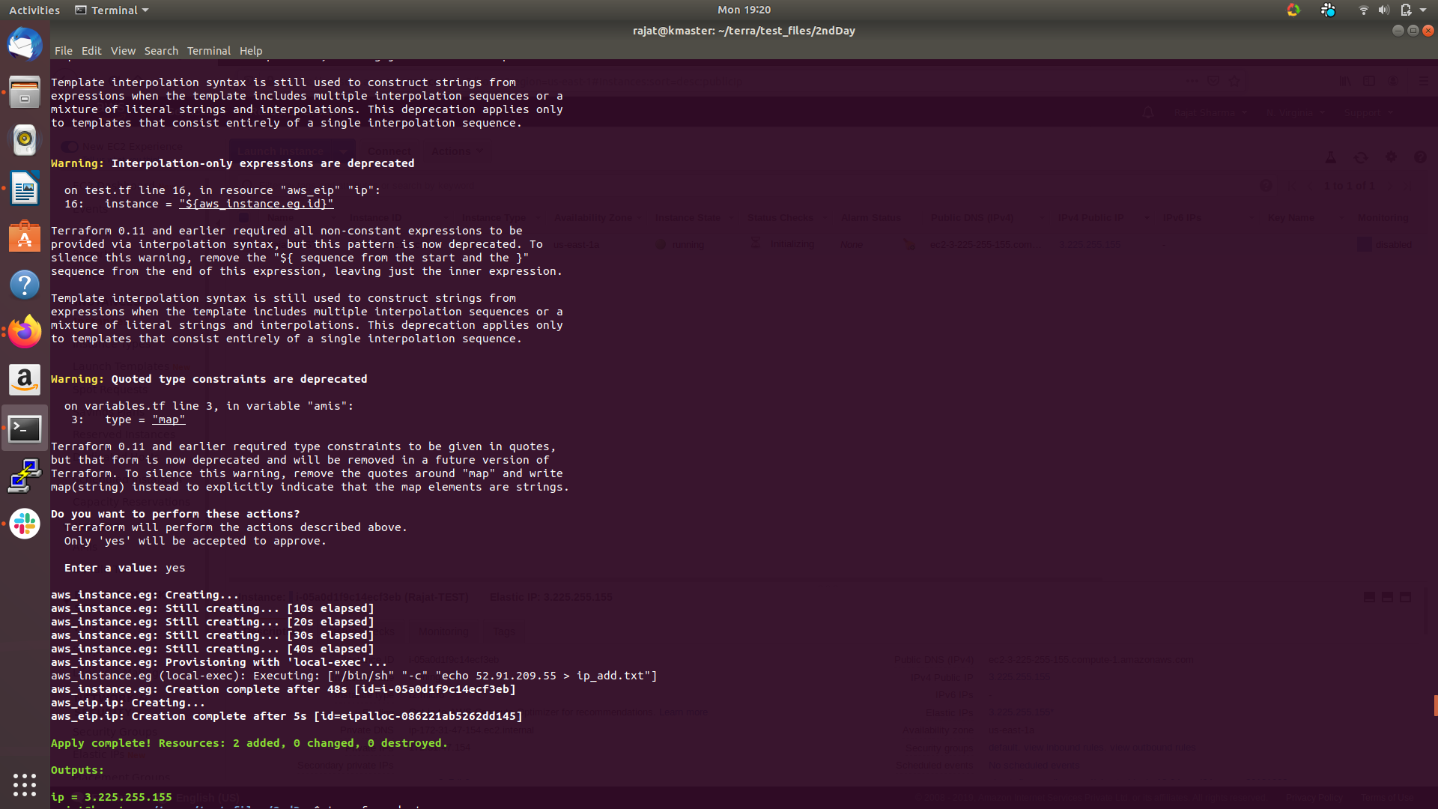

- After that, if all done successfully, you would be able to use the resources from your cloud provider console.

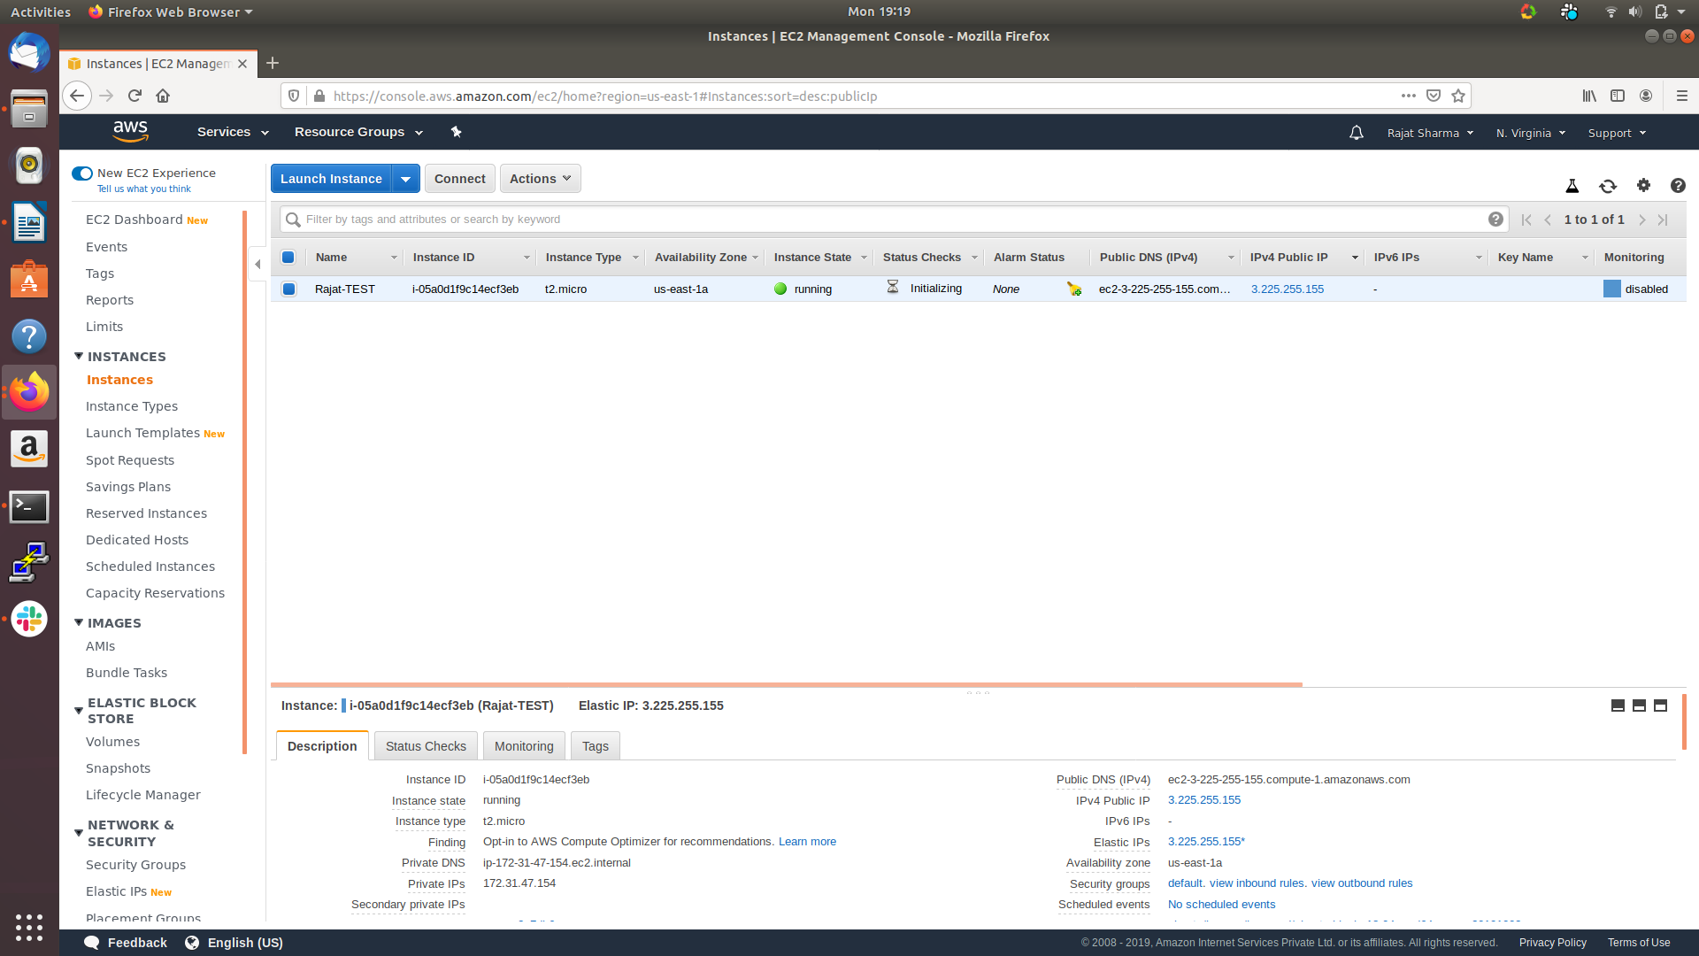

Do destroy the infrastructure is not so as to not get billed. To destroy use “terraform destroy”.

