ShopNest Store Power BI Capstone - Dashboard Report

Q1. Top Categories by Total Price
Question Statement:
Identify and visually represent the top 10 product categories by total sales.
Visualization:
Screenshot of the corresponding chart from dashboard
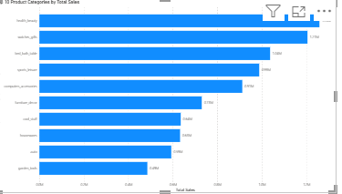
Explanation:
This visual shows the top-performing categories based on total revenue. It helps identify which categories contribute the most to overall sales.

Q2. Delayed Orders Analysis
Question Statement:
Determine the number of delayed orders in each category.
Visualization:
Screenshot of the corresponding chart from dashboard

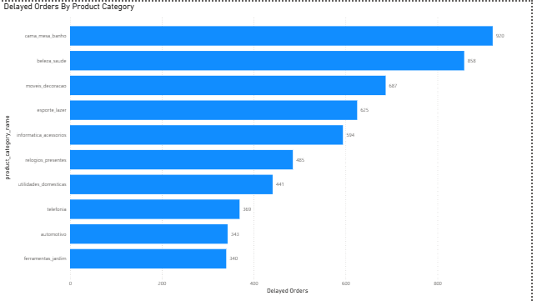

Explanation:
This chart highlights categories with the highest delayed orders, helping identify operational inefficiencies in delivery.

Q3. Monthly Comparison of Delayed and On-Time Orders
Question Statement:
Compare delayed and on-time orders month-wise.
Visualization:
Screenshot of the corresponding chart from dashboard
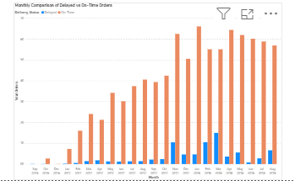

Explanation:
This visual shows monthly performance of delivery. It helps track improvement or decline in delivery efficiency.

Q4. Payment Method Analysis
Question Statement:
Analyze most frequently used payment methods.
Visualization:
Screenshot of the corresponding chart from dashboard
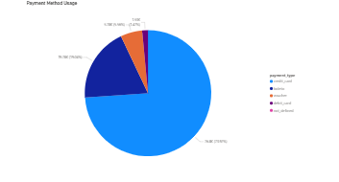

Explanation:
This pie chart shows customer payment preferences, helping business optimize payment options.

Q5. Product Rating Analysis
Question Statement:
Identify top 10 highest-rated and bottom 10 lowest-rated products.
Visualization:
Screenshot of the corresponding chart from dashboard

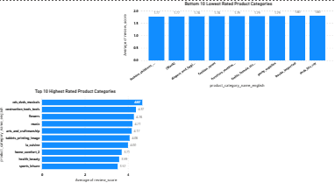

Explanation:
This analysis highlights customer satisfaction levels and helps identify strong and weak products.

Q6. State-wise Sales Analysis
Question Statement:
Identify states with high and low sales.
Visualization:
Screenshot of the corresponding chart from dashboard
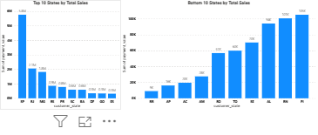

Explanation:
This visual shows regional performance and helps target high and low performing states.

Q7. Seasonal Sales Patterns
Question Statement:
Analyze quarterly sales trends.
Visualization:
Screenshot of the corresponding chart from dashboard
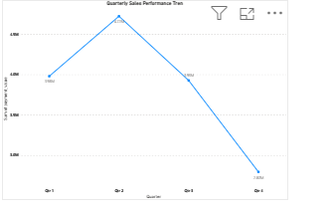

Explanation:
This chart shows seasonal variations in sales, helping in planning inventory and promotions.

Q8. Revenue Analysis
Question Statement:
Analyze yearly revenue trends.
Visualization:
Screenshot of the corresponding chart from dashboard
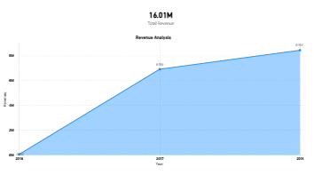

Explanation:
This visual shows revenue growth over time and overall business performance.

