|  |  |
| --- | --- |
| **Cognizant Digital Nurture 4.0: Deep Skilling** | |
| Name: Rajatesh Paul | Superset ID: 6365356 |
| Week: 02 | Advance SQL Server (Exercise-Views) |

**Employee Management System - SQL Exercises**

Database Schema

* Departments Table

CREATE TABLE Departments ( DepartmentID INT PRIMARY KEY, DepartmentName VARCHAR(100) );

* Employees Table

CREATE TABLE Employees ( EmployeeID INT PRIMARY KEY, FirstName VARCHAR(50), LastName VARCHAR(50), DepartmentID INT FOREIGN KEY REFERENCES Departments(DepartmentID), Salary DECIMAL(10, 2), JoinDate DATE );

**Exercises**

**Exercise 1:** Create a Simple View

Goal: Create a view to show basic employee details. Task: Create a view named vw_EmployeeBasicInfo that displays EmployeeID, FirstName, LastName, and DepartmentName by joining Employees and Departments.

**Code:**

create database Exercise2;

use Exercise2;

CREATE TABLE Departments ( DepartmentID INT PRIMARY KEY, DepartmentName VARCHAR(100) );

CREATE TABLE Employees (

EmployeeID INT PRIMARY KEY,

FirstName VARCHAR(50),

LastName VARCHAR(50),

DepartmentID INT FOREIGN KEY REFERENCES Departments(DepartmentID),

Salary DECIMAL(10, 2),

JoinDate DATE );

INSERT INTO Departments (DepartmentID, DepartmentName) VALUES

(1, 'Human Resources'),

(2, 'Finance'),

(3, 'Engineering'),

(4, 'Sales'),

(5, 'IT Support');

INSERT INTO Employees (EmployeeID, FirstName, LastName, DepartmentID, Salary, JoinDate) VALUES

(101, 'Alice', 'Johnson', 1, 60000.00, '2020-03-15'),

(102, 'Bob', 'Smith', 2, 75000.00, '2019-07-10'),

(103, 'Charlie', 'Lee', 3, 85000.00, '2021-01-05'),

(104, 'Diana', 'Garcia', 3, 88000.00, '2018-11-20'),

(105, 'Ethan', 'Brown', 4, 50000.00, '2022-06-01'),

(106, 'Fiona', 'Davis', 1, 62000.00, '2021-09-13'),

(107, 'George', 'Wilson', 2, 74000.00, '2020-12-24'),

(108, 'Hannah', 'Martinez', 5, 68000.00, '2017-04-30'),

(109, 'Ian', 'Taylor', 4, 52000.00, '2023-01-11'),

(110, 'Jane', 'Anderson', 5, 69000.00, '2019-02-18');

CREATE VIEW vw_EmployeeBasicInfo AS

SELECT

E.EmployeeID,

E.FirstName,

E.LastName,

D.DepartmentName

FROM Employees E

INNER JOIN Departments D ON E.DepartmentID = D.DepartmentID;

SELECT * FROM vw_EmployeeBasicInfo;

**Output:**

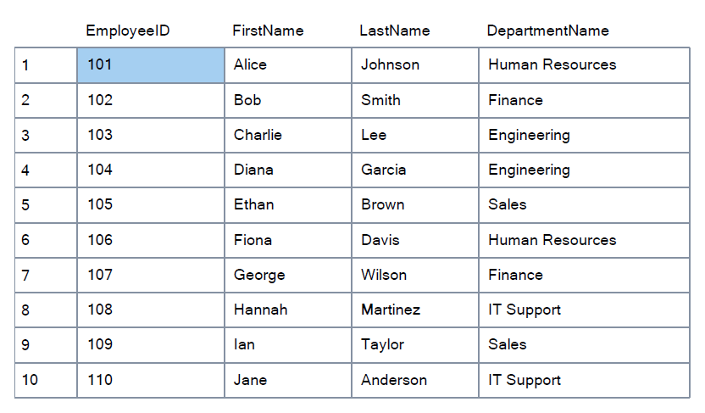

**Exercise 2:** Add Computed Column - Full Name

Goal: Use a computed column in a view. Task: Modify or create a view named vw_EmployeeFullName that includes a computed column FullName (concatenation of FirstName and LastName).

Example Computed Column: FirstName + ' ' + LastName AS FullName

**Code:**

CREATE VIEW vw_EmployeeFullName AS

SELECT

EmployeeID,

FirstName,

LastName,

FirstName + ' ' + LastName AS FullName

FROM Employees;

SELECT * FROM vw_EmployeeFullName;

**Output:**

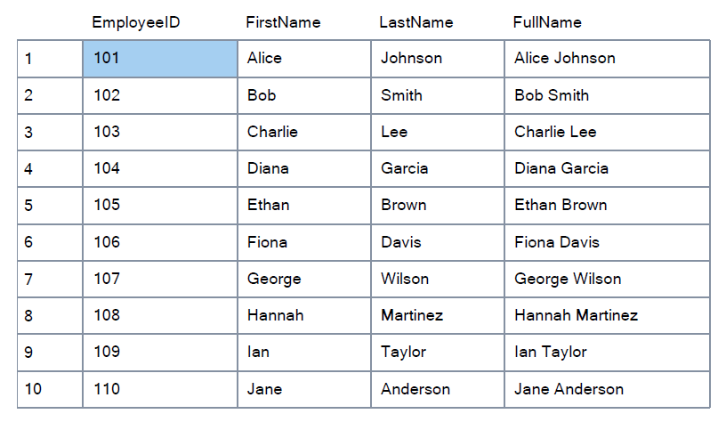

**Exercise 3:** Add Computed Column - Annual Salary

Goal: Add a financial computed column. Task: Create a view named vw_EmployeeAnnualSalary that includes a computed column AnnualSalary (Salary * 12).

**Code:**

CREATE VIEW vw_EmployeeAnnualSalary AS

SELECT

EmployeeID,

FirstName,

LastName,

Salary,

Salary * 12 AS AnnualSalary

FROM Employees;

SELECT * FROM vw_EmployeeAnnualSalary;

**Output:**

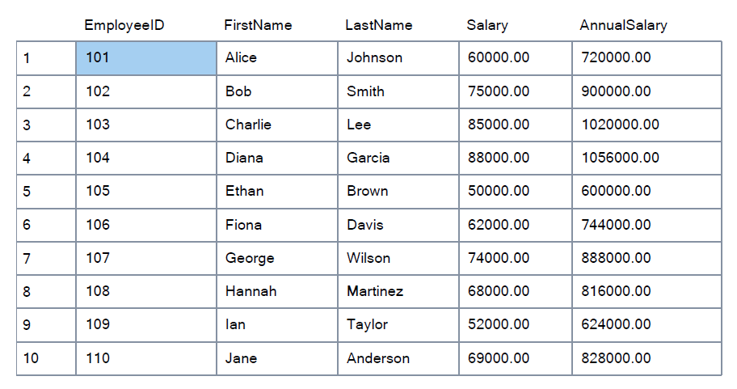

**Exercise 4:** Add Multiple Computed Columns

Goal: Combine multiple computed columns in a single view. Task: Create a view named vw_EmployeeReport that includes: - EmployeeID - FullName - DepartmentName - AnnualSalary - Bonus (10% of AnnualSalary) Example Bonus Calculation: (Salary * 12) * 0.10 AS Bonus

**Code:**

CREATE VIEW vw_EmployeeReport AS

SELECT

E.EmployeeID,

E.FirstName + ' ' + E.LastName AS FullName,

D.DepartmentName,

E.Salary * 12 AS AnnualSalary,

(E.Salary * 12) * 0.10 AS Bonus

FROM Employees E

INNER JOIN Departments D ON E.DepartmentID = D.DepartmentID;

SELECT * FROM vw_EmployeeReport;

**Output:**

