Humanoid Robot - Reception Assistant (CLI simulation)
1.Overview
This project is a Python simulation of a humanoid robot acting as a reception assistant in a smart office. The system demonstrates object-oriented design, uses standard data structures (list, stack, queue), and provides a simple command-line interface (CLI) for interaction. It simulates three main operations:
- Greeting visitors and validating appointments.
- Guiding visitors to meeting rooms (simulated navigation).
- Monitoring the environment using a pseudo-random sensor suite.
Structure and presentation

- Code is organized with a clear separation between model classes and CLI.
- Inline comments explain design rationale and important implementation details.
- The README (this file) contains the project description, instructions, and explanation of choices.

Project Structure
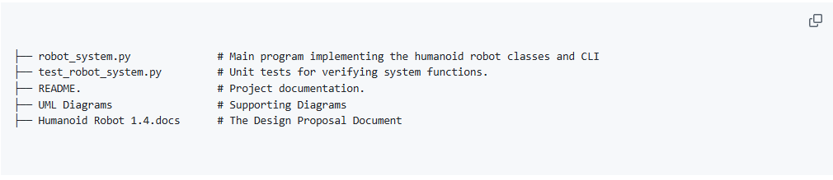

2.Design and OOP features
Classes:
- Visitor: simple data holder for visitor name.
- Visitor Log: list-based chronological log (append-only) that stores interactions for later retrieval.
- Appointment Stack: appointment list implemented as a stack to fulfill the assignment constraint; supports push, pop, and contains.
- Visitor Queue: deque-based FIFO queue to manage waiting visitors.
- Sensor Suite: simulates sensors for temperature (°C), noise (dB), and light (lux).
- Humanoid Robot: orchestrator tying everything together: greeting, validation, navigation, logging, and monitoring.

- Encapsulation: each concern (sensors, logging, queueing) is encapsulated in a class to improve modularity and testability.
- Data structures: list for logs (ordered history), stack for appointments (per assignment requirement), and queue for waiting visitors (natural FIFO semantics).

3. Implementation
Ensure you have Python 3.8+ installed.
- Place files in a directory:
  - robot_system.py
  - test_robot_system.py
- To run the interactive CLI: $ python robot_system.py follow on-screen prompts:
  - Register visitor / Greet: enter a visitor name, robot will check the appointment stack and either guide or queue the visitor.
  - Guide next visitor: robot will guide the first waiting visitor from the queue.
  - Monitor environment returns simulated sensor readings and any alerts.
  - Show visitor log displays recorded events with timestamps.
  - Preload appointment: add a name to the appointment stack for testing.
  - q: quit

4. Testing:

To run tests:

Test data used

- Initial appointments preloaded in robot_system.py when run as script: "Alice Johnson", "Bob Smith", "Charlie Li".
- Unit tests in `test_robot_system.py` use a smaller appointment list and verify:
  - appointment validation,
  - correct behavior when greeting appointment vs non-appointment visitors,
  - queueing and guiding mechanics,
  - Sensor monitoring returns expected keys.

5.Extensibility ideas

- Replace appointment stack with a more realistic database-backed appointment system or hash-set for faster lookups.
- Add visitor recognition (e.g., persisted visitor profiles).
- Add more realistic navigation and mapping (graph-based pathfinding).
- Add concurrency: sensor monitoring in a background thread and an event-driven architecture.
- Replace CLI with a GUI or web interface for improved usability.

6.Limitations

- The assignment required demonstrating a stack; while stacks are unusual for appointment lists, it's implemented to meet the requirement.
- Sensors are simulated; real hardware integration would require I/O drivers and safety checks.
- This simulation takes short time. Sleep calls for simple realism;

Reference list.

- CS4 Python Style Guide. (n.d.). Available at: https://cs.brown.edu/courses/csci0040/CS4_Python_Style_Guide.pdf [Accessed 13 Oct. 2025].
- van Rossum, G., Warsaw, B. and Coghlan, N. (2001). PEP 8 – Style Guide for Python Code. [online] peps.python.org. Available at: https://peps.python.org/pep-0008/.
- Visual Paradigm (2019). Visual Paradigm [online] Visual-paradigm.com. Available at: https://online.visual-paradigm.com/.
- Write Docs. (2024). Software documentation guide. [online] Available at: https://www.writethedocs.org/guide/index.html.
- Alchin, M. (2010) 'PEP 8 Style Guide for Python', in: Alchin, M. Pro Python. United States: Apress L. P.

