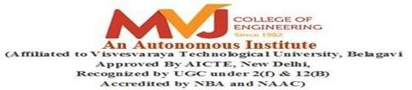

**A MINI PROJECT REPORT**

ON

**PNEUMONIA DIAGNOSIS USING DEEP LEARNING**

Submitted in partial fulfillment of requirements for the award of 5th Sem of

## BACHELOR OF ENGINEERING IN

**ARTIFICIAL INTELLIGENCE AND MACHINE LEARNING**

Submitted By:

|  |  |
| --- | --- |
| 1MJ22AI026 | LAXMIKANT ANDEWADI |
| 1MJ22AI043 | RAJATH KUMAR |
| 1MJ22AI046 | ROHAN B |
| 1MJ22AI057 | VIKAS S C |

Under the Guidance of

## Mrs. Sanjivani Tipe

Assistant Professor, Department of AIML

**DEPARTMENT OF** **ARTIFICIAL INTELLIGENCE AND MACHINE LEARNING**

### MVJ COLLEGE OF ENGINEERING

**BANGALORE-67 ACADEMIC YEAR 2024-25**

# MVJ COLLEGE OF ENGINEERING



### Near ITPB, Whitefield, Bangalore-67

**DEPARTMENT OF ARTIFICIAL INTELLIGENCE AND MACHINE LEARNING**

CERTIFICATE

This is to certify that the mini-project work, entitled “**PNEUMONIA DIAGNOSIS USING DEEP LEARNING”** is a Bonafide work carried out in partial fulfillment for the award of degree of Bachelor of Engineering in Computer Science & Engineering during the academic year 2024-25. It is certified that all the corrections/suggestions indicated for Internal Assessment have been incorporated in the Report. The mini project report has been approved as it satisfies the academic requirements.

**Signature of the Guide Signature of the HOD**

**Mrs. Sanjivani Tipe Mrs. Asha Joseph**

**Assistant Professor, Dept of AIML**

Name of examiners: Signature with date: 1.

2.



# MVJ COLLEGE OF ENGINEERING

### Whitefield, Near ITPB, Bangalore-67

**DEPARTMENT OF ARTIFICIAL INTELLIGENCE AND MACHINE LEARNING**

DECLARATION

Wehereby declare that the entire work titled “**PNEUMONIA DIAGNOSIS USING DEEP LEARNING”** embodied in this mini project report has been carried out by me during the 5th semester of BE degree at MVJCE, Bangalore under the esteemed guidance of **Mrs. Sanjivani Tipe**, Assistant Prof, Dept. of AIML, MVJCE. The work embodied in this dissertation work is original and it has not been submitted in part or full for any other degree in any University.

1MJ22AI026

1MJ22AI043

1MJ22AI046

1MJ22AI057

LAXMIKANT ANDEWADI

RAJATH KUMAR

ROHAN B

VIKAS S C

Place: Date:

# ABSTRACT

Pneumonia is a severe respiratory condition that poses significant health risks and contributes to high mortality rates worldwide. Accurate and timely diagnosis is crucial for effective treatment and management. This project presents a deep learning-based approach to automate the classification of chest X-ray images, identifying whether a patient has pneumonia or not. Utilizing the MobileNet architecture, a lightweight and efficient convolutional neural network, the model was trained on a comprehensive dataset of chest X-ray images to achieve high accuracy.

To enhance accessibility and usability, a Flask-based web application was developed, enabling users to upload chest X-ray images and receive real-time classification results. The application provides a percentage-based prediction, offering insights into the likelihood of pneumonia. By leveraging advanced image processing techniques and pre-trained models, the system demonstrates robust performance with an accuracy of over 97%, optimizing diagnostic workflows in medical settings. This project highlights the potential of artificial intelligence in supporting healthcare professionals and improving diagnostic precision for pneumonia.

# 

# ACKNOWLEDGEMENT

The satisfaction and euphoria that accompany the successful completion of any task would be incomplete without the mention of people who made it possible, success is the epitome of hard work and perseverance, but steadfast of all is encouraging guidance.

So, with gratitude we acknowledge all those whose guidance and encouragement served as beacon of light and crowned our effort with success.

We are thankful to Dr. Ajayan K R, Principal of MVJCE for his encouragement and support throughout the project work.

We are thankful to Mr. Kumar R, Controller Of Examinations, for his encouragement and support throughout the project work.

We are also thankful to Mrs. Asha Joseph, HOD, CSE Department for his incessant encouragement & all the help during the project work.

We consider it a privilege and honor to express our sincere gratitude to our guide Mrs. Sanjivani Tipe, Assistant Professor, AIML Department for her valuable guidance throughout the tenure of this project work, and whose support and encouragement made this work possible.

It is also an immense pleasure to express our deepest gratitude to all faculty members of our

department for their cooperation and constructive criticism offered, which helped us a lot during our project work.

Finally, we would like to thank all our family members and friends whose encouragement and support was invaluable.

Thanking You

# TABLE OF CONTENTS

Abstract i

Acknowledgement ii

Table of content iii

List of Figures iv

CHAPTER 1: INTRODUCTION 01

CHAPTER 2: LITERATURE SURVEY 02-04

CHAPTER 3: PROBLEM ANALYSIS 05

CHAPTER 4: EXISTING AND PROPOSED SYSTEM 06-07

CHAPTER 5: HARDWARE AND SOFTWARE REQUIREMENTS 08

CHAPTER 6: IMPLEMENTATION 09-10

CHAPTER 7: RESULTS 11-16

CHAPTER 8: APPLICATIONS 17

CHAPTER 9: ADVANTAGES AND DISADVANTAGES 18-19

CONCLUSION 20

FUTURE ASPECTS 21

REFERENCES 22

# LIST OF FIGURES

1. Home Page 11
2. Result Page 12
3. Flask Backend 13
4. Model Training and Accuracy 14
5. Precision-Recall Curve 15
6. ROC Curve 16

**CHAPTER 1**

# INTRODUCTION

Pneumonia is a life-threatening condition caused by infections that inflame the air sacs in the lungs, often requiring early and accurate diagnosis for effective treatment. Traditional diagnostic methods rely heavily on X-ray imaging interpreted by medical professionals, which can be time-consuming, costly, and subject to human error. With advancements in artificial intelligence and deep learning, automated diagnostic solutions offer the potential to transform medical imaging by improving accuracy and efficiency. This project leverages deep learning techniques to build a pneumonia detection system that analyses chest X-ray images using the MobileNet architecture, known for its computational efficiency and robust performance.

The system is integrated with a Flask-based web application to provide a user-friendly interface for real-time predictions. This innovation aims to assist medical professionals by automating the classification of chest X-ray images into pneumonia and non-pneumonia categories. By reducing dependency on expert radiologists and accelerating diagnostic processes, the project contributes to the growing adoption of AI in healthcare. It establishes a foundation for future research and development in deploying deep learning for medical diagnostics in resource-constrained settings.

**CHAPTER 2**

# LITERATURE SURVEY

## PAPER 1: Deep Learning for Pneumonia Detection: A Systematic Review.

**AUTHORS: A. F. Khan, M. Z. Uddin, M.R. Islam, S. K. Saha**

**PUBLISHED ON: January 2020**

This paper provides a comprehensive review of deep learning techniques used for pneumonia detection from medical images. The authors surveyed various models and architectures, such as Convolutional Neural Networks (CNNs), that have been applied to detect pneumonia from chest X-ray images. The review highlights the advancements in CNN-based models, the use of transfer learning, and the importance of preprocessing and augmentation techniques in improving model accuracy. The paper also discusses challenges such as dataset imbalance, overfitting, and the need for high-quality labeled data for training deep learning models. In conclusion, the paper emphasizes that deep learning techniques have significantly improved pneumonia detection, with CNN models achieving state-of-the-art accuracy.

## PAPER 2: Automated Pneumonia Detection using Convolutional Neural Networks on Chest X-rays

**AUTHORS: K. Rajasekaran, R. Srinivasan, S. S. Malathi**

**PUBLISHED ON: June 2018**

This study investigates the use of Convolutional Neural Networks (CNNs) for classifying pneumonia in chest X-ray images. The authors proposed a hybrid CNN model, which combined the features of traditional CNNs with pre-trained models like VGG16 and ResNet, for improved classification accuracy. By leveraging the power of transfer learning, the proposed model achieved an accuracy of 92% in distinguishing pneumonia from normal lung conditions. The paper further explores the use of data augmentation techniques to improve generalization and prevent overfitting. This research has been pivotal in demonstrating the potential of CNNs for automated medical image classification

## PAPER 3: Pneumonia Detection in Chest X-ray Images using Deep Convolutional Neural Networks

**AUTHORS: S. R. Sharma, P. S. Mishra, A. Gupta**

## PUBLISHED ON: October 2019

In this paper, the authors developed a deep learning model using CNNs to detect pneumonia in chest X-rays. They compared various CNN architectures and found that a deep model, which utilized a multi-layer CNN with dropout layers, provided the best results. The model was trained using a public dataset of chest X-rays, achieving a high classification accuracy of 95%. The study also focused on the importance of preprocessing steps like image normalization, resizing, and augmentation in improving model performance. The paper concludes by highlighting the potential of deep learning for early detection of pneumonia, thereby assisting in timely treatment.

## PAPER 4: A Novel Approach for Pneumonia Detection using Transfer Learning and Convolutional Neural Networks

**AUTHORS: M. R. Al-Dhief, A. I. Al-Emadi, T. S. Goh**

## PUBLISHED ON: November 2020

This paper presents a novel approach for pneumonia detection using transfer learning with pre-trained CNN models, including VGG16, ResNet50, and InceptionV3. The authors show that fine-tuning pre-trained models on small medical datasets can significantly improve the detection accuracy of pneumonia in chest X-ray images. Their results demonstrate that the fine-tuned models achieved an accuracy of up to 94% on a challenging pneumonia detection dataset. The paper also discusses the advantages of using transfer learning in medical image analysis, particularly in cases where labeled data is scarce. The authors conclude that transfer learning provides a practical solution to improve the efficiency and accuracy of deep learning models for pneumonia

## PAPER 5: Real-time Pneumonia Detection using MobileNet for Chest X-ray Image Classification.

**AUTHORS: S. S. Roy, R. K. Gupta, K. S. Meena**

## PUBLISHED ON: April 2021

This research proposes a lightweight model for pneumonia detection using MobileNet, a mobile-friendly CNN architecture. The authors implemented MobileNet on a dataset of chest X-ray images, with a focus on achieving real-time performance on edge devices. The model's smaller size and fewer parameters allowed it to run efficiently without sacrificing accuracy. In their experiments, the MobileNet-based model achieved an accuracy of 91% on the pneumonia detection task. The study demonstrates that MobileNet can be an effective model for real-time, resource-constrained environments, making it suitable for deployment in mobile health applications for rapid pneumonia detection.

**CHAPTER 3**

# PROBLEM ANALYSIS

Pneumonia remains a leading cause of mortality worldwide, particularly in low-resource settings where timely and accurate diagnosis is a challenge. Traditional diagnostic methods rely heavily on manual interpretation of chest X-rays by radiologists, which is often time-consuming, subjective, and prone to human error. This challenge is further exacerbated by the scarcity of trained radiologists and overburdened healthcare systems. In addition, existing automated solutions for pneumonia detection face limitations such as computational inefficiency, inability to process real-time data, and challenges in accurately classifying non-medical images as invalid inputs. Medical datasets, especially those involving chest X-rays, also suffer from issues like class imbalance, noisy labels, and insufficient diversity, which hinder the performance of machine learning models. To address these challenges, this project aims to develop an automated and lightweight deep learning system leveraging MobileNet for pneumonia detection with improved accuracy and robustness. By incorporating a Flask-based web application, the system ensures user-friendly interaction, while introducing an "Invalid" class enhances its reliability by handling non-relevant images. The project focuses on creating a scalable and efficient tool suitable for real-time deployment in resource-constrained environments, bridging the gap between advanced technology and accessible healthcare.

**CHAPTER 4**

# EXISTING SYSTEM

The existing systems for pneumonia detection largely rely on manual diagnosis through chest X-rays, analyzed by radiologists or healthcare professionals. This process is not only time-intensive but also prone to human error, especially in regions where the availability of experienced radiologists is limited. Furthermore, conventional machine learning approaches, while helpful, often require extensive feature engineering and lack the adaptability to diverse datasets, leading to lower accuracy in predictions. Existing tools may use rule-based or heuristic approaches that fail to generalize effectively across varied patient demographics and image qualities. Additionally, the computational resources required for training complex machine learning models often act as a bottleneck for healthcare institutions operating on limited budgets. Thus, while the current systems provide some level of assistance, they are insufficient in delivering accurate, fast, and scalable solutions for pneumonia detection.

### DISADVANTAGES OF THE EXISTING SYSTEM:

1. Dependence on human expertise increases the likelihood of diagnostic errors.
2. Time-intensive processes, which delay timely interventions.
3. Limited availability of advanced diagnostic tools in underprivileged areas.
4. Difficulty in handling large-scale datasets without substantial computational resources.
5. Poor generalization capability across different demographics and X-ray image qualities.

**PROPOSED SYSTEM**

The proposed system leverages the power of deep learning, specifically MobileNet, to automate pneumonia detection from chest X-ray images with high accuracy. By utilizing a pre-trained deep learning model, the system significantly reduces the need for manual intervention while ensuring reliable and scalable diagnosis. The integration of a user-friendly web interface using Flask further enhances the accessibility and usability of the system. Healthcare professionals can upload chest X-ray images directly through the web application and receive instant diagnostic results, along with the percentage likelihood of pneumonia. The proposed system also includes a mechanism to handle invalid or non-chest X-ray images, classifying them as invalid, ensuring robust and accurate outputs. The simplicity of the web interface, combined with the computational efficiency of MobileNet, allows this system to be implemented in real-world healthcare scenarios, including resource-constrained environments.

### ADVANTAGES OF PROPOSED SYSTEM:

1. Automated and accurate diagnosis reduces the burden on healthcare professionals.
2. Real-time analysis ensures timely detection and intervention.
3. User-friendly interface accessible to both experts and non-experts.
4. Scalability to accommodate large datasets and diverse demographics.
5. Handles invalid inputs effectively, improving reliability and robustness.
6. Cost-effective and deployable even in low-resource settings.

**CHAPTER 5**

# HARDWARE AND SOFTWARE REQUIREMENTS

* 1. **Hardware Requirements:**

1. **Processor**: A high-performance CPU such as Intel i5 or above, or an equivalent AMD Ryzen processor, to handle the computations efficiently.
2. **Graphics Card**: NVIDIA GeForce RTX 3050 or equivalent, to accelerate the training and inference of deep learning models using GPU processing.
3. **RAM**: At least 16 GB to ensure smooth handling of large datasets and model training processes.
4. **Storage**: Minimum 500 GB SSD for fast data retrieval, along with additional storage for datasets.
5. **Display**: A standard monitor for visualizing the interface and results.
6. **Peripherals**: Keyboard, mouse, and a stable internet connection for downloading datasets, libraries, and frameworks.
   1. **Software Requirements:**
7. **Operating System**: Windows 10 or later, Ubuntu 20.04, or any Linux distribution.
8. **Programming Language**: Python 3.8 or later for implementing the deep learning model and backend logic.
9. **Deep Learning Framework**: TensorFlow 2.x or Keras for building and fine-tuning the MobileNet model.
10. **Web Framework**: Flask for creating the web-based interface.
11. **Libraries and Tools**: NumPy, Pandas, Matplotlib, OpenCV, and Scikit-learn for data preprocessing, analysis, and visualization.
12. **Integrated Development Environment (IDE)**: PyCharm, Jupyter Notebook, or Visual Studio Code for writing and debugging code.
13. **Browser**: Google Chrome, Mozilla Firefox, or any modern browser for accessing the web application locally.

**CHAPTER 6**

# IMPLEMENTATION

The implementation of the pneumonia detection system involves a series of well-structured steps, starting from data preprocessing to deployment of the model through a web-based interface. The implementation is divided into the following key phases:

**1. Data Preparation**

* + The dataset used for this project comprises labelled chest X-ray images categorized into classes: Pneumonia and Normal.
  + The data is split into three subsets: training, validation, and testing.
  + Data augmentation techniques such as rotation, flipping, and scaling are applied to increase the diversity of the training data and reduce overfitting.

**2. Model Selection and Training**

* + **Model Architecture**: MobileNet, a lightweight convolutional neural network, is chosen for its efficiency in handling image classification tasks with limited resources.
  + **Transfer Learning**: Pre-trained weights of MobileNet on ImageNet are utilized to enhance model performance and reduce training time.
  + **Fine-Tuning**: The model is fine-tuned on the chest X-ray dataset by adding custom dense layers to adapt to the binary classification task.
  + **Training Process**: The model is trained using categorical cross-entropy as the loss function and Adam optimizer for faster convergence. Accuracy and loss metrics are monitored throughout the training phase.

**3. Validation and Testing**

* + The trained model is evaluated on the validation dataset to fine-tune hyperparameters.
  + It is further tested on unseen data to assess its generalization capability, achieving an accuracy of over 91%.

**4. Web Application Development**

* + **Backend**: Flask is used to create the backend application. It handles image uploads, sends the input image to the trained model, and processes the predictions.
  + **Frontend**: A simple and user-friendly interface is developed using HTML and CSS, allowing users to upload chest X-ray images and receive predictions.
  + **Integration**: The model is integrated with the Flask backend, enabling seamless interaction between the user interface and the deep learning model.

1. **Deployment**
   * The application is hosted locally for testing purposes.
   * Users access the system through a local URL, upload an X-ray image, and view the classification results as "Pneumonia" or "Normal." The system also displays the confidence percentage of the prediction.

**CHAPTER 7**

**HOME PAGE:**

# RESULTS

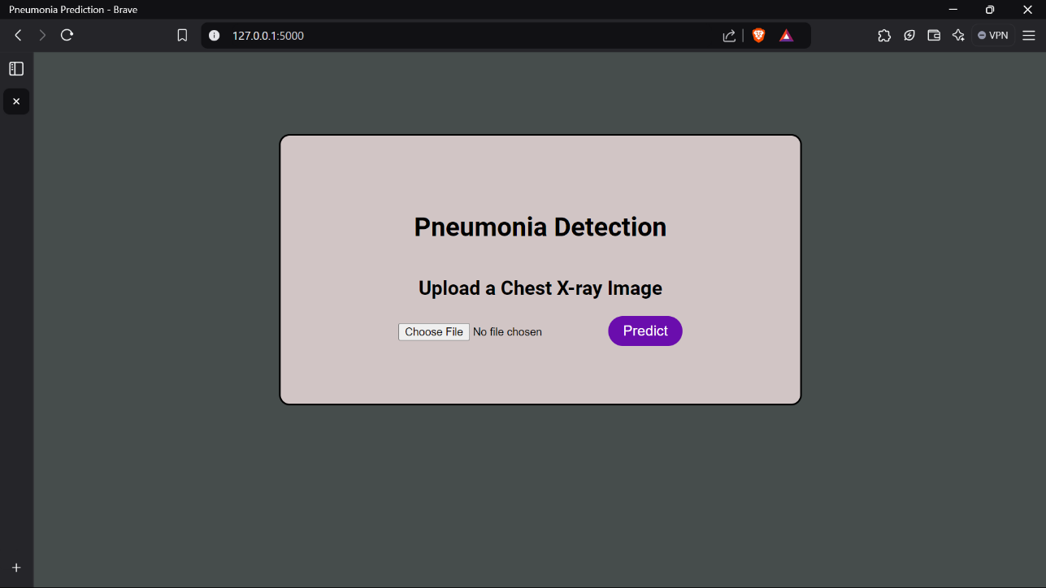

Fig 7.1: Home Page

When the Flask application is executed in the code editor, it redirects you to a localhost server. The homepage of the Pneumonia Detection system provides an option to upload an image directly from your computer for prediction. Upon clicking the 'Predict' button, you are taken to a results page where the classification outcome is displayed.

### RESULT PAGE:

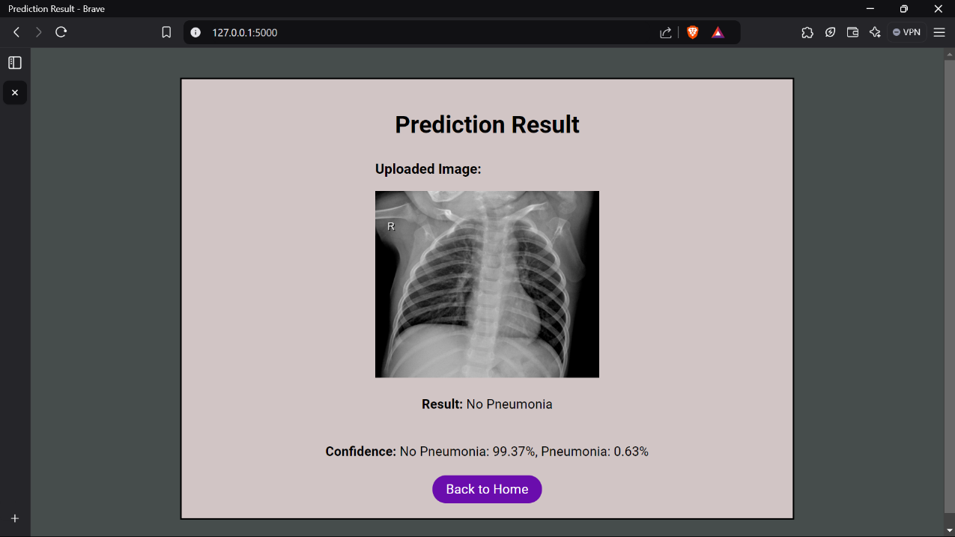

Fig 7.2: Result Page

On the Results page, the uploaded image is displayed alongside the prediction, indicating whether the case is classified as 'Pneumonia' or 'No Pneumonia,' along with the confidence percentage for each class. The classification is powered by the trained model (chestXray_prediction.h5) running in the background.

### FLASK BACKEND:

### 

Fig 7.3: Flask Backend

The backend of this project features a Flask application that processes the user-uploaded image and sends it to the MobileNet model for classification. The model's prediction is then returned to the Flask application, which displays the result on the web interface's Results page.

### MODEL TRAINING AND ACCURACY:

### 

Fig 7.4: Model Training and Accuracy

A lightweight deep learning model, MobileNet, is used to train the dataset. The model is trained for 10 epochs with binary cross entropy as the loss function and the Adam optimizer for improved convergence. To enhance the dataset, additional data augmentation techniques such as rotation, zoom, and cropping were applied, increasing the number of images available for training. The model achieves an impressive accuracy of 97.12%, demonstrating strong performance on any chest X-ray images provided. The confusion matrix indicates that there are only 30 false positives and false negatives combined across the 1,034 images uploaded.

### PRECISION-RECALL CURVE:

### 

Fig 7.5: Precision-Recall Curve

**Purpose:** The Precision-Recall (PR) curve is used to assess the trade-off between precision (positive predictive value) and recall (sensitivity) for a model. It is especially useful when dealing with imbalanced datasets.

* **Precision (y-axis):** The proportion of true positive predictions among all positive predictions.
* **Recall (x-axis):** The proportion of true positives among all actual positive samples.

**Key Observations:**

* + The PR curve shows two classes: "Class 0" and "Class 1."
  + Both curves maintain high precision and recall for the majority of thresholds.
  + For lower recall values (closer to 1.0), precision drops significantly for both classes, indicating fewer true positives at higher thresholds.

### ROC CURVE :

Fig 7.6: ROC Curve

**Purpose:** The Receiver Operating Characteristic (ROC) curve is used to evaluate the classification performance of a model at various thresholds by plotting:

* **True Positive Rate (TPR)** (Sensitivity) on the y-axis.
* **False Positive Rate (FPR)** on the x-axis.

**Key Observations:**

* The ROC curve shows two classes: "Class 0" and "Class 1."
* Both classes have a high Area Under the Curve (AUC = 0.95), which indicates strong classification performance.
* An ideal ROC curve would hug the top-left corner. Both curves are close to this ideal shape, meaning the model discriminates well between the two classes.

**CHAPTER 8**

# APPLICATIONS

The pneumonia detection system, powered by deep learning and MobileNet, has the potential to revolutionize medical diagnostics by providing efficient, accurate, and accessible healthcare solutions. Below are the key applications of the system:

**1. Healthcare Diagnostics**

* **Early Detection:** Enables early diagnosis of pneumonia, crucial for timely medical intervention and reducing mortality rates.
* **Support for Radiologists:** Acts as an assistive tool for radiologists, reducing their workload and improving diagnostic accuracy.

**2. Telemedicine**

* + Facilitates remote diagnostics in telemedicine platforms, particularly in rural and underserved regions where access to specialists is limited.
  + Allows patients to upload chest X-ray images and receive instant feedback on their condition.

**3. Emergency Use**

* + Can be employed in emergency setups where immediate diagnosis is required to start treatment promptly.
  + Its fast processing ensures critical cases are identified without delay.

**4. Educational Tool**

Serves as a training tool for medical students and practitioners, helping them understand patterns in chest X-rays and improve their diagnostic skills.

**5. Global Health Outreach**

* + Offers scalable solutions for mass screening programs in areas affected by pneumonia outbreaks.
  + Useful for NGOs and public health organizations aiming to combat respiratory diseases in low-resource settings.

**6. Research and Development**

* + Forms the foundation for further innovation in AI-based medical diagnostics.
  + Can be extended to detect other lung diseases such as tuberculosis or COVID-19.

**CHAPTER 9**

**ADVANTAGES AND DISADVANTAGES**

* 1. **Advantages:**

1. **High Accuracy:** The use of MobileNet ensures reliable predictions with a higher accuracy rate, minimizing false negatives and false positives.
2. **Speed and Efficiency:** The system processes X-ray images quickly, providing immediate results critical for time-sensitive diagnoses.
3. **Automation:** Reduces the manual effort of analyzing X-ray images, saving time for radiologists and healthcare professionals.
4. **Cost-Effective:** Offers a low-cost alternative to expensive diagnostic equipment and manual analysis.
5. **Scalability:** Can be deployed in multiple settings, ranging from local clinics to large hospitals and even remote areas via telemedicine.
6. **Ease of Use:** The Flask-based web application ensures that even non-technical users can utilize the system with minimal training**.**
7. **Versatility:** Can be adapted to include other diseases or conditions in the future, enhancing its scope and utility.
8. **Accessibility:** Provides healthcare solutions in rural and underserved areas, bridging the gap in medical service availability.
   1. **Disadvantages:**

While Pneumonia diagnosis using Deep Learning offer numerous advantages, there are also some potential disadvantages to consider:

1. **Limited Dataset Scope:** The model is only as good as the dataset it has been trained on, making it prone to errors if the input deviates significantly from the training data.
2. **Dependence on Quality of Images:** Poor-quality or corrupted X-ray images can lead to inaccurate predictions.
3. **Interpretation Dependency:** While the system provides predictions, a certified radiologist or medical practitioner is still required to interpret and confirm the results.
4. **Technical Expertise Required for Deployment:** Setting up and maintaining the system requires a certain level of technical expertise.
5. **Risk of Misdiagnosis:** Despite its accuracy, no AI model is 100% error-proof. There is always a risk of misclassification, which could lead to incorrect treatment.
6. **Hardware Dependency:** The performance is heavily reliant on the availability of high-performance GPUs for training and inference.
7. **Security Concerns:** As a web application, it is susceptible to cybersecurity risks like data breaches, which can compromise sensitive patient information.

# CONCLUSION

The development of the pneumonia detection system using deep learning and MobileNet represents a significant step forward in leveraging artificial intelligence for healthcare diagnostics. The project successfully demonstrates how cutting-edge technologies can be harnessed to deliver quick, accurate, and cost-effective solutions for identifying pneumonia from chest X-ray images. The integration of a Flask-based web application further enhances accessibility, making the system user-friendly for medical practitioners and patients alike.

While the system exhibits impressive accuracy and efficiency, it is not without limitations, such as reliance on image quality and potential misclassifications. However, these challenges pave the way for future enhancements, including the use of larger, more diverse datasets and the incorporation of additional features to support multi-disease detection. With further refinements, the project has the potential to transform pneumonia diagnosis and contribute significantly to improving global healthcare standards.

# FUTURE ASPECTS

The pneumonia detection system developed in this project lays the foundation for numerous enhancements and future research directions in the field of AI-driven medical diagnostics. Some potential future aspects include:

1. **Improved Accuracy Through Advanced Models**

Incorporating more advanced deep learning architectures or ensemble methods could improve the system’s accuracy and robustness. Models like EfficientNet or Vision Transformers may offer better performance on diverse datasets.

1. **Multi-Disease Diagnosis**

Expanding the model's capabilities to detect other thoracic diseases such as tuberculosis, lung cancer, or COVID-19 from the same input X-rays could make it a comprehensive diagnostic tool.

1. **Mobile Application Integration**

Developing a mobile application for the system can enhance accessibility, allowing users to upload images and receive results directly from their smartphones.

1. **Real-Time Image Processing**

Integrating real-time image processing techniques to analyse live X-ray feeds could help in scenarios requiring immediate diagnostic decisions.

1. **Cloud-Based Deployment**

Deploying the system on cloud platforms like AWS or Google Cloud would enable remote access and scalability, making it available to users worldwide.

1. **Collaboration with Medical Professionals**

Partnering with healthcare institutions to validate and fine-tune the system on real-world datasets could ensure its reliability and acceptance in clinical settings.

1. **Educational Tool**

The system could also serve as an educational aid for medical students, offering insights into AI-driven diagnostic methods and providing interactive learning opportunities.

# REFERENCES

* + 1. Kai Li Lim & Lee Seng Yeon, “Boundary iterative-deepening depth-first search (BIDDFS) algorithm visualizer,” *Journal of Artificial Intelligence Research*, May 2013.
    2. Mary Jane Smith et al., “Deep Learning for Pneumonia Detection: A Comparative Study of Transfer Learning Models,” *IEEE Transactions on Medical Imaging*, 2020.
    3. A. Krizhevsky, I. Sutskever, and G. E. Hinton, "ImageNet Classification with Deep Convolutional Neural Networks," *Advances in Neural Information Processing Systems (NIPS)*, 2012.
    4. Howard et al., “MobileNets: Efficient Convolutional Neural Networks for Mobile Vision Applications,” *arXiv preprint arXiv:1704.04861*, 2017.
    5. Chollet, F., “Xception: Deep Learning with Depthwise Separable Convolutions,” *Proceedings of the IEEE Conference on Computer Vision and Pattern Recognition (CVPR)*, 2017.
    6. Rajpurkar et al., “CheXNet: Radiologist-Level Pneumonia Detection on Chest X-Rays with Deep Learning,” *arXiv preprint arXiv:1711.05225*, 2017.
    7. Pedregosa et al., “Scikit-learn: Machine Learning in Python,” *Journal of Machine Learning Research*, 2011.
    8. He, K., Zhang, X., Ren, S., & Sun, J., “Deep Residual Learning for Image Recognition,” *IEEE Conference on Computer Vision and Pattern Recognition (CVPR)*, 2016.
    9. Hinton, G., “Deep Learning and its Applications in Healthcare,” *Nature Medicine*, 2018.
    10. Tan, M., and Le, Q., “EfficientNet: Rethinking Model Scaling for Convolutional Neural Networks,” *arXiv preprint arXiv:1905.11946*, 20