Technical Design Document Version 1.2

Project Name : PCI Compliance Project

Document Name : EG-IS-3PCI_encryption_PKI_Technical_Design_Document

Document Summary
This document helps the developer to understand how the proposed system is to be built, continuing from the System Delivery Specifications for encrypting sensitive payment card information as required by PCI DSS and the related key management requirements. It details Database Design, Menu Design, Program Design, and Database Control and Security Constraints to be used for a proposed system. It also gives an overview of System/Technical Architecture, Software/Hardware/Network Environment and the Design Constraints which assists developer for the development of the proposed system.

Document Release Note
Document Reviewed By: ___________________ Date: --/--/-----

Document Approved By: ___________________ Date: --/--/-----
____________________________

Document Revision History
Version | Status | Update Comment | By | Date
0.1 | Draft | Initial Draft | Abdul Khaliq Gaffar | 18 Feb 2009

Distribution
Name | Title | Department
PCI Project Team
SOA team

Definitions & List of Abbreviations

Abbreviation | Description
SLO | Service Level Objectives
SSAD | Structured System Analysis and Design
UML | Unified Modelling Language
PCI DSS | Payment Card Industry Data Security Standards
PKI | Public Key Infrastructure
ITS&R | IT Security & Risk Management
PAN | Primary Account Number

Table of contents

1 Introduction 5
2 Functional Description 5
3 Technical Architecture 5
4 Hardware Environment 5
5 Software Environment 5
6 Network Environment 6
7 Assumptions and Dependencies 6
8 Data Base Design 6
8.1 Physical Database Design 6
8.1.1 Tables 6
8.1.2 Views 6
8.1.3 Sequences 6
8.1.4 Others 6
9 Program Design 7
9.1.1 Process Flow for Encryption 7
9.1.2 Process Flow for Decryption 8
9.1.3 Process Flow for Key Management 8
10 Process Flow 10
10.1.1 Creation of New Key 10
10.1.2 Regenerate All Keys 12
10.1.3 Regenerate Single Application Key 14
10.1.4 Deletion of Symmetric/Asymmetric Key (Soft Delete) 15
10.1.5 Admin Login 16
10.1.6 Pre-Load/Re-Initialize Application Memory Cache 17
10.1.7 Encryption 18
10.1.8 Decryption 19
10.1.9 Hashing 20
10.1.10 Decryption by other Application Keys 21
11 Screens 23
11.1.1 General 23
11.1.2 Menu Standards 23
11.1.3 Validation Standards 23
11.1.4 Navigational Standards 23
11.1.5 Error Handling Strategy 23
11.1.6 Login Screen 23
11.1.7 Home Page 24
11.1.8 User Management 25
11.1.9 Key Management 27

- Introduction

This document helps the developer to understand how the proposed system is to be build, continuing from the User Requirement Specifications. The design is specific to the technical environment in which the system is to operate as defined in the Technology Architecture Report.

- Functional Description
The system delivers the following functionalities:
- Provide Encryption, Decryption and Hashing as SOA service.
- Key Management.
- Technical Architecture

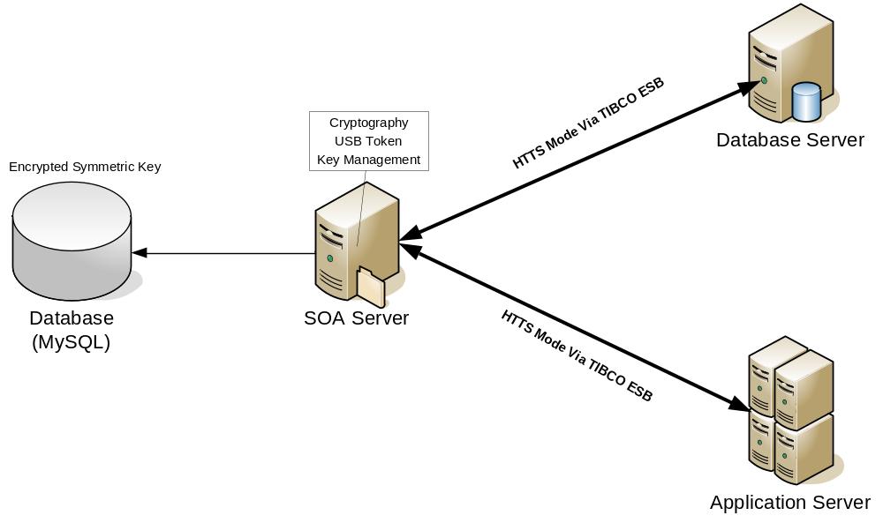

- Hardware Environment
Hardware Resources:
- DL380 G3 HP Linux
- USB Host
- Software Environment

- LINUX
- JBOSS 4.22
- MY-SQL 5.05
- Eclipse
- JRE 1.5

- Network Environment
Corporate LAN / Intranet - Server should be connected in the EK Network

- Assumptions and Dependencies

No. | Assumption
1. | Encrypted Symmetric Keys will be stored in Database
2. | Private Keys will be stored in flash Drive and the location of flash drive should be defined in the properties file.

- Data Base Design

Physical Database Design

Tables

No. | Table Name | Description
1. | SOA_APP_KEY | Stores Symmetric Keys for particular Application
2. | SOA_APP_CREDENTIALS | Stores Application Credentials

Views
NONE

Sequences
NONE

Others

- Program Design

Process Flow for Encryption

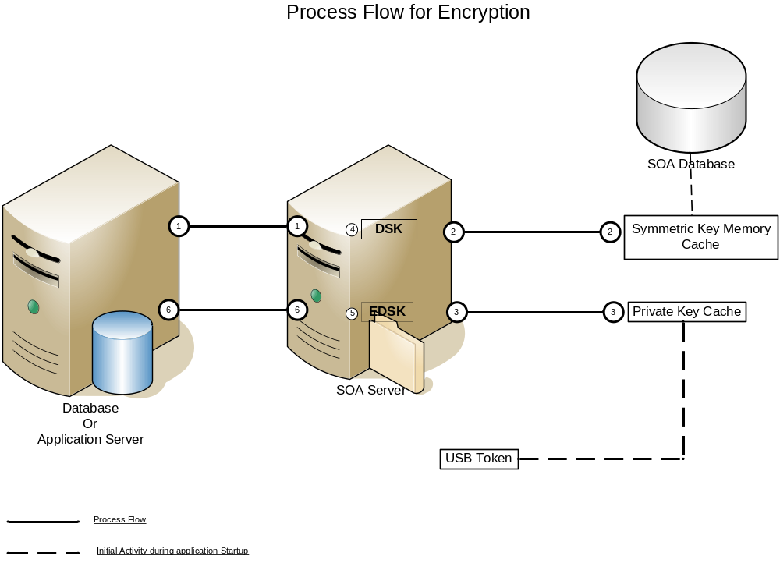

Pre Condition For the Process Flow
- SOA Server Reads the encrypted symmetric from the database and stores it in application memory cache.
- SOA Server Reads private from USB token and stores them in memory cache.

Stepwise Guide for Encryption Process Flow
- Clients Sends the Raw Data along with application id for encryption via HTTPS to SOA Server
- SOA Server gets encrypted symmetric key from memory cache for particular application id
- SOA Server gets private key from memory cache for particular application id.
- SOA Server Decrypts the encrypted Symmetric key using the private key.
- Using the Symmetric key SOA server encrypts the raw data.
- Encrypted data is sent back to the client via https protocol

Process Flow for Decryption
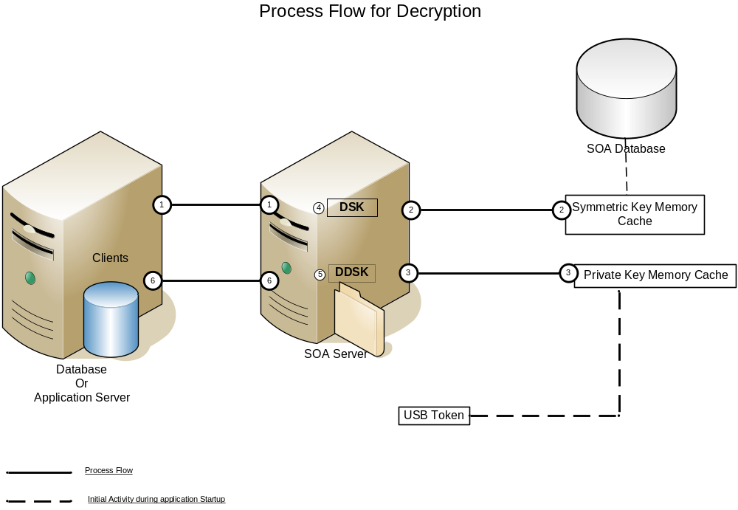

Pre Condition For the Process Flow

- SOA Server Reads the encrypted symmetric from the database and stores it in application memory cache.
- SOA Server Reads private from USB token and stores them in memory cache.

Stepwise Guide for Decryption Process Flow
- Clients Sends the Encrypted Data along with application id for encryption via HTTPS to SOA Server
- SOA Server gets encrypted symmetric key from memory cache for particular application id
- SOA Server gets private key from memory cache for particular application id.
- SOA Server Decrypts the encrypted Symmetric key using the private key.
- Using the Symmetric key SOA server decrypts the encrypted data.
- Raw data is sent back to the client via https protocol

Process Flow for Key Management

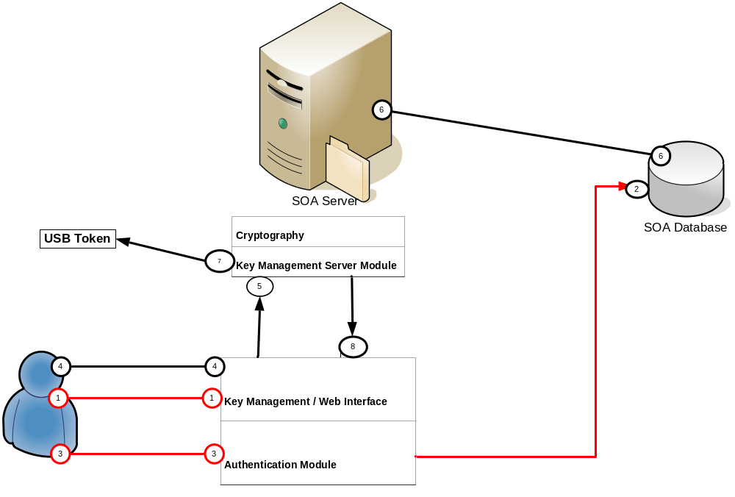

Stepwise Guide for Key Management Process Flow
- User logs on to application using his or her credentials, these credentials details are sent to key management web interface module.
- Using the credentials the web interface talks to authentication module for authentication, which in turn talks to database for credentials details.
- On Successful authentication the application takes the user to key management page.
- User is free to invoke any of the key management activities such as
  - GeneratePrivateKeys(This is one time activity usually done during start of the system)
  - GeneratePrivateKey (This is used to generate private key and symmetric for one application)
  - RegeneratePrivateKeys(This is used to re-generate keys for all the application )
  - RegerenatePrivateKey(This is used to regenerate key for particular application )
- All the private keys are stored in USB Token on pre-defined path which is set using properties file.

- Process Flow

Creation of New Key
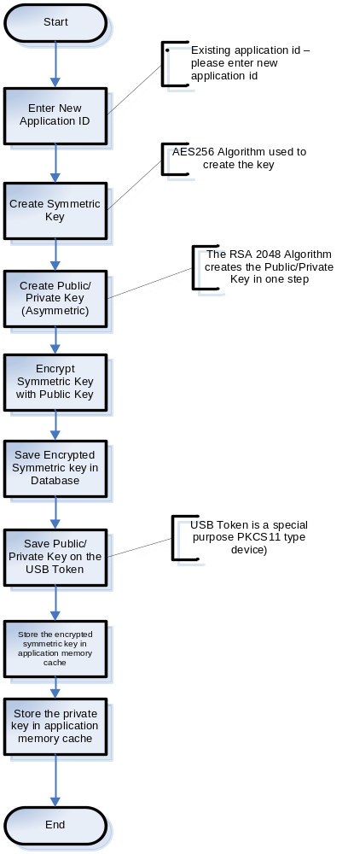

Brief Description:
Steps followed in user creation process are
- End User Logs on to web application using admin credentials.
- On successful login user traverses to create key in key management admin console menu.
- User keys in the new application id using the web console.
- If the application id already exists the backend application throws “Application exist Exception”.
- If the application id does not exists then new symmetric key are generated using AES256 algorithm
- New public/private key pairs are generated using RSA2048 algorithm
- Using the newly generated public key the application encrypts the generated symmetric key.
- Application stores the encrypted symmetric key in the database.
- Private keys are stored in USB Flash drive.
- Private keys and symmetric key are updated into application cache memory.

Regenerate All Keys
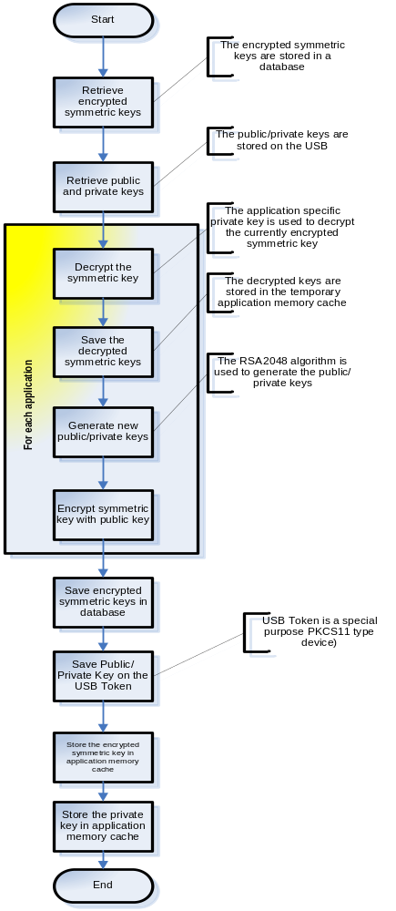

Brief Description:
Steps followed in Regeneration of all keys are
- End User Logs on to web application using admin credentials.
- On successful login user clicks on regeneration of all keys.
- Application retrieves all the symmetric and private keys from the application cache.
- For each of the application symmetric key, private key is used to decrypt the symmetric key and stores it in temp memory cache. New public/private key are generated , encrypt the symmetric key using the new generated public key
- Encrypted symmetric keys are stored back in database.
- New public/private keys are stored in USB.
- Application memory cache are updated with encrypted symmetric key and private key

Regenerate Single Application Key
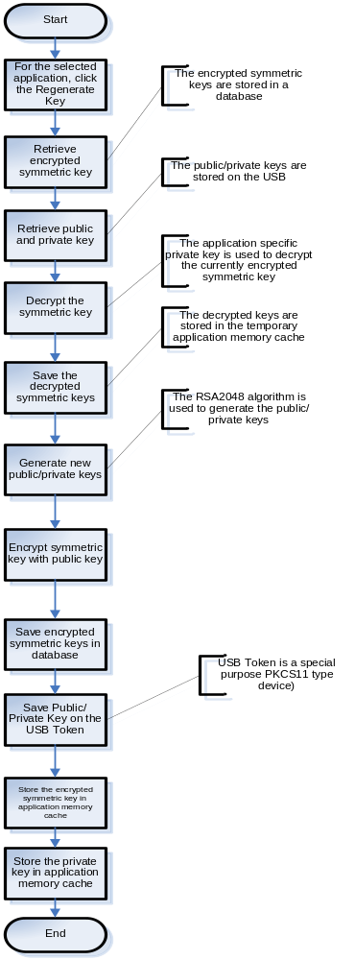
Brief Description:
Steps followed in Regeneration of Single Application Key
- End User Logs on to web application using admin credentials.
- On successful login clicks on the application for which user wants to regenerate new key.
- Application retrieves symmetric and private keys from the application cache for particular application.
- Private Key is used to decrypt the symmetric key and stored in temp memory cache. New public/private key are generated, symmetric key are encrypted using new generated public key.
- Encrypted symmetric key is stored back in database.
- New public/private key are stored in USB.
- Application memory cache are updated with encrypted symmetric key and private key

Deletion of Symmetric/Asymmetric Key (Soft Delete)
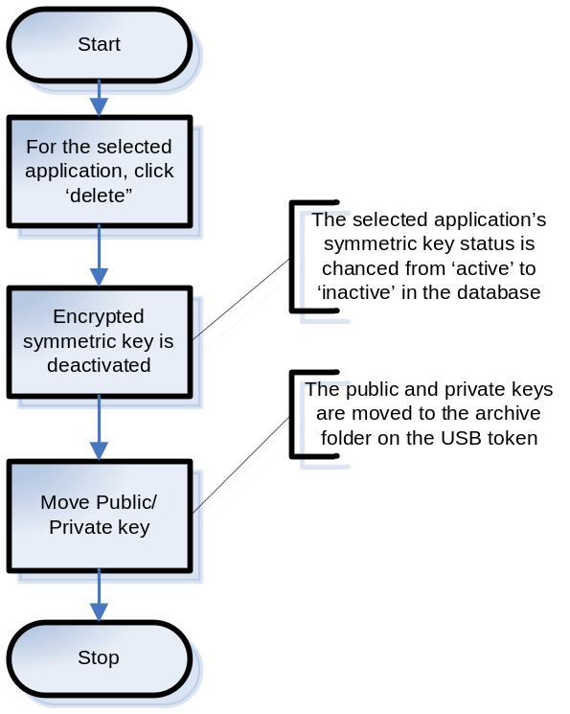
Brief Description:
Steps followed in Deletion of symmetric/asymmetric application key
- End User Logs on to web application using admin credentials.
- On successful login clicks on the application for which user wants to delete symmetric/asymmetric key.
- Application marks the symmetric key as Inactive in database.
- Moves the private key to archive folder in USB Flash Drive.

Admin Login
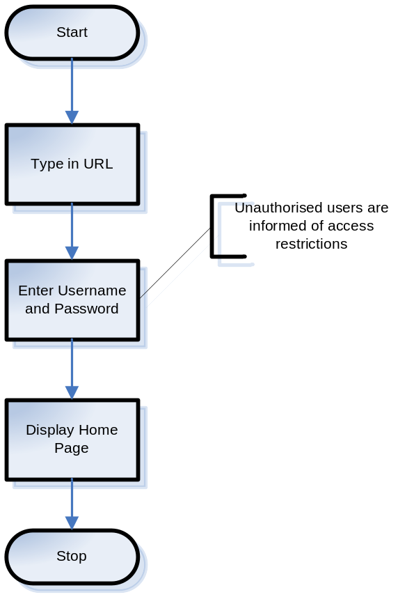
Brief Description:
Steps followed in Admin Login
- End User Logs on to web application using the url “https://hqlinuxdebbl2:8080/keyManagmentWebConsole/”.
- User Needs to enter username and password to access the system.
- Unauthorized users will be informed of access restriction
- On Successful login user would be transferred to home page.

Pre-Load/Re-Initialize Application Memory Cache
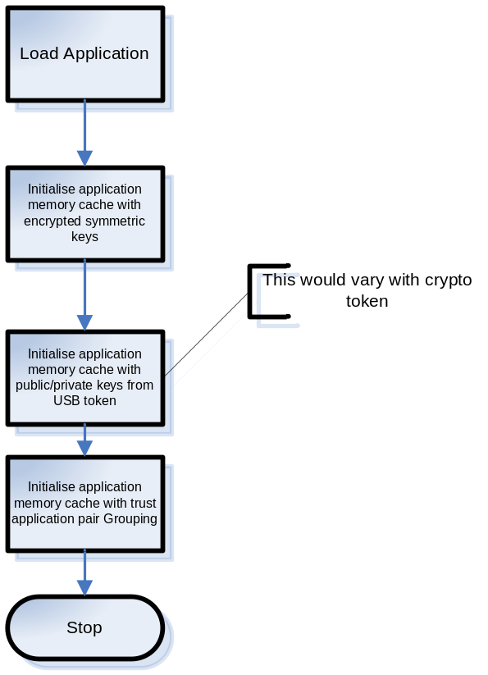

Brief Description:
Steps followed during pre-load/re-initialize
- During the application load time, encrypted symmetric keys are loaded from the database and stored into application cache memory.
- Private keys are loaded from USB flash drive and stored into application cache memory.
- Trust application Pair’s are loaded from the database and stored into application cache memory
- At any point of time the application memory cache can be updated via accessing a link in key management web console.

Encryption
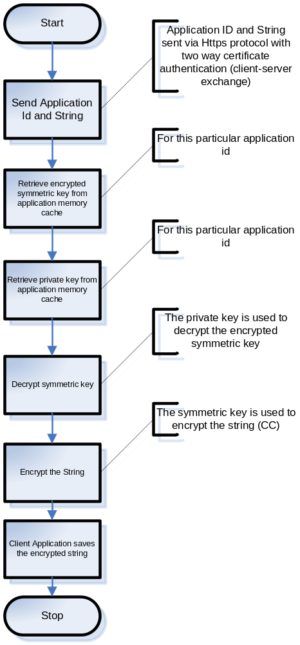
Brief Description:
Steps followed in Encryption Process
- End User sends application id and string to be encrypted via https protocol with two way certificate authentication.
- If the certificate is authenticated then the application retrieves encrypted symmetric key from application memory cache for particular application id.
- Application retrieves the private key from the memory cache for particular application id.
- Private Key is used to decrypt the encrypted symmetric key
- Using the symmetric key, user sent string gets encrypted.
- Encrypted String is sent back to the calling user via https protocol.

Decryption
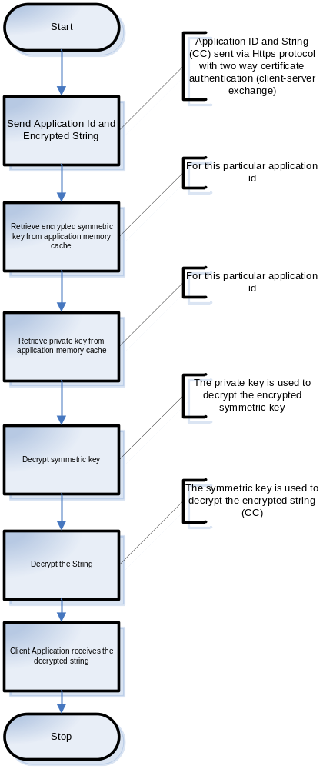

Brief Description:
Steps followed in Decryption Process
- End User sends application id and encrypted string via https protocol with two way certificate authentication.
- If the certificate is authenticated then the application retrieves encrypted symmetric key from application memory cache for particular application id.
- Application retrieves the private key from the memory cache for particular application id.
- Private Key is used to decrypt the encrypted symmetric key
- Using the symmetric key, user sent encrypted string gets decrypted.
- Plain String is sent back to the calling user via https protocol.

Hashing
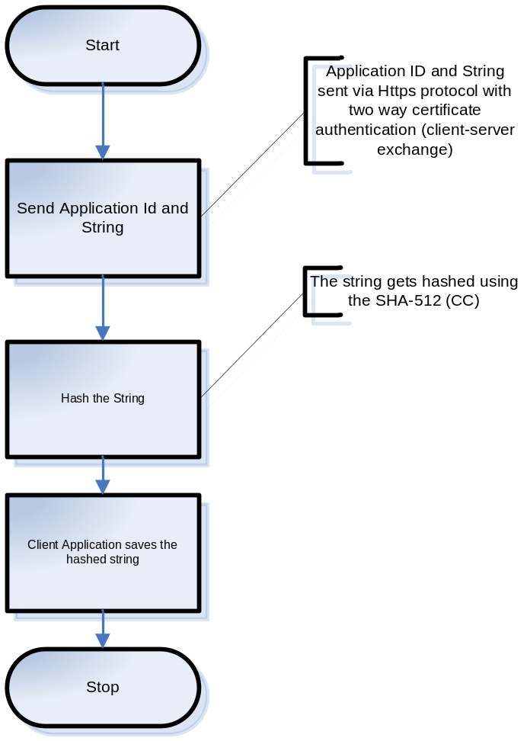

Brief Description:
Steps followed in Hashing Process
- End User sends application id and encrypted string via https protocol with two way certificate authentication.
- If the certificate is authenticated then the application hashes the string using SHA-512 algorithm.
- Hashed String is sent back to the calling user via https protocol.

Decryption by other Application Keys

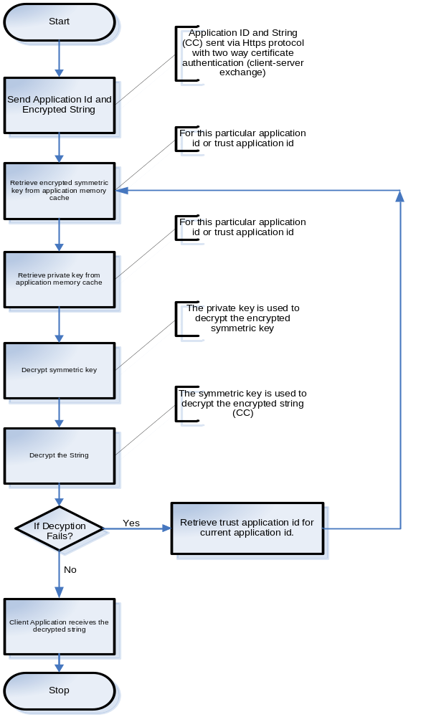

Brief Description:
Steps followed in Decryption Process
- End User sends application id and encrypted string via https protocol with two way certificate authentication.
- If the certificate is authenticated then the application retrieves encrypted symmetric key from application memory cache for particular application id.
- Application retrieves the private key from the memory cache for particular application id.
- Private Key is used to decrypt the encrypted symmetric key
- If the decryption of symmetric key fails then application loads the trust application id from the application cache repeats the same process as defined in step 2.
- Using the symmetric key, user sent encrypted string gets decrypted.
- Plain String is sent back to the calling user via https protocol.

- Screens

General

As part of key Management the proposed solution for accessing key management functionality is addressed by web application.

Menu Standards

- Menus should be standard across all the pages of the site.
- Menus should be of the same font.

Validation Standards
NONE

Navigational Standards
NONE

Error Handling Strategy

- Exceptions should be handled through the try,catch,block
- Error log should be maintained

Login Screen

- Purpose

To authenticate user to access the keymangement

- Layout
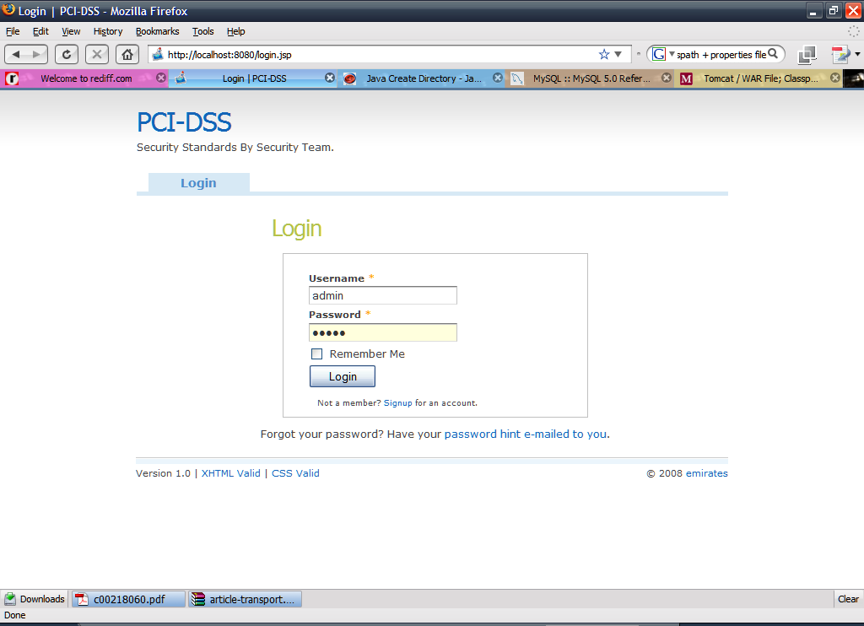

- Called From/By

Called using browser by administrator

Home Page

- Purpose

Initial Screen When user logs on successfully.

- Layout

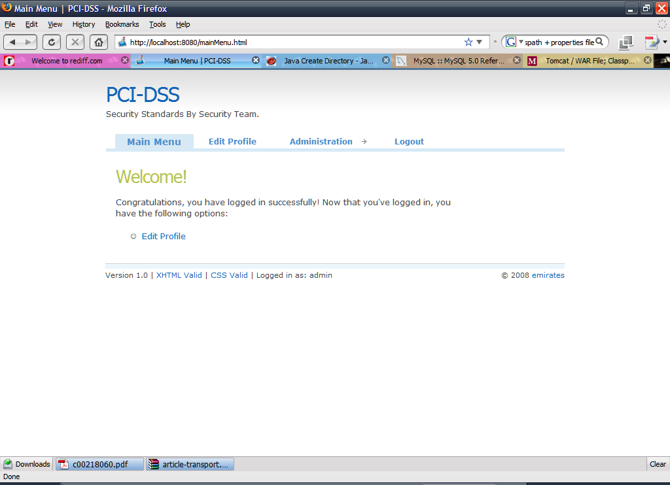

- Called From/By

Called using browser by administrator

User Management

- Purpose

To add , modify or remove user

- Layout

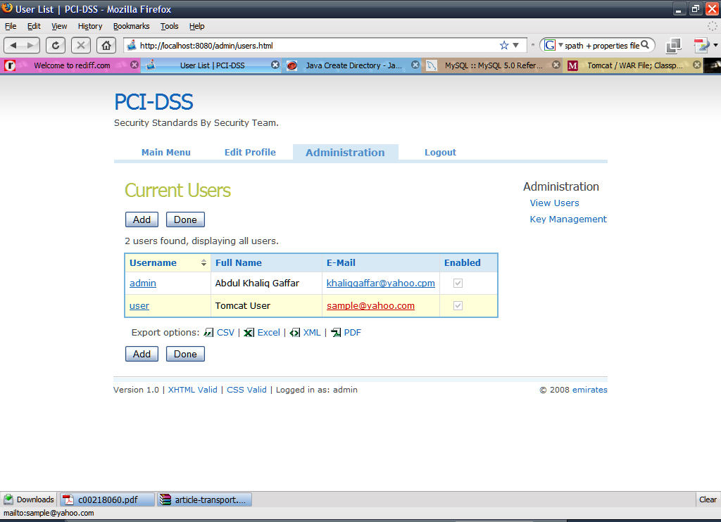

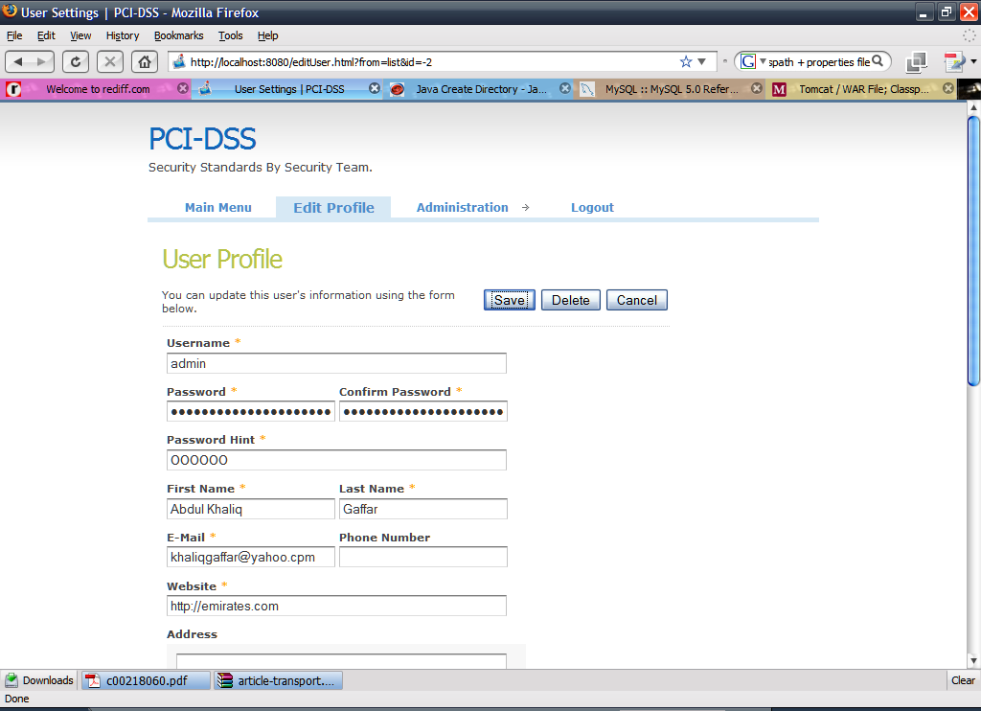

- Called From/By

Called using browser by administrator

Key Management

- Purpose

To Carry Out all key management related activities.

- Layout

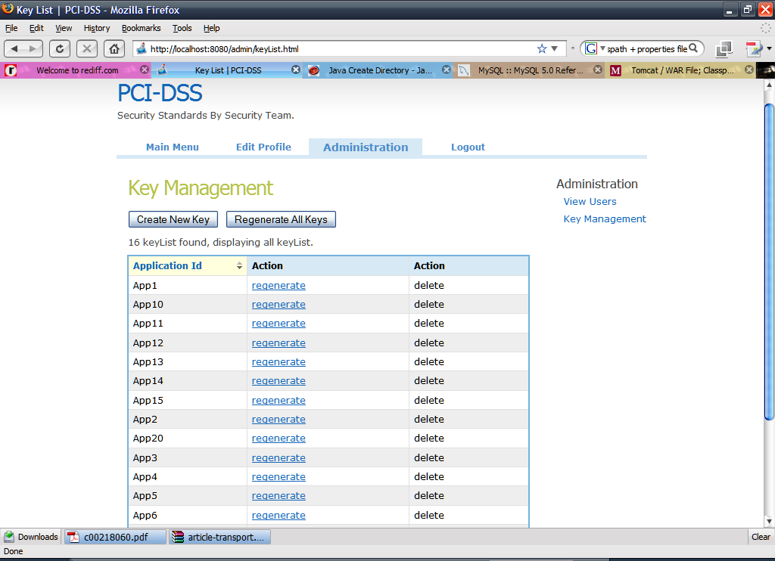

- Called From/By

Called using browser by administrator

