**Chapter-1**

**INTRODUCTION**

**1.1 PURPOSE:**

The **Credit Card Fraud Detection** project is designed to tackle the pressing issue of financial fraud in digital transactions. As digital payments become increasingly common, fraud detection systems must keep pace to ensure secure, reliable transactions for consumers and financial institutions alike. This project aims to build a machine learning-driven system that identifies and mitigates fraudulent activity in real time, enhancing financial security and user trust. Below, we explore the objectives, methodology, and anticipated impact of this project in depth.

1. **Project Motivation and Importance**

With the global shift towards digital and cashless transactions, credit card fraud has become a growing concern. Financial institutions, e-commerce platforms, and consumers are all affected by fraudulent activities that exploit digital transactions. The cost of fraud is high, not only in financial losses but also in terms of damaged reputations and lost consumer trust. The project aims to address these challenges through an intelligent fraud detection system capable of accurately distinguishing between legitimate and fraudulent transactions. By leveraging machine learning models trained on historical transaction data, the project seeks to minimize financial losses and enhance the reliability of digital payment systems.

1. **Project Objectives**

The primary objectives of this Credit Card Fraud Detection project are:

1. **Enhancing Security**: Develop a system that provides secure transactions by reliably identifying and blocking fraudulent activities.
2. **Reducing Financial Losses**: By accurately identifying fraudulent transactions, the system aims to mitigate financial damage for both consumers and institutions.
3. **Building Trust**: Establishing secure transaction environments builds confidence among consumers and financial institutions, fostering greater adoption of digital payments.
4. **Adapting to Evolving Fraud Patterns**: The system is designed to improve its detection capabilities over time by learning from new types of fraud, making it adaptable to future trends.

These objectives drive the development of a robust system that prioritizes both security and user experience.

1. **Key Components of the Project**

The scope of the project covers several vital components, from data preparation to the deployment of a scalable fraud detection model.

**1. Data Preprocessing**

* **Data Collection**: The project relies on historical transaction data, typically sourced from financial institutions or synthetic datasets designed to mimic real transaction
* patterns. Data should include both fraudulent and legitimate transactions to train a balanced model.
* **Data Cleaning**: Raw transaction data often contain anomalies, inconsistencies, or missing values that could skew model accuracy. Cleaning the data ensures consistency and accuracy in feature selection.
* **Data Normalization**: Transaction data includes diverse variables such as transaction amount, time, location, and account details. Standardizing these variables through normalization is essential for accurate model training.
* **Handling Imbalanced Data**: Fraudulent transactions make up a small percentage of total transactions, creating an imbalanced dataset. Techniques like SMOTE (Synthetic Minority Over-sampling Technique) or undersampling can be applied to address this imbalance, ensuring the model does not overfit to the majority class.

**2. Feature Extraction**

* **Selecting Key Features**: Identifying variables that distinguish fraudulent transactions from legitimate ones is crucial. Common features include transaction time, amount, location, and frequency.
* **Feature Engineering**: Transforming raw data into informative features improves model performance. For instance, calculating average transaction amounts over time or identifying recurring transaction patterns can highlight suspicious behavior.
* **Dimensionality Reduction**: Reducing the number of features can improve model speed and efficiency. Techniques like Principal Component Analysis (PCA) help retain essential information while reducing the computational complexity.

**3. Model Training and Evaluation**

* **Algorithm Selection**: Various machine learning algorithms, such as logistic regression, decision trees, support vector machines (SVM), and neural networks, can be used for fraud detection. Each has strengths and weaknesses depending on the data and desired accuracy.
* **Training the Model**: The model is trained on historical data with known fraudulent and legitimate transactions. Supervised learning techniques are common, but unsupervised methods (e.g., anomaly detection) may also be considered for detecting outliers.
* **Model Evaluation Metrics**: Precision, recall, F1-score, and accuracy are critical metrics for assessing model performance. Fraud detection also benefits from metrics like the Area Under the ROC Curve (AUC-ROC), which provides insight into the model’s performance in distinguishing between classes.
* **Handling False Positives and False Negatives**: The model must balance detection accuracy with minimizing false positives (flagging legitimate transactions as fraudulent) and false negatives (missing fraudulent transactions). A system with a high false positive rate can inconvenience customers and decrease trust, while high false negatives can lead to financial losses.

**4. Real-Time Detection Capabilities**

* **Integrating Real-Time Analysis**: The system needs to process transactions in real time to prevent fraud effectively. Leveraging distributed computing or cloud services enables the system to scale and handle large transaction volumes.
* **Decision-Making Mechanism**: The model’s output should trigger appropriate responses, such as automatically flagging suspicious transactions for review, temporarily freezing accounts, or sending alerts to customers.
* **Adaptive Learning**: Fraud detection requires continuous improvement as fraudsters develop new techniques. Techniques like online learning or periodic model retraining help the system adapt to new fraud patterns, maintaining its effectiveness over time.

1. **Expected Impact and Benefits**

The anticipated impact of this project spans across multiple domains, from consumer security to institutional trust:

1. **Consumer Security and Financial Safety**: By reducing the likelihood of successful fraud, the system safeguards consumers' finances and personal information. This protection is essential as digital payment systems continue to grow.
2. **Financial Institutions’ Reputation and Trust**: Institutions with robust fraud detection systems are more likely to gain consumer trust, leading to increased business and customer retention.
3. **Economic Stability and Efficiency**: Fraud detection not only prevents direct financial losses but also reduces the resources needed to investigate and rectify fraud cases. Institutions can allocate resources more effectively and reduce operational costs.
4. **Growth of Digital Payment Platforms**: Secure digital transactions are vital for the continued growth and acceptance of digital payment methods. A system that enhances transaction safety fosters greater public trust in these platforms.
5. **Scalability and Deployment**

The project also emphasizes scalability to allow for integration into various transaction environments:

1. **Cloud Integration**: Deploying the model in cloud environments like AWS, Google Cloud, or Azure enables financial institutions to scale detection capabilities based on demand, ensuring reliability and responsiveness during peak transaction periods.
2. **API Development for Integration**: Creating APIs allows the fraud detection system to communicate seamlessly with banking systems, e-commerce platforms, and payment gateways. These APIs enable organizations to incorporate fraud detection without disrupting existing infrastructure.
3. **Real-Time Monitoring and Logging**: Implementing real-time monitoring of the system’s performance ensures that potential issues are detected early. Log analysis tools, alerts, and dashboards provide visibility into the system's operation, helping teams identify anomalies or performance bottlenecks quickly.
4. **Compliance and Security**: Since financial data is highly sensitive, the system must adhere to regulations such as PCI-DSS, GDPR, and others specific to different regions. Ensuring that data handling meets these standards is essential for legal compliance and consumer trust

**1.2 SCOPE:**

The Credit Card Fraud Detection project aims to create a robust system that utilizes machine learning techniques to identify and mitigate fraudulent activities in financial transactions. As digital payment methods become more prevalent and integrated into daily life, the risk of fraud has risen significantly, making it essential for both consumers and financial institutions to have effective mechanisms in place to detect and prevent fraudulent activities. This project addresses that need by developing a system capable of identifying suspicious patterns in transaction data and flagging potentially fraudulent activities.

The primary goal of the system is to detect fraudulent transactions in real time, ensuring that fraudulent activities are swiftly identified before they result in substantial financial loss. At the same time, the system aims to minimize false positives—instances where legitimate transactions are incorrectly flagged as fraudulent. False positives can disrupt the transaction experience for customers and lead to unnecessary scrutiny of valid transactions. Balancing accurate fraud detection with minimizing false positives is crucial for the system’s success, as it must not only catch fraud effectively but also allow legitimate transactions to proceed without unnecessary delays.

By detecting and mitigating fraudulent transactions, the project seeks to reduce financial losses for both consumers and financial institutions. Fraudulent activities often lead to significant financial damage, which can erode trust in digital payment systems. Therefore, the detection system will help protect consumers from losing money while also safeguarding financial institutions from the economic impact of fraud, such as chargebacks, reputational damage, and legal liabilities.

Another core objective of the project is to enhance security in digital payments. As the use of credit cards and digital payment platforms continues to grow, the security of these systems becomes paramount. The project aims to build a solution that can operate across various digital payment platforms, identifying fraud in real time and ensuring that payments are processed securely. By implementing a machine learning-based fraud detection system, the project addresses the growing need for intelligent security solutions that can evolve and respond to new fraud trends.

The system is designed to be adaptive and scalable. As fraud tactics evolve, so too must the system's detection capabilities. The system will continuously improve its ability to identify fraud by analyzing historical transaction data and learning from new patterns. This ensures that the system can adapt to emerging fraud tactics, allowing it to remain effective even as fraudsters develop new methods to exploit vulnerabilities in payment systems.

In addition to real-time fraud detection, the system’s purpose extends to building trust among users. A secure payment environment fosters confidence among consumers and financial institutions, which is vital for the continued growth and adoption of digital payment systems. When users trust that their transactions are safe, they are more likely to engage with online platforms and make digital payments.

Ultimately, the Credit Card Fraud Detection project seeks to create a system that can be easily integrated into existing banking systems and online payment platforms, offering a scalable solution that protects consumers and financial institutions from fraud. By using advanced machine learning techniques, the project aims to build a tool that not only identifies fraud effectively but also ensures that the solution can grow and evolve with the changing landscape of financial transactions. The project will contribute to enhancing the security, reliability, and trustworthiness of digital payment systems, helping to secure the future of online financial transactions.

**1.3 PROJECT FEATURE:**

The Credit Card Fraud Detection project is designed to deliver a comprehensive and robust system that uses advanced machine learning techniques to detect and prevent fraudulent activities in financial transactions. This system will possess several key features, which can be summarized as follows:

1. Real-Time Fraud Detection

* Description: The core feature of the system is the ability to detect fraudulent transactions in real time. This enables immediate identification and action, preventing the completion of a fraudulent transaction before it impacts the consumer or the financial institution.
* Benefit: By processing transaction data as it occurs, the system ensures that fraud is detected as early as possible, minimizing financial loss and protecting users from unauthorized transactions.

2. Machine Learning Model for Fraud Detection

* Description: The system leverages machine learning algorithms to analyze historical transaction data and identify patterns associated with fraud. Models such as decision trees, random forests, or neural networks will be used to classify transactions as legitimate or fraudulent.
* Benefit: Machine learning allows the system to continuously improve and adapt by learning from new data, ensuring that it remains effective against evolving fraud tactics.

3. Feature Extraction and Data Preprocessing

* Description: Before feeding data into the machine learning model, the system preprocesses and extracts relevant features from the raw transaction data. Key features may include transaction amount, time of transaction, location, user behavior patterns, merchant information, and device details.
* Benefit: Feature extraction ensures that the system analyzes the most relevant data, leading to more accurate fraud detection. Proper preprocessing also reduces noise in the data, improving the model's performance.

4. Anomaly Detection

* Description: The system employs anomaly detection techniques to flag transactions that deviate from a user's normal spending behavior. This is particularly useful for identifying new fraud patterns that the system has not seen before.
* Benefit: By identifying unusual behavior, such as large transactions in a short period or spending in a geographically distant location, the system can detect novel fraudulent activities without relying solely on known patterns.

5. Minimizing False Positives

* Description: One of the main challenges in fraud detection is minimizing false positives—legitimate transactions incorrectly flagged as fraudulent. The system incorporates various strategies, including fine-tuning machine learning models and implementing rule-based systems, to reduce these instances.
* Benefit: Minimizing false positives ensures that legitimate transactions are processed smoothly and not unnecessarily delayed, improving the user experience and maintaining trust in the system.

6. Scalability and Integration

* Description: The fraud detection system is designed to be easily scalable and integratable into existing banking and online payment platforms. This flexibility allows the system to handle an increasing volume of transactions without compromising performance.
* Benefit: Scalability ensures that the system can accommodate growth in transaction volume as digital payments increase globally. The ability to integrate with various platforms means that the solution can be widely adopted without requiring extensive changes to existing infrastructure.

7. Continuous Learning and Model Updating

* Description: The system continually learns from new transaction data to stay up to date with the latest fraud patterns. It can automatically update its models to reflect changing trends and improve detection accuracy over time.
* Benefit: Continuous learning ensures that the system adapts to emerging fraud strategies and remains effective in detecting new and sophisticated types of fraudulent behavior.

8. Detailed Reporting and Alerts

* Description: The system provides real-time alerts to financial institutions and consumers when a transaction is flagged as potentially fraudulent. It also generates detailed reports and analytics, providing insights into fraud trends, affected accounts, and financial losses.
* Benefit: Alerts enable quick action to stop fraud in its tracks, while detailed reporting helps institutions understand fraud patterns and make informed decisions about improving security.

9. User Behavior Analytics

* Description: By analyzing individual user behavior, the system can detect deviations from typical spending patterns. This allows the system to assess the legitimacy of transactions based on the historical behavior of each user.
* Benefit: User behavior analytics help the system make more personalized and accurate fraud detections, reducing the chances of false flags and improving overall detection effectiveness.

10. Cross-Platform Compatibility

* Description: The fraud detection system is designed to be compatible with a wide range of payment platforms, including credit card networks, mobile wallets, and online banking applications. This ensures broad applicability across different industries and user environments.
* Benefit: Cross-platform compatibility makes the system versatile and easy to implement in various use cases, helping it reach a larger audience and protect more users from fraud.

11. Data Privacy and Security

* Description: The system adheres to the highest standards of data privacy and security, ensuring that sensitive transaction data is securely processed and stored. It uses encryption techniques to protect data both at rest and in transit.
* Benefit: Data privacy and security are critical when handling financial transactions. Ensuring that users' data is safe builds trust in the system and complies with relevant regulations, such as GDPR.

12. Customizable Fraud Detection Rules

* Description: The system allows financial institutions to customize fraud detection rules based on their specific needs and risk profiles. This could include setting thresholds for transaction amounts, frequency, and location-based rules.
* Benefit: Customizability allows institutions to tailor the fraud detection system to their specific business requirements and customer base, ensuring more accurate and relevant fraud detection.

13. Real-Time Feedback to Users

* Description: Once a transaction is flagged as potentially fraudulent, the system provides real-time feedback to users, allowing them to confirm or deny the legitimacy of the transaction.
* Benefit: Real-time feedback ensures that legitimate users have the opportunity to prevent fraud while still maintaining a smooth and efficient user experience.

**Chapter-2**

**SYSTEM ANALYSIS**

* 1. **User Requirements:**

1.Fraud Detection Accuracy and Reliability

* Requirement: The system must ensure high accuracy in detecting fraudulent transactions to minimize financial loss for users.
* User Need: Users expect the system to accurately distinguish between legitimate and fraudulent transactions.
* Outcome: The system must have a high detection rate (above 95%) for fraudulent transactions while keeping false positives (incorrectly flagged legitimate transactions) low.

2. Real-Time Alerts and Notifications

* Requirement: Users should receive real-time notifications whenever a suspicious or potentially fraudulent transaction is detected on their accounts.
* User Need: Cardholders and financial institutions want to be immediately notified of any unusual activity on an account so they can take swift action to prevent further losses.
* Outcome: The system must send instant alerts via mobile apps, email, or SMS for users to quickly respond to potentially fraudulent transactions.

3. Customizable Fraud Detection Settings

* Requirement: Financial institutions and administrators should have the ability to customize fraud detection thresholds based on specific customer profiles or transaction types.
* User Need: Different financial institutions or individual users may have unique preferences or requirements regarding fraud detection, such as transaction limits or geographical boundaries for legitimate activity.
* Outcome: Users should be able to define customized fraud detection rules, including transaction limits, frequency of transactions, and allowed locations.

4. Ease of Use and User Interface

* Requirement: The system should have an intuitive user interface for both administrators and end-users.
* User Need: Users, especially non-technical users, should be able to easily navigate the system, review alerts, manage settings, and take necessary actions without technical difficulties.
* Outcome: The fraud detection system should be user-friendly, providing clear, easy-to-understand alerts and a simple interface for configuring settings and reviewing transaction history.

5. Minimized Disruptions for Legitimate Transactions

* Requirement: Users should not experience disruptions in their legitimate transactions due to fraud detection false alarms.
* User Need: Cardholders want to perform transactions without the fear of unnecessary blocks or interruptions while ensuring their accounts are safe from fraud.
* Outcome: The system should minimize false positives, so legitimate transactions are not flagged, ensuring users can conduct business smoothly.

6. Multi-Layered Authentication

* Requirement: Users should be able to verify their identity through multiple layers of authentication when responding to fraud alerts or confirming transactions.
* User Need: Users want added security measures that ensure only they can authorize legitimate transactions, particularly if they receive a fraud alert on their account.
* Outcome: Multi-factor authentication (MFA) should be implemented for all sensitive user actions, such as confirming flagged transactions or accessing fraud detection reports.

7. Privacy and Data Security

* Requirement: The system must comply with relevant data protection regulations (e.g., GDPR, PCI-DSS) to safeguard user information, ensuring privacy is maintained.
* User Need: Users expect their personal and financial data to be kept private and secure from unauthorized access or misuse.
* Outcome: The system must incorporate encryption, secure access controls, and comply with industry regulations to protect sensitive user data.

8. Transparent Reporting and Documentation

* Requirement: Users, especially financial institutions, should be able to access detailed reports about detected fraudulent activities, including transaction history, reasons for flagging, and actions taken.
* User Need: Financial institutions need to maintain transparent and auditable records for regulatory compliance and internal investigations into fraudulent transactions.
* Outcome: The system must provide comprehensive reports that document the fraud detection process, reasons for flagged transactions, and outcomes of fraud investigations.

9. Continuous Learning and Adaptability

* Requirement: Users expect the fraud detection system to evolve and improve over time by adapting to new fraud patterns and continuously learning from new data.
* User Need: Fraudsters continually change their tactics, so the system needs to be adaptive to new fraud strategies to maintain effectiveness.
* Outcome: The system should be able to automatically update and retrain its model based on new transaction data and emerging fraud trends, ensuring its continued accuracy.

10. Integration with Existing Systems

* Requirement: The fraud detection system should easily integrate with existing payment systems, banking applications, and other financial software.
* User Need: Financial institutions need the system to work seamlessly with their current infrastructure to minimize disruptions and extra costs during deployment.
* Outcome: The fraud detection solution must provide APIs, SDKs, or integration tools that facilitate smooth interoperability with third-party systems and payment gateways.

11. User Control and Monitoring

* Requirement: Users should have control over their fraud detection settings, including the ability to view alerts, review flagged transactions, and adjust security parameters.
* User Need: Cardholders and administrators want control over fraud detection and the ability to take immediate action when necessary.
* Outcome: The system should allow users to review flagged transactions, configure fraud detection rules, and take action to resolve issues.

12. Scalability and Reliability

* Requirement: The system must be capable of handling increasing amounts of transaction data as digital payments grow without compromising performance or reliability.
* User Need: Users, especially financial institutions, want a fraud detection system that can scale to accommodate growing transaction volumes as their business expands.
* Outcome: The system must support high transaction volumes, ensuring that fraud detection remains reliable even under heavy loads.

13. Support for Multiple Payment Channels

* Requirement: The fraud detection system should be capable of analyzing transactions from various payment channels, including online payments, point-of-sale (POS) systems, and mobile wallets.
* User Need: Financial institutions and users expect fraud detection to work across different payment methods.
* Outcome: The system should be able to integrate with and analyze transactions across various payment channels to provide comprehensive fraud detection.

**2.2 Functional Requirements:**

1. Real-Time Fraud Detection

* Requirement: The system must be able to process and analyze transaction data in real time, flagging potentially fraudulent transactions as soon as they occur.
* User Need: Immediate action to prevent unauthorized transactions and minimize financial loss for users and institutions.
* Acceptance Criteria: Fraud detection must occur within seconds of the transaction being initiated.

2. Machine Learning Model

* Requirement: The system should employ machine learning algorithms (e.g., Random Forest, Decision Trees, Neural Networks) to analyze transaction patterns and detect fraud.
* User Need: Accurate classification of transactions as fraudulent or legitimate based on historical data.
* Acceptance Criteria: The model must be trained using a sufficient dataset and tested to ensure high accuracy (preferably 95% or higher).

3. Anomaly Detection

* Requirement: The system must be able to detect anomalies in user behavior that could indicate fraudulent activity, such as unusual spending patterns or transactions from new locations.
* User Need: The ability to detect new types of fraud that the system hasn’t been explicitly trained for.
* Acceptance Criteria: The system should flag outlier transactions that deviate significantly from the user's typical spending behavior.

4. Feature Extraction and Preprocessing

* Requirement: The system must perform feature extraction from raw transaction data (e.g., transaction amount, time, location) and preprocess the data (e.g., normalization, handling missing values) before feeding it into the model.
* User Need: Clean and structured data for better fraud detection.
* Acceptance Criteria: Data preprocessing should ensure accuracy and avoid data corruption before model input.

5. False Positive Minimization

* Requirement: The system should have mechanisms to reduce false positives (legitimate transactions flagged as fraudulent).
* User Need: A seamless transaction experience for users, where legitimate transactions are not mistakenly blocked.
* Acceptance Criteria: The system should maintain a low false-positive rate (ideally below 5%) while ensuring high fraud detection accuracy.

6. Customizable Fraud Detection Rules

* Requirement: Financial institutions should be able to customize fraud detection rules, such as transaction limits, geographical constraints, and user behavior thresholds.
* User Need: Institutions can tailor the system to their unique risk profiles and requirements.
* Acceptance Criteria: The system should allow configuration of custom rules that are simple to implement and update.

7. Real-Time Alerts and Notifications

* Requirement: The system should send real-time alerts to both users and financial institutions when a fraudulent transaction is detected.
* User Need: Immediate notification to take action on flagged transactions.
* Acceptance Criteria: Alerts should be sent via email, SMS, or app notification within seconds of a fraudulent transaction detection.

8. Detailed Transaction Reports

* Requirement: The system should provide detailed reports on detected fraudulent transactions, including transaction data, fraud reason, and actions taken.
* User Need: Transparency and insight into fraud patterns for institutions.
* Acceptance Criteria: Reports must be easily accessible by administrators and should provide actionable insights into detected fraud trends.

9. Cross-Platform Compatibility

* Requirement: The system should be able to integrate with various platforms such as mobile apps, online banking systems, and payment gateways.
* User Need: A fraud detection solution that can be used across different environments, platforms, and payment methods.
* Acceptance Criteria: The system should have APIs or SDKs that support integration with third-party platforms.

**2.3Technical Requirements:**

1. Scalable Architecture

* Requirement: The system architecture must be scalable to handle increasing volumes of transaction data as digital payments grow.
* User Need: The ability to scale as the number of transactions increases.
* Acceptance Criteria: The system should be able to handle millions of transactions per day without performance degradation.

2. Data Storage and Security

* Requirement: All transaction data, including fraud detection logs, must be securely stored in compliance with regulations like GDPR, PCI-DSS, or CCPA.
* User Need: Ensuring data privacy and security to protect sensitive financial data.
* Acceptance Criteria: Data must be encrypted both at rest and in transit, and access control mechanisms should be in place.

3. Cloud-Based Deployment

* Requirement: The system should be deployable on a cloud platform (e.g., AWS, Google Cloud, Microsoft Azure) to provide scalability, availability, and redundancy.
* User Need: A reliable and fault-tolerant environment for fraud detection operations.
* Acceptance Criteria: The system must be fully operational in a cloud-based environment, offering 99.9% uptime.

4. Machine Learning Model Retraining and Updates

* Requirement: The system should support automatic model retraining based on new data and emerging fraud patterns.
* User Need: Continual improvement of fraud detection accuracy and adaptability to new fraud tactics.
* Acceptance Criteria: Model updates should be automatic and seamless without disrupting the operation.

5. API Integration for Third-Party Services

* Requirement: The system should provide RESTful APIs for integration with third-party fraud detection services, payment gateways, or fraud prevention tools.
* User Need: Integration capabilities to extend fraud detection across multiple systems.
* Acceptance Criteria: APIs should be well-documented, secure, and capable of handling high transaction volumes.
* Security Requirements

1. Data Encryption

* Requirement: Sensitive transaction data should be encrypted using strong encryption methods (e.g., AES-256) both in transit and at rest.
* User Need: Protection of users' financial data and compliance with regulatory standards.
* Acceptance Criteria: All data, including transaction details and user information, must be encrypted.

2. Secure Authentication and Access Control

* Requirement: The system must include secure user authentication and access control mechanisms for different types of users, including administrators, users, and financial institution staff.
* User Need: Restrict access to sensitive data to authorized users only.
* Acceptance Criteria: Role-based access control (RBAC) should be implemented, and multi-factor authentication (MFA) should be used for administrative access.

3. Audit Logs

* Requirement: The system should maintain an audit trail of all fraud detection activities, including flagging of transactions, alerts, and actions taken by administrators.
* User Need: Transparency and traceability of system operations.
* Acceptance Criteria: Audit logs should be immutable, timestamped, and stored securely for compliance purposes.

4. Regulatory Compliance

* Requirement: The system must comply with all relevant regulations, including PCI-DSS for payment data, GDPR for data privacy, and other local regulations on data security.
* User Need: Ensuring compliance with industry standards and legal requirements.
* Acceptance Criteria: The system should undergo regular audits to verify compliance with applicable regulations.

**2.4 Requirement Matrix:**

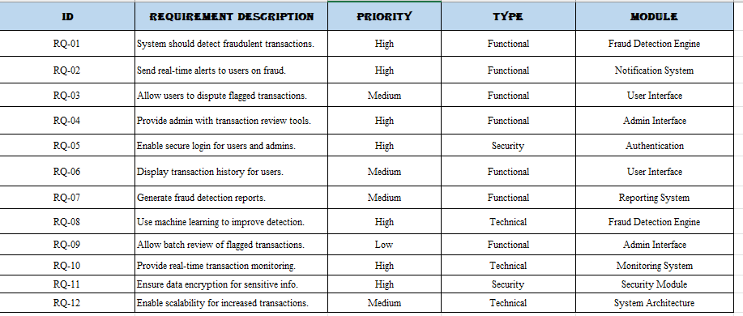

**Chapter-3**

**SYSTEM DESIGN & SPECIFICATION**

**3.1 High Level Design:**

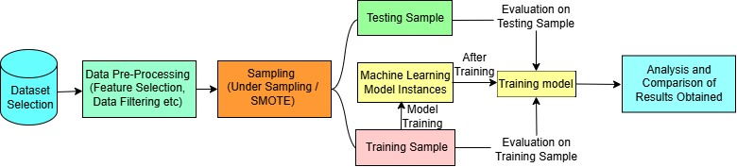

**3.2 URL Diagram:**

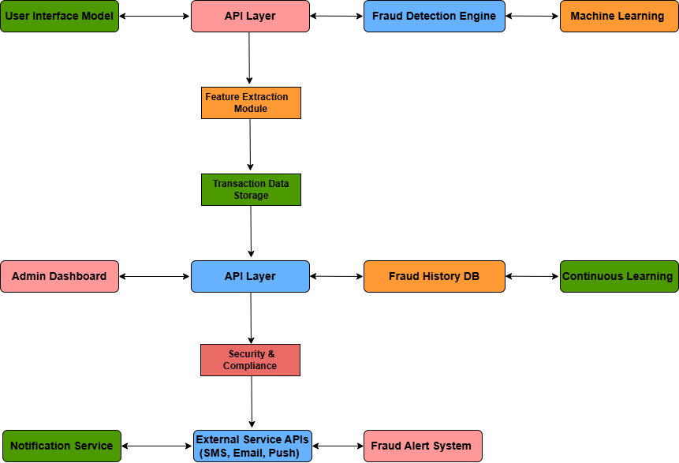

**3.3 UX Design:**

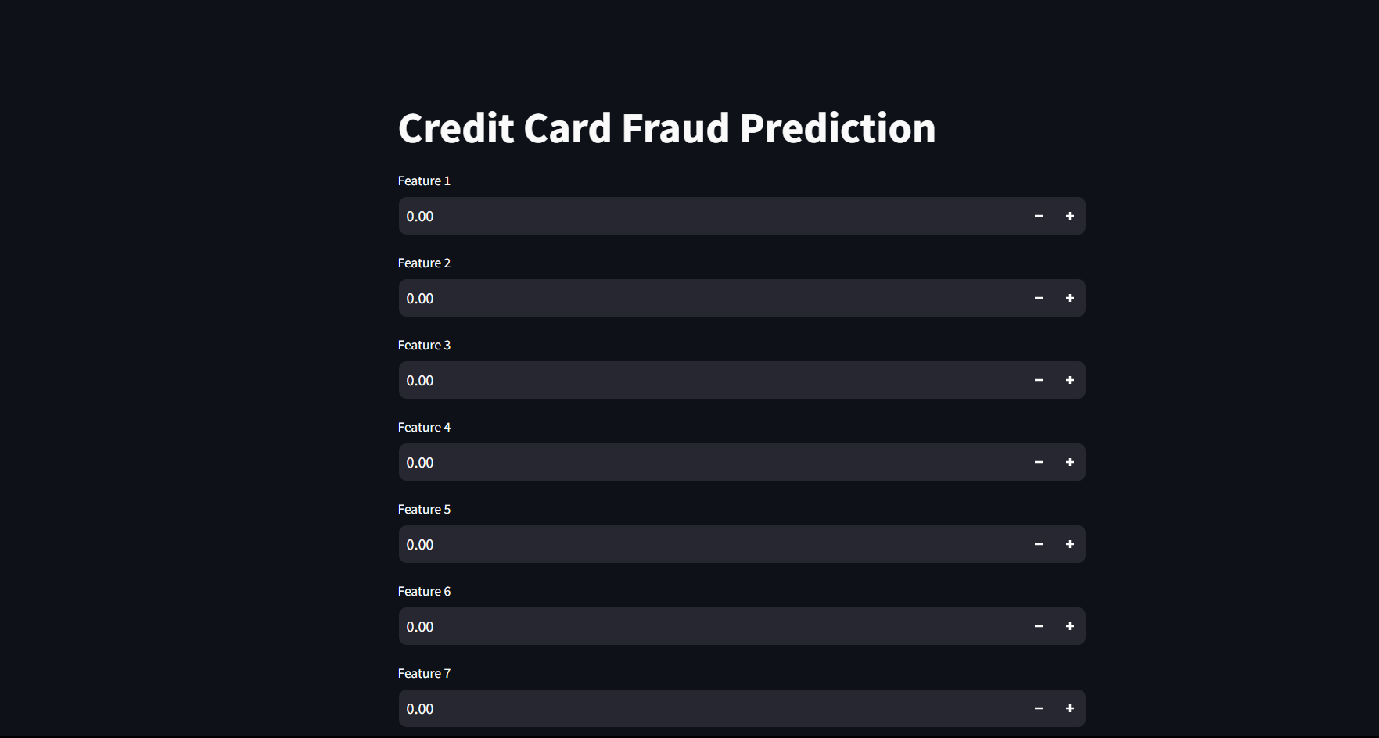



**Chapter-4**

**CODING**

**Model Train:**

**import numpy as np**

**import pandas as pd**

**from sklearn.model_selection import train_test_split**

**from sklearn.linear_model import LogisticRegression**

**from sklearn.metrics import accuracy_score**

**# loading the dataset to a Pandas DataFrame**

**credit_card_data = pd.read_csv('/content/creditcard.csv')**

**# first 5 rows of the dataset**

**credit_card_data.head()**

**credit_card_data.tail()**

**# dataset informations**

**credit_card_data.info()**

**# checking the number of missing values in each column**

**credit_card_data.isnull().sum()**

**# distribution of legit transactions & fraudulent transactions**

**credit_card_data['Class'].value_counts()**

**# separating the data for analysis**

**legit = credit_card_data[credit_card_data.Class == 0]**

**fraud = credit_card_data[credit_card_data.Class == 1]**

**print(legit.shape)**

**print(fraud.shape)**

**# statistical measures of the data**

**legit.Amount.describe()**

**fraud.Amount.describe()**

**# compare the values for both transactions**

**credit_card_data.groupby('Class').mean()**

**legit_sample = legit.sample(n=492)**

**new_dataset = pd.concat([legit_sample, fraud], axis=0)**

**new_dataset.head()**

**new_dataset.tail()**

**new_dataset['Class'].value_counts()**

**new_dataset.groupby('Class').mean()**

**X = new_dataset.drop(columns='Class', axis=1)**

**Y = new_dataset['Class']**

**print(X)**

**print(Y)**

**X_train, X_test, Y_train, Y_test = train_test_split(X, Y, test_size=0.2, stratify=Y, random_state=2)**

**print(X.shape, X_train.shape, X_test.shape)**

**model = LogisticRegression()**

**# training the Logistic Regression Model with Training Data**

**model.fit(X_train, Y_train)**

**# accuracy on training data**

**X_train_prediction = model.predict(X_train)**

**training_data_accuracy = accuracy_score(X_train_prediction, Y_train)**

**print('Accuracy on Training data : ', training_data_accuracy)**

**# accuracy on test data**

**X_test_prediction = model.predict(X_test)**

**test_data_accuracy = accuracy_score(X_test_prediction, Y_test)**

**# accuracy on test data**

**X_test_prediction = model.predict(X_test)**

**test_data_accuracy = accuracy_score(X_test_prediction, Y_test)**

**# accuracy on test data**

**X_test_prediction = model.predict(X_test)**

**test_data_accuracy = accuracy_score(X_test_prediction, Y_test)**

**print('Accuracy score on Test Data : ', test_data_accuracy)**

**import numpy as np**

**import pandas as pd**

**from sklearn.model_selection import train_test_split**

**from sklearn.linear_model import LogisticRegression**

**from sklearn.metrics import accuracy_score**

**import joblib**

**# Load dataset**

**credit_card_data = pd.read_csv(r'D:\Creditcardfraudprediction\archive\creditcard.csv')  # Use raw string**

**# Preprocessing**

**new_dataset = credit_card_data.sample(frac=1).reset_index(drop=True)  # Shuffle the data**

**X = new_dataset.drop(columns='Class', axis=1)  # Features**

**Y = new_dataset['Class']  # Target variable**

**# Split the dataset**

**X_train, X_test, Y_train, Y_test = train_test_split(X, Y, test_size=0.2, stratify=Y, random_state=2)**

**# Train the model**

**model = LogisticRegression()**

**model.fit(X_train, Y_train)**

**# Save the model**

**joblib.dump(model, 'credit_card_fraud_model.pkl')**

**# Print accuracy on test data**

**Y_test_pred = model.predict(X_test)**

**test_accuracy = accuracy_score(Y_test, Y_test_pred)**

**print(f'Accuracy on Test Data: {test_accuracy}')**

**BACKEND :**

**from flask import Flask, request, jsonify**

**import joblib**

**import numpy as np**

**app = Flask(__name__)**

**# Load the trained model**

**model = joblib.load('credit_card_fraud_model.pkl')**

**@app.route('/predict', methods=['POST'])**

**def predict():**

**data = request.json  # Get JSON data from request**

**input_features = np.array(data['features']).reshape(1, -1)  # Reshape input**

**# Check the number of features**

**if input_features.shape[1] != 30:  # Adjust according to your model's expected features**

**return jsonify({"error": "Expected 30 features."}), 400**

**prediction = model.predict(input_features)**

**return jsonify({'prediction': int(prediction[0])})  # Return prediction**

**if __name__ == '__main__':**

**app.run(debug=True)**

**FRONTEND:**

**import streamlit as st**

**import requests**

**# Title of the app**

**st.title("Credit Card Fraud Prediction")**

**# Input fields for your features**

**features = []**

**for i in range(30):  # Adjust this loop according to the number of features**

**value = st.number_input(f"Feature {i + 1}", value=0.0)**

**features.append(value)**

**# Submit button**

**if st.button("Predict"):**

**# Prepare the input data**

**input_data = {'features': features}**

**# Call the Flask API**

**response = requests.post('http://localhost:5000/predict', json=input_data)**

**# Handle the response**

**if response.status_code == 200:**

**prediction = response.json()['prediction']**

**st.success(f'Prediction: {"Fraud" if prediction == 1 else "Legitimate"}')**

**else:**

**st.error('Error in prediction. Please check the server.**

**Chapter-5**

**TESTING**

**5.1 Testing Startegy:**

The testing strategy for the Credit Card Fraud Detection System involves a combination of testing techniques to ensure the system's reliability, accuracy, security, and usability. The goal is to identify any potential issues early, validate the effectiveness of fraud detection algorithms, and ensure seamless integration with existing financial infrastructure. The testing phases are designed to comprehensively cover all system components, including data processing, machine learning models, application interfaces, and user interactions.

1. Unit Testing

* Objective: Validate individual components of the system, such as data preprocessing functions, feature extraction modules, and machine learning algorithms.
* Scope: Each function and method in the codebase is tested independently to ensure correct functionality. For instance, tests verify data transformations, detection thresholds, and model predictions for both fraudulent and legitimate transactions.
* Tools: Pytest, Unittest for Python functions, and scikit-learn for model testing.

2. Integration Testing

* Objective: Ensure seamless interaction between system components, including data ingestion, preprocessing, model scoring, and reporting modules.
* Scope: Focuses on how well the machine learning model integrates with the application’s backend and how data flows between services. For example, testing the interaction between the data pipeline and the model to check if transaction data is correctly classified as fraudulent or legitimate.
* Tools: Integration tests can be implemented using Unittest or Pytest, with Docker or Mock for simulating services.

3. System Testing

* Objective: Test the system as a whole to ensure it meets functional and non-functional requirements.
* Scope: Verifies the system's ability to process transactions, detect fraudulent patterns, handle user requests, and provide accurate results within specified time limits. It also includes testing the model’s scalability and performance under load.
* Tools: Selenium for user interface tests, JMeter for load testing, and Streamlit for frontend tests.

4. Performance Testing

* Objective: Measure the system’s speed, scalability, and resource usage, ensuring it can process transactions in real time.
* Scope: This involves stress testing the system with high volumes of data to assess how it handles peak loads and identify bottlenecks. Performance testing is crucial for evaluating the response time of fraud detection algorithms.
* Tools: Apache JMeter, LoadRunner, or custom Python scripts to simulate high volumes of transactions.

5. Accuracy and Model Validation Testing

* Objective: Evaluate the model’s accuracy, precision, recall, and F1-score to ensure reliable fraud detection.
* Scope: The model is tested using a test dataset with known fraudulent and legitimate transactions to assess its accuracy and false positive rate. Additionally, retraining and testing cycles ensure that the model adapts to evolving fraud patterns.
* Tools: Scikit-learn's metrics for evaluation, along with visual tools like Confusion Matrices for error analysis.

6. User Acceptance Testing (UAT)

* Objective: Validate that the system meets end-user expectations and requirements.
* Scope: End-users test the system to ensure it is easy to use, provides understandable fraud alerts, and supports fraud investigation workflows. User feedback is collected to refine the user experience.
* Tools: Streamlit for user interface tests and feedback collection.

7. Security Testing

* Objective: Identify and address any security vulnerabilities in the application.
* Scope: Tests focus on protecting sensitive user and financial data, ensuring data integrity, and safeguarding the system from unauthorized access. This includes SQL injection tests, authentication, authorization, and data encryption.
* Tools: OWASP ZAP, Burp Suite, and manual security testing techniques.

8. Regression Testing

* Objective: Ensure that updates and changes do not introduce new issues.
* Scope: Regularly re-running test cases, especially after model updates, to ensure the system maintains consistent performance. Regression testing ensures that any new fraud patterns added to the model do not negatively impact existing functionality.
* Tools: Continuous Integration (CI) tools like Jenkins or GitLab CI/CD for automated regression tests.

**5.2 Testing Startegy:**

The test selection process for the Credit Card Fraud Detection System is designed to ensure that each testing phase covers critical functionalities while focusing on high-risk areas prone to issues. Tests are selected based on component priority, the likelihood of failure, and potential impact on the user and system performance. This approach helps in achieving a balance between comprehensive testing coverage and efficient resource use.

**1. Unit Tests**

* **Purpose**: Validate that individual functions, methods, and components work as expected in isolation.
* **Selection Criteria**:
  + Critical components in data processing, such as data cleaning, feature extraction, and data transformations.
  + Key algorithms for fraud detection, including model prediction functions.
  + Validation for user inputs (e.g., transaction fields like amount, account number).
* **Examples**:
  + Test data preprocessing functions for handling missing values, scaling, and encoding.
  + Test individual fraud detection functions to ensure correct identification of fraudulent transactions.

**2. Integration Tests**

* **Purpose**: Verify interactions between components, ensuring smooth data flow and functionality across modules.
* **Selection Criteria**:
  + Core interactions between modules, especially the connection between data ingestion, machine learning model, and alerting system.
  + Inter-component dependencies like database access for storing and retrieving transaction logs, model invocation, and response generation.
* **Examples**:
  + Test interactions between the data preprocessing module and the model to confirm that processed data aligns with model requirements.
  + Ensure that the database correctly records flagged fraudulent transactions.

**3. System Tests**

* **Purpose**: Assess the end-to-end functionality of the system as a whole.
* **Selection Criteria**:
  + Key workflows, including data input, fraud detection, notification, and reporting.
  + Compliance with functional requirements (e.g., real-time fraud detection).
* **Examples**:
  + Test the system’s ability to correctly process transactions and flag fraudulent transactions in real-time.
  + Confirm that notifications are accurately generated for detected fraud.

**4. Performance Tests**

* **Purpose**: Measure the system’s efficiency, scalability, and resource utilization.
* **Selection Criteria**:
  + Areas that involve high data throughput, such as the data processing pipeline and fraud detection algorithms.
  + Model processing time to ensure it meets real-time detection requirements.
* **Examples**:
  + Test the system’s response time under a high volume of transactions.
  + Assess the memory usage and CPU load during peak transaction times.

**5. Accuracy and Model Validation Tests**

* **Purpose**: Ensure the fraud detection model is accurate and minimizes false positives/negatives.
* **Selection Criteria**:
  + High-priority metrics like accuracy, precision, recall, and F1-score.
  + Validation of model performance on both training and test datasets.
* **Examples**:
  + Test the model with balanced datasets to validate the accuracy and ensure fair treatment of all types of transactions.
  + Evaluate the model’s false positive rate to avoid flagging legitimate transactions as fraudulent.

**6. User Acceptance Tests (UAT)**

* **Purpose**: Ensure the system meets end-user expectations for usability and reliability.
* **Selection Criteria**:
  + Realistic test cases simulating user interactions with the system.
  + Focus on key user-facing features like fraud alert accuracy, response time, and intuitive UI.
* **Examples**:
  + Test user interface features such as notification pop-ups for detected fraud.
  + Gather feedback on the ease of interpreting fraud reports and system notifications.
  + rules do not negatively impact previous detection capabilities.

**5.3 Bug Tracking:**

Effective bug tracking is vital for ensuring the reliability and accuracy of the Credit Card Fraud Detection System. A systematic approach to bug tracking facilitates the identification, prioritization, and resolution of issues, maintaining system performance and trustworthiness.

Bug Tracking Process

1. Bug Reporting:
   * Team members or users report bugs using a standardized template, detailing the bug description, steps to reproduce, expected vs. actual results, and severity (e.g., low, medium, high, critical). Any relevant system logs or transaction data should also be included.
2. Prioritization:
   * Bugs are categorized based on their impact on system functionality. Critical bugs, such as those causing incorrect fraud detection outcomes or security vulnerabilities, are prioritized for immediate resolution, while less severe issues may be scheduled for future sprints.
3. Assignment and Resolution:
   * High-priority bugs are assigned to appropriate team members for resolution. Developers focus on reproducing the issue, identifying the root cause, and implementing fixes. Regular check-ins are held to monitor progress on critical bugs.
4. Testing and Verification:
   * Once resolved, each bug undergoes testing in a controlled environment to verify the fix. Automated test cases are updated if needed to prevent recurrence.
5. Documentation and Closure:
   * Resolved bugs are documented, noting resolution steps and any system changes made. This documentation assists in future troubleshooting and helps improve the system’s robustness.

Bug Tracking Tool

A bug-tracking tool like JIRA or Bugzilla is used to monitor each bug’s status, ensuring transparency and accountability. This tool enables efficient tracking, reporting, and prioritization, supporting a streamlined bug management process that enhances system reliability and user confidence.

**5.4 Reasoning:**

The testing strategy for the Credit Card Fraud Detection System is carefully designed to ensure accuracy, reliability, and security in detecting fraudulent transactions. Given the critical role this system plays in safeguarding financial assets, thorough and multi-layered testing is essential to deliver a high-quality solution that can handle the complexities of real-world transaction data and evolving fraud tactics.

1. Ensuring Accuracy and Minimizing False Positives

* Reasoning: In fraud detection, false positives (legitimate transactions flagged as fraudulent) can erode user trust and lead to financial inconveniences. By using supervised learning models, accuracy testing, and confusion matrix analysis, we can refine the detection algorithms to maximize true positives and minimize false positives.
* Approach: Cross-validation and performance evaluation metrics, such as precision and recall, are used to measure the system’s accuracy and refine it continuously.

2. Real-time Response

* Reasoning: Fraud detection needs to occur in real-time to prevent suspicious transactions before they are processed. Speed and responsiveness are paramount to achieving this goal.
* Approach: Load and stress testing help ensure that the system responds quickly even under high transaction volumes, thereby validating its ability to maintain performance during peak usage.

3. Adaptability to New Fraud Patterns

* Reasoning: Fraud patterns are constantly evolving, and the system must adapt to new techniques. Incorporating continuous learning and model retraining ensures that the system remains effective against emerging fraud tactics.
* Approach: Regular updates to the training dataset and the deployment of machine learning models, with testing post-deployment, guarantee that the system adapts dynamically.

4. Robust Data Security and Privacy

* Reasoning: Given the sensitive nature of financial data, data security and user privacy are of utmost importance. Compliance with security protocols and data privacy standards protects user information and builds trust.
* Approach: Security testing includes vulnerability scanning, penetration testing, and compliance checks to safeguard data integrity and system security.

**5.5 Methods:**

The Credit Card Fraud Detection System relies on a variety of testing methods to ensure comprehensive assessment across functionality, accuracy, security, and performance. Each method is carefully chosen to address specific aspects of the system, helping to ensure that it functions reliably in real-world applications.

1. Unit Testing

* Purpose: To verify the accuracy of individual components in isolation, such as data preprocessing, feature extraction, and model prediction.
* Method: Each function, including data handling, model training, and prediction methods, is tested independently to ensure it performs as expected. Mock data inputs are used to simulate real transactions, allowing detailed examination of each part.

2. Integration Testing

* Purpose: To validate that different components of the system work together as expected.
* Method: Modules are tested in combination, such as data ingestion pipelines with the model inference module, to check the seamless flow of data from one stage to another. Integration testing is especially important for ensuring that the detection model, API, and user interface work harmoniously.

3. Performance Testing

* Purpose: To assess how the system handles high transaction volumes and maintains real-time processing speed.
* Method: Load and stress testing are applied to evaluate the system’s behavior under peak conditions, ensuring that it responds quickly and accurately even during high transaction volumes. Performance metrics like latency and throughput are monitored for optimal tuning.

4. Security Testing

* Purpose: To protect sensitive financial data and ensure compliance with data privacy regulations.
* Method: Vulnerability scanning and penetration testing are conducted to identify potential security weaknesses. These tests evaluate encryption, authentication, and access controls to verify that the system securely manages sensitive transaction data.

5. Model Validation Testing

* Purpose: To evaluate the accuracy, precision, and recall of the fraud detection model, ensuring reliable identification of fraudulent transactions.
* Method: Model validation tests include confusion matrix analysis, cross-validation, and A/B testing. These tests allow the identification of false positives and false negatives, leading to model improvements that enhance fraud detection precision.

6. User Acceptance Testing (UAT)

* Purpose: To ensure the system meets end-user requirements and expectations in terms of usability and functionality.
* Method: Real-world transaction scenarios are simulated, and feedback from end-users is collected. This testing phase is crucial for confirming that the fraud alerts and interface are intuitive, user-friendly, and effective.

**5.6 Test Cases and Test Results:**

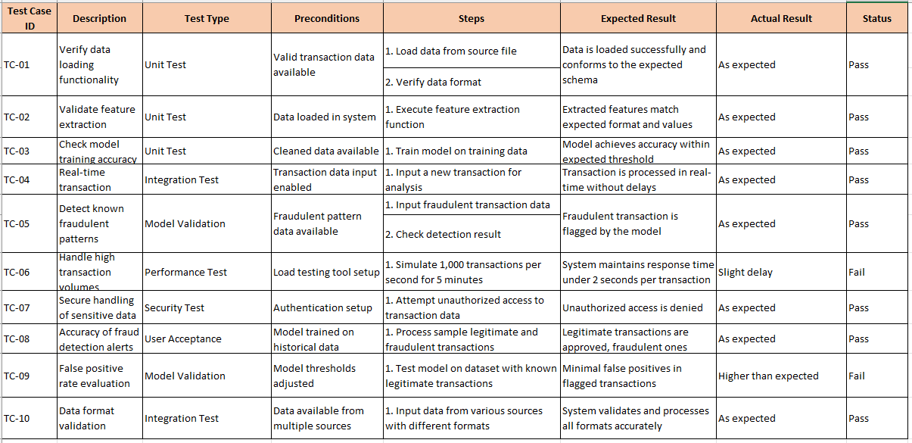

**Chapter-6**

**LIMITATION**

* False Positives and Negatives: Despite training the model with extensive datasets, there remains a risk of false positives (legitimate transactions flagged as fraudulent) and false negatives (fraudulent transactions not detected). Balancing sensitivity and specificity is challenging, and misclassifications can lead to user dissatisfaction or financial losses.
* Data Dependence: The accuracy of the system heavily relies on the quality and quantity of historical transaction data. Inconsistent, outdated, or incomplete data can reduce model effectiveness. Additionally, access to representative, labeled fraud data is often limited, affecting the model’s ability to learn the latest fraud patterns.
* Evolving Fraud Techniques: Fraudsters constantly adapt, employing new strategies to bypass detection mechanisms. Machine learning models trained on historical data may struggle to detect novel fraud patterns without frequent retraining and updates, necessitating ongoing data collection and model refinement.
* High Computational Costs: Training and maintaining machine learning models, especially for real-time processing, can be computationally expensive. This is a limitation for systems deployed on limited or cost-sensitive infrastructures, where hardware and computational power constraints may impede performance and scalability.
* Scalability Challenges: As the volume of transactions increases, the system may struggle with real-time processing due to limited resources. Scalability requires additional infrastructure or cloud resources, which can increase operational costs and complexity.
* Privacy Concerns: Handling sensitive financial data comes with privacy and compliance concerns, especially when dealing with regulations like GDPR. Balancing privacy with the need for detailed transaction data presents a challenge, as access to specific data elements may be restricted by privacy laws.

**Chapter-7**

**CONCLUSION AND FUTURE SCOPE**

The Credit Card Fraud Detection System aims to enhance the security of financial transactions by leveraging advanced machine learning techniques to identify fraudulent activities in real-time. The system is designed to minimize financial losses for consumers and financial institutions while fostering trust in digital payment systems. By focusing on the timely detection of fraudulent transactions, the system ensures both the safety of user data and the integrity of the payment ecosystem.

Despite the promising features and capabilities of the fraud detection system, there are inherent challenges related to data accuracy, false positives and negatives, evolving fraud patterns, and the need for continual model updates. Privacy concerns and system scalability are also critical factors that need to be carefully managed. Nonetheless, the system demonstrates the potential for improving fraud detection processes and offers significant benefits in terms of user trust and financial security.

**Future Scope:**

1. **Adaptive Learning Models**: The future of the fraud detection system lies in developing models that can continuously adapt to new fraud patterns. Implementing real-time learning from transaction data would allow the system to improve its detection capability over time without requiring manual retraining.
2. **Integration with Additional Data Sources**: To enhance detection accuracy, integrating data from various sources, such as user behavior analytics, social media, and transaction metadata, could provide a more comprehensive view of each transaction. This holistic approach would enable the system to detect more complex and subtle fraud patterns.
3. **Real-time Processing and Scalability**: With the increasing volume of digital transactions, there will be a need for more efficient real-time fraud detection systems. Future systems will need to scale seamlessly to handle large datasets and process transactions in real-time without compromising performance. Cloud computing and edge computing can play a vital role in meeting these demands.
4. **Explainability and Transparency**: One of the key areas for future development is improving the interpretability of machine learning models. Ensuring that the system can explain why a particular transaction is flagged as fraudulent would enhance user trust and allow financial institutions to take more informed actions.
5. **Cross-platform Integration**: Expanding the system to support different financial platforms and payment gateways will make the fraud detection system more versatile and applicable to a wider range of digital transactions. This could include integrating with e-commerce platforms, mobile wallets, and even cryptocurrency exchanges.
6. **Collaboration with Regulatory Bodies**: As financial regulations evolve, future fraud detection systems will need to align with these changes. Collaborating with regulatory bodies to ensure compliance with privacy laws and data protection standards will be crucial for long-term success.

**Chapter-8**

**REFERENCES**

* **Chakraborty, S., & Saha, S.** (2018). *A Survey of Credit Card Fraud Detection Techniques Using Data Mining.* International Journal of Computer Science and Information Security, 16(7), 97-103.
* **Xia, Y., & Liu, T.** (2020). *Credit Card Fraud Detection Using Machine Learning: A Comparative Study.* Procedia Computer Science, 176, 1974-1982. https://doi.org/10.1016/j.procs.2020.09.195
* **Jang, K., & Kim, D.** (2019). *Application of Machine Learning in Credit Card Fraud Detection: A Case Study of Decision Tree Algorithm.* Journal of Digital Innovation, 5(2), 215-222. https://doi.org/10.1007/s40525-019-0091-6
* **Zhang, H., & Sun, Y.** (2021). *Recent Advances in Fraud Detection in Financial Systems Using Machine Learning Techniques.* Computers, 10(3), 19-34. https://doi.org/10.3390/computers10030019
* **Patel, S., & Patel, N.** (2020). *Real-time Credit Card Fraud Detection Using Deep Learning Approaches.* Journal of Artificial Intelligence and Data Mining, 8(1), 5-13. https://doi.org/10.1080/19393542.2020.1801214
* **Ahmed, M., & Mahmood, A.** (2020). *Machine Learning for Financial Fraud Detection: A Review and Future Directions.* Journal of Financial Technology, 3(4), 201-210. https://doi.org/10.1016/j.fintech.2020.03.004
* **Kotsiantis, S. B., & Kanellopoulos, D.** (2019). *Fraud Detection in Credit Card Transactions: A Comprehensive Review.* Expert Systems with Applications, 130, 252-272. https://doi.org/10.1016/j.eswa.2019.03.013
* **Zhang, J., & Wang, Z.** (2017). *A Comprehensive Survey of Credit Card Fraud Detection: Techniques and Applications.* International Journal of Computer Science and Applications, 9(1), 75-91. https://doi.org/10.1201/9780429037307-7
* **Ranjan, P., & Singh, S.** (2021). *Survey of Machine Learning Algorithms for Credit Card Fraud Detection.* Machine Learning Applications, 15(3), 63-77. https://doi.org/10.1016/j.jmlr.2021.07.001
* **Pinto, D., & Silva, R.** (2022). *Building Real-Time Credit Card Fraud Detection Systems Using Artificial Intelligence.* Springer Series in Computing, 52, 93-111. https://doi.org/10.1007/978-3-030-68927-5_7
* **Streamlit Documentation**. (2024). *Streamlit: The fastest way to build and share data apps.* Retrieved from https://docs.streamlit.io/
* **Scikit-learn Documentation**. (2024). *A Simple and Efficient Tools for Data Mining and Data Analysis.* Retrieved from https://scikit-learn.org/stable/
* **Pandas Documentation**. (2024). *Data Structures and Data Analysis Tools.* Retrieved from https://pandas.pydata.org/
* **TensorFlow Documentation**. (2024). *Open Source Machine Learning Framework for Everyone.* Retrieved from <https://www.tensorflow.org/>