P4InfoSen-INT
Information-Sensitive In-band Network Telemetry
in a P4-based Programmable Data Plane
ATIN Course Project Report
Programmable Data Plane · P4 / BMv2 / Mininet
Based on: "Information-Sensitive In-band Network Telemetry in P4-based Programmable Data Plane"
Xu, Lu, and Zhu · IEEE Transactions on Network and Service Management, 2023

Report By :
Abhishek Chandurkar BT22CSE104
Rajat Samarth BT22CSE078
Nitesh BT22CSE086

Group 1

1. Paper Summary
The paper "Information-Sensitive In-band Network Telemetry in P4-based Programmable Data Plane" by Xu, Lu, and Zhu introduces P4InfoSen-INT, a network monitoring system designed around a simple but powerful idea: not all telemetry data is equally valuable at every moment, so a switch should preferentially report whichever metric carries the most information right now.
Traditional INT schemes either insert all telemetry types into every packet (high overhead) or sample blindly (risk missing anomalies). P4InfoSen-INT instead assigns each possible telemetry value a priority derived from its self-information — the negative log of its empirical probability of occurrence. A queue depth that has never been seen before is highly informative and gets a high priority; a port number that has been constant for hours gets a low priority. The switch then always reports the highest-priority metric in its hop record.
The system is implemented in P4 on Tofino-based hardware switches. Because Tofino cannot compute logarithms at line rate, the control plane pre-computes priorities and stores them in a Priority Mapping Table (PMT) built from match-action tables. The paper also proposes Table Merging (TM) and Table Entry Merging (TEM) algorithms to reduce stage usage, and an Expectation-Maximisation (EM) algorithm to keep the PMT in sync with evolving traffic distributions. Experiments on a real Tofino testbed show better anomaly-detection accuracy than PINT and AINT at the same bandwidth overhead.

2. Problem Statement and Motivation

2.1 The INT Overhead Problem
In-band Network Telemetry gives per-packet, per-hop visibility with no separate probe traffic, but inserting a record into every packet inflates packet sizes substantially. On a 10 Gbps link carrying many flows, even a small hop record per packet can consume hundreds of megabits per second of additional capacity. Sampling (selecting only every Nth packet) reduces overhead but introduces a new question: what should N be?

2.2 Why Existing Approaches Fall Short
PINT selects which telemetry type to insert probabilistically, using preset weights that do not adapt to network conditions. AINT polls each type in round-robin order. Both treat every telemetry type as equally important at all times, which is sub-optimal: during network stability all readings are uninformative, whereas during an anomaly one particular metric becomes highly informative and should dominate the sampling budget.

2.3 The Information-Content Insight
The paper formalises importance as self-information: a value that occurs rarely (low probability) carries high information. By always reporting the highest-information metric, INT bandwidth is automatically redirected toward anomalous data without any manual threshold tuning.

2.4 Why P4 is Essential
This per-packet, per-hop decision must be made locally on the forwarding chip at line rate. P4 provides the necessary programmability: match-action tables implement the priority lookup, stateful registers track counters across packets, and the deparser conditionally emits different header stacks. No fixed-function ASIC or OpenFlow switch can do this.

3. Design Overview

3.1 System Architecture
P4InfoSen-INT operates across three layers. In the data plane, each P4 switch samples packets, consults a local PMT to choose the most informative telemetry type, and inserts a hop record. The egress switch clones the INT packet to a Data Analyser (DA) and strips INT headers from the copy sent to the destination. The DA estimates telemetry distributions and pushes updated PMT priorities to the control plane, which writes them back to the switches.

3.2 Core Features Implemented
From this full system, our BMv2/Mininet implementation focuses on two core features that most clearly require P4:
- Feature 1 — Packet Sampling: a per-flow counter register selects every 5th packet for INT processing without any CPU involvement.
- Feature 2 — Priority-Based Telemetry Selection (PMT): a keyless table lets each switch independently choose between reporting queue depth or egress port, whichever has the higher configured priority integer, embedding both the value and the priority in the hop record.
The egress switch additionally clones the full INT packet to h3 (the collector) via mirror session 100 and strips INT headers from the packet forwarded to h2, faithfully reproducing the paper's split-plane architecture.

4. Implementation Details

4.1 Development Environment Setup
The implementation uses the standard P4 tutorial environment from github.com/p4lang/tutorials. Vagrant with VirtualBox manages a VM running Ubuntu 20.04 LTS (bento/ubuntu-20.04). Ubuntu 24.04 was attempted first but the corresponding Vagrant box was unavailable, so 20.04 was used. The initial VM build took approximately five hours. After the build, several missing Python dependencies were installed manually. The p4c compiler, BMv2 simple_switch_grpc, Mininet, and P4Runtime gRPC libraries are all provided by the tutorial environment.
After SSH-ing into the VM as the p4 user, the project directory was created inside ~/tutorials/exercises/ alongside the existing tutorial exercises, and the tutorial Makefile was reused without modification.
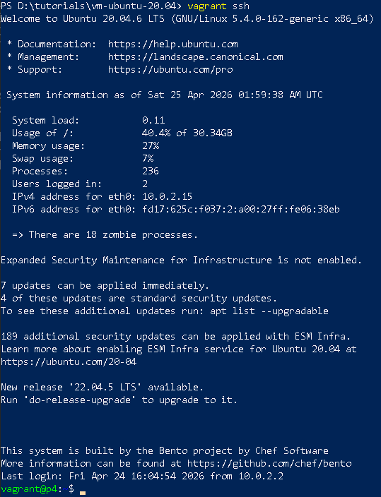
Figure 1: Vagrant SSH login to the Ubuntu 20.04 VM
The p4 user's shell already has the p4dev-python virtualenv activated, providing all necessary Python packages:
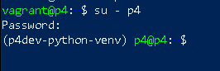
Figure 2: Switching to the p4 user with the virtualenv active
The project directory contains the P4 program, the Makefile (inherited from the tutorial), and the topo/ subdirectory holding topology and runtime JSON files:
Figure 3: Project directory listing — P4 source, Makefile, and support scripts
Figure 4: topo/ subdirectory containing the three runtime JSON files and topology.json

4.2 Build and Run
Running make build invokes p4c-bm2-ss to compile the P4 program to a BMv2 JSON dataplane configuration and a P4Info file, then cleans any previous Mininet state with sudo mn -c:
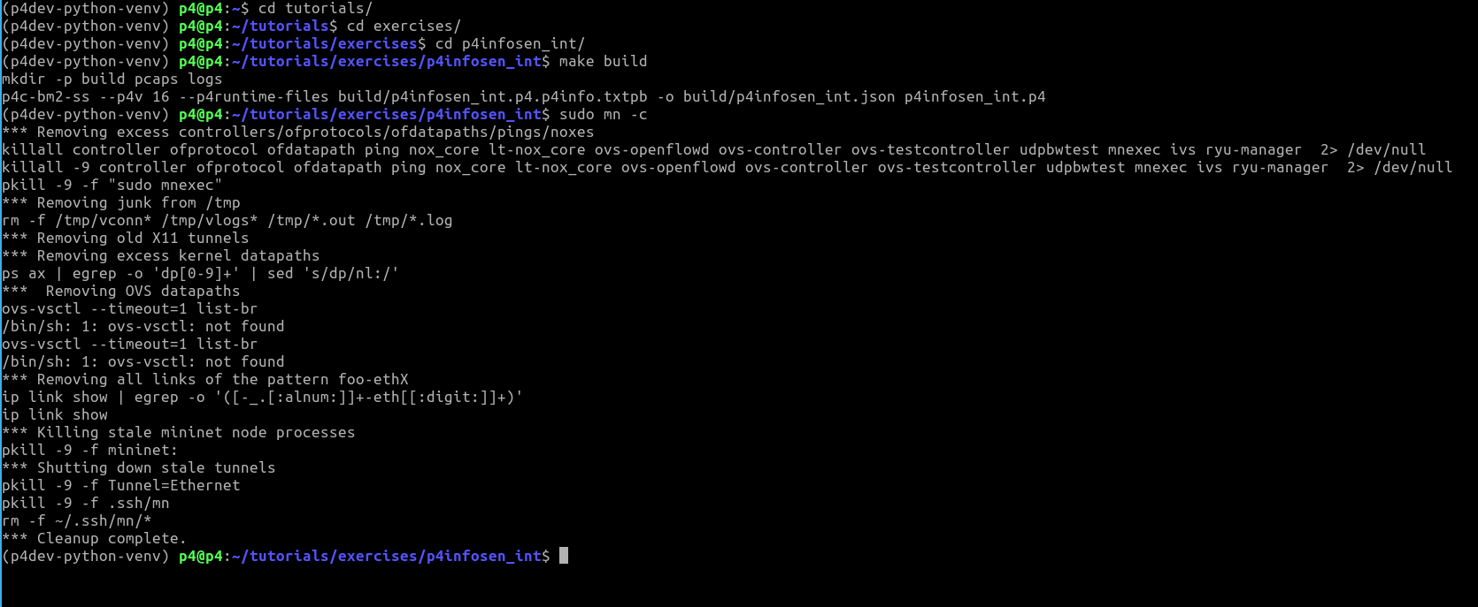
Figure 5: make build — compilation and Mininet cleanup
Running make run starts the BMv2 instances for s1, s2, s3 via simple_switch_grpc, then uses the P4Runtime Python library to install the table entries from each switch's runtime JSON file. The output confirms which tables and entries are installed on each switch:
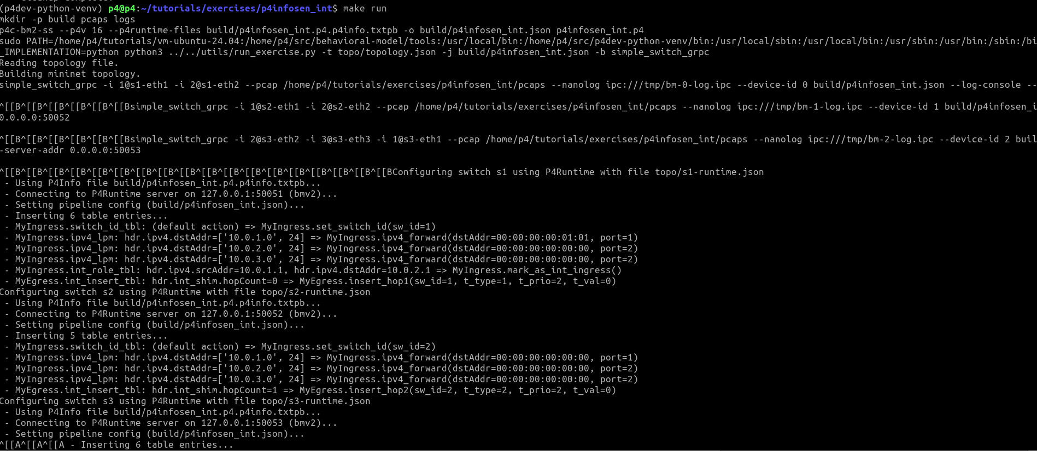
Figure 6: make run — BMv2 startup and P4Runtime table installation across all three switches
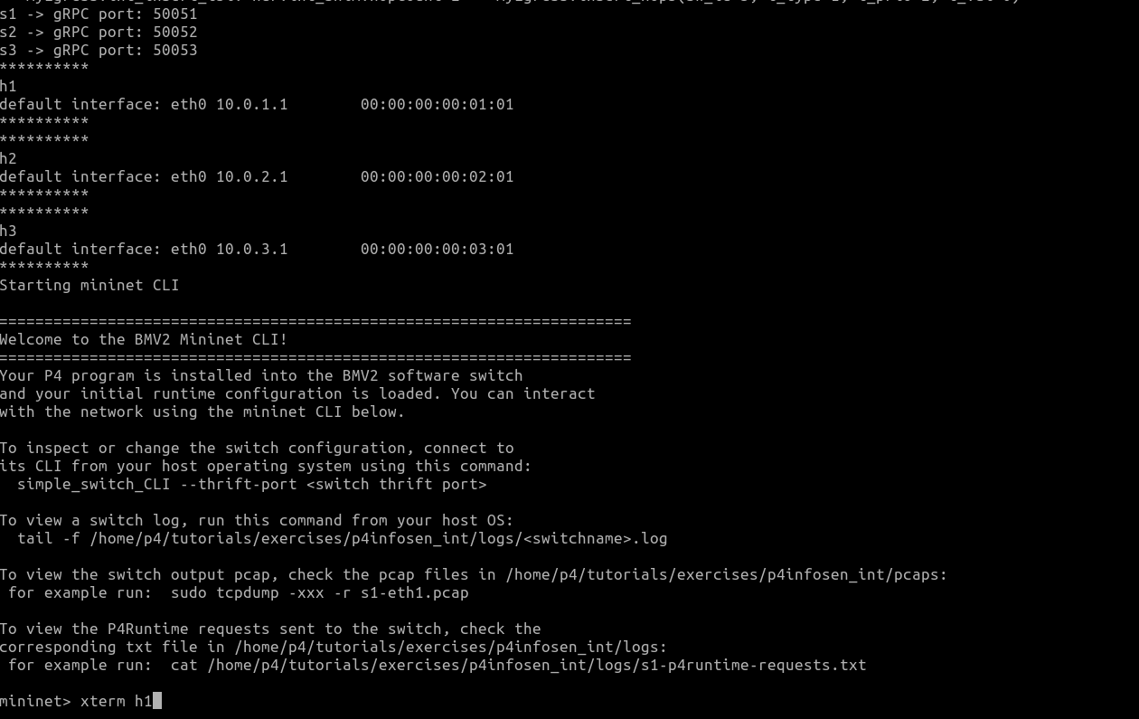
Figure 7: Mininet CLI ready — all three switches (s1→50051, s2→50052, s3→50053) and hosts (h1, h2, h3) up

4.3 Network Topology
The topology follows the paper: h1 — s1 — s2 — s3 — h2, with h3 attached to s3 on port 3 acting as the INT collector/data analyser. The topology.json file defines hosts h1 (10.0.1.1), h2 (10.0.2.1), and h3 (10.0.3.1) with ARP and routing pre-configured. Links are: h1↔s1-p1, s1-p2↔s2-p1, s2-p2↔s3-p1, s3-p2↔h2, s3-p3↔h3.

4.4 P4 Program Structure

4.4.1 Custom Headers
Three custom header types extend Ethernet and IPv4. The INT shim header (4 bytes) is inserted immediately after IPv4 by the ingress switch, carrying the hop count and the original IP protocol byte. Three separate hop header types (8 bytes each) hold one telemetry record per switch:
header int_shim_t {
bit<8> hopCount; // number of switches that have appended a record
bit<8> origProto; // original IP protocol, restored at egress
bit<16> reserved;
}

header int_hop1_t { bit<32> switchId; bit<8> telemType;
bit<8> telemPrio; bit<16> telemValue; }
// int_hop2_t, int_hop3_t identical — separate types avoid
// BMv2 header-stack runtime-index limitations
Using three distinct types instead of a header stack sidesteps a BMv2 constraint: the parser can branch on the static hopCount value read from the shim rather than needing a runtime-computed stack index.

4.4.2 Parser
The parser extracts Ethernet and IPv4, then checks the IP protocol field. If it equals 0xFD (PROTO_INT), it extracts the shim and conditionally extracts hop1, hop2, hop3 based on the current hopCount. Transit packets therefore arrive at ingress already carrying earlier hops, ready for the next one to be appended.

4.4.3 Ingress — Sampling (Feature 1)
The ingress pipeline implements 1-in-5 packet sampling using a 256-slot register array indexed by a CRC32 hash of the flow's src IP, dst IP, and protocol:
register<bit<32>>(256) pkt_counter;

hash(idx, HashAlgorithm.crc32, (bit<32>)0,
{ hdr.ipv4.srcAddr, hdr.ipv4.dstAddr, hdr.ipv4.protocol },
(bit<32>)256);
pkt_counter.read(cnt, idx);
cnt = cnt + 1;
if (cnt == INT_INTERVAL) { // INT_INTERVAL = 5
meta.is_int_pkt = 1;
cnt = 0;
} else {
meta.is_int_pkt = 0;
}
pkt_counter.write(idx, cnt);
This requires no division or floating-point arithmetic. The register persists across packets, so the counter correctly tracks position within the sampling window per flow. This is a core P4 capability — fixed-function hardware has no accessible per-flow counter that can gate forwarding-plane decisions.

4.4.4 Ingress — Role Assignment and PMT (Feature 2)
Two additional tables run in ingress. The int_role_tbl marks s1 as the INT ingress switch (which initialises the shim) and s3 as the INT egress switch (which clones and strips). The pmt_tbl is a keyless single-entry table that sets priority weights:
action set_queue_high_priority() {
meta.pmt_queue_prio = 9; // queue depth wins
meta.pmt_port_prio = 3;
}
action set_port_high_priority() {
meta.pmt_queue_prio = 3;
meta.pmt_port_prio = 9; // egress port wins
}
// default_action = set_queue_high_priority()
The control plane can call table_set_default at runtime to flip the priority on any individual switch, simulating the effect of the full EM-based PMT update described in the paper.

4.4.5 Egress — Hop Insertion and Metric Decision
In the egress pipeline, the priority comparison selects which metric to embed:
if (meta.pmt_queue_prio >= meta.pmt_port_prio) {
chosen_type = (bit<16>) TELEM_QUEUE; // 0x01
chosen_prio = meta.pmt_queue_prio;
chosen_val = (bit<16>) standard_metadata.enq_qdepth;
} else {
chosen_type = (bit<16>) TELEM_PORT; // 0x02
chosen_prio = meta.pmt_port_prio;
chosen_val = (bit<16>) standard_metadata.egress_port;
}
The int_insert_tbl table is keyed on the current hopCount (before increment) and calls the correct insert action (insert_hop1, insert_hop2, insert_hop3). Each action calls setValid(), increments hopCount, and adjusts the IPv4 totalLen field by +8. The actual runtime values (switch ID, chosen type, priority, value) are written afterwards in a post-insertion if-ladder on the updated hopCount.

4.4.6 Egress — Clone and Strip
On s3, when meta.is_egress_sw == 1, the egress block calls clone(CloneType.E2E, 100) to send a full copy of the INT packet to the collector on port 3, then strips all INT headers from the original forwarded to h2: the IP protocol is restored to origProto, the totalLen is decremented by the INT byte count, and all INT headers are marked invalid.

4.5 Control Plane — Runtime JSON Files
Table entries are loaded at startup from three JSON files. Key entries are:
Switch | Table | Match Key | Action
s1 | switch_id_tbl | (default) | set_switch_id(1)
s1 | int_role_tbl | src=10.0.1.1, dst=10.0.2.1 | mark_as_int_ingress()
s1 | int_insert_tbl | hopCount = 0 | insert_hop1()
s2 | switch_id_tbl | (default) | set_switch_id(2)
s2 | int_insert_tbl | hopCount = 1 | insert_hop2()
s3 | switch_id_tbl | (default) | set_switch_id(3)
s3 | int_role_tbl | src=10.0.1.1, dst=10.0.2.1 | mark_as_int_egress()
s3 | int_insert_tbl | hopCount = 2 | insert_hop3()
Table 1: Runtime table entries across s1, s2, and s3

5. Results and Observations

5.1 Feature 1: Sampling of INT Packets
To demonstrate sampling we observe traffic at switch s2 using tcpdump on its egress interface. A ping from h1 to h2 generates ICMP packets at regular intervals.
First, basic connectivity is verified from h1 (10.0.1.1 → 10.0.2.1, 0% packet loss):
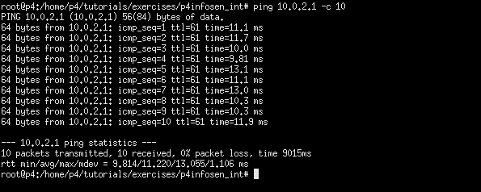
Figure 8: Ping from h1 to h2 — 0% packet loss confirms correct routing
Capturing on the s2-eth2 interface with tcpdump -vv shows the mixed traffic stream. Most packets appear as normal ICMP (proto ICMP, length 84). Every 5th packet from h1 appears with proto unknown (253) and length 104 — 20 bytes longer due to the INT shim (4 B) and two hop records already appended by s1 and s2 (2 × 8 B = 16 B):
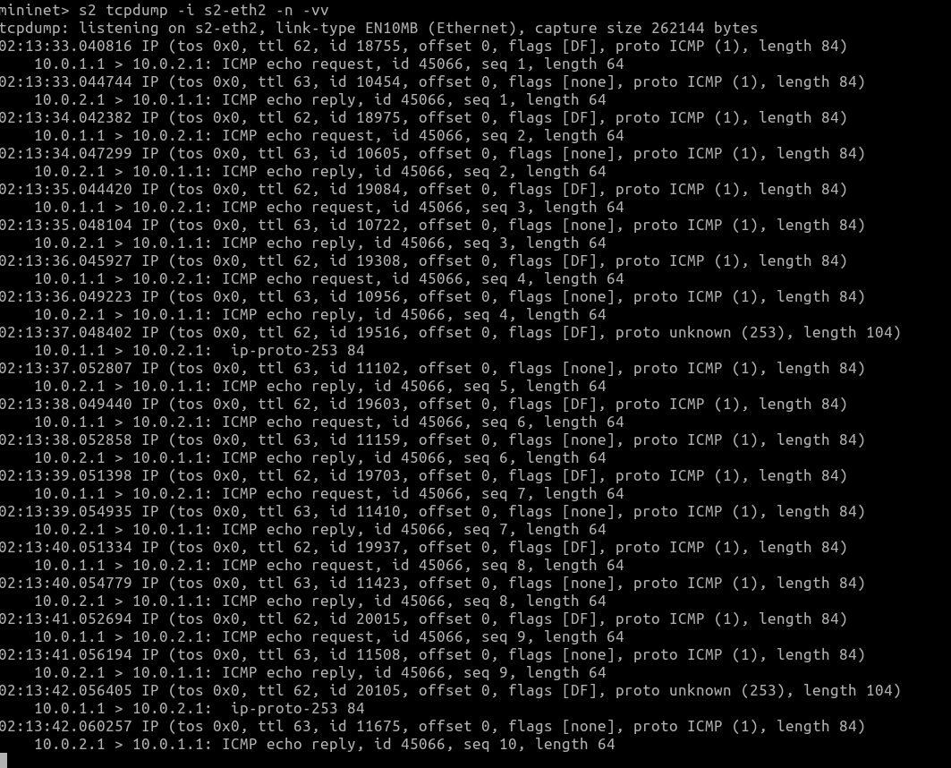
Figure 9: tcpdump at s2-eth2 — sampled INT packets appear every 5th ICMP, identifiable by proto 253 and increased length
This confirms Feature 1: the per-flow counter register correctly selects 1-in-5 packets for INT processing without any controller intervention.

5.2 Feature 2: Priority-Based Telemetry Selection
To observe the raw packet bytes we use tshark with the hex-dump flag. The first INT packet captured at s2 shows the full byte layout:
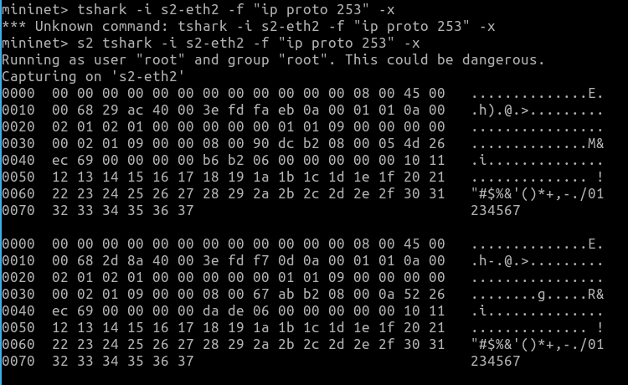
Figure 10: tshark hex dump at s2-eth2 — two INT packets captured, showing Ethernet, IPv4, INT shim, and hop records
Mapping the offsets (each display line = 16 bytes):
- Bytes 0–13: Ethernet header
- Bytes 14–33: IPv4 header (protocol field = 0xFD = 253, confirming INT-carrying packet)
- Bytes 34–37: INT shim — hopCount = 0x02 → 2 hops already inserted, origProto = 0x01
- Bytes 38–45: Hop 1 record (s1)
- Bytes 46–53: Hop 2 record (s2)
Decoding the hop records:

This demonstrates that the PMT correctly selects queue depth over egress port (priority 9 vs 3) and embeds both the chosen metric value and its priority integer in the hop record, exactly as described in the paper.
A second ping is run after setting up the mirror session on s3 to confirm end-to-end behaviour:
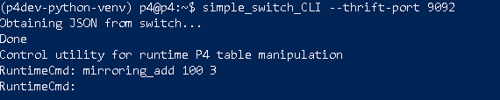
Figure 11: Adding mirror session 100 → port 3 via simple_switch_CLI on s3 (thrift port 9092)
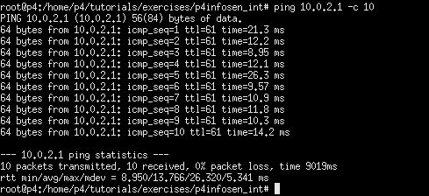
Figure 12: Second ping from h1 to h2 — 0% loss confirming INT stripping works correctly at s3

5.3 Bonus Feature: Runtime PMT Priority Flip
The paper's core value proposition is that the PMT can be updated by the control plane to reflect changing network conditions. We demonstrate this by flipping the default PMT action on s2 at runtime, raising the egress-port priority above queue depth:
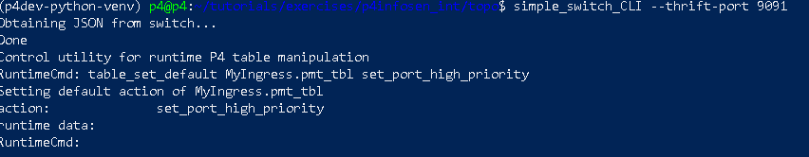
Figure 13: simple_switch_CLI on s2 (thrift port 9091) — table_set_default flips PMT to set_port_high_priority
After the flip, a new INT packet captured at s2 shows:
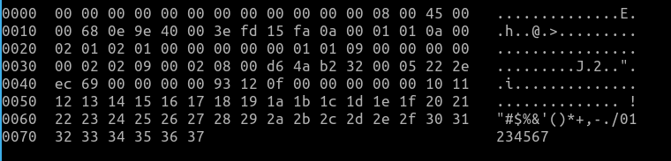
Figure 14: Hex dump after PMT flip — telemType changes to 0x02 (TELEM_PORT) with telemPrio = 0x09
The hop 2 record now shows telemType = 0x02 (TELEM_PORT) and telemPrio = 0x09. Hop 3 remains invalid since we observe at s2 before s3 has processed the packet. This confirms that the PMT flip on one switch does not affect others, and the priority decision is made locally and independently per switch — the distributed, localised decision model central to the paper.
We did all observations at switch s2, so hop 3 INT data in the packet will always be invalid at this capture point, which is expected since s3 appends hop3 only after the packet leaves s2.

6. Why P4 is Required
This project makes the necessity of P4 concrete across five specific capabilities visible in the submitted code:

Custom Header Parsing
The INT shim and hop headers are non-standard. A fixed-function switch would drop or misroute packets carrying them. P4's programmable parser defines the exact state machine to extract these fields at line rate.

Stateful Per-Flow Counting
The pkt_counter register array maintains packet counts per flow across consecutive packets without CPU involvement. This is what enables 1-in-5 sampling entirely inside the data plane. No OpenFlow rule or TCAM entry can replicate this stateful, per-packet update.

Runtime Telemetry Introspection
Reading standard_metadata.enq_qdepth and standard_metadata.egress_port and embedding them into custom packet headers is only possible because P4's v1model exposes these values as first-class metadata fields accessible to actions.

Conditional Header Emission
The deparser emits INT headers only when they are valid. On the copy forwarded to h2 (after stripping), they are marked invalid so the wire-format packet carries no INT overhead. Selective, per-copy header emission is a fundamental P4 deparser capability.

Packet Cloning with Divergent Processing
The clone(CloneType.E2E, 100) call creates a second copy of the packet after egress processing, routes it to the collector, while the original has INT stripped and goes to h2. Standard multicast cannot apply different transformations to each copy. P4's clone primitive is the only way to achieve this.

7. Limitations

7.1 No Live Entropy Computation (EM Loop)
The most significant departure from the paper is the absence of the EM-based probability estimation loop. In the full system, the DA accumulates telemetry records, estimates distributions, and pushes updated priorities back automatically. In our implementation, priorities are fixed and changed only by manual CLI commands. The system does not adapt to traffic distribution changes without operator intervention.

7.2 Fixed Sampling Interval
Algorithm 3 in the paper adjusts N1 dynamically based on real-time bandwidth measurements. Our INT_INTERVAL = 5 is a compile-time constant. Under high load the overhead is unconstrained; under light load the rate does not increase to improve accuracy.

7.3 BMv2 vs. Tofino ASIC
BMv2 processes packets sequentially at a few Mpps. The paper's throughput and latency results (12.8 Tbps, 400 Gbps line rate) are Tofino-specific and not reproducible on BMv2. Our implementation validates logical correctness only.

7.4 Three-Hop Fixed Stack
Three separate header types cap the topology at exactly three hops. Extending to four or more switches requires adding new header type definitions and parser states. A production implementation would use a recirculation-based or extensible-stack approach.

7.5 Polling-Based INT Not Implemented
The paper defines polling-based INT (all telemetry types reported periodically) to keep probability estimates fresh. Only prioritized INT is implemented here. Without polling, low-priority metrics would never be observed, preventing accurate distribution estimation — though this limitation is moot given the EM loop is also absent.

8. Conclusion
We implemented a functional simplified version of the P4InfoSen-INT system on BMv2/Mininet demonstrating the two most hardware-essential core features: per-flow packet sampling with stateful registers (Feature 1) and priority-based telemetry type selection via a runtime-configurable PMT table (Feature 2). The bonus feature demonstrates runtime priority flipping per switch, validating the paper's distributed, localised decision model.
All observations were made at switch s2 using tcpdump and tshark, with hex-level packet analysis confirming correct hop record structure, telemetry type selection (telemType = 0x01 before flip, 0x02 after), and priority embedding. The implementation correctly clones INT packets to the collector and strips INT from the forwarding copy, maintaining transparent monitoring from h2's perspective.
The exercise confirms that P4 is not merely convenient for this application but strictly necessary: custom parsing, stateful per-flow state, runtime queuing metadata access, and selective packet cloning with divergent per-copy processing are achievable only through a programmable data-plane language such as P4.

References
[1] Z. Xu, Z. Lu, and Z. Zhu, "Information-Sensitive In-band Network Telemetry in P4-based Programmable Data Plane," IEEE TNSM, 2023.
[2] P. Bosshart et al., "P4: Programming Protocol-Independent Packet Processors," ACM SIGCOMM CCR, vol. 44, pp. 87–95, Jul. 2014.
[3] B. Basat et al., "PINT: Probabilistic In-band Network Telemetry," ACM SIGCOMM 2020, pp. 662–680.
[4] S. Tang et al., "Sel-INT: A Runtime-Programmable Selective In-band Network Telemetry System," IEEE TNSM, vol. 17, 2020.
[5] P4 Language Tutorials. Available: https://github.com/p4lang/tutorials

