- Write a program that reads two integer numbers and output their sum, difference, product, and quotient.

- Write a program that converts Fahrenheit degrees to Celsius degrees. Use the formula Celsius = 5.0 (Fahrenheit – 32.0) / 9.0 for conversion. Input the Fahrenheit temperature as a double type number. Output the computed Celsius temperature.

- Write a program that reads the radius of a circle and computes and displays the area and circumference of the circle. Use a C# constant declaration to represent the value, 3.1415, of PI.

- Write a program that reads the length and the width of a rectangle and computes the area and the perimeter of that rectangle. Display the length, width, and the computed area and perimeter.

- Write a program that inputs number of seconds and converts it to an equivalent number of hours, minutes, and seconds. Use division and modulus operators to accomplish this. An example output is shown below:

4540 seconds = 1 hour, 15 minutes, 40 seconds

- Write a program that reads principal amount, rate of interest, and length of time in years, and computes simple interest using the formula interest = principal * rate * time. Display the computed interest.

- Write a program that reads hourly pay rate and hours worked. Compute and display the gross pay, taxes paid, and net pay. Use 10% as rate of tax.

- Write a program that reads distance traveled in miles during a trip, miles per gallon, and the cost of gas per gallon. Compute and display the cost of the trip.

- Write a program that reads a four digit number and displays the digits in the number one per line. Use division and modulus operators to accomplish this. For example, the number 4523 will be displayed as follows:

4
5
2
3

- Write a program that reads the first name and the last name of a person and displays the output as follows (if input first name is John and last name is Doe):

Hello John Doe, Welcome to the world of C# and .NET!!!!

- Write a program that reads the values of constants a, b, and c of a quadratic equation of the form 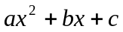. Compute and display the roots of a quadratic equation. Use the following formulae to compute the roots:

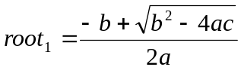 and 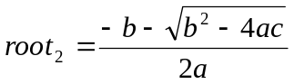

- Write a program that reads the value of the variable x in the polynomial 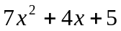 and displays the value of the polynomial.

- Write a class named Product with the following member variables with private access level – id, name, and price. Provide public get and set methods for each of these member variables. Equip your class definition with a Main method which creates an instance of the Product class, sets each of its member fields, and displays the product details by invoking appropriate get methods.

