Kritter learning:
1.Unix Basics:

2. atp-get
It is a rapid, practical, and efficient way to install packages on your system. Dependencies are managed automatically, configuration files are maintained, and upgrades and downgrades are handled carefully to ensure system stability.
An update should always be performed before an upgrade or dist-upgrade.
An update should always be performed first so that apt-get knows which new versions of packages are available.
Install:
install installs one or more packages desired for installation or upgrading. Packages are specified by their package name, not a fully qualified file name (for instance, in a Debian system, "apt-utils" would be the argument provided, not "apt-utils_0.9.7.7ubuntu4_amd64.deb"). All packages required by the package(s) specified for installation will also be retrieved and installed. The /etc/apt/sources.list file is used to locate the desired packages.
If a hyphen is appended to the package name (with no intervening space), the identified package will be removed if it is installed. Similarly a plus sign can be used to designate a package to install. These annotation features may be used to override decisions made by apt-get's default conflict resolution system.
A specific version of a package can be selected for installation by following the package name with an equals and the version of the package to select. This will cause that specific version to be located and installed. Alternatively, a specific distribution can be selected by following the package name with a slash and the version of the distribution or the Archive name ("stable", "testing", "unstable").
Both of the version selection mechanisms can downgrade packages and must be used with care. You don't want to manually remove a package that another installed package is dependent on.
If no package matches the given expression and the expression contains one of '.', '?' or '*' then it is assumed to be a POSIX-style regular expression, and it is applied to all package names in the database. Any matches are then installed (or removed). (Note that matching is done by substring; so 'lo.*' matches 'how-lo' and also 'lowest'. If this is undesired, anchor the regular expression with a '^' or '$' character, or create a more specific regular expression.
remove | identical to install except that packages are removed instead of installed.  Note that removing a package leaves its configuration files on the system.  If a plus sign is appended to the package name (with no intervening space),  the identified package will be installed instead of removed.
purge | identical to remove except that packages are removed and purged  (any configuration files are also deleted).
3 Vim:
To install Vim on Ubuntu, use the command:
sudo apt-get install vim
If you are already interested in some plugins, use the command:
sudo apt-cache search vim
This will give you a long list of packages related to Vim. Among them are some for various programming languages, addon managers, etc.
For this tutorial, I will be using the latest version of Vim (7.3.154) on Ubuntu. You can use any other version though.
First of all, to use any menu-type function like save or exit, your command should begin with a colon (:). Saving is :w and quitting is :q. If you want to quit a file without saving, use the force quit command :q!. A cool thing with Vim is that you don’t have to type commands separately. In other words, if you want to save and then quit, you can directly use :wq.
So for now, quit Vim and open it on a sample text file. Simply add the name of the text file that you want to edit after the command:
vim [text file name]
By default, when you open a text file, you are in visual mode. It is quite specific to Vim and confusing at the beginning. Vim is composed mainly of two modes: visual and editing. The visual mode is for viewing a text and using some commands. To go into editing mode, just press i to insert and a to add some text. To go back into the visual mode and access all the menu-type functions, press the “Escape” key. The difference between insertion and addition is simply whether you want the text you type to appear before or after the cursor in visual mode. To understand this fully, you should really try it yourself. My advice is: add at the end of lines, and insert in other cases.
To move the cursor within a text, whet her you are in visual or editing mode, you can generally use the keyboard arrows. A real purist would tell you to use the keys h for left, j for down, k for up, and l for right.
Now that you are warmed up and know how to control Vim at a basic level, let’s go to the core.
A few basic commands
Now that you master the transformation from visual to editing mode, here are a few commands that you can use in visual mode:
- x: to delete a character
- u: to undo an action (the equivalent of Ctrl+z)
- dd: to delete a line
- dw: to delete a word
- yy: to copy a line
- yw: to copy a word
- p: to paste the previously deleted or copied line or word
- e : to move to the next word (faster than just moving with the arrow keys)
- r: to replace a letter (press r, then the new letter)
And of course, there are more, but this is enough for now. If you master all of them, you will already be very fluent with Vim.

What Is SSH?
One essential tool to master as a system administrator is SSH.
SSH, or Secure Shell, is a protocol used to securely log onto remote systems. It is the most common way to access remote Linux and Unix-like servers.
In this guide, we will discuss how to use SSH to connect to a remote system.

Basic Syntax
The tool on Linux for connecting to a remote system using SSH is called, unsurprisingly, ssh.
The most basic form of the command is:
· $ssh remote_host
The remote_host in this example is the IP address or domain name that you are trying to connect to.
This command assumes that your username on the remote system is the same as your username on your local system.
If your username is different on the remote system, you can specify it by using this syntax:
· $ssh remote_username@remote_host
Once you have connected to the server, you will probably be asked to verify your identity by providing a password.
Later, we will cover how to generate keys to use instead of passwords.
To exit back into your local session, simply type:
· $exit
SCP:
Secure Copy (scp) allows files to be copied between, to or from different hosts. It uses ssh for data transfer and provides the same authentication and same level of security as ssh. It has some exit status, 0 on success, and if an error occurs it uses >0. I used some scp options in my Ubuntu terminal. Here I am sharing some information about scp options that are used in Ubuntu - terminal.

Local Backup
sudo rsync -azvv /home/path/folder1/ /home/path/folder2
Backup Over Network
sudo rsync --dry-run --delete -azvv -e ssh /home/path/folder1/ remoteuser@remotehost.remotedomain:/home/path/folder2
An explanation of above options to commands:
- --dry-run This tells rsync to not actually do anything. It will just write a log of what it would do to the screen. Once you've made sure everything will work as you expect, you have to remove this option, and run the command again to perform the actual backup.
- --delete deletes files that don't exist on the system being backed up.(Optional)
- -a preserves the date and times, and permissions of the files (same as -rlptgoD).
- With this option rsync will:
  - Descend recursively into all directories (-r),
  - copy symlinks as symlinks (-l),
  - preserve file permissions (-p),
  - preserve modification times (-t),
  - preserve groups (-g),
  - preserve file ownership (-o), and
  - preserve devices as devices (-D).
- -z compresses the data
- -vv increases the verbosity of the reporting process
- -e specifies remote shell to use

How to use wget?
The wget command allows you to download files from the Internet using a Linux operating system such as Ubuntu. Use this command to download either a single Web page or a complete copy of your company's website. It also includes an option for downloading any external links included on the site. The command recreates the complete directory structure of the site downloaded on your computer's hard drive, and you can store the local copy as a backup or use it for testing purposes.
1. Click on the "Search" button in the Ubuntu launcher bar, type "terminal," then double-click "Terminal" to open the application.
2. Type the following command to install the package, if it is not currently installed:
sudo apt-get install wget
Type your password when prompted.
3. Type the following command to download a single page from the website:
wget http://www.example.com/filename
Replace "www.example.com" with the name of the site you want to download, and replace "filename" with the name of the file you want to download.
4. Type the following command to download an entire website:
wget -r http://www.example.com
5. Type the following command to download the entire website and any external links:
wget -r -H http://www.example.com

1. Find Files Using Name in Current Directory
Find all the files whose name is tecmint.txt in a current working directory.
# find . -name tecmint.txt
./tecmint.txt

2. Find Files Under Home Directory
Find all the files under /home directory with name tecmint.txt.
# find /home -name tecmint.txt
/home/tecmint.txt

3. Find Files Using Name and Ignoring Case
Find all the files whose name is tecmint.txt and contains both capital and small letters in /home directory.
# find /home -iname tecmint.txt
./tecmint.txt
./Tecmint.txt

4. Find Directories Using Name
Find all directories whose name is Tecmint in / directory.
# find / -type d -name Tecmint
/Tecmint

5. Find PHP Files Using Name
Find all php files whose name is tecmint.php in a current working directory.
# find . -type f -name tecmint.php
./tecmint.php

6. Find all PHP Files in Directory
Find all php files in a directory.
# find . -type f -name "*.php"
./tecmint.php
./login.php
./index.php
Part II – Find Files Based on their Permissions

7. Find Files With 777 Permissions
Find all the files whose permissions are 777.
# find . -type f -perm 0777 -print

8. Find Files Without 777 Permissions
Find all the files without permission 777.
# find / -type f ! -perm 777

#=====================================

General Syntax of Cat command
cat [OPTION] [FILE]...

1. Display Contents of File
In the below example, it will show contents of /etc/passwd file.
# cat /etc/passwd
root:x:0:0:root:/root:/bin/bash
bin:x:1:1:bin:/bin:/sbin/nologin
narad:x:500:500::/home/narad:/bin/bash

2. View Contents of Multiple Files in terminal
In below example, it will display contents of test and test1 file in terminal.
# cat test test1
Hello everybody
Hi world,

3. Create a File with Cat Command
We will create a file called test2 file with below command.
# cat >test2
Awaits input from user, type desired text and press CTRL+D (hold down Ctrl Key and type ‘d‘) to exit. The text will be written in test2 file. You can see content of file with following cat command.
# cat test2
hello everyone, how do you do?

4. Use Cat Command with More & Less Options
If file having large number of content that won’t fit in output terminal and screen scrolls up very fast, we can use parameters more and less with cat command as show above.
# cat song.txt | more
# cat song.txt | less

5. Display Line Numbers in File
With -n option you could see the line numbers of a file song.txt in the output terminal.
# cat -n song.txt
1 "Heal The World"
2 There's A Place In
3 Your Heart
4 And I Know That It Is Love
5 And This Place Could
6 Be Much
7 Brighter Than Tomorrow
8 And If You Really Try
9 You'll Find There's No Need
10 To Cry
11 In This Place You'll Feel
12 There's No Hurt Or Sorrow

Checking a URL with CURL

You can check whether a URL is valid or not with CURL.

You can run the following command to check whether a URL for example https://www.google.com is valid or not.

$ curl https://www.google.com

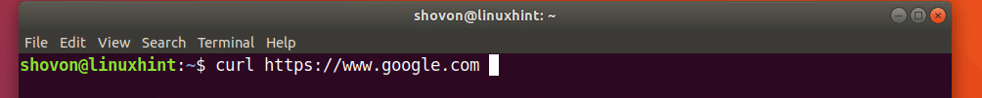

As you can see from the screenshot below, a lot of texts are displayed on the terminal. It means the URL https://www.google.com is valid.

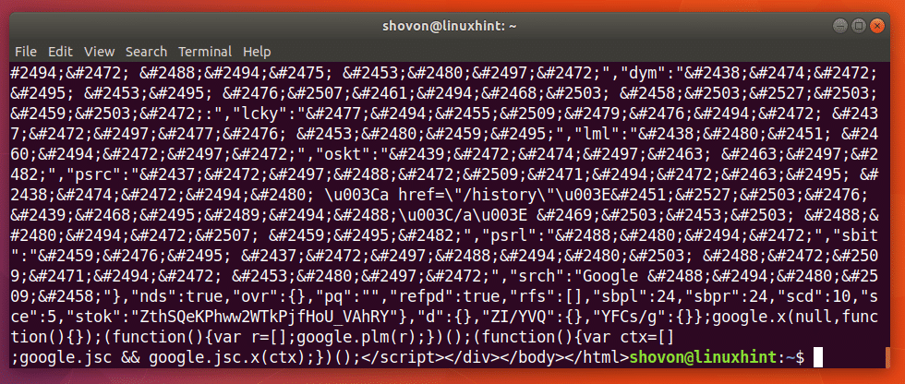

I ran the following command just to show you how a bad URL looks like.

$ curl http://notfound.notfound

As you can see from the screenshot below, it says Could not resolve host. It means the URL is not valid.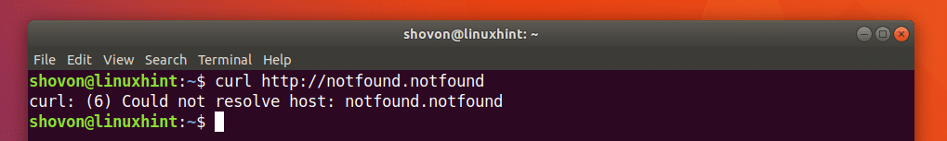

Downloading a Webpage with CURL

You can download a webpage from a URL using CURL.

The format of the command is:

$ curl -o FILENAME URL

Here, FILENAME is the name or path of the file where you want to save the downloaded webpage. URL is the location or address of the webpage.

Let’s say you want to download the official webpage of CURL and save it as curl-official.html file. Run the following command to do that:

$ curl -o curl-official.html https://curl.haxx.se/docs/httpscripting.html

AWK command in Unix/Linux with examples
Awk is a scripting language used for manipulating data and generating reports.The awk command programming language requires no compiling, and allows the user to use variables, numeric functions, string functions, and logical operators.
WHAT CAN WE DO WITH AWK ?
1. AWK Operations:
- (a) Scans a file line by line
- (b) Splits each input line into fields
- (c) Compares input line/fields to pattern
- (d) Performs action(s) on matched lines
2. Useful For:
- (a) Transform data files
- (b) Produce formatted reports
3. Programming Constructs:
- (a) Format output lines
- (b) Arithmetic and string operations
- (c) Conditionals and loops

1. Default behavior of Awk : By default Awk prints every line of data from the specified file.
$ awk '{print}' employee.txt
Output:
ajay manager account 45000
sunil clerk account 25000
varun manager sales 50000
amit manager account 47000
tarun peon sales 15000
deepak clerk sales 23000
sunil peon sales 13000
satvik director purchase 80000
In the above example, no pattern is given. So the actions are applicable to all the lines. Action print without any argument prints the whole line by default, so it prints all the lines of the file without failure.
2. Print the lines which matches with the given pattern.
$ awk '/manager/ {print}' employee.txt
Output:
ajay manager account 45000
varun manager sales 50000
amit manager account 47000
In the above example, the awk command prints all the line which matches with the ‘manager’.
3. Spliting a Line Into Fields : For each record i.e line, the awk command splits the record delimited by whitespace character by default and stores it in the $n variables. If the line has 4 words, it will be stored in $1, $2, $3 and $4 respectively. Also, $0 represents the whole line.
$ awk '{print $1,$4}' employee.txt
Output:
ajay 45000
sunil 25000
varun 50000
amit 47000
tarun 15000
deepak 23000
sunil 13000
satvik 80000
In the above example, $1 and $4 represents Name and Salary fields respectively.

SORT command in Linux/Unix with examples
SORT command is used to sort a file, arranging the records in a particular order. By default, the sort command sorts file assuming the contents are ASCII. Using options in sort command, it can also be used to sort numerically.
- SORT command sorts the contents of a text file, line by line.
- sort is a standard command line program that prints the lines of its input or concatenation of all files listed in its argument list in sorted order.
- The sort command is a command line utility for sorting lines of text files. It supports sorting alphabetically, in reverse order, by number, by month and can also remove duplicates.
- The sort command can also sort by items not at the beginning of the line, ignore case sensitivity and return whether a file is sorted or not. Sorting is done based on one or more sort keys extracted from each line of input.
- By default, the entire input is taken as sort key. Blank space is the default field separator.
The sort command follows these features as stated below:
- Lines starting with a number will appear before lines starting with a letter.
- Lines starting with a letter that appears earlier in the alphabet will appear before lines starting with a letter that appears later in the alphabet.
- Lines starting with a lowercase letter will appear before lines starting with the same letter in uppercase.
Examples
Suppose you create a data file with name file.txt
Command :
$ cat > file.txt
abhishek
chitransh
satish
rajan
naveen
divyam
harsh
Sorting a file : Now use the sort command
Syntax :

$ sort filename.txt
Command:
$ sort file.txt
Output :
abhishek
chitransh
divyam
harsh
naveen
rajan
satish
Note: This command does not actually change the input file, i.e. file.txt.
Sort function with mix file i.e. uppercase and lower case : When we have a mix file with both uppercase and lowercase letters then first the lower case letters would be sorted following with the upper case letters .
Example:
Create a file mix.txt
Command :
$ cat > mix.txt
abc
apple
BALL
Abc
bat
Now use the sort command
Command :
$ sort mix.txt
Output :
abc
Abc
apple
bat
BALL
Options with sort function
- -o Option : Unix also provides us with special facilities like if you want to write the output to a new file, output.txt, redirects the output like this or you can also use the built-in sort option -o, which allows you to specify an output file.
- Using the -o option is functionally the same as redirecting the output to a file.
- Note: Neither one has an advantage over the other.
- Example:The input file is the same as mentioned above.
- Syntax :
- $ sort inputfile.txt > filename.txt
$ sort -o filename.txt inputfile.txt
- Command:
$ sort file.txt > output.txt
$ sort -o output.txt file.txt
$ cat output.txt
Output :
abhishek
chitransh
divyam
harsh
naveen
rajan
satish
- -r Option: Sorting In Reverse Order : You can perform a reverse-order sort using the -r flag. the -r flag is an option of the sort command which sorts the input file in reverse order i.e. descending order by default.
- Example: The input file is the same as mentioned above.
- Syntax :
- $ sort -r inputfile.txt
- Command :
$ sort -r file.txt
Output :
satish
rajan
naveen
harsh
divyam
chitransh
abhishek
- -n Option : To sort a file numerically used –n option. -n option is also predefined in unix as the above options are. This option is used to sort the file with numeric data present inside.
- Example :
- Let us consider a file with numbers:
- Command :
$ cat > file1.txt
50
39
15
89
200
- Syntax :
- $ sort -n filename.txt
- Command :
$ sort -n file1.txt
Output :
15
39
50
89
200

Head command in Linux with examples
It is the complementary of Tail command. The head command, as the name implies, print the top N number of data of the given input. By default it prints the first 10 lines of the specified files. If more than one file name is provided then data from each file is precedes by its file name.
Syntax:
head [OPTION]... [FILE]...
Let us consider two files having name state.txt and capital.txtcontains all the names of the Indian states and capitals respectively.
$ cat state.txt
Andhra Pradesh
Arunachal Pradesh
Assam
Bihar
Chhattisgarh
Goa
Gujarat
Haryana
Himachal Pradesh
Jammu and Kashmir
Jharkhand
Karnataka
Kerala
Madhya Pradesh
Maharashtra
Manipur
Meghalaya
Mizoram
Nagaland
Odisha
Punjab
Rajasthan
Sikkim
Tamil Nadu
Telangana
Tripura
Uttar Pradesh
Uttarakhand
West Bengal
Without any option it display only the first 10 lines of the file specified.
Example:
$ head state.txt
Andhra Pradesh
Arunachal Pradesh
Assam
Bihar
Chhattisgarh
Goa
Gujarat
Haryana
Himachal Pradesh
Jammu and Kashmir
Options

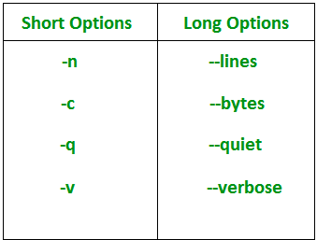

uniq Command in LINUX with examples
The uniq command in Linux is a command line utility that reports or filters out the repeated lines in a file.
In simple words, uniq is the tool that helps to detect the adjacent duplicate lines and also deletes the duplicate lines. uniq filters out the adjacent matching lines from the input file(that is required as an argument) and writes the filtered data to the output file .
Syntax of uniq Command :
//...syntax of uniq...//
$uniq [OPTION] [INPUT[OUTPUT]]
The syntax of this is quite easy to understand. Here, INPUT refers to the input file in which repeated lines need to be filtered out and if INPUT isn’t specified then uniq reads from the standard input. OUTPUT refers to the output file in which you can store the filtered output generated by uniq command and as in case of INPUT if OUTPUT isn’t specified then uniq writes to the standard output.
Now, let’s understand the use of this with the help of an example. Suppose you have a text file named kt.txt which contains repeated lines that needs to be omitted. This can simply be done with uniq.
//displaying contents of kt.txt//
$cat kt.txt
I love music.
I love music.
I love music.
I love music of Kartik.
I love music of Kartik.
Thanks.
Now, as we can see that the above file contains multiple duplicate lines. Now, lets’s use uniq command to remove them:

//...using uniq command.../
$uniq kt.txt
I love music.
I love music of Kartik.
Thanks.
/* with the use of uniq all
the repeated lines are removed*/
As you can see that we just used the name of input file in the above uniq example and as we didn’t use any output file to store the produced output, the uniq command displayed the filtered output on the standard output with all the duplicate lines removed.
Note: uniq isn’t able to detect the duplicate lines unless they are adjacent. The content in the file must be therefore sorted before using uniq or you can simply use sort -u instead f uniq.
Options For uniq Command:
- -c – -count : It tells how many times a line was repeated by displaying a number as a prefix with the line.
- -d – -repeated : It only prints the repeated lines and not the lines which aren’t repeated.
- -D – -all-repeated[=METHOD] : It prints all duplicate lines and METHOD can be any of the following:
  - none : Do not delimit duplicate lines at all. This is the default.
  - prepend : Insert a blank line before each set of duplicated lines.
  - separate : Insert a blank line between each set of duplicated lines.
- -f N – -skip-fields(N) : It allows you to skip N fields(a field is a group of characters, delimited by whitespace) of a line before determining uniqueness of a line.
- -i – -ignore case : By default, comparisons done are case sensitive but with this option case insensitive comparisons can be made.
- -s N – -skip-chars(N) : It doesn’t compares the first N characters of each line while determining uniqueness. This is like the -f option, but it skips individual characters rather than fields.
- -u – -unique : It allows you to print only unique lines.
- -z – -zero-terminated : It will make a line end with 0 byte(NULL), instead of a newline.
- -w N – -check-chars(N) : It only compares N characters in a line.
- – – help : It displays a help message and exit.
- – – version : It displays version information and exit.
Examples of uniq with Options
1. Using -c option : It tells the number of times a line was repeated.
//using uniq with -c//
$uniq -c kt.txt
3 I love music.
1
2 I love music of Kartik.
1
1 Thanks.
/*at the starting of each
line its repeated number is
displayed*/
2. Using -d option : It only prints the repeated lines.
//using uniq with -d//
$uniq -d kt.txt
I love music.
I love music of Kartik.
/*it only displayed one
duplicate line per group*/
3. Using -D option : It also prints only duplicate lines but not one per group.
//using -D option//
$uniq -D kt.txt
I love music.
I love music.
I love music.
I love music of Kartik.
I love music of Kartik.
/* all the duplicate lines
are displayed*/
4. Using -u option : It prints only the unique lines.
//using -u option//
$uniq -u kt.txt
Thanks.
/*only unique lines are
displayed*/

