Name:K.Rajavardhan reddy
Hall ticket:2403A51108
Lab-20.3
Task 1 – Input Validation Check
Task:
Analyze an AI-generated Python login script for input validation
vulnerabilities.
Instructions:
• Prompt AI to generate a simple username-password login
program.
• Review whether input sanitization and validation are
implemented.
• Suggest secure improvements (e.g., using re for input validation).
Expected Output:
• A secure version of the login script with proper input validation.
Prompt:
generate a simple username-password login
program.
• Review whether input sanitization and validation are
implemented.
• Suggest secure improvements (e.g., using re for input validation).
Code:
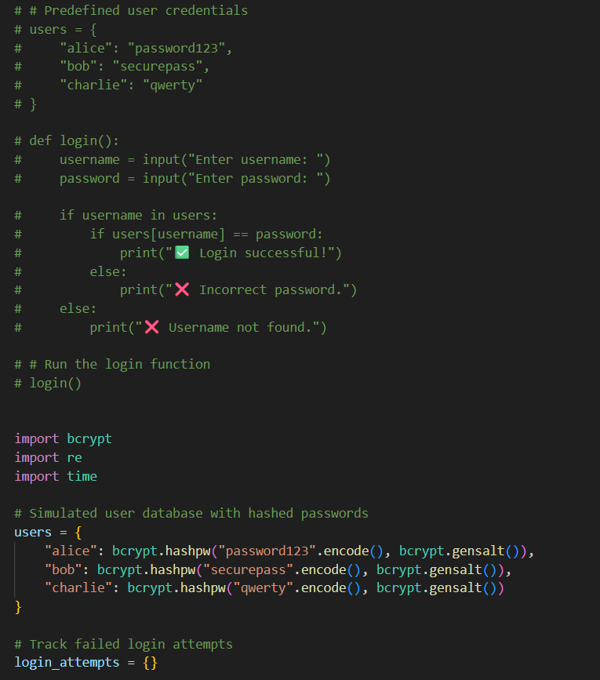
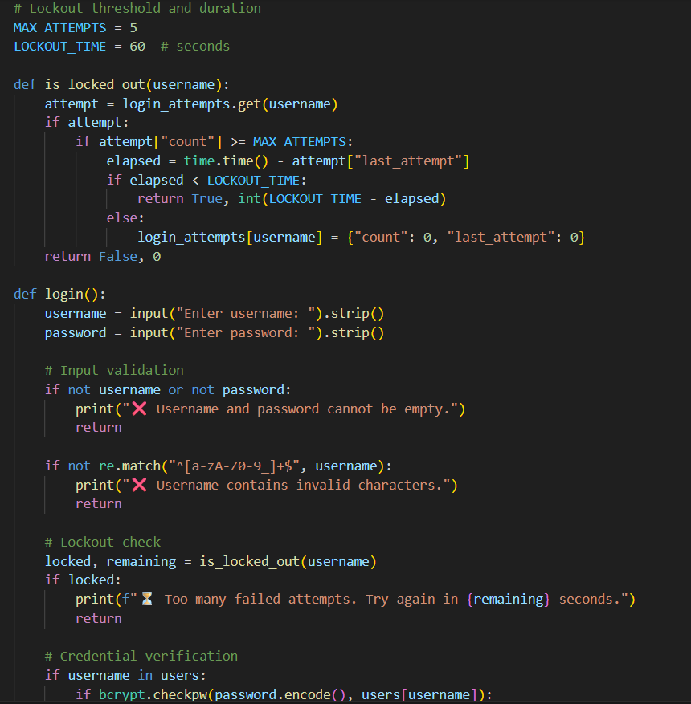
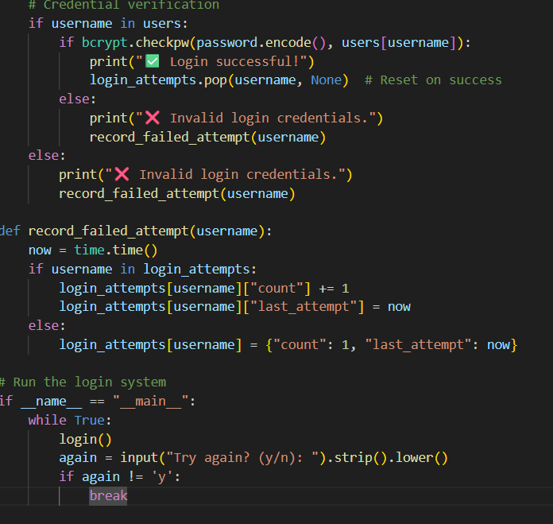
Output:
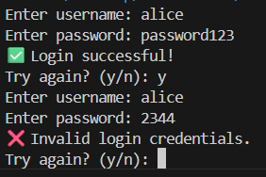
Observation:
It securely checks usernames and passwords, and blocks users after too many failed attempts.
That’s the core idea. It uses for password safety, tracks login failures, and temporarily locks out users who try too many times. Clean, effective, and secure.
Let me know if you want to add features like email alerts, CAPTCHA, or a GUI next.

Task 2 – SQL Injection Prevention
Task:
Test an AI-generated script that performs SQL queries on a database.
Instructions:
• Ask AI to generate a Python script using SQLite/MySQL to fetch
user details.
• Identify if the code is vulnerable to SQL injection (e.g., using
string concatenation in queries).
• Refactor using parameterized queries (prepared statements).
Expected Output:
• A secure database query script resistant to SQL injection
Prompt:
generate a Python script using SQLite/MySQL to fetch
user details.
• Identify if the code is vulnerable to SQL injection (e.g., using
string concatenation in queries).
• Refactor using parameterized queries (prepared statements).
Expected Output:
• A secure database query script resistant to SQL injection

code:
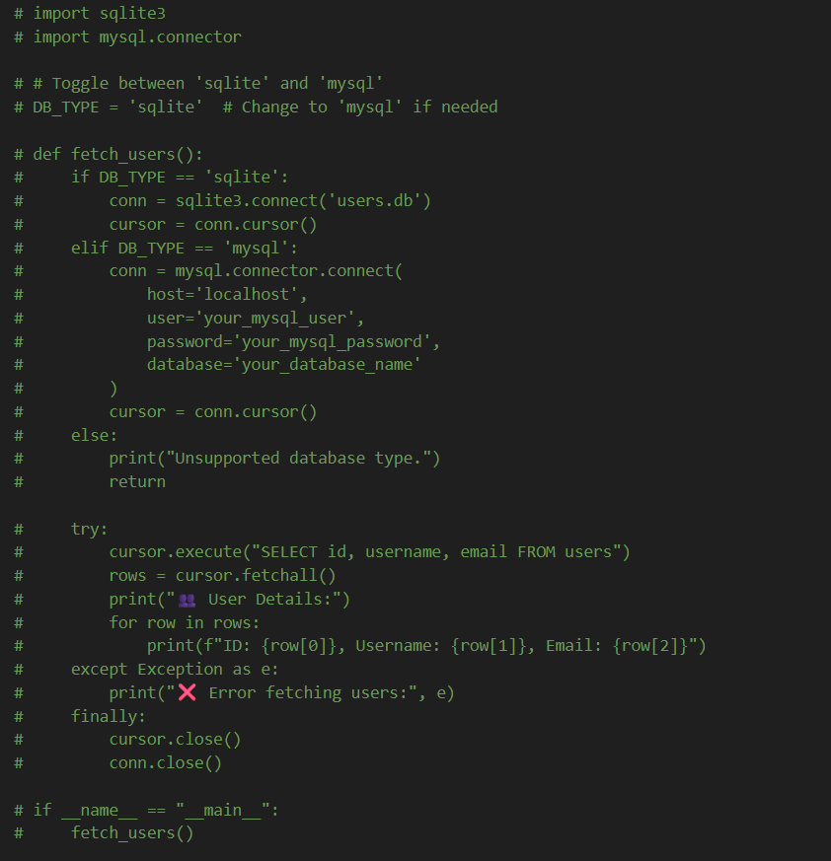
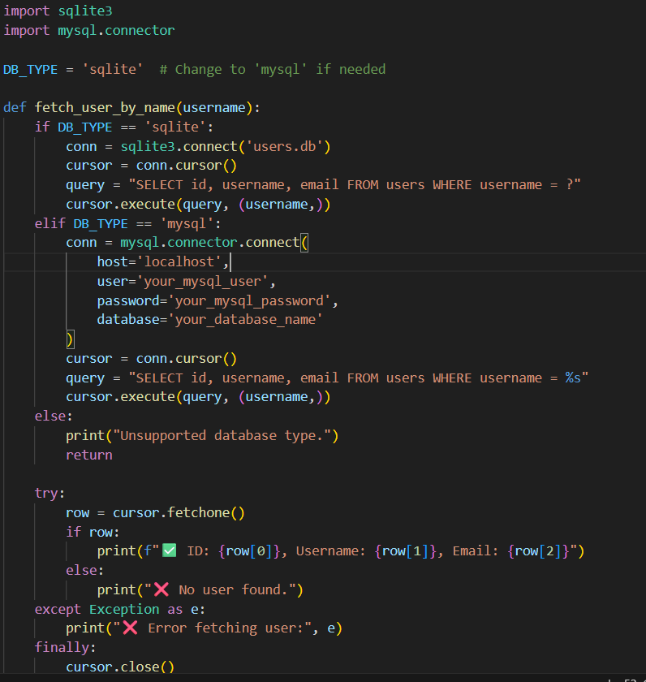
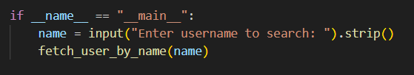
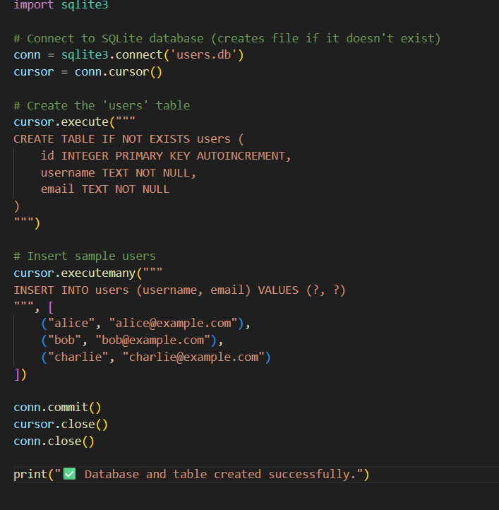
Output:
Observation:
If the script builds SQL queries using string concatenation with user input, it's vulnerable to SQL injection. Using parameterized queries (like cursor.execute("SELECT ... WHERE id = ?", (user_id,))) prevents this and makes the script secure.

Task 3 – Cross-Site Scripting (XSS) Check
Task:
Evaluate an AI-generated HTML form with JavaScript for XSS
vulnerabilities.
Instructions:
• Ask AI to generate a feedback form with JavaScript-based output.
• Test whether untrusted inputs are directly rendered without
escaping.
• Implement secure measures (e.g., escaping HTML entities, using
CSP).
Expected Output:
• A secure form that prevents XSS attacks.
Prompt:
generate a feedback form with JavaScript-based output.
• Test whether untrusted inputs are directly rendered without
escaping.
• Implement secure measures (e.g., escaping HTML entities, using
CSP).
Code:
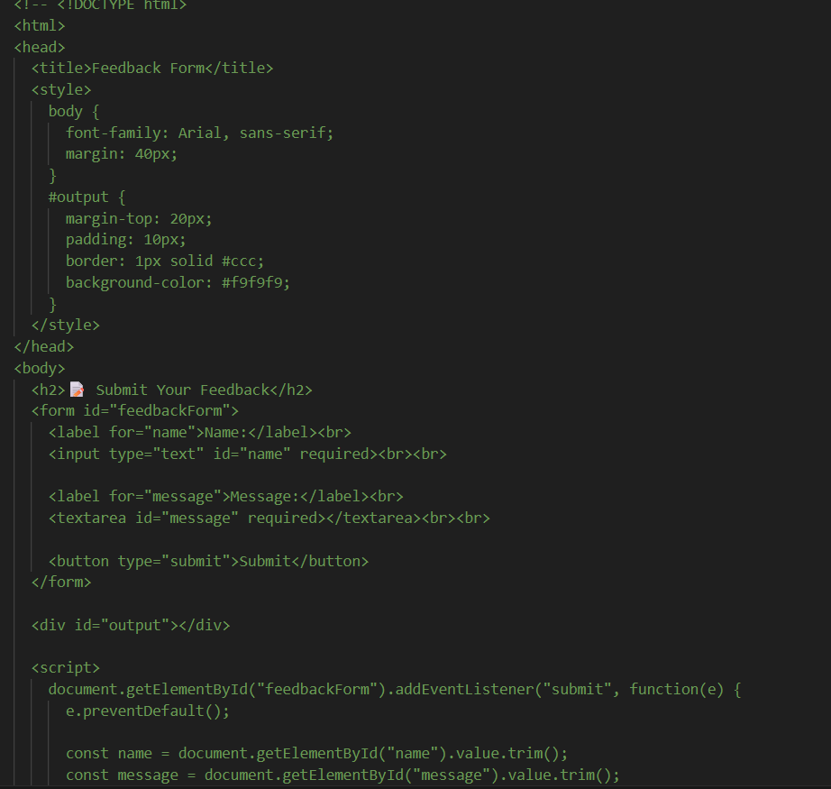
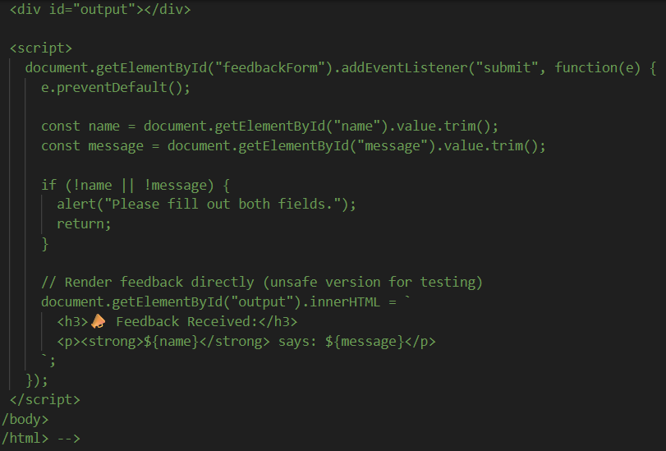
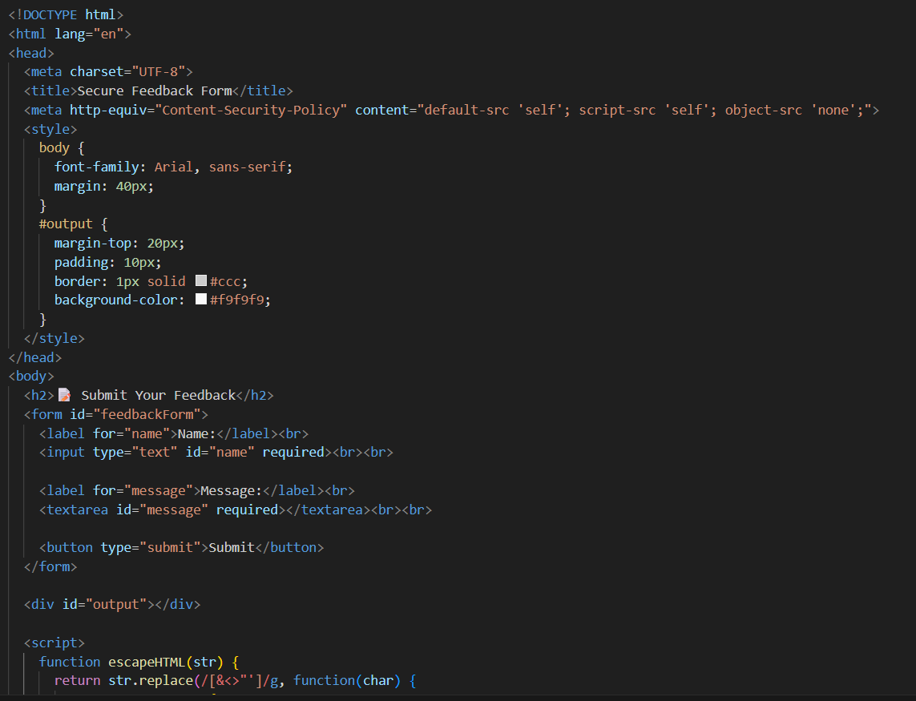

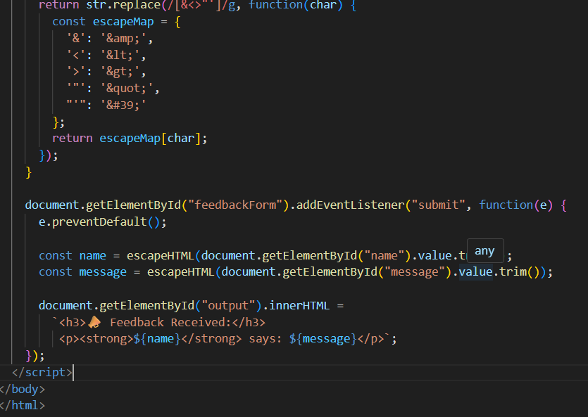
Output:
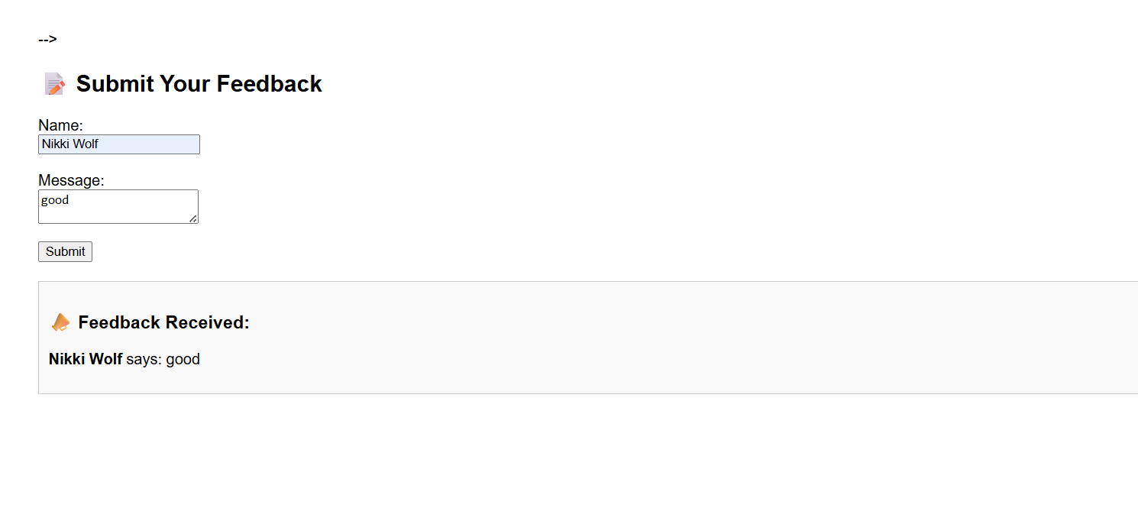
Observation:
If the form displays user input directly into the page using innerHTML without escaping, it's vulnerable to XSS. To prevent this, inputs should be sanitized (e.g., escape <, >, "), and security headers like Content Security Policy (CSP) should be used.

Task 4 – Real-Time Application: Security Audit of AI-Generated
Code
Scenario:
Students pick an AI-generated project snippet (e.g., login form, API
integration, or file upload).
Instructions:
• Perform a security audit to detect possible vulnerabilities.
• Prompt AI to suggest secure coding practices to fix issues.
• Compare insecure vs secure versions side by side.
Expected Output:
• A security-audited code snippet with documented vulnerabilities
and fixes
Prompt:
Students pick an AI-generated project snippet (e.g., login form, API
integration, or file upload).
Instructions:
• Perform a security audit to detect possible vulnerabilities.
• Prompt AI to suggest secure coding practices to fix issues.
• Compare insecure vs secure versions side by side
Code:app.py
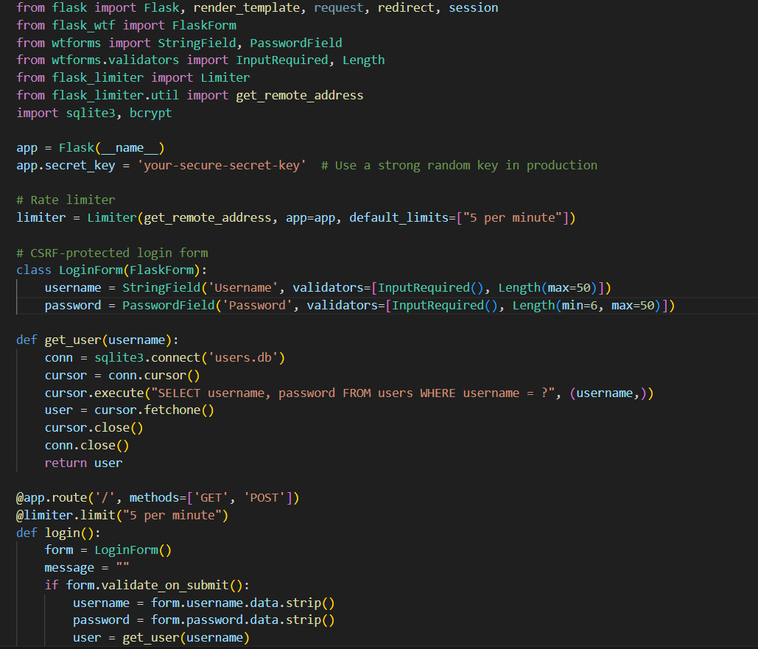
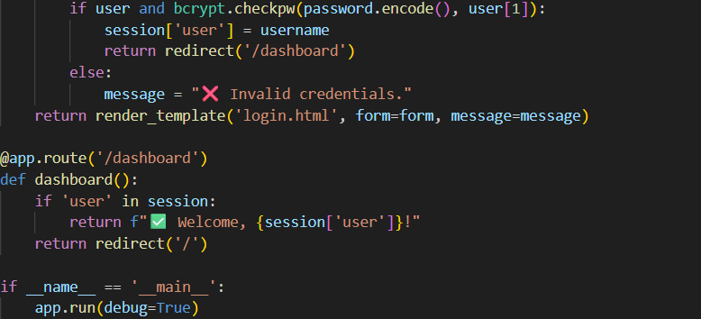

Init_db.py
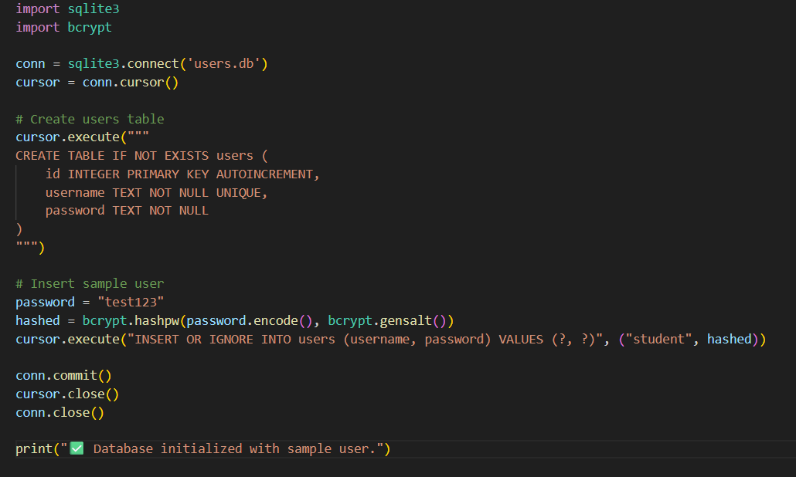
Login.html
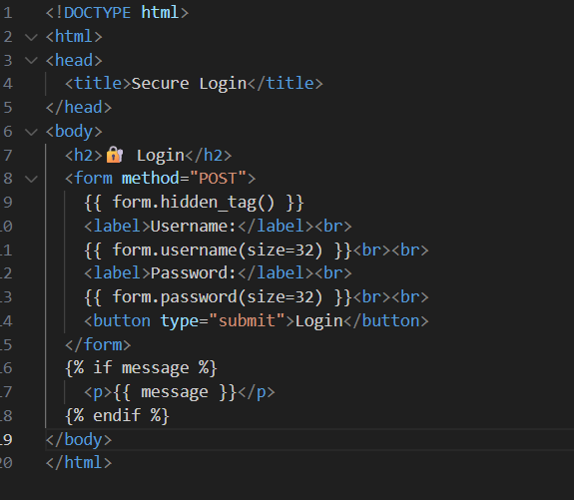
Output:
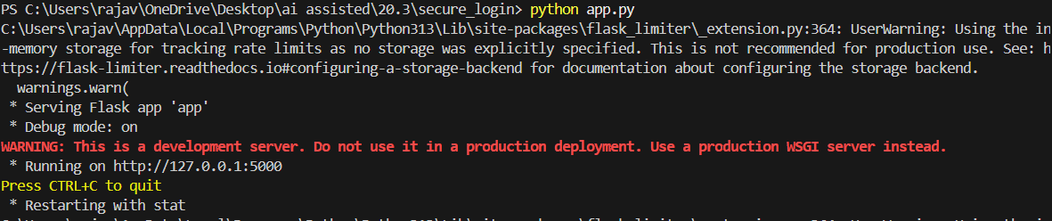
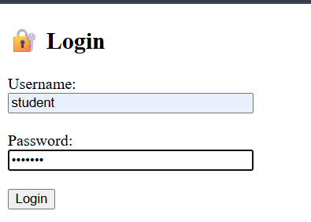
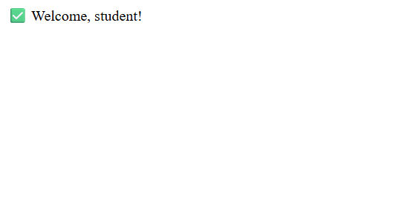
Observation:

If the AI-generated snippet handles user input (like login credentials or file uploads) without validation, sanitization, or secure storage (e.g., plain-text passwords, unrestricted file types), it's vulnerable. Secure coding practices—like input validation, output encoding, and using secure libraries—should be applied. Comparing insecure and secure versions highlights these improvements clearly.

