Name: K.Rajavardhan Reddy
Batch:06
Hall Tno.:2403A51108

Task 1: Use AI to generate a Stack class with push, pop, peek, and is_empty methods.Sample Input Code:
class Stack:
pass

Prompt: Generate a Stack class with push, pop, peek, and is_empty methods.
Codes:
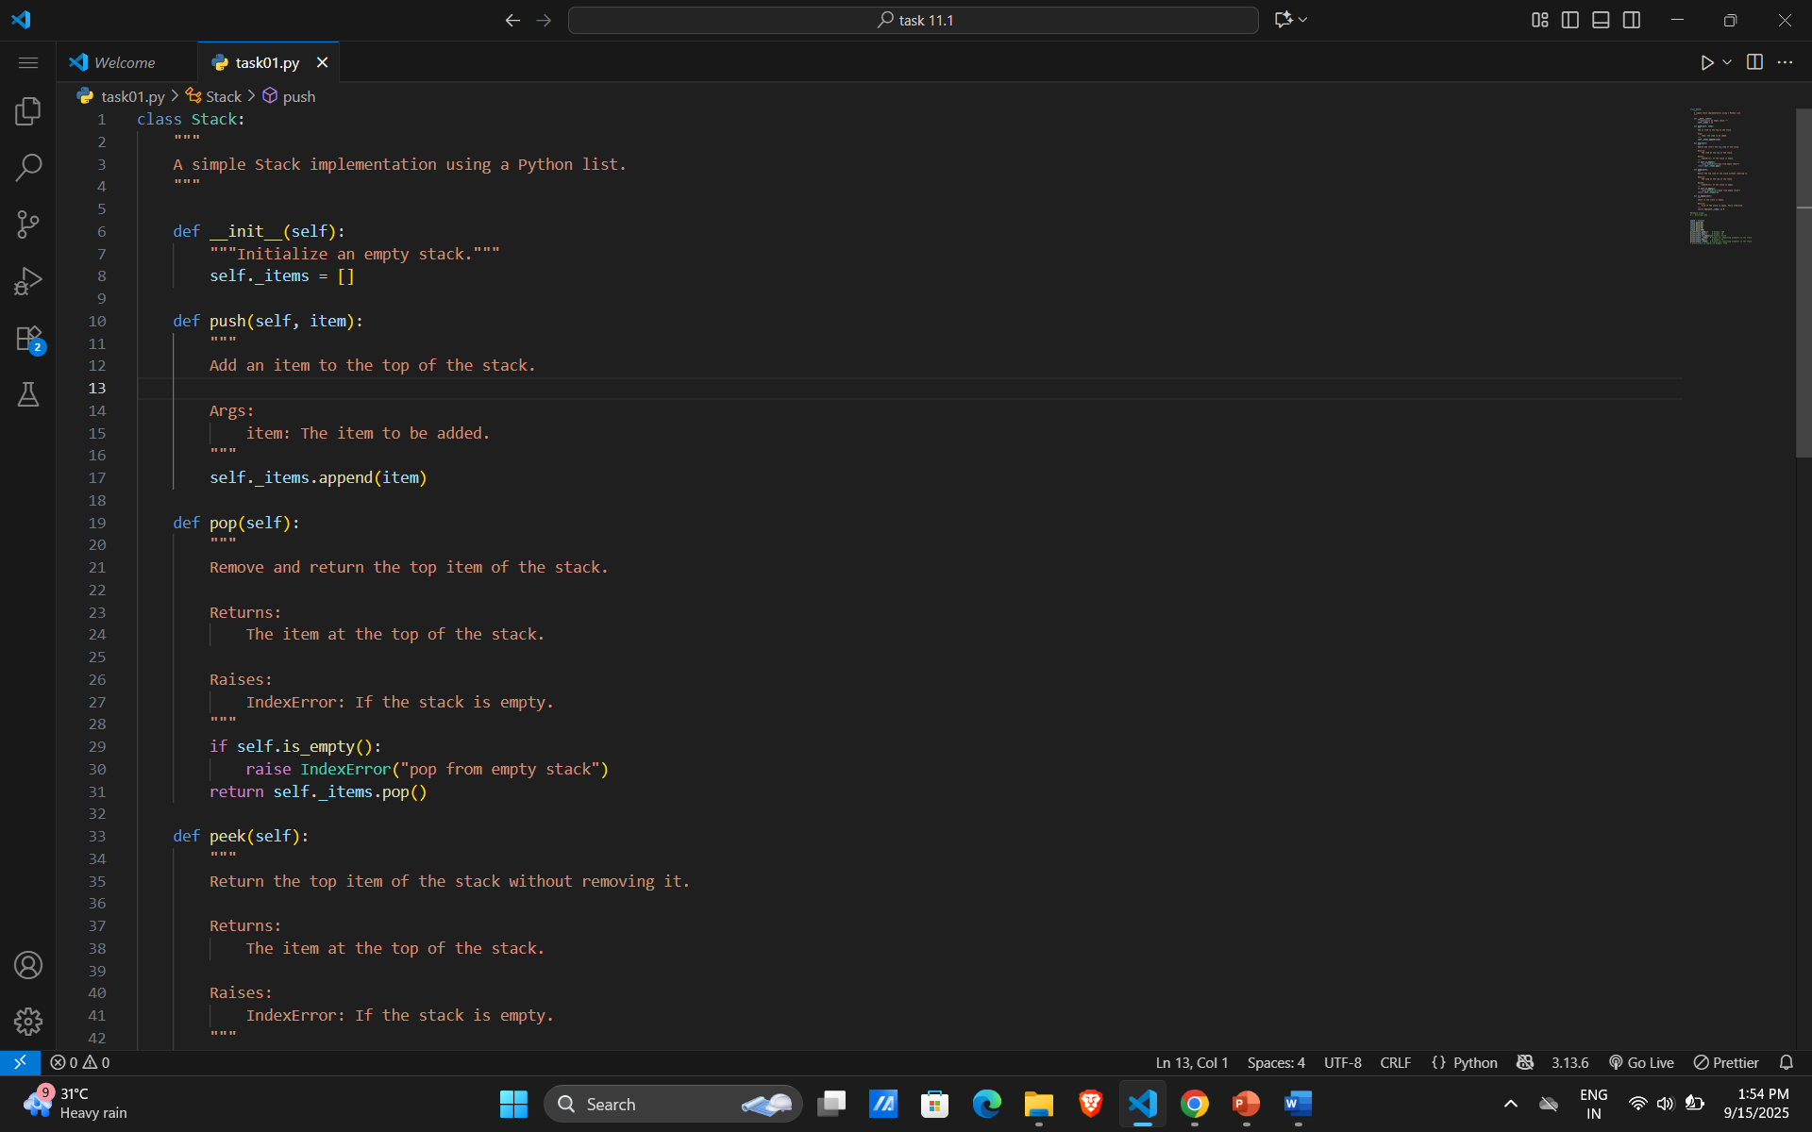
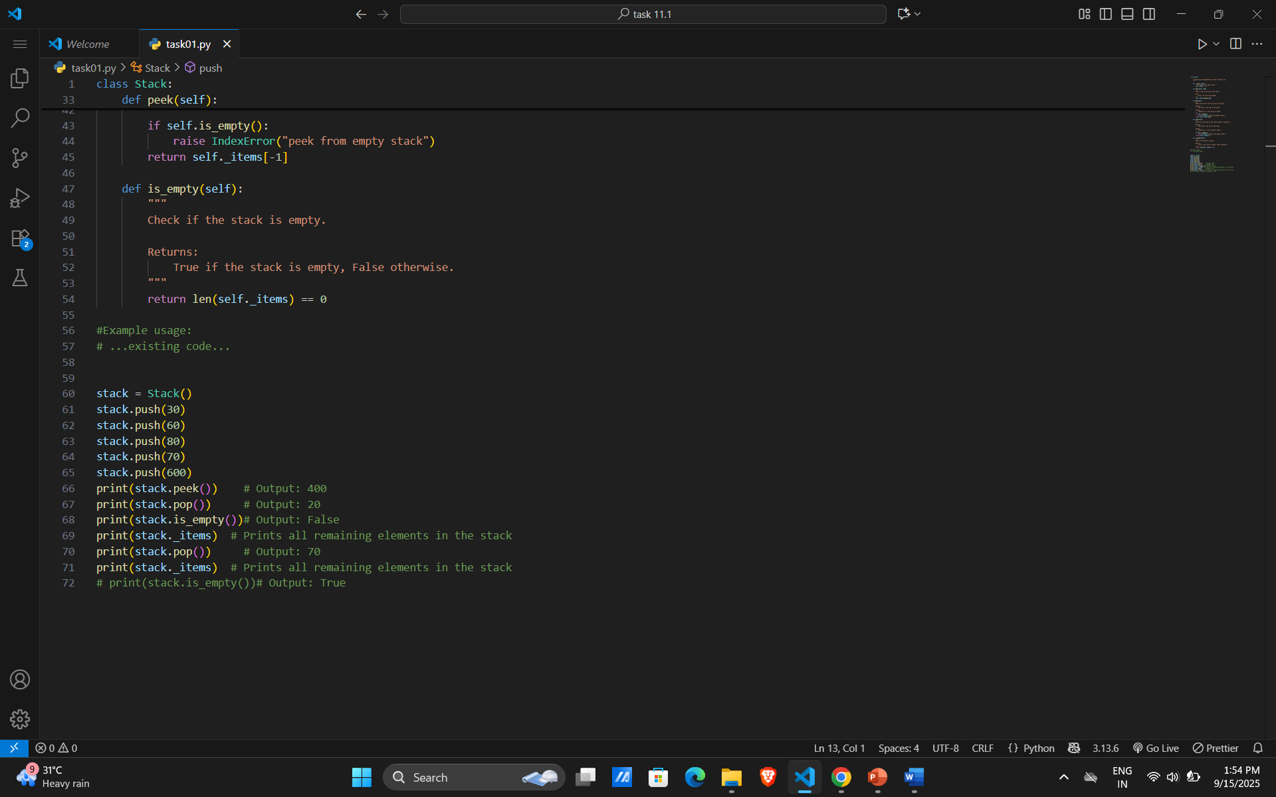

Output:
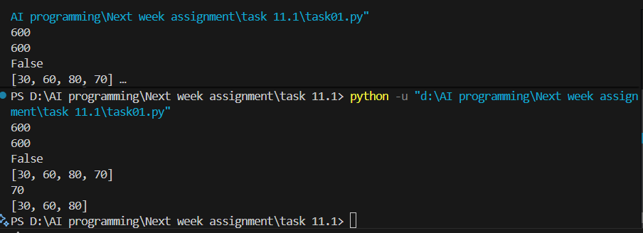Observation:
- Stack Implementation:
  - The Stack class uses a Python list (self._items) to store elements.
  - It provides standard stack operations: push, pop, peek, and is_empty, each with clear docstrings.
- Example Usage:
  - You create a stack and push several integers onto it: 30, 60, 80, 70, and 600.
  - print(stack.peek()) prints the top element (should be 600, not 400 as the comment says).
  - print(stack.pop()) removes and prints the top element (600).
  - print(stack.is_empty()) checks if the stack is empty (should be False).
  - print(stack._items) prints the remaining elements in the stack ([30, 60, 80, 70]).
  - Another pop removes 70, and printing _items again shows [30, 60, 80].
- Direct Attribute Access:
  - You access stack._items directly to print the stack contents. This works, but it's better practice to add a method (e.g., get_items()) for this purpose.
- Comment Mismatch:
  - The comments for print(stack.peek()) and print(stack.pop()) do not match the actual values (should be 600, not 400 or 20).
- Error Handling:
  - The pop and peek methods correctly raise an IndexError if the stack is empty.

Task 2: Queue Implementation ,Task: Use AI to implement a Queue using Python lists.
Sample Input Code:
class Queue:
pass

Prompt: Create a Python class called Queue. implement a Queue using Python lists.

Codes: 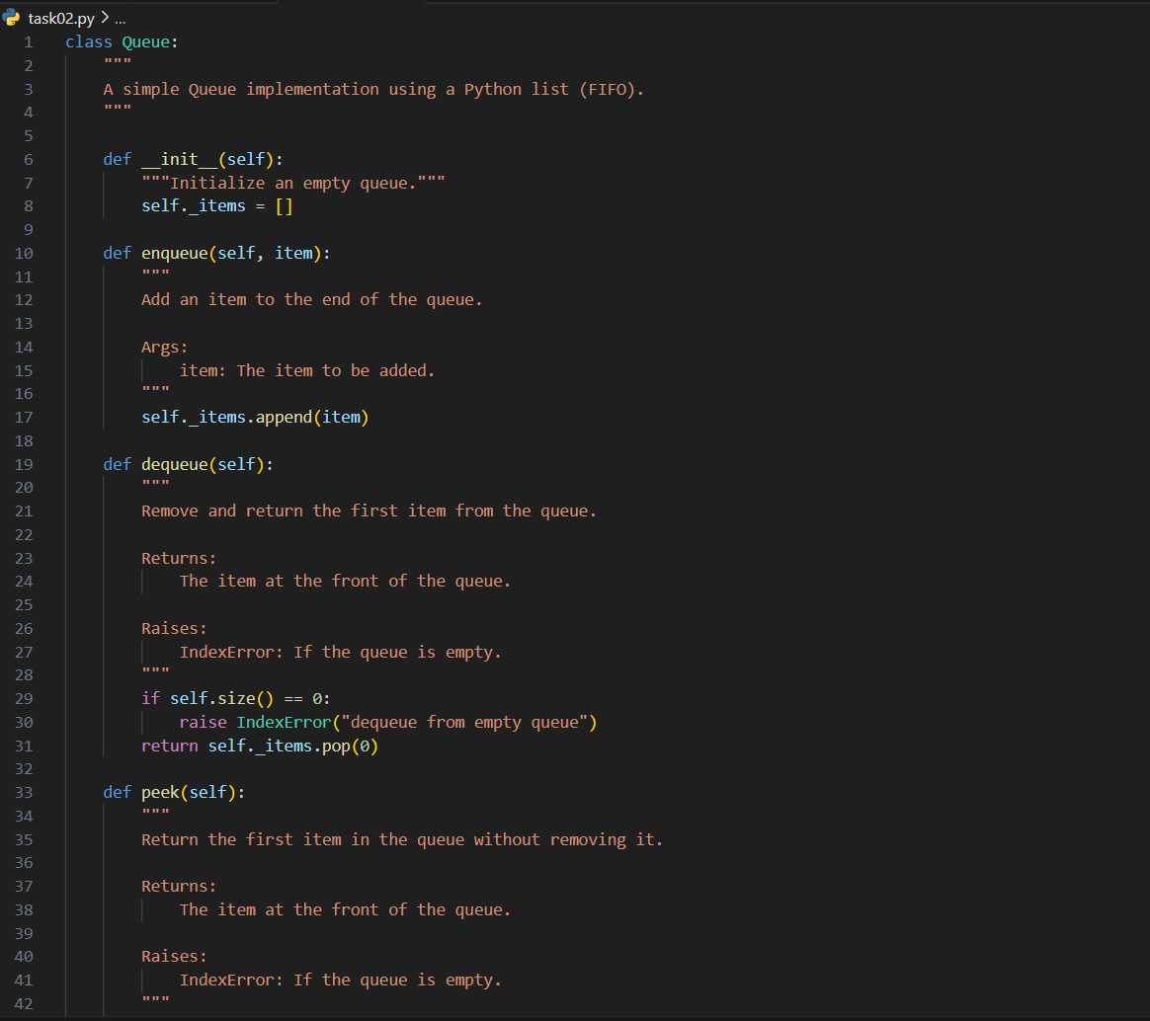
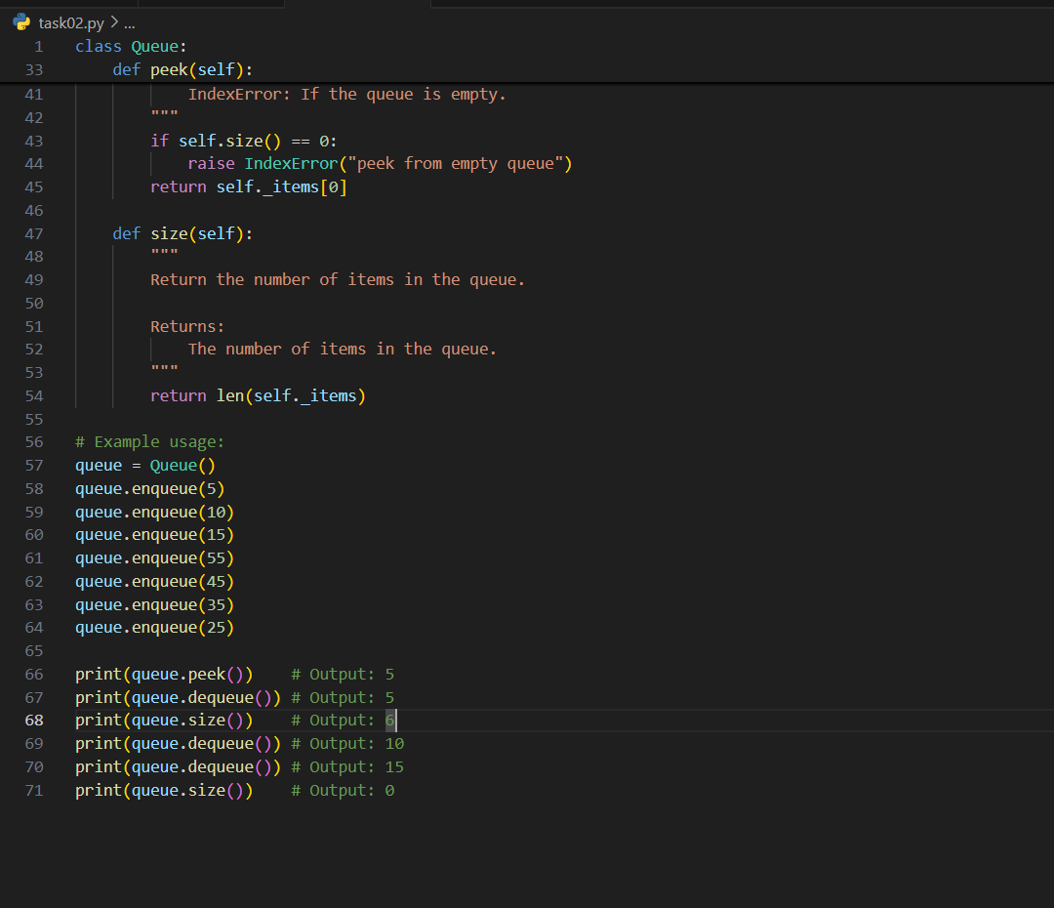

Observation:
Implements a FIFO queue using a Python list.
enqueue() adds items to the end; dequeue() removes from the front.
peek() returns the first item without removing it.
Raises IndexError if trying to dequeue() or peek() when empty.
size() returns the number of items in the queue.

Task 3: – Linked List
Task: Use AI to generate a Singly Linked List with insert and display methods.
Sample Input Code:
class Node:
pass
class LinkedList:
pass
Prompt: Generate a Singly Linked List with insert and display methods.

Codes:
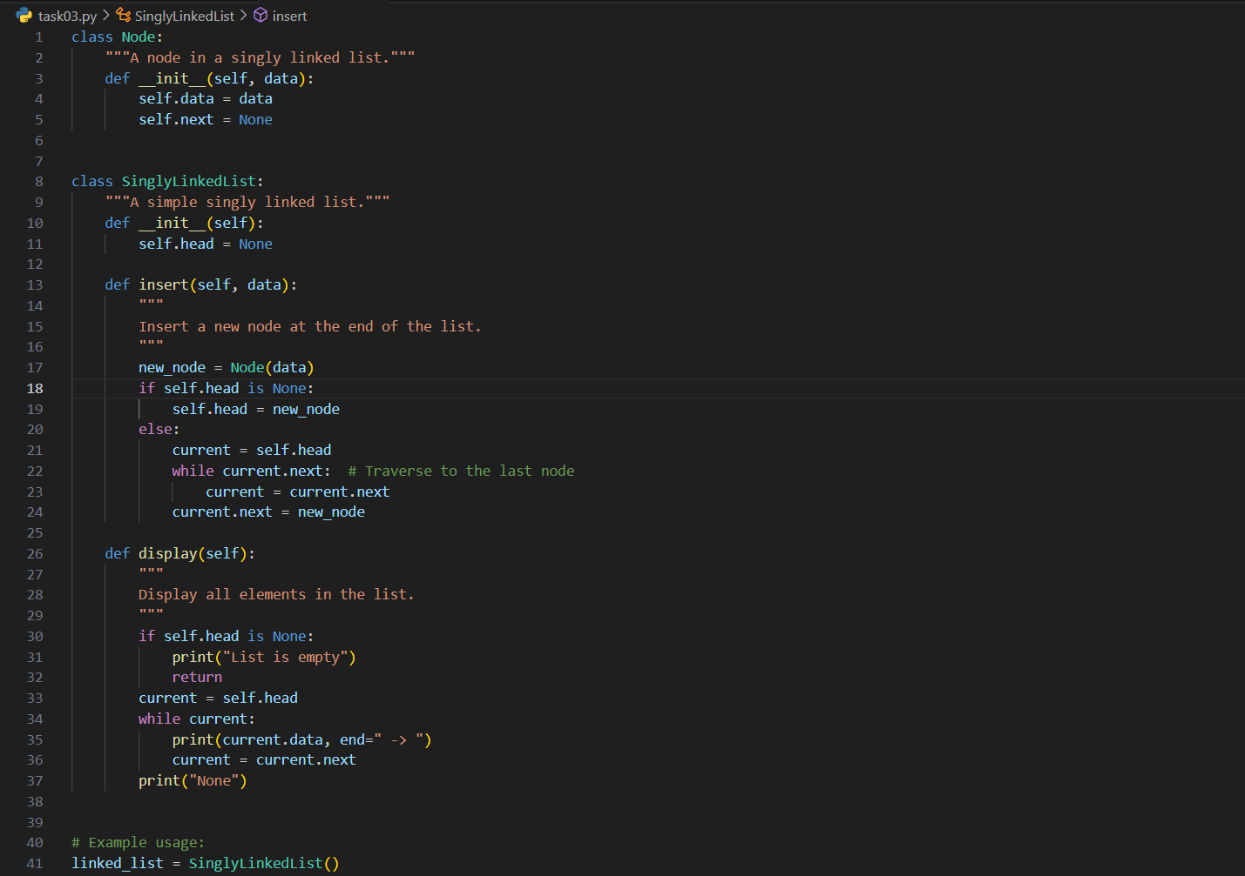
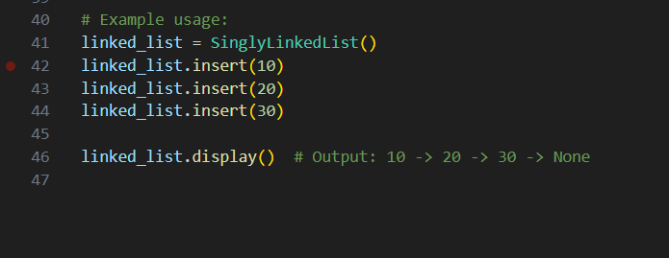
Output: 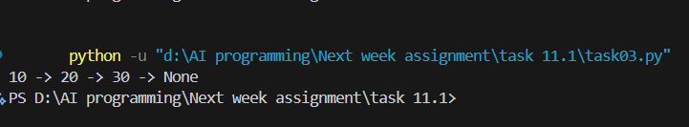
Observation :
• Structure:
- Uses a Node class to store data and a next pointer.
- SinglyLinkedList manages the head node and provides methods to insert and display elements.
• Insert Logic:
- insert_at_end() correctly adds new nodes at the tail of the list.
- Traverses from head to the last node before linking the new node.
• Display Logic:
- display() starts from head and prints each node’s data until it reaches None.
- Nicely shows the chain of nodes with " -> " formatting.
• Behavior:
- Handles empty list insertion properly (sets head to the new node).
- Works for multiple insertions in sequence.
• Limitations:
- No method to remove nodes.
- No size tracking — must traverse to count elements.

Task 4: – Binary Search Tree (BST)
Task: Use AI to create a BST with insert and in-order traversal methods.
Sample Input Code:
class BST:
pass
Prompt:
create a BST with insert and in-order traversal methods

Code:
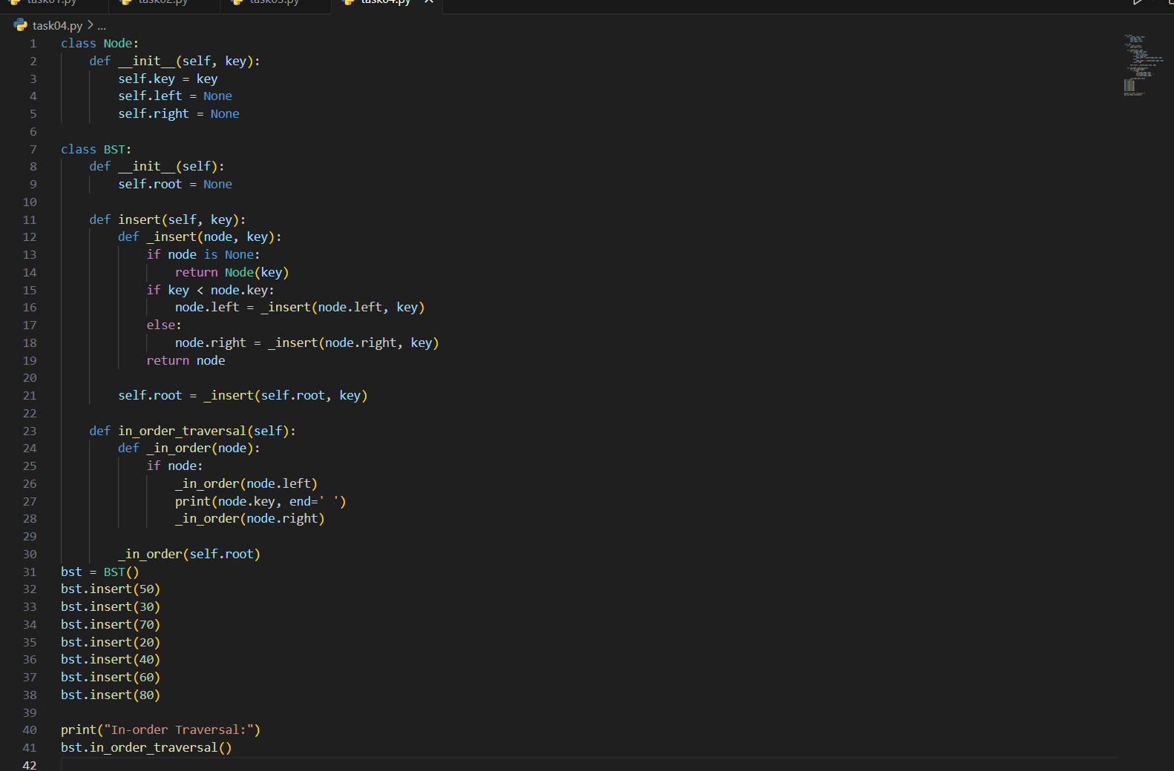
Output:
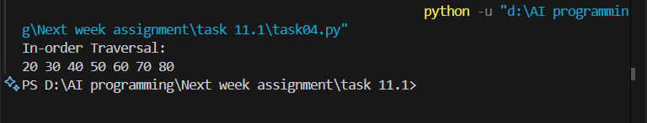

- Observation:
- The code uses two well-defined classes: Node for individual elements and BST for managing the tree. This separation makes the logic modular and easy to maintain.
- Recursion is used effectively in both insert and in_order_traversal, which suits tree-based operations well.
🌿 Insert Method
- Maintains the binary search property: values less than the current node go left, greater or equal go right.
- Handles the empty tree case by initializing the root node properly.
- No explicit handling of duplicate values—duplicates are inserted to the right by default.
🍃 In-Order Traversal
- Traverses the tree in left-root-right order, producing a sorted sequence of keys.
- Uses direct printing (print()), which is fine for simple output but limits flexibility for reuse (e.g., returning a list).
⚙️ Potential Enhancements
- Return Values: Modify in_order_traversal to return a list for better integration with other code.
- Duplicate Control: Add logic to prevent or manage duplicates if needed.
- Iterative Alternatives: For large trees, consider iterative versions to avoid stack overflow from deep recursion.

Task 5: – Hash Table
Task: Use AI to implement a hash table with basic insert, search, and delete methods.
Sample Input Code:
class HashTable:
Prompt:
Implement a hash table with basic insert, search, and delete methods

Code:
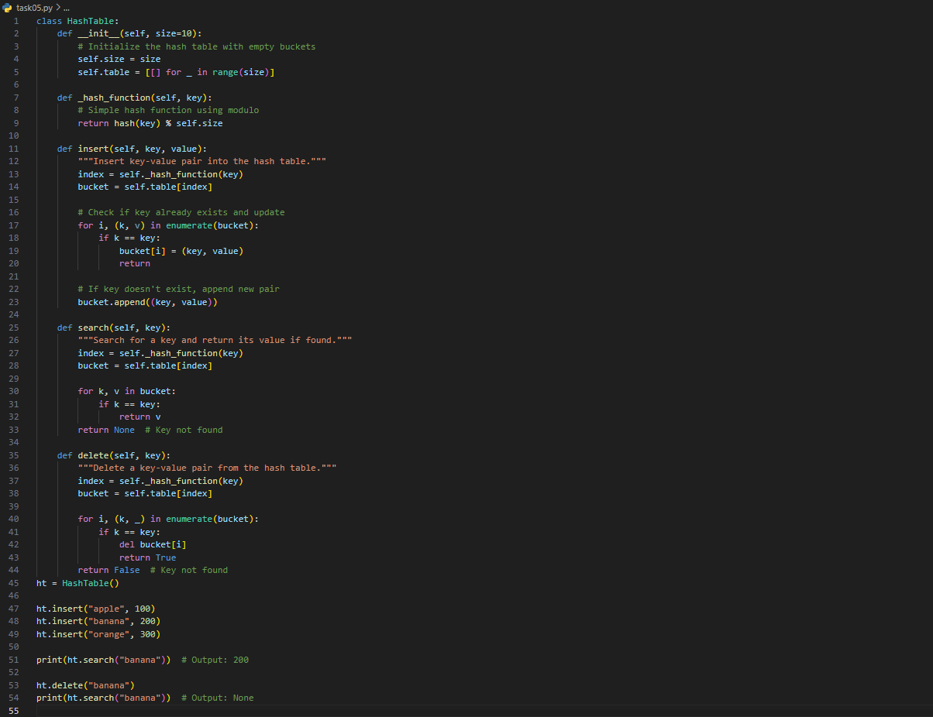
Output:
Observation:
• Structure: The class HashTable is well-organized, with a customizable size and a list of buckets initialized as empty lists.
• Hashing: Uses Python’s built-in hash() function combined with modulo to map keys to bucket indices—simple and effective.
• Collision Handling: Implements chaining, where each bucket is a list that can store multiple key-value pairs. This is a standard and reliable method for managing collisions.
• Insert Method: Checks for existing keys and updates their values if found, otherwise appends a new pair—efficient and avoids duplicates.
• Search Method: Traverses the appropriate bucket to find the key and return its value, or None if not found.
• Delete Method: Locates the key in the bucket and removes it, returning a boolean to indicate success or failure.

Task 06:- Graph Representation
Task: Use AI to implement a graph using an adjacency list.
Sample Input Code:
class Graph:
pass

Prompt: to implement a graph using an adjacency list.

Code: 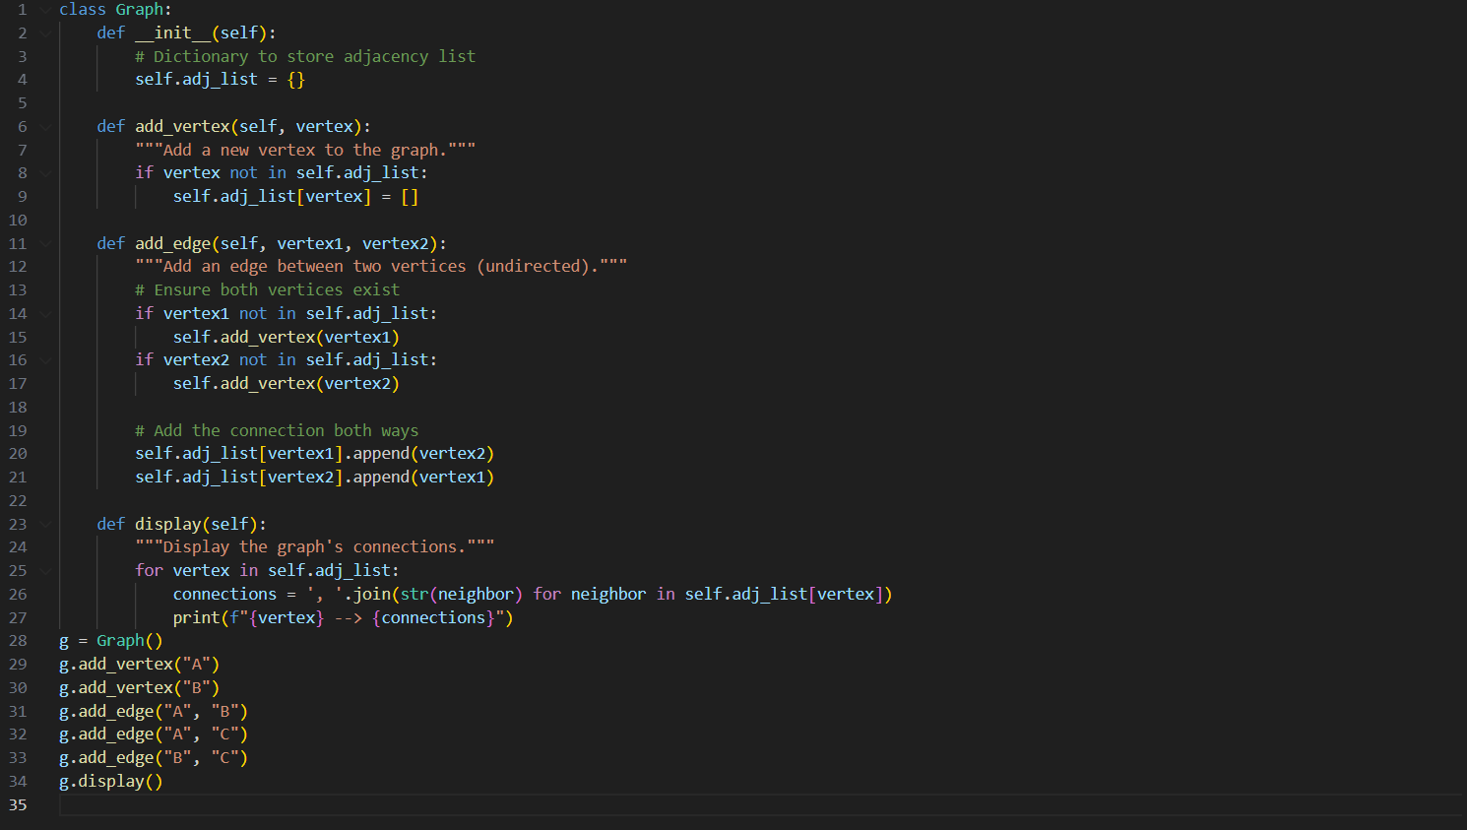
Output:
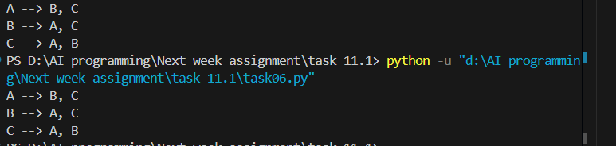
Observation:
- Adjacency List Structure: The graph is represented using a dictionary, which efficiently maps each vertex to its list of connected neighbors.
- Vertex Management: The add_vertex method ensures that new vertices are added only if they don’t already exist, preventing duplication.
- Edge Handling: The add_edge method adds undirected edges by updating both vertices’ adjacency lists. It also auto-creates missing vertices, which simplifies usage.
- Display Method: Clearly prints each vertex and its connections, making the graph easy to visualize and debug.
- Scalability: Suitable for sparse graphs and easily extendable to support directed edges, weights, or traversal algorithms.

Task07: Priority Queue
Task: Use AI to implement a priority queue using Python’s heapq module.
Sample Input Code:
class PriorityQueue:
pass

Prompt: implement a priority queue using Python’s heapq module. In python

Code:
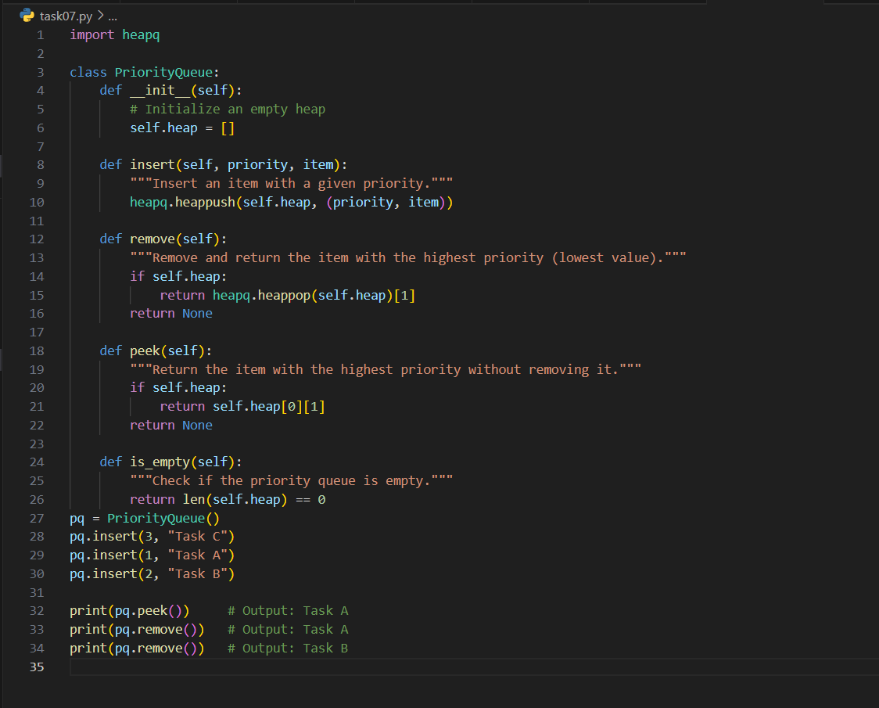
Output:
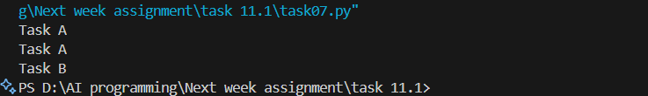
Observation:
- Efficient Structure: Uses Python’s built-in heapq to maintain a min-heap, ensuring fast insertions and removals (O(log n)).
- Tuple-Based Priority: Items are stored as (priority, value) pairs, allowing easy comparison based on priority.
- Insert Method: Adds items with associated priority using heappush, maintaining heap order.
- Remove Method: Retrieves and removes the item with the highest priority (lowest numerical value) using heappop.
- Peek Method: Allows inspection of the next item without removal—useful for scheduling or previewing tasks.
- Robustness: Includes is_empty() to check if the queue is empty, improving usability and
preventing errors.

Task 08:
– Deque
Task: Use AI to implement a double-ended queue using collections.deque.
Sample Input Code:
class DequeDS:
pass

Prompt:
To implement a double-ended queue using collections.deque.

Code:
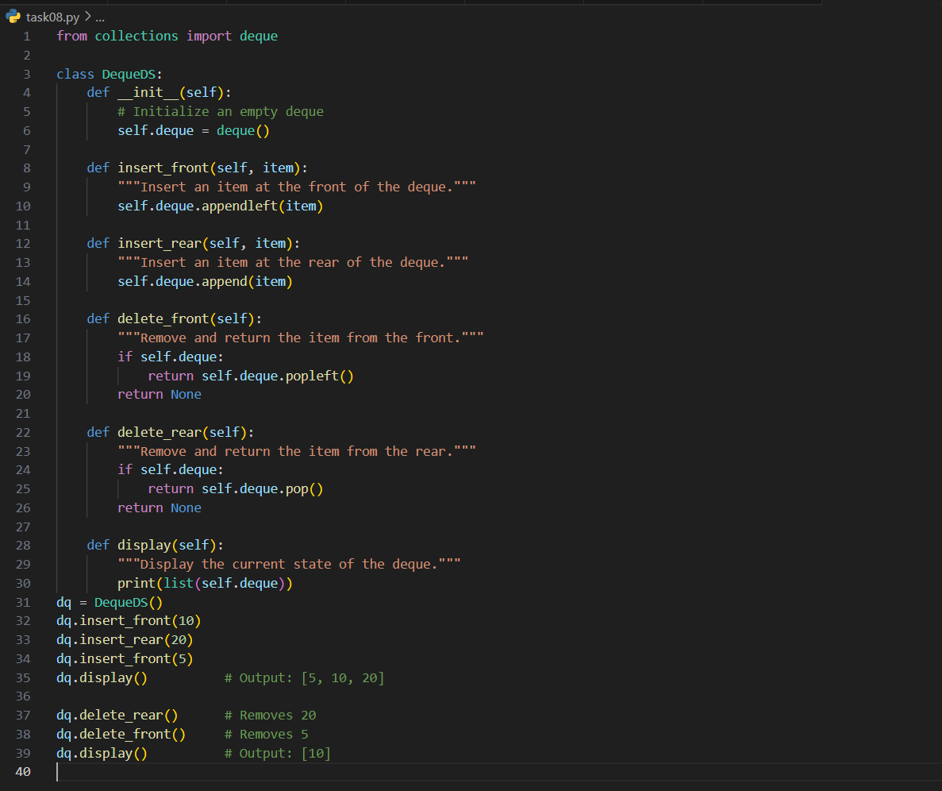

Output:
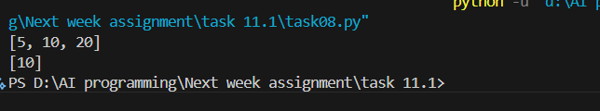

Task 09: AI-Generated Data Structure Comparisons
Task: Use AI to generate a comparison table of different data structures (stack,
queue, linked list, etc.) including time complexities.
Sample Input Code:
# No code, prompt AI for a data structure comparison table

Prompt: generate a comparison table of different data structures (stack,
queue, linked list

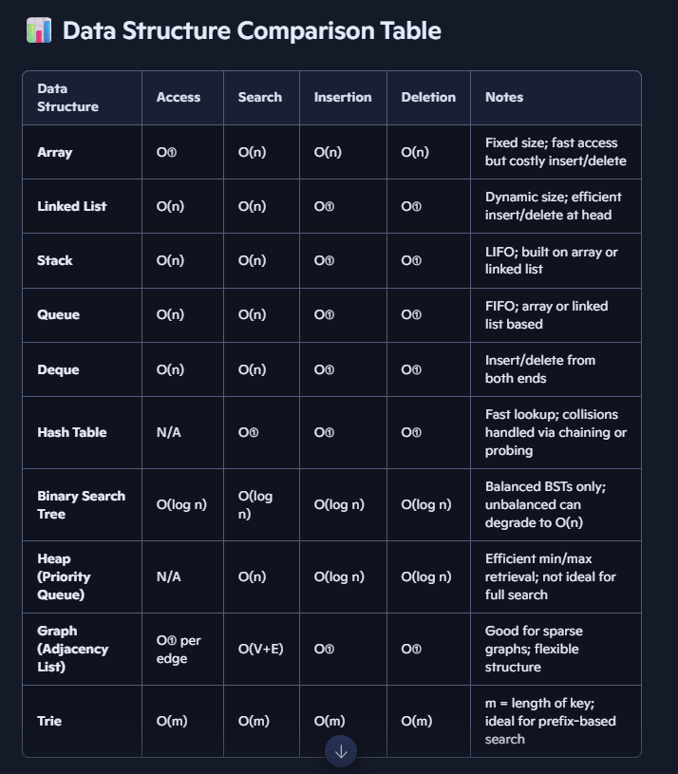

Task 10;
Real-Time Application Challenge – Choose the
Right Data Structure
Scenario:
Your college wants to develop a Campus Resource Management System that
handles:
1. Student Attendance Tracking – Daily log of students entering/exiting
the campus.
2. Event Registration System – Manage participants in events with quick
search and removal.
3. Library Book Borrowing – Keep track of available books and their due
dates.
4. Bus Scheduling System – Maintain bus routes and stop connections.
5. Cafeteria Order Queue – Serve students in the order they arrive.
Student Task:
• For each feature, select the most appropriate data structure from the list
below:
o Stack
o Queue
o Priority Queue
o Linked List
o Binary Search Tree (BST)
o Graph
o Hash Table
o Deque
• Justify your choice in 2–3 sentences per feature.
• Implement one selected feature as a working Python program with AI-
assisted code generation.

Prompt:
Implemented a Library Book Borrowing system using a priority queue in Python. The program tracks books by due date, supports borrowing, peeking, and returning operations, and includes assert-based test cases to verify correctness

Code:
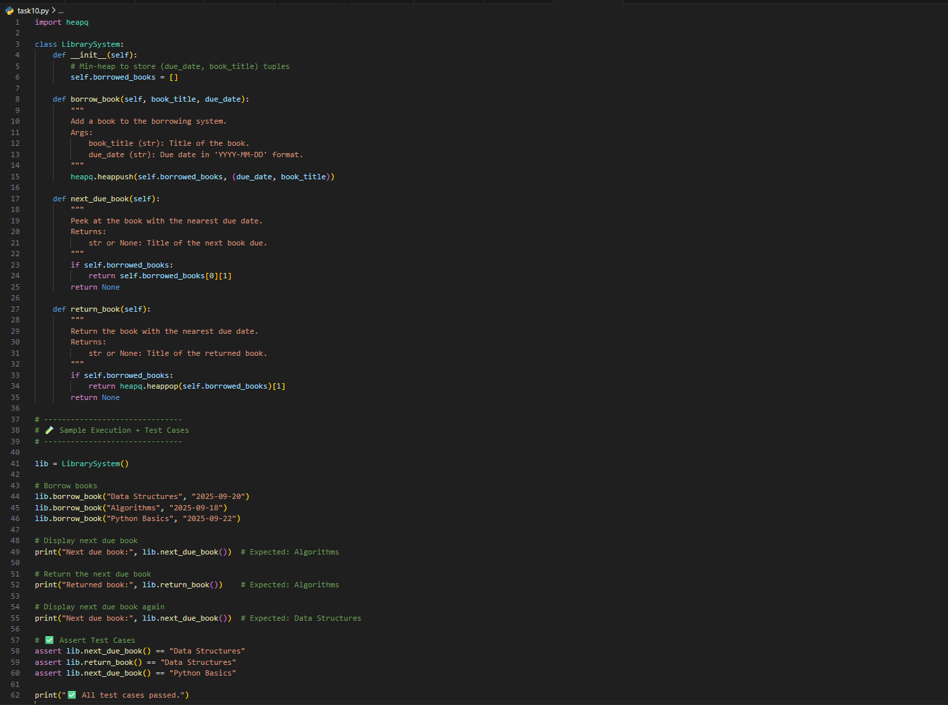
Output:
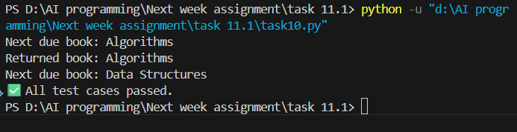
Observation:
• Efficient Structure: The system uses Python’s heapq to implement a min-heap, allowing books to be prioritized by due date. This ensures that the book with the earliest deadline is always accessible in constant time.
• Tuple-Based Entries: Each book is stored as a (due_date, title) tuple, leveraging lexicographic ordering of strings for date comparison. This keeps the implementation simple and avoids custom comparator logic.
• Method Design: The borrow_book, next_due_book, and return_book methods are clearly separated and intuitive. Each handles a distinct responsibility, making the code modular and easy to extend.
• Robustness: The system gracefully handles empty states by returning None when no books are available, preventing runtime errors.
• Test Coverage: Includes assert-based test cases that validate both peek and removal behavior, confirming correct priority handling and functional integrity.

