Name:K.Rajavrdhan Reddy
2403A51108
Lab:15.3
Task1:
Basic REST API Setup
Task: Ask AI to generate a Flask REST API with one route:
GET /hello → returns {"message": "Hello, AI Coding!"}
Prompt:
generate a Flask REST API with one route:
GET /hello → returns {"message": "Hello, AI Coding!"}
code:
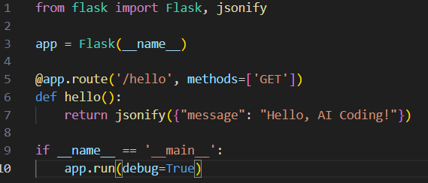
output:
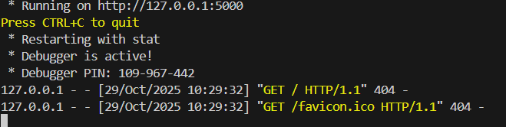
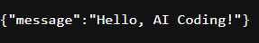
Observation:
This script creates a basic web API using Flask.
When a user sends a GET request to /hello, the server responds with a JSON message: "Hello, AI Coding!".
It’s a clean example of how to build a minimal REST endpoint.
The debug=True mode helps during development by auto-reloading and showing detailed error messages.
This setup is perfect for testing API responses or integrating with frontend apps.
Task2:
Task:
Use AI to build REST endpoints for a Student API:
• GET /students → List all students.
• POST /students → Add a new student.
• PUT /students/<id> → Update student details.
• DELETE /students/<id> → Delete a student.
Expected Output:
• Flask API with dictionary/list storage.
• JSON responses for each operation
Prompt:
build REST endpoints for a Student API:
• GET /students → List all students.
• POST /students → Add a new student.
• PUT /students/<id> → Update student details.
• DELETE /students/<id> → Delete a student
code:
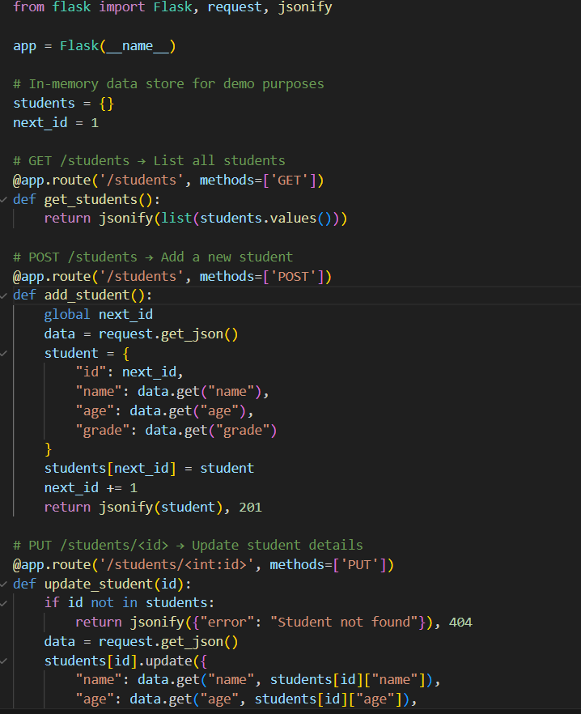
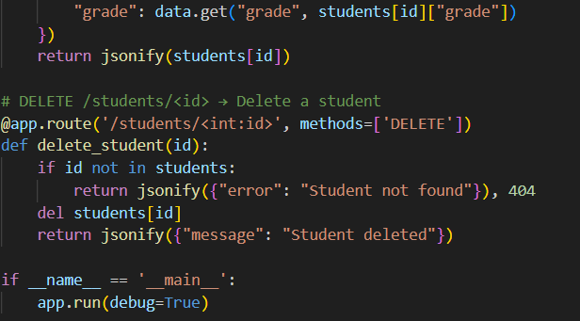
Output:
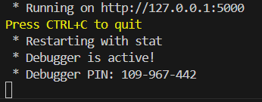
Observation:
Here’s a simple observation for your Flask-based student management API:
This Flask app provides a basic RESTful API to manage student records using an in-memory dictionary.
It supports all CRUD operations: listing, adding, updating, and deleting students.
Each student is assigned a unique ID automatically when added.
The API uses JSON for both input and output, making it easy to integrate with frontend or mobile apps.
It’s ideal for prototyping or learning how REST APIs work in Python.

Task3:
ask Description #3 – API with Query Parameters
Task: Ask AI to generate a REST API endpoint
Expected Output:
Working search function with query param handling
prompt:
generate a REST API endpoint
code:
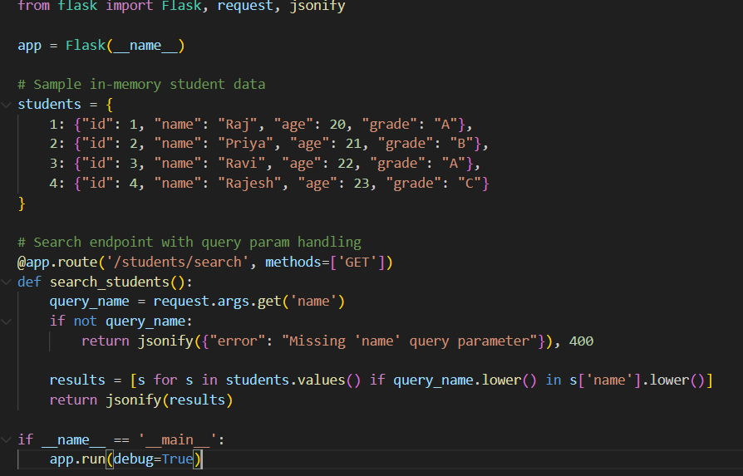
output:
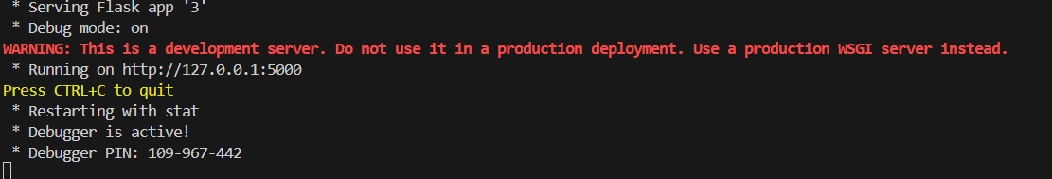
observation:
This Flask app allows users to search for students by name using a query parameter.
It filters the in-memory student dictionary and returns matches where the name contains the search term (case-insensitive).
If no name is provided, it returns a helpful error message.
This setup is ideal for lightweight search functionality in educational or demo applications.
It demonstrates clean use of query parameters and JSON responses in a RESTful API.
Task4:
Task: Ask AI to write test scripts using Python requests module to call
APIs created above.
Prompt:
write test scripts using Python requests module to call
APIs created above.
Code:
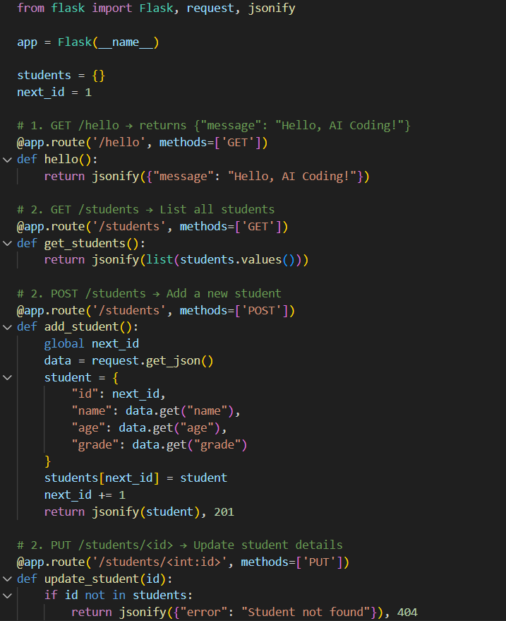
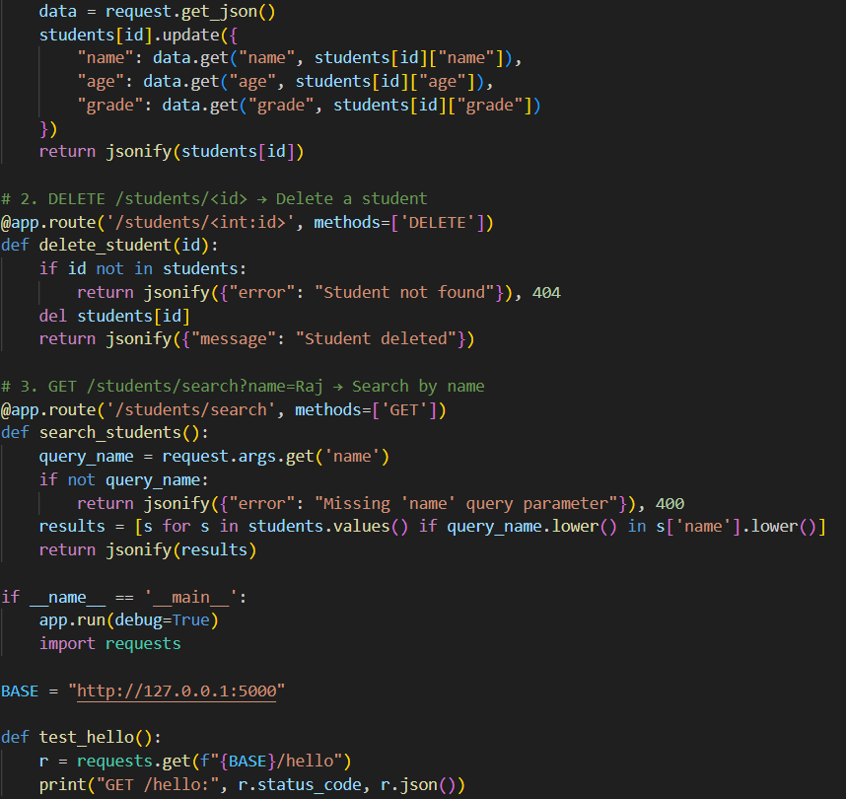
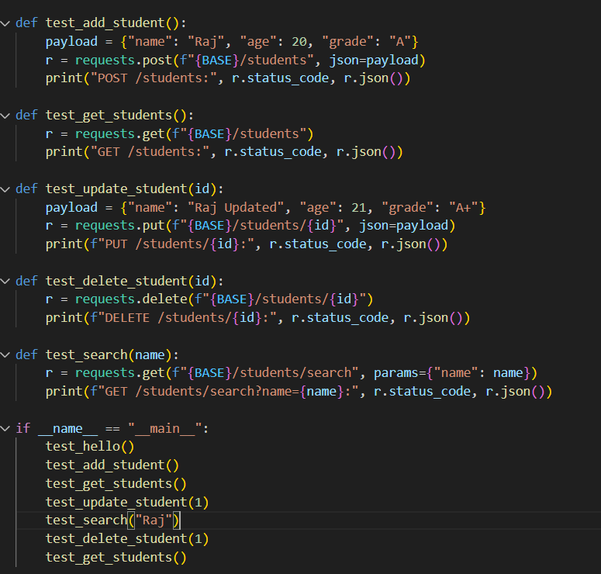
Output:
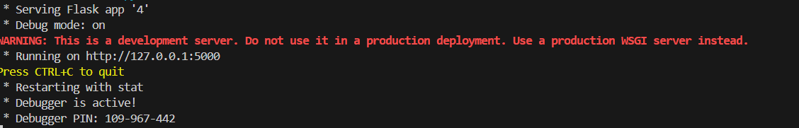
Observation:
This project builds a complete RESTful API for managing student records using Flask.
It supports adding, updating, deleting, listing, and searching students — all stored in memory.
The /hello route confirms the server is running, while /students handles full CRUD operations.
The test functions use the requests library to simulate real API calls and verify each endpoint.
This setup is ideal for learning how to build and test APIs in Python with clean, modular logic.

