Name:K.Rajavardhan Reddy
2403A51108
Lab-13.3
Task1:
Task: Provide AI with the following redundant code and ask it to
refactor
Python Code
def calculate_area(shape, x, y=0):
if shape == "rectangle":
return x * y
elif shape == "square":
return x * x
elif shape == "circle":
return 3.14 * x * x
Expected Output
• Refactored version with dictionary-based dispatch or separate
functions.
• Cleaner and modular design
Prompt:
code with Refactored version with dictionary-based dispatch or separate functions with Cleaner and modular design
Code:
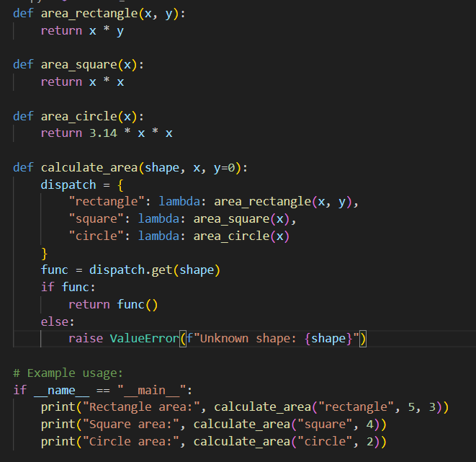
Output:
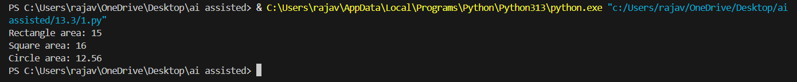
Observation:
This Python script uses a dispatch dictionary to dynamically select and compute the area of different geometric shapes—rectangle, square, or circle—based on the shape argument. It cleanly separates shape-specific logic into individual functions and avoids multiple if-else statements by using lambda functions for deferred execution. This makes the code modular, readable, and easy to extend.

Task2:
Task: Legacy function without proper error handling
Python Code
def read_file(filename):
f = open(filename, "r")
data = f.read()
f.close()
return data
Expected Output:
AI refactors with with open() and try-except:
prompt:
code with with open() and try-except:
code:
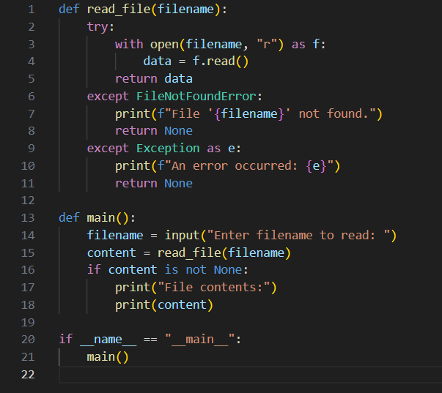
Output:

Observation:
This script demonstrates a basic yet robust file-reading utility in Python. It uses a try-except block to gracefully handle errors like missing files (FileNotFoundError) and other unexpected issues. The read_file function encapsulates the logic, while main() handles user input and displays the content. It's a clean example of exception handling, modular design, and user interaction via CLI.

Task3:
Task: Provide this legacy class to AI for readability and modularity
improvements:
Python Code
class Student:
def __init__(self, n, a, m1, m2, m3):
self.n = n
self.a = a
self.m1 = m1
self.m2 = m2
self.m3 = m3
def details(self):
print("Name:", self.n, "Age:", self.a)
def total(self):
return self.m1+self.m2+self.m3
Expected Output:
• AI improves naming (name, age, marks).
• Adds docstrings.
• Improves print readability.
• Possibly uses sum(self.marks) if marks stored in a list.
Prompt:
Code with improves naming (name, age, marks).
Adds docstrings. Improves print readability.Possibly uses sum(self.marks) if marks stored in a list.
Code:
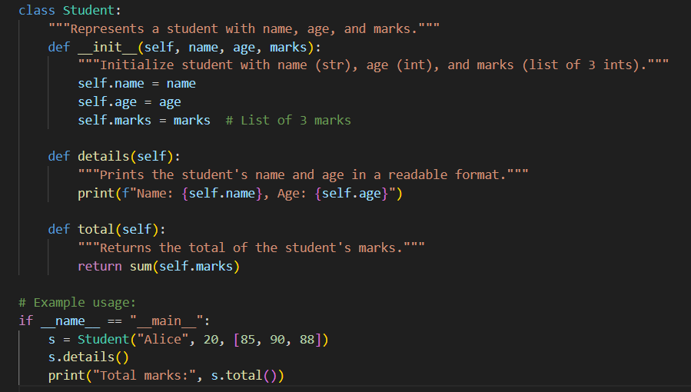
Output:
Observation:
This class-based Python script models a student using object-oriented programming. It encapsulates student attributes (name, age, and marks) and provides methods to display details and compute total marks. The design is clean and intuitive, demonstrating key OOP principles like encapsulation, initialization via __init__, and method definition for behavior. It's a great starting point for building more complex student management systems.

Task4:
Task: Refactor this inefficient loop with AI help
Python Code
nums = [1,2,3,4,5,6,7,8,9,10]
squares = []
for i in nums:
squares.append(i * i)
Expected Output: AI suggested a list comprehension
Prompt:
Code with efficicent looping and a list comprehension
Code:
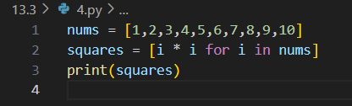
Output:
Observation:
This snippet uses a list comprehension to efficiently generate a list of squares for numbers 1 through 10. It's a concise and Pythonic way to transform a sequence, showcasing how readable and powerful list comprehensions are for simple data transformations

