**Step by Step procedure to Install Cisco Packet tracer on Windows PC –**

[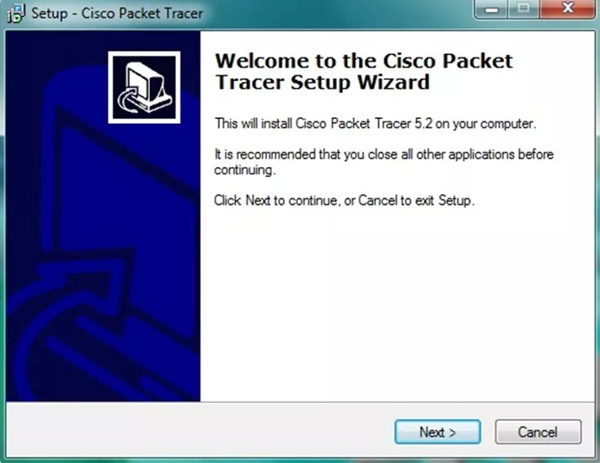](http://ipwithease.com/how-to-install-packet-tracer-on-windows-system/171how-to-install-packet-tracer-on-windows-system-01/)

[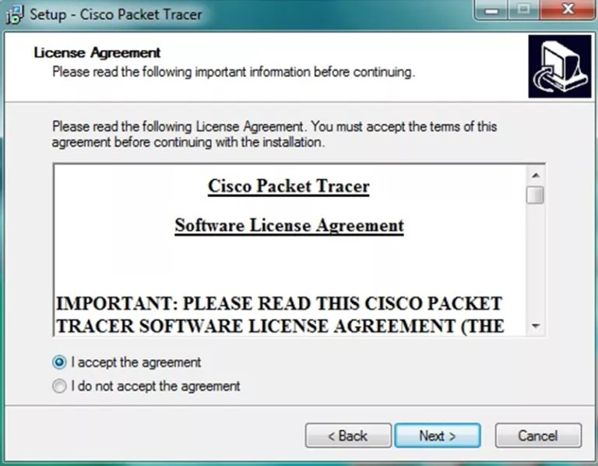](http://ipwithease.com/how-to-install-packet-tracer-on-windows-system/171how-to-install-packet-tracer-on-windows-system-02/)

Step 2 of install packet tracer, click on next again & again and the on install

Step 1 of install packet tracer after packet tracer download

[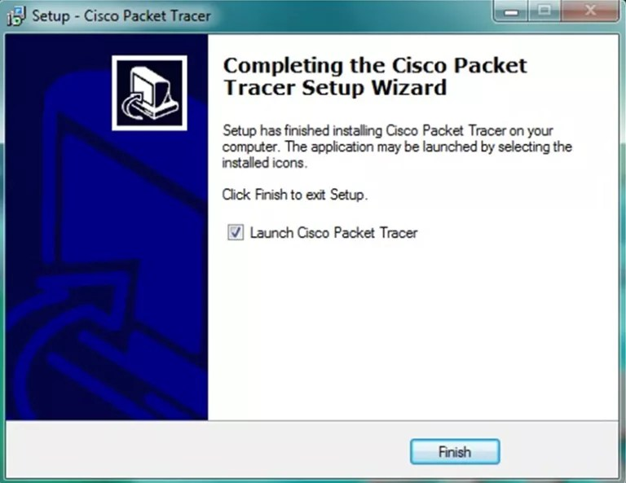](http://ipwithease.com/how-to-install-packet-tracer-on-windows-system/171how-to-install-packet-tracer-on-windows-system-07/)[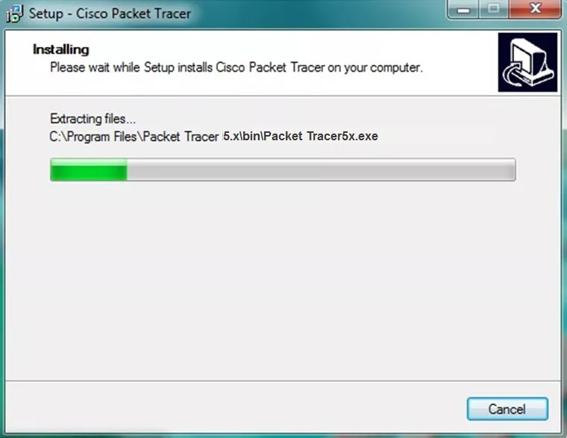](http://ipwithease.com/how-to-install-packet-tracer-on-windows-system/171how-to-install-packet-tracer-on-windows-system-06/)

Click “OK” on next popup asking you to close or restart your computer.

The cisco packet tracer installation starts as shown below